Manufacturing Innovation Fund Advisory Board
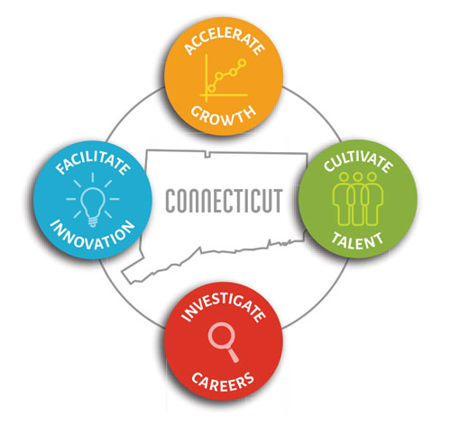

Meeting Agenda

TEAMS Meeting Call In Number: 1-860-840-2075
Participant Passcode: 860 906 390#

Friday, December 11, 2020
11:00 a.m. - 12:00 p.m.

- Welcome & Introductions

- October Minutes (Vote)

- 2020 Annual Report (Vote)

- Portfolio

- Incumbent Worker Training (Vote)

- Energy on the Line (Vote)

- Defense Manufacturing Community Support Program –
CT Digital Model Initiative

- Program Update - MVP

- 2021 Schedule of Meetings

- Other Business

