Manufacturing Innovation Advisory Board
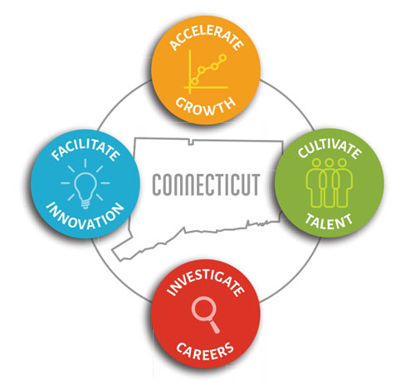

Meeting Agenda

TEAMS Meeting Call In Number: 1-860-840-2075
Participant Passcode: 581 475 813#

Tuesday, October 5, 2021
10:30 a.m. - 12:00 p.m.

- Welcome & Introductions

- August Minutes (Vote)

- Portfolio

- Legacy Programs (Vote)
- Manufacturing Voucher Program
- Apprenticeship Program

- New Initiatives (Vote)
- Engineering Interns
- Digital Transformation/Cyber Security Roadmaps
- CT Innovators/CT Manufacturers
- Hearts & Minds Advertising Campaign
- Manufacturing Website
- Regional Career Fairs

- Other Business

