Connecticut Customized Employment Services

Connecticut Customized Employment is a collaborative approach to service provision, based upon agreement that job seekers should be provided vocational options with priority placed upon creating opportunities for competitive work in the community providing for integration, economic self-sufficiency, challenge, and career growth. Services will be delivered based upon an individualized plan for a person according to his or her needs. Individual informed choice of service options will be honored to the extent possible through a coordinated service delivery system that makes the best use of existing and potential financial, human and community resources.

The Department of Developmental Services (DDS), the Department of Aging and Disability Services (ADS), and the State Department of Education partnered to roll out the Connecticut Customized Employment (CE) Curriculum in October 2021. The CT
CE curriculum was developed by the Regional Educational Service Center (RESC) Alliance in consultation with ADS, DDS and SDE to be provider focused. The service is meant to provide another option to obtain competency in CE. To become certified in Customized Employment Services, providers have the option of choosing the state curriculum or pursuing alternative ACRE Accredited Certification Courses for which reciprocity will be allowed. ACRE Certification of the CT CE Curriculum will be pursued in the coming year following fine-tuning of the curriculum.

All modules are virtual with a combination of deadline oriented asynchronous
(self – study) work and live online synchronous (class) sessions. The modules will engage learners with readings, videos, lecture style information sharing, presentations, role plays, case studies, discussion board posts, and practice tasks. Modules will vary between 8.5 hours and 13 hours and 40 minutes and completion will vary by course as well as by learner because some portions of the modules are self-paced.
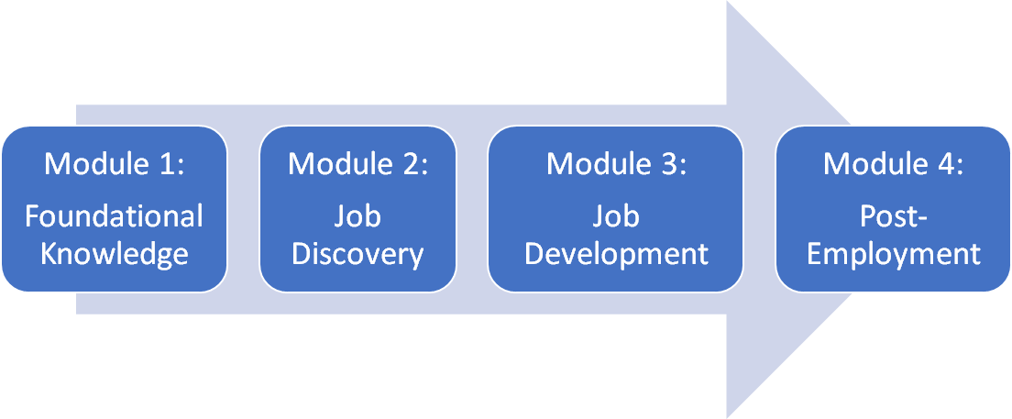

Provider and agency staff attending will be required to attend all four training modules including Module 1: Foundational Knowledge. Completion of all 4 modules includes Foundational Knowledge, Job Discovery, Job Development, Negotiation and Placement and Post Employment Support will be necessary to obtain CT CE certification.

2022 Winter-Spring CT Customized Employment Course schedule is as follows:
Module 1
Monday 1/31/22 Module 1 opens (8:00am)
Tuesday 2/22/22 Module 1 synch session 1 (10:00-1:00pm)
Friday 2/25/22 Module 1 assessment due and course closes (5:00pm)

Module 2
Monday 2/28/22 Module 2 opens (8:00am)
Tuesday 3/8/22 Module 2 synch session 1 (10:00-12:30pm)
Tuesday 3/22/22 Module 2 synch session 2 (10:00-12:00pm)
Friday 3/25/22 Module 2 assessment due and course closes (5:00pm)

Module 3
Monday 4/4/22 Module 3 opens (8:00am)
Tuesday 4/26/22 Module 3 synch session 1 (10:00-12:30pm)
Friday 4/29/22 Module 3 assessment due and course closes (5:00pm)

Module 4
Monday 5/2/22 Module 4 opens (8:00am)
Tuesday 5/10/22 Module 4 synch session 1 (10:00-1:00am)
Tuesday 5/24/22 Module 4 synch session 2 (10:00-1:00am)
Friday 5/27/22 Module 4 assessment due and course closes (5:00pm)

Agency Contacts

ADS Contact: Torrey Morse torrey.morse@ct.gov 860-876-9602
Heidi Henaire heidi.henaire@ct.gov 860-876-9598 TEXT

DDS Contact: Trever Rogers trever.rogers@ct.gov 860-418-8783
Amber Burke amber.burke@ct.gov 860-418-6006

CT CE Course participants will receive contact information for User support
concerns following enrollment in the training.

