Follow these steps to complete your initial Agency Provider application online with a User ID and Password

Follow these steps to renew your CLA license online with a User ID and Password

Follow these steps to renew your CLA license online with a User ID and Password

- We recommend use of a desktop or laptop computer to apply; webpages may not display properly on a tablet or mobile device.
- Open Google Chrome or Microsoft Edge and go to: https://www.elicense.ct.gov/login.aspx

Table of Contents
Step 1: Register an Account or Log into An Existing Account 2
Step 2: Complete Initial Application 4
Step 3: Upload Any Additional Requested Documents 13

Step 1: Register an Account or Log into An Existing Account
  - (If the Applicant has an existing eLicense account skip to Step 2: Complete Initial Application)

- Click on the “Register” link next to “Don’t have an account?”
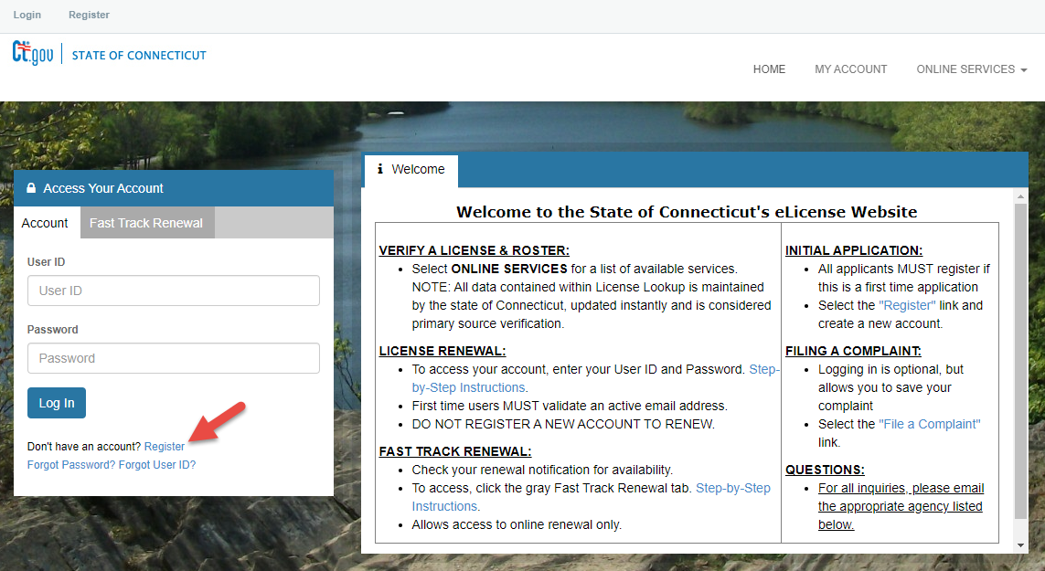

- Under “Register as:” click the radial button for “Business”; choose “No” for prior Licensing interactions and click the “Next” button”.
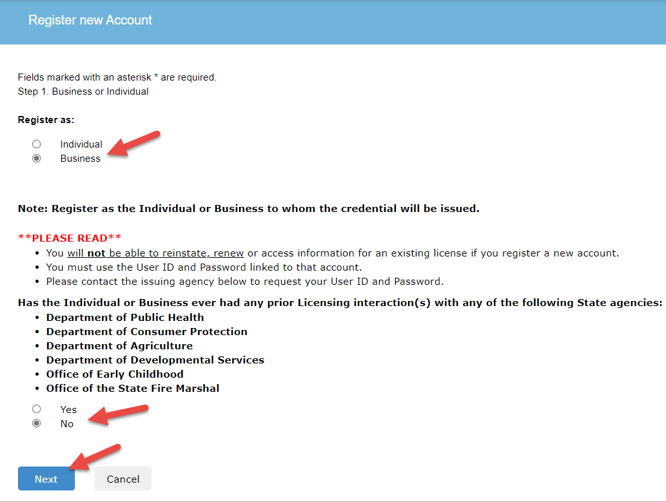
- Enter all required fields on the Registration page including
  - Account Information to set up a User ID and Password (Please enter 5 or more characters for the User ID with no spaces or special characters.),
  - Personal Information,
  - Public Address,
  - Mailing Address (tick the checkbox for “Same as Public Address”, if applicable),
  - Enter the Captcha Verification code and then click “Create Account” button.

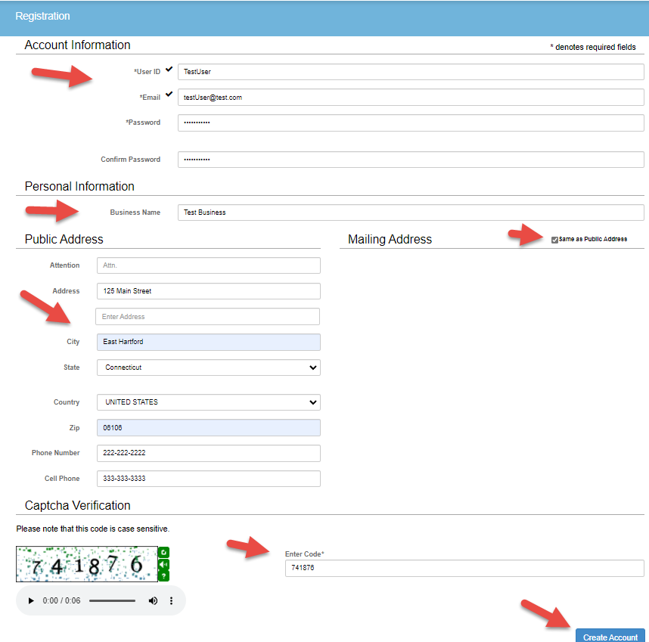

- The User Account page will now display. In order to validate your new account, a verification email has been sent to the email that was entered in the previous step. An opportunity is provided to update the email or User Id, if needed.

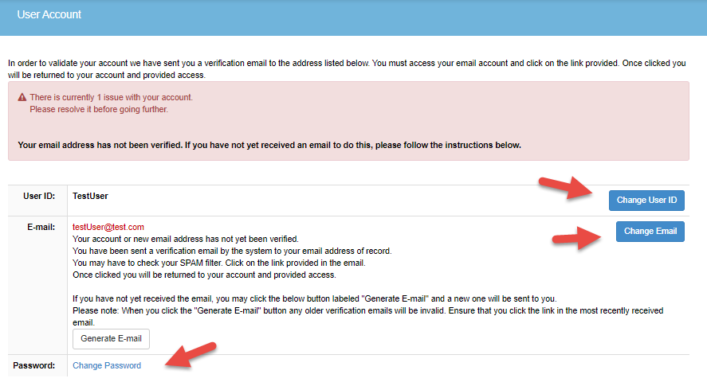

- An email should be received at the email address provided in the previous step. Follow the email instructions to click on the link provided to verify the email address.

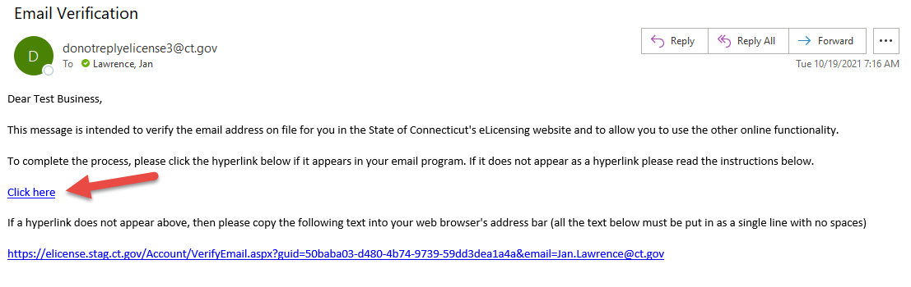
- A confirmation page will appear in the browser like the one pictured below.

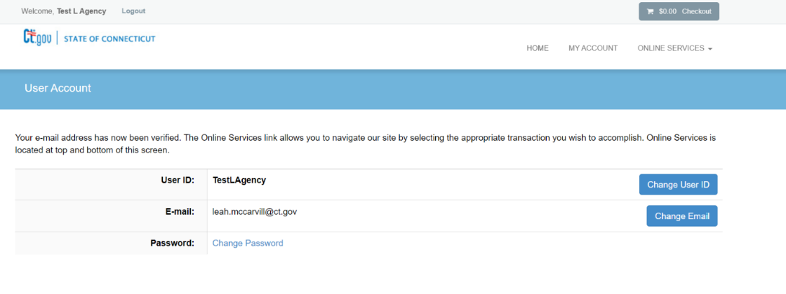

Step 2: Complete Initial Application
- There are 2 options for this next step you can:
  - click on Online Services then click on Initial Application from Activities in the dropdown menu
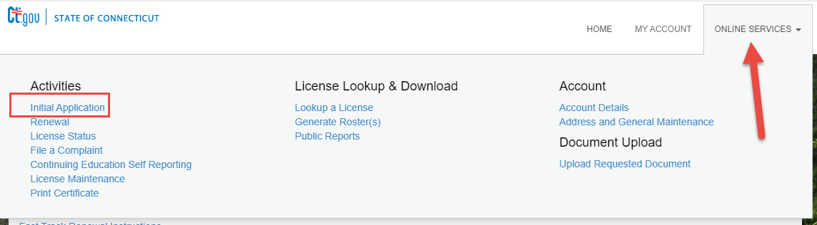

  - or you can scroll down on the page to “More Online Services” and click on “Initial Application” under “Activities”.

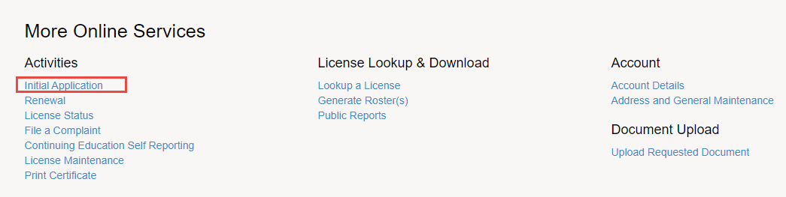
- Click on “Developmental Services” from the dropdown list.

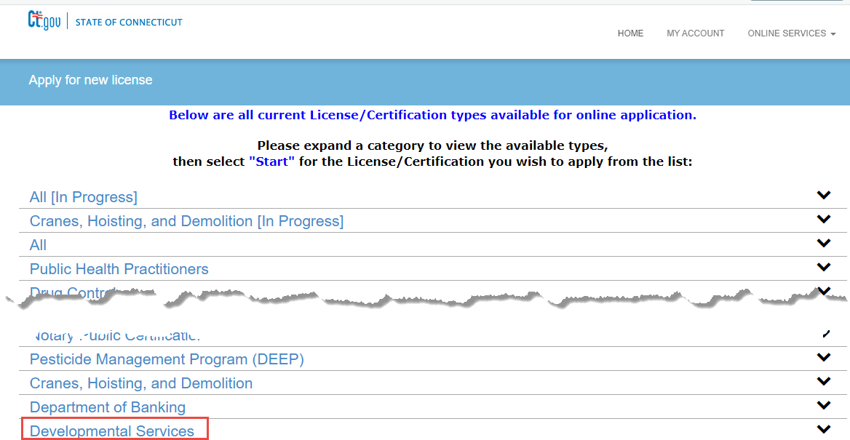

- Click “Start” next to “Developmental Services Agency Provider” 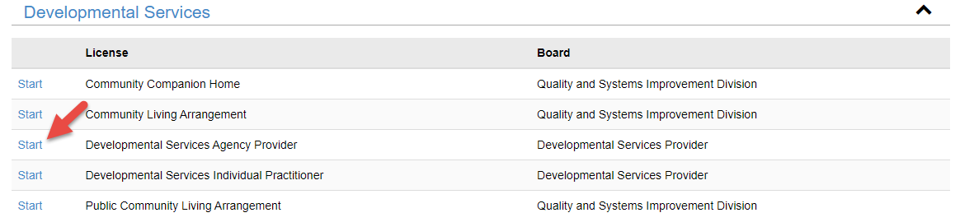

- You will be taken to the Welcome Page. Please review this page thoroughly. There are instructions and links to checklists that provide information about the types of documents that will be required to be uploaded during the application. It is recommended you prepare and gather those documents prior to continuing the application.

- Note that, at any time, the application can be Saved and Closed by clicking on the “Close and Save” button located in the lower right-hand section of the form.
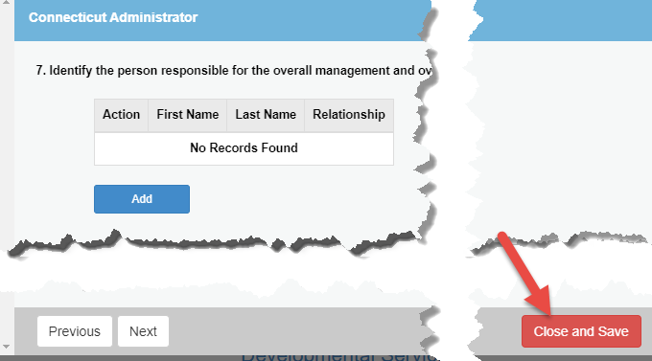
The saved application can be continued by logging back into the system and choosing the in-process application.
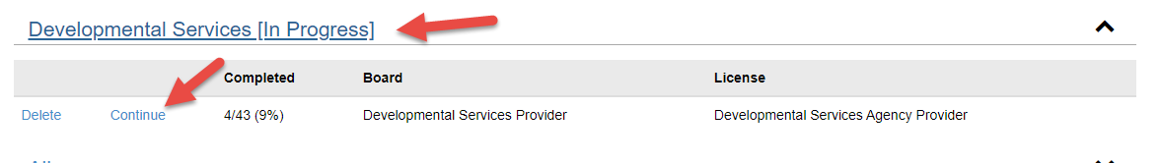
- For question 1, review the HCBS Waiver Manual via the link and then click “Yes” to acknowledge reading and understanding the document. Click “Next”.

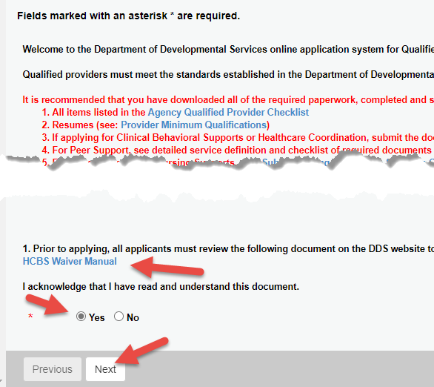

- Address Update - Make any necessary changes for the Primary and Mailing Address. Click “Next”.
Fields marked with an asterisk * are required.
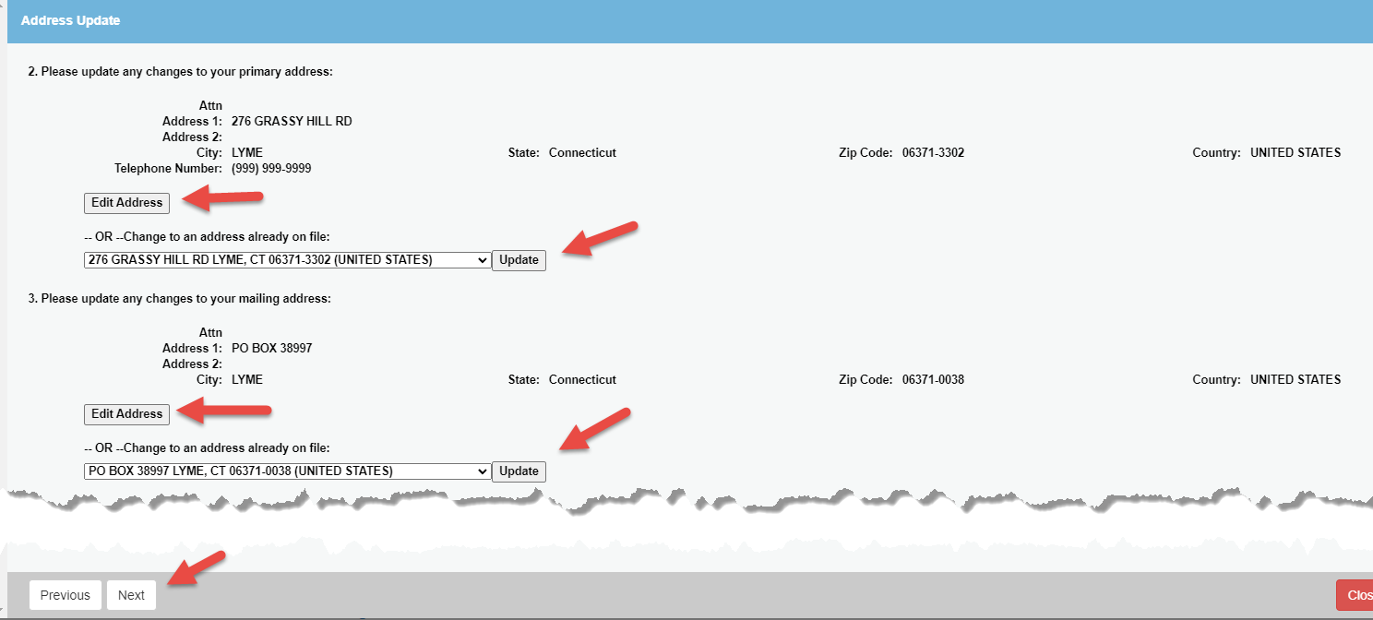

- Provider Information –
  - Make any necessary changes to “Provider’s Business Name”. This will update the account Business Name that was originally set up during the registration process in Step 3.
  - Enter the FEIN.
  - Click the “Add” button and enter the Principal of the Entity of the Provider Agency, enter the required information and click “OK”.
  - Select Current, Neither, or Past from the dropdown menu if you or have been a CT State Employee.
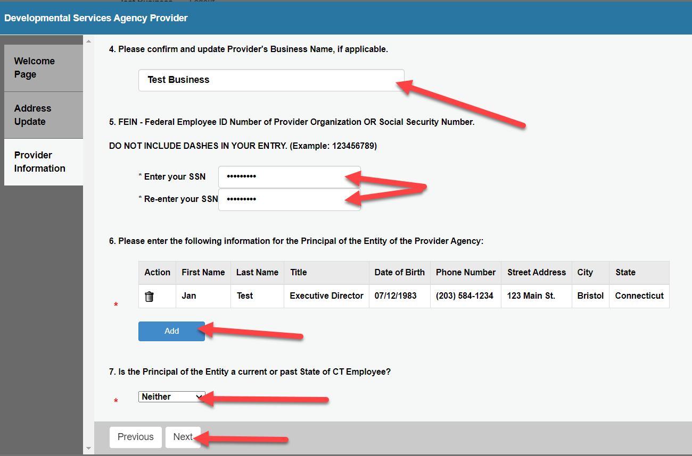
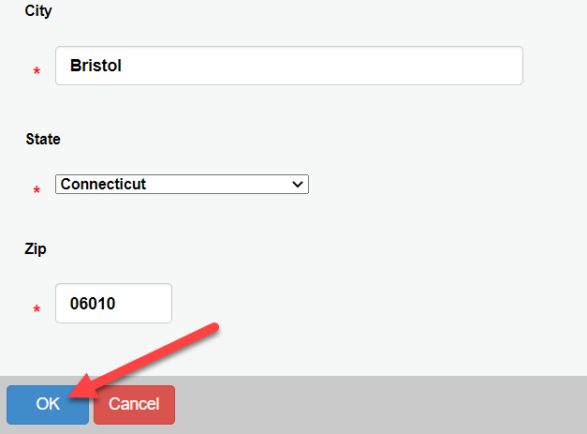
  - Click “Next”.

- Connecticut Administrator-
  - Click on the “Add” button

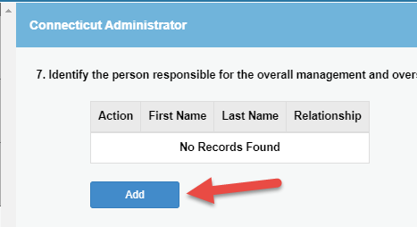

  - Enter information requested; choose “Administrator” for the Relationship field; click OK.

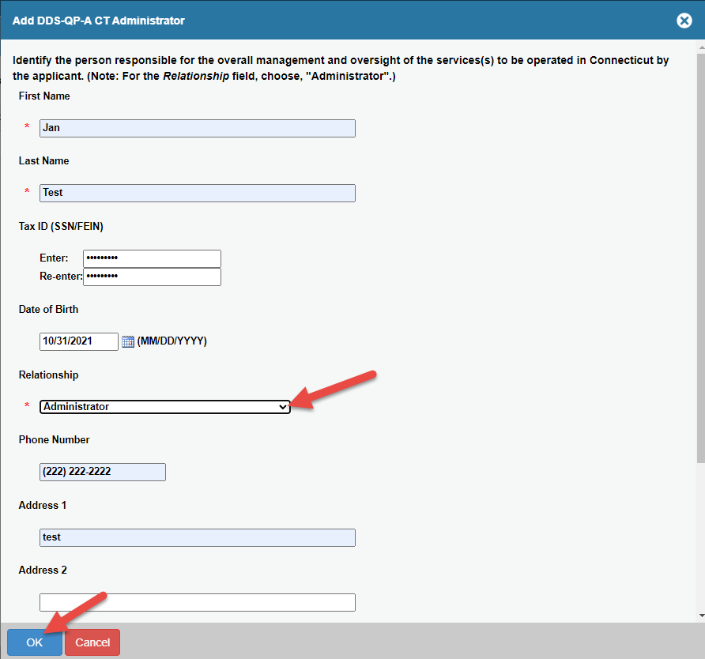

  - Enter
  - Click “Next”.

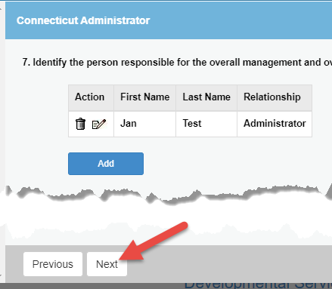

- Does the Provider Agency have a Parent Organization- Click Yes or No and click “Next”. If “No” is chosen, go to Step 13, otherwise proceed to Step 11.
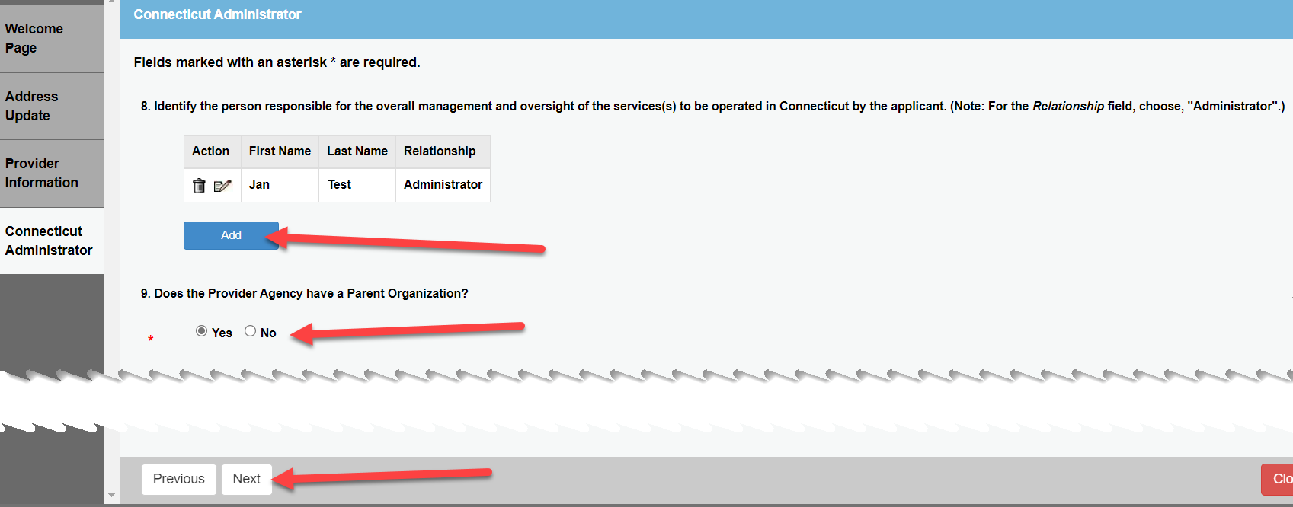
- Parent Organization Structure – Select the from the drop down list then click Next
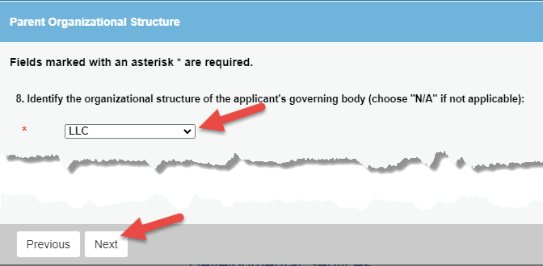
- Parent Organization- enter required information by clicking the Add button for questions 9 & 10.
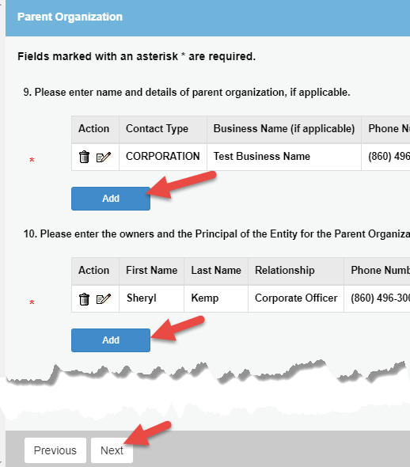

- Managing Partners & Service Information pages – enter requested information.
- Service Category pages – click Yes for a Service Category that has services the agency is applying to provide; click “Next”.
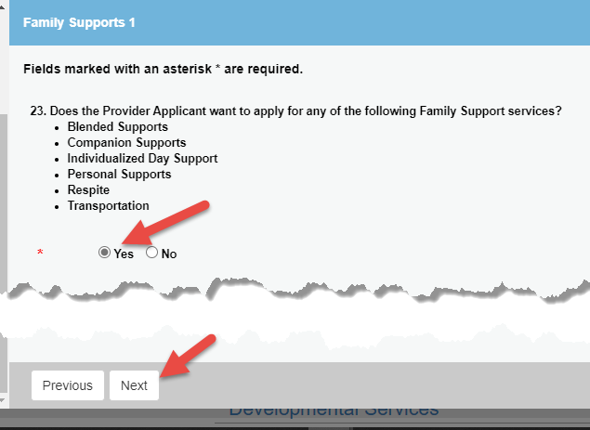

- For each Service Category that an agency is including in its application,
  - Click the Add button and pick a service the agency is applying to provide; click “OK”.
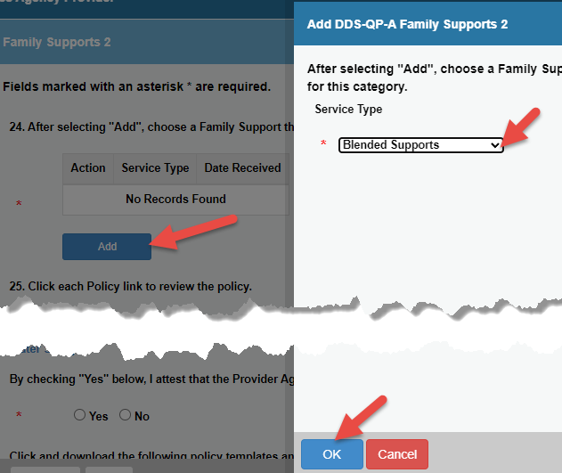
  - To add additional Services, repeat step 14a.

  - Review each Policy link and attest that the agency will follow the Policies listed.
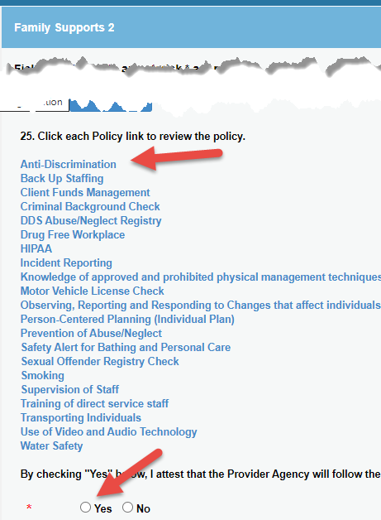
  - Click and download any listed policy templates and additional documents. Update the downloaded documents and then follow the instructions to upload the required documents; click “Next”.

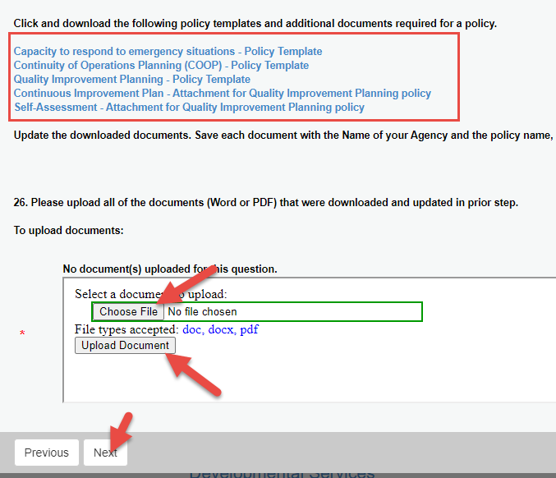

- Required Attachments – upload all documents listed on this page; click “Next”.
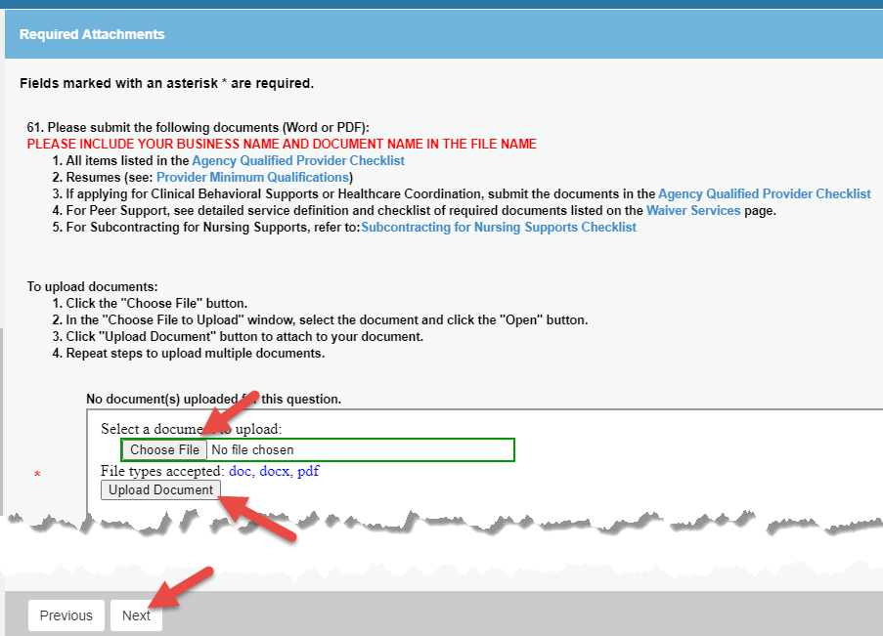
- Administrator’s Certification and Attestation – attest and fill out required fields; click “Next” for each page.
- Provider Agency Acknowledgment – certify and fill out required fields.
- Review the entire application and click “Finish” if completed. The application can also be closed and saved to be completed later. Do not click “Finish” button if you have not uploaded ALL required documents. YOU WILL NOT BE ABLE TO UPLOAD ADDITIONAL DOCUMENTS ONCE THE “FINISH” BUTTON IS CLICKED.
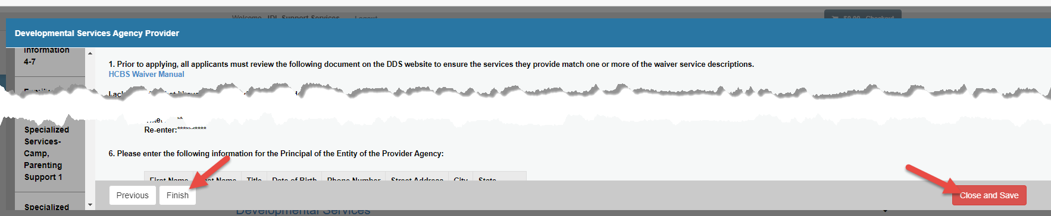

- Once the applicant has clicked “Finish”, a confirmation screen will display, and a Print Receipt button is available.
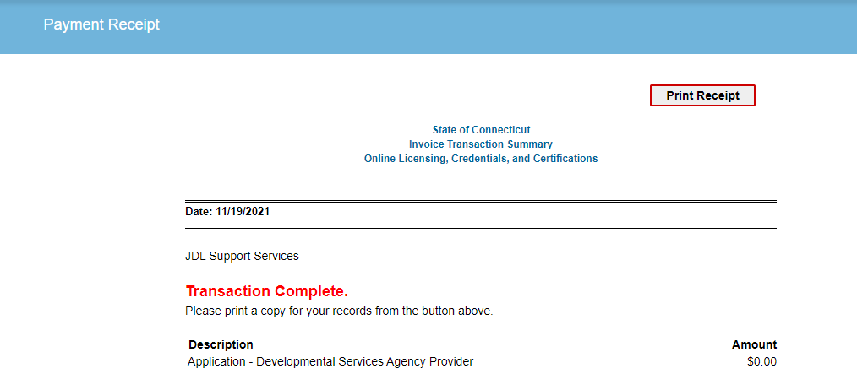

Step 3: Upload Any Additional Requested Documents
- After the initial application is submitted, DDS will proceed with the review process. During this process, applicants may receive email notifications to upload additional requested documents. If an email notification is received, log into the eLicense system at: eLicense Online (ct.gov) and log into the system with the UserID and Password that setup when the account was originally registered.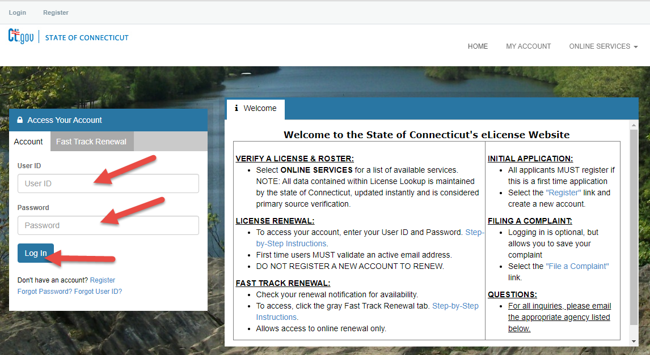

- Once logged in, select ‘Upload Requested Documents’ under ‘Document Upload’.
To upload a document:
Have the document scanned and stored on your device
Select the 'Upload Requested Documents' link.

- Select the “Start” link and then complete the upload.

