Follow these steps to complete your initial Agency Provider application online with a User ID and Password

Follow these steps to renew your CLA license online with a User ID and Password

Follow these steps to renew your CLA license online with a User ID and Password

- We recommend use of a desktop or laptop computer to apply; webpages may not display properly on a tablet or mobile device.
- Open Google Chrome or Microsoft Edge and go to: https://www.elicense.ct.gov/login.aspx

Table of Contents
Step 1: Login to existing Account 2
Step 2: Select Add or Remove Services (Classifications) 2
Step 3: Add Services 4
Step 4: Remove Services 7
Step 5: Upload Any Additional Requested Documents 7

Step 1: Login to existing Account

Enter User ID and Password and click “Log In” button.
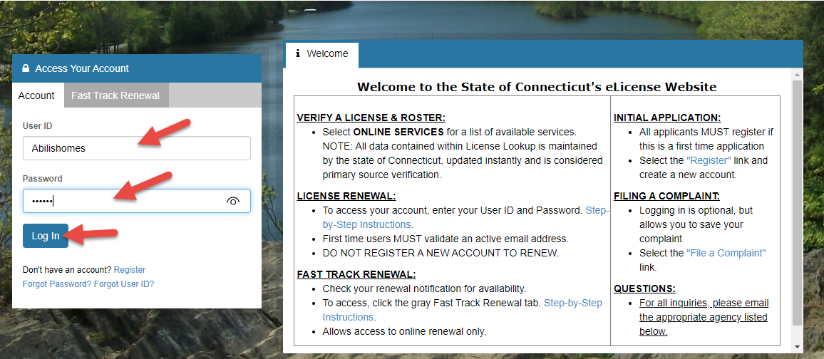

Step 2: Select Add or Remove Services (Classifications)
- There are 2 options for this next step you can:
  - Click on “Online Services” then click on “Classifications” from Activities in the dropdown menu
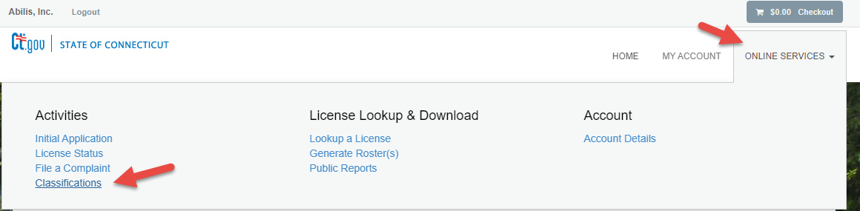

  - or you can scroll down on the page to “More Online Services” and click on “Classifications” under “Activities”.

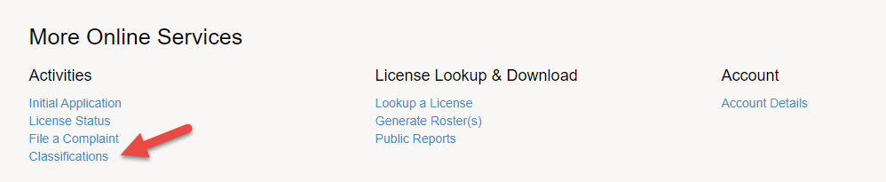

- Click on “Start” next to “Developmental Services Agency Provider”.
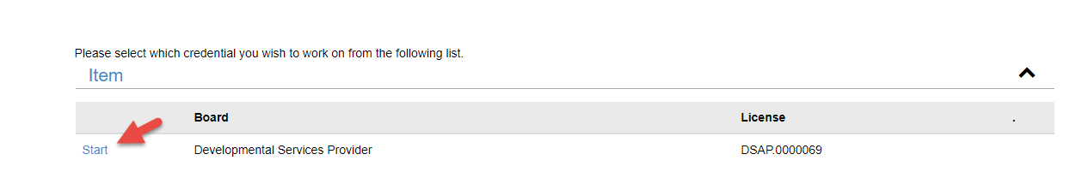

- You will be taken to the Welcome Page. Please review this page thoroughly. There are instructions and links to checklists that provide information about the types of documents that will be required to be uploaded during the application. If adding services, it is recommended you prepare and gather any needed documents prior to continuing the application; click “Next”.

- Note that, at any time, the application can be Saved and Closed by clicking on the “Close and Save” button located in the lower right-hand section of the form.
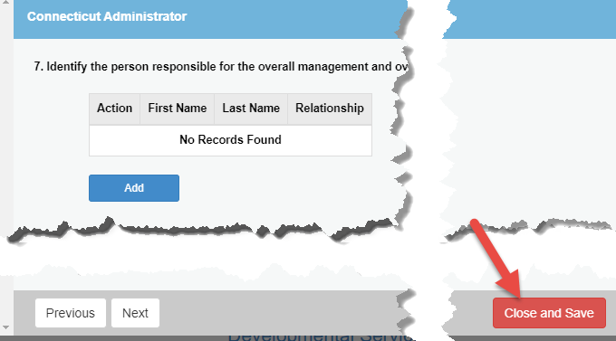
Note: The saved application can be continued by logging back into the system and choosing the in-process application.
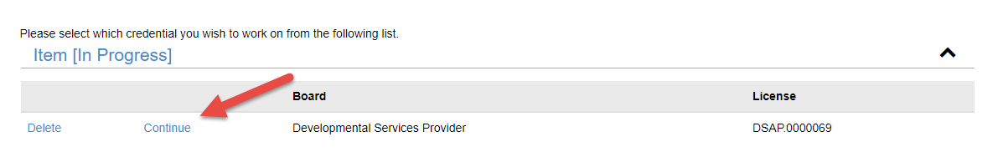

- Add/Remove Services Menu –
  - If you are requesting to ADD any services, choose “Add Services Type(s)” from the drop down; click “Next”; proceed to Step 3: Add Services.
  - If you are requesting to ONLY Remove services, choose, “Remove Service Types(s)”; click “Next”; proceed to Step 4: Remove Services.
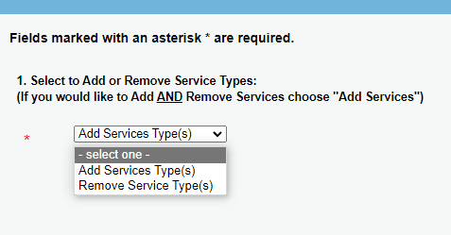

Step 3: Add Services

- For each Service Category, indicate if the Provider wants to add services; click “Next”.

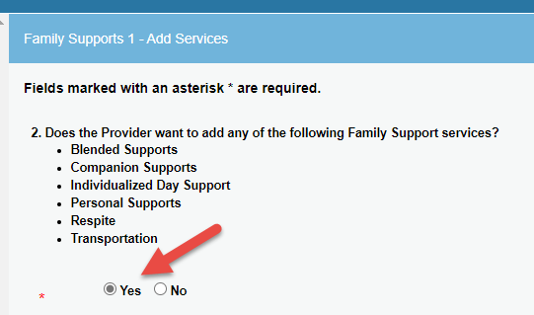

- For each Service Category that an agency is including in its application,
  - Click the Add button and pick a service the agency is applying to provide; click “OK”.
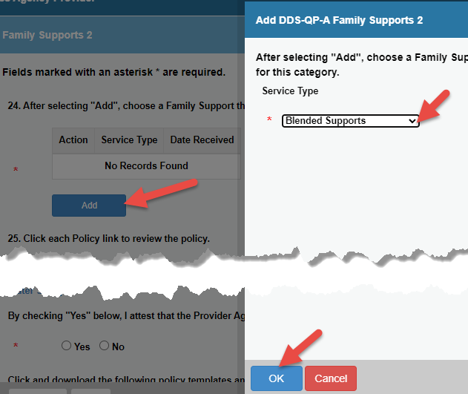
  - To add additional Services, repeat step 3.

  - Review each Policy link and attest that the agency will follow the Policies listed.
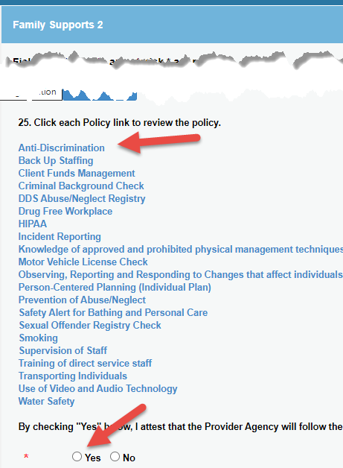
  - Click and download any listed policy templates and additional documents. Update the downloaded documents and then follow the instructions to upload the required documents; click “Next”.

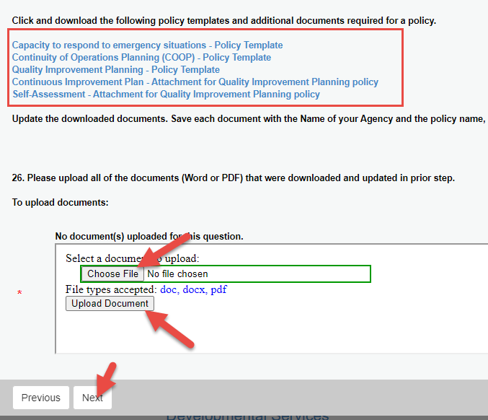

- Required Attachments – upload all documents listed on this page; click “Next”.
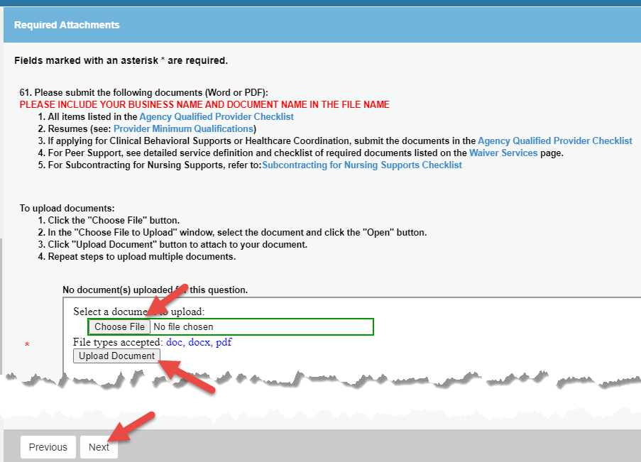

Step 4: Remove Services
- To skip this step, select “No” and click “Next” and proceed to Step 5: Complete Application.
- To remove a service, review the current Services Types associated with the Provider.
- To remove a service, click the Add/Edit button to choose a service the provider wants to remove.

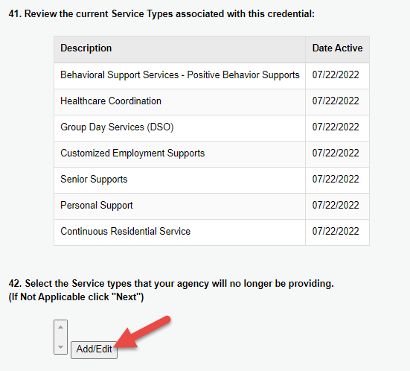
- Select a service by clicking under the “Available” column and then the “>” button to move the service over to the “Selected” column; Click “OK” when complete.
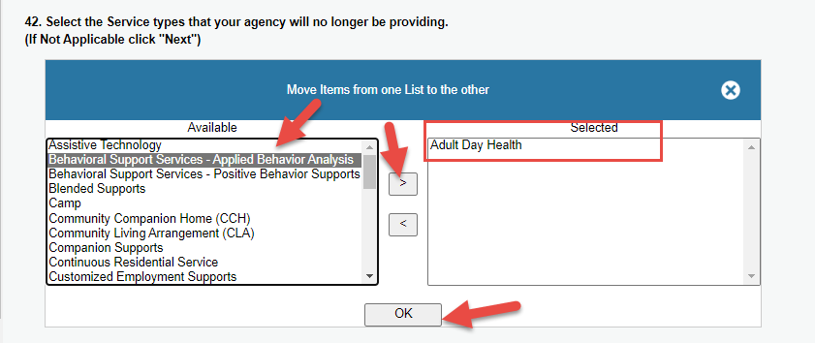

NOTE: if a service was incorrectly moved to the “Selected” pane on right, click on the Service Type, and then click the “<” button to move it back to the “Available” pane.

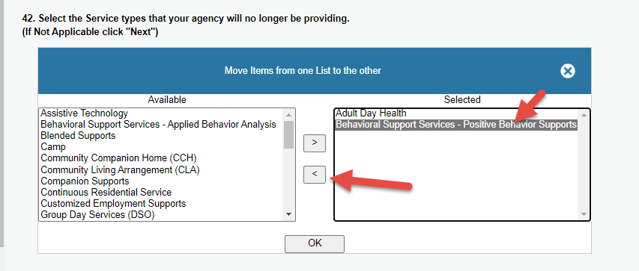
- Confirm list of services to be removed and click, “Next”.
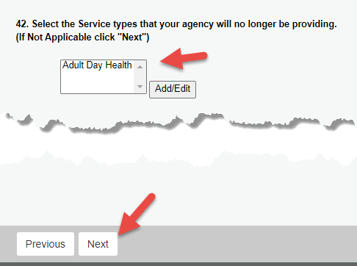

Step 5: Complete Application

Review the entire application and click “Finish” if completed. The application can also be closed and saved to be completed later. Do not click “Finish” button if you have not uploaded ALL required documents. YOU WILL NOT BE ABLE TO UPLOAD ADDITIONAL DOCUMENTS ONCE THE “FINISH” BUTTON IS CLICKED.

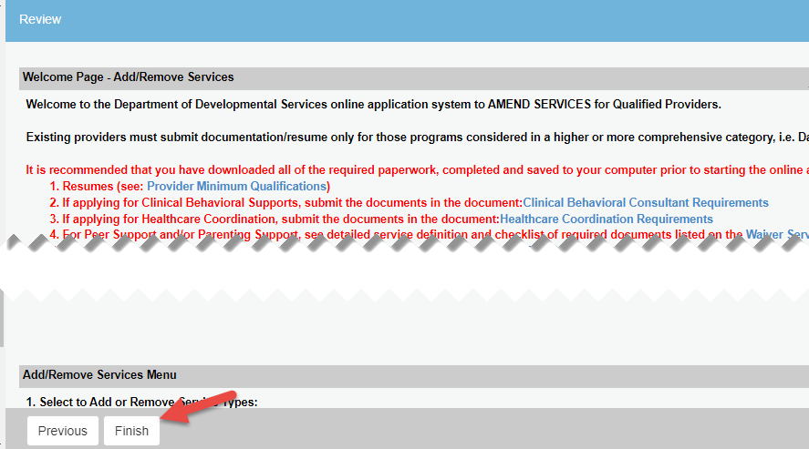

Step 6: Upload Any Additional Requested Documents
- After the add/remove services application is submitted, DDS will proceed with the review process. During this process, applicants may receive email notifications to upload additional requested documents. If an email notification is received, log into the eLicense system at: eLicense Online (ct.gov) and log into the system with the UserID and Password that setup when the account was originally registered.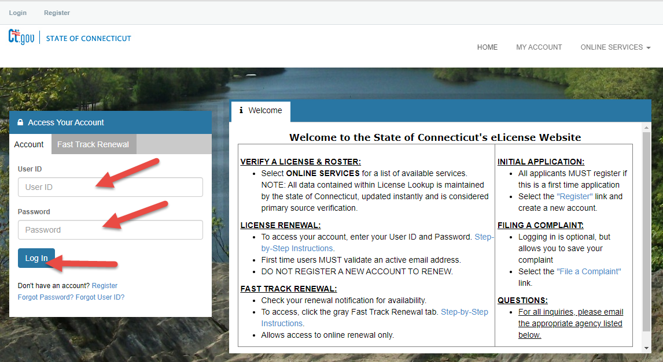

- Once logged in, select ‘Upload Requested Documents’ under ‘Document Upload’.
To upload a document:
Have the document scanned and stored on your device
Select the 'Upload Requested Documents' link.

- Select the “Start” link and then complete the upload.

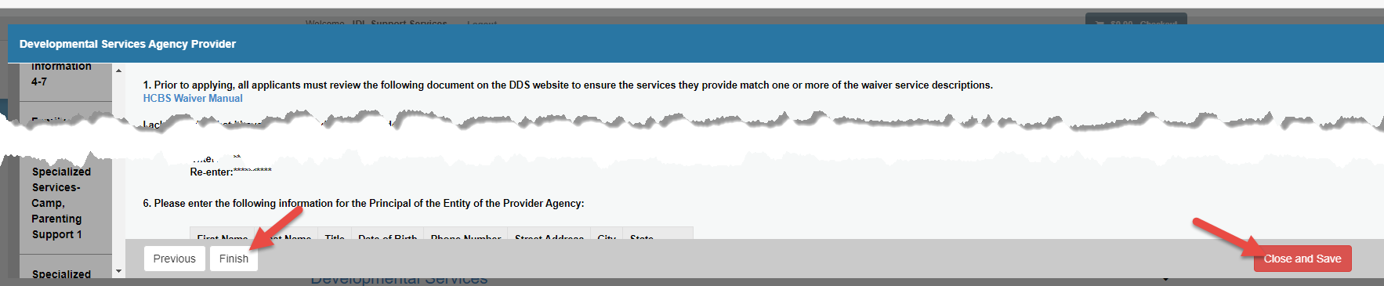

- Once the applicant has clicked “Finish”, a confirmation screen will display, and a Print Receipt button is available.
