Application for Replacement Pass to Camp Harkness
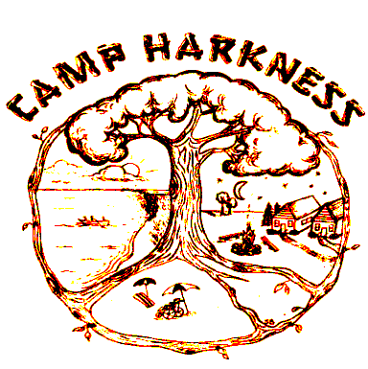

301 GREAT NECK ROAD
WATERFORD, CT 06385

Please complete the Camp Harkness Replacement Admission Pass Application form below for lost, misplaced or stolen cards, include a check or money order in the amount of $25.00 made out to the “Camp Harkness” and return it to:

Jacqueline Staller, DDS Camp Harkness, 301 Great Neck Road, Waterford, CT 06385
Telephone: 860-443-7818

Pass Holder must be in attendance – Passes are not transferable.

Name of Pass Holder/Applicant:__________________________________________________________________
Name of Parent/Guardian/Contact: _______________________________________________________________
Address: _____________________________________________________________________________________
Telephone Number: ________________________________ E-mail:_____________________________________

Lost or stolen pass cards will deactivated.

**FOR RESERVATIONS OR QUESTIONS REGARDING CAMP PLEASE CALL 860.443.7818**

Camp Harkness is a Connecticut State Park designated for use by individuals with a disability, accompanied by their families and friends. The definition of a disability is a physical or mental impairment, which substantially limits one’s major life activity. Admission to Camp Harkness is by special pass that must be presented at the main entrance of the camp.

For office use only
Date received | Check # | By | Date To Business Office

May 26, 2019

