Enter the Individual’s First Name & Last Name, DDS#, Case Manager’s Name and the Meeting Date:
Da Person Centered Plan DDS # 12345
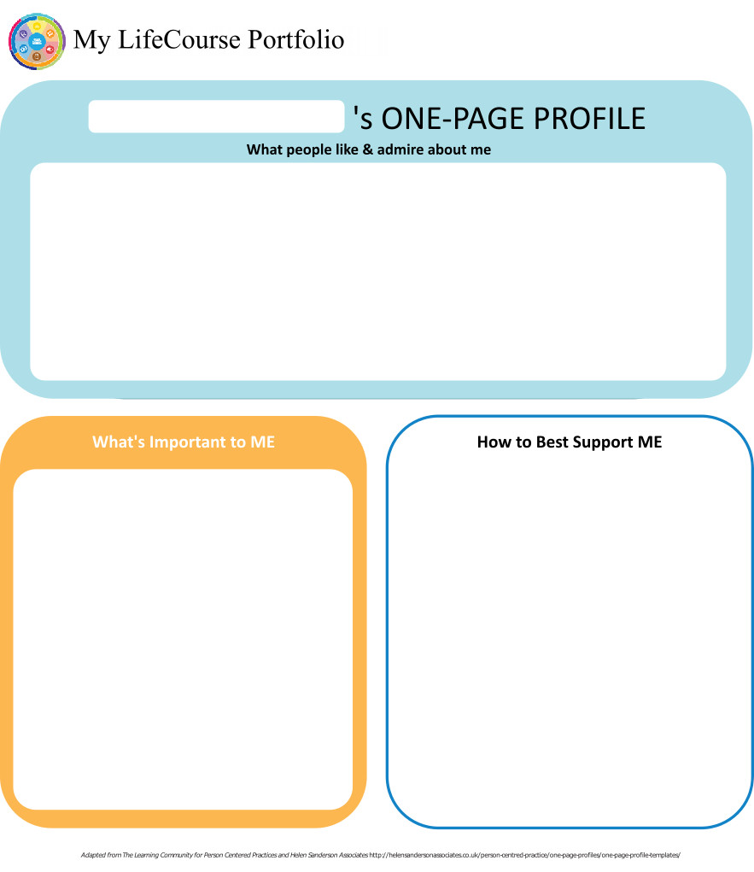
Case Manager: A… Meeting Date: 1/14/2019

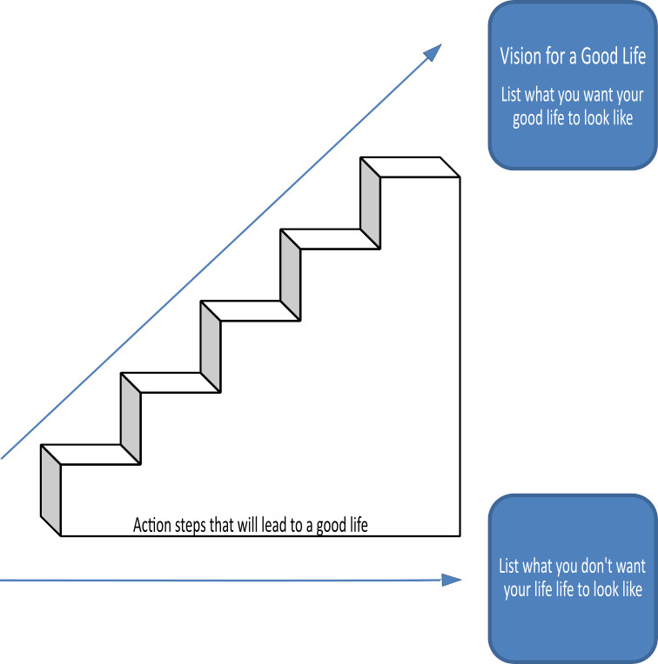

Home Life
Current Status Please include schedule, supports received, supervision needs, LON Risk areas, and accomplishments: Steve has his own efficiency apartment in the ….Assisted Living. Residential Care Assistants stop by multiple times daily to ensure Steve is ok. He takes his meals in the dining room and says the food is good. He keeps bagels and what he needs to make iced coffee in his fridge. He has a Keurig machine and a microwave that he knows how to use. He spends his time in his recliner watching movies, vintage tv shows, and the game show channel. He has Privately Hired staff from his Individual Budget for 16.5 hours each week. Staff schedule hours around MD appointments, community shopping trips, and other needs he communicates. He has a home health aide Monday - Friday to help with hygiene routines, and general housekeeping. LON risks are addressed by onsite supports, HHA services, and intermittent staffing from trained Personal Support staff.

- What I want my Home to be like How do you like to spend your time at home: "Quiet" He likes to have his supply of breakfast bars - Peanutbutter and Chocolate and a giant jar of parmesian cheese that he takes with him to the dining room. He also wants to have bottles of water on hand. He does his own laundry that is located across the hall.

- Would you like to live anywhere else, what’s your vision? "I like it here" While he doesn't want to live anywhere else - he does wish that some people who live there would stop bugging him. He said one gentleman who sits at his table for meals bugs him - but Steve said that he wasn't going to move - wants the other guy to move.

- What Supports do you need to help with this? "None" - no changes needed at this time. Later in conversation he said he would like the Home Health Aides to come 7 days a week.

- Do you need support with your finances?
Providers please include financial assessment and report if applicable. Do you have a representative payee? Please list.

Steve avoided the questions about money. He waved his hand at me. Part of the … assisted living's setting - they are the payee and manage the finances for residents. Steve is able to get spending money as needed.
- You are required to obtain and maintain Medicaid benefits. Do you require help maintaining
Medicaid?
- If yes, who is responsible to help you? ……..'s business office handles all benefits and entitlements.

- Financial Information:
- Earned Income NA
- Benefits Income (list programs and amounts) SSA $1028
- Bank Accounts $1325.64
- Burial/Funeral Account? NA
- Total assets: Varies - $1325.64 at time of meeting.
- Are you satisfied with the supports you are receiving at home?
Describe: While laughing, Steve did say that I was not a good Alex Trebec but did say the staff were "ok"

- Emergency contact: T… - Sister ########## Suffield.

- Emergency Back-Up Plan:
An Emergency Back-Up plan must be completed for individuals who receive waiver services and live in their own home, family home or other settings where staff might not be continuously available, and who receive personal care and/or supervision supports and the failure of those supports to be available would lead to an immediate risk to the individual’s health and/or safety.

There are ………'s staff present for all hours. They are the primary support system for Steve's needs.

Work, Day, Retirement or School
Current Status Description/schedule of what the individual is doing, level of support and supervision needed, identify any LON Risk areas, modes of transportation, accomplishments: Steve is retired. He used to work at Big Y. He does not have any formal day program supports. Personal Support hours are scheduled when he needs them. There are a few private hired staff that work with Steve. Most days he can be found in his recliner watching his favorite shows or working on his Word Search puzzles. He has dozen of movies - of all types that he watches. He knows how to work all of his various machines. His willingness to engage varies.

- Do you like the job you have or the activities you do during the day? "What do you think" Steve is clearly happy with his daytime routine as he makes his own schedule. He is effective at voicing his concerns or compaints if he had any.
- What do you like about it, what would you like to change? Steve wouldn't answer this question but team knows that Steve loves to be in charge of his life - if he wants a change - he will make sure someone knows.
- What new skills, education or activities would you like to learn or take part in this year? Steve is retired and indicated he likes the things he does now.
- What are your career goals? Vision for the future? Steve didn't provide any answer aside from a grunt to this question. Team feels from past things he has said that he wants to keep things the same.

- What supports do you need during work or activities? "Already answered that question". Staff will schedule time during daytime hours if there is an apppointment or something he wants to do. Steve can be quite grumpy at times and will snap at staff - it is best to leave then and come back another time.

- Do you have Transportation to get you to and from work on time?

Describe: Steve has the rides he needs for community activities.
- Do you make minimum wage or better? NA

- Are you satisfied with your wages?

Describe: NA - retired
- Do you make enough money to do the things you want? Yes - Steve has the funds to make purchases and travel.

- What can you do this year to make more money? NA

- Are you satisfied with the supports you are receiving?
Describe: Steve wouldn't answer so I directed to him. "people that help me are ….for $2000. "OK". Got an ok when I asked about …….'s RCA's, HHA, Personal Support Staff. "But not you - you're no good" Then he laughed.

Health and Wellness
Current Status: How is your health? What supports are you receiving? What activities do you do to stay healthy? Please include current medications, diagnosis, doctor’s orders, dental, last physical, known allergies, adaptive equipment, brief overview of health history unless noted in Nursing Report, attach Nursing Report to plan if available. Is there a behavior plan in place? Please attach.
Steve lives in a supported setting where there are trained staff and nurses present for waking hours. He also has Home Health supports from S…..agency that include an RN visit weekly to pack his meds and a Home Health Aide 5 days/week. Personal Support staff schedule and facilitate all appointments. Steve reluctantly goes to appointments, hates needles, and really doesn't want to be bothered. He has lymphoma which is in remission so he knows what lots of appointments means. Staff work to combine appointments with something he enjoys.
- What’s Important to me about my health and safety Any areas you want or need to work on? This was a difficult topic for Steve to discuss. No amount of encouragement could get him to provide an answer beside not wanting to get a colonoscopy that he mentioned earlier.
2. Are you up to date on routine medical tests and visits?
Are you able to follow recommended health guidelines? List any deferrals.
Explain: Steve had a recent appointment where a colonoscopy was discussed. Steve refused all discussion, all options, and said he was not going to go through the process. Will be referred to RN for follow-up.
- What supports do you need to improve your health and safety? Please include a plan to support any health risk identified in your LON. What do you need to do to be healthy for $500_____? "Eat well, sleep well, go to appointments." LON Risk areas are addressed by the RN Care plan (attached), HHA services, and onsite supports at S……...
4. Are you satisfied with the supports you are receiving?
Describe: Steve did not answer directly but he does let people in to assist him and he wouldn't do that if he did not like them. Steve did ask about wanting the Home Health Aide to come 7 days/week. He also needs a new rolling walker or to have his repaired as the brakes and other parts are broken.

Friendships, Relationships and Activities

- Who do you enjoy spending time with? Family, friends, co-workers, acquaintances? Any special relationships? For $500 Who do you liike spending time with? "My family". Steve really likes his time alone. He spends time with family for the holidays and an enjoys lunch and dinner out with them. He speaks with his mother on the phone. He will agree to suggestions for plans with his Personal Support staff, or request an alternative. He likes consistency as he has a tough time with new people. He can be a bit grumpy and has been known to kick people out if he is upset about something or simply doesn't want anyone in his space.

- What are your interests and hobbies? "TV". Steve enjoys Vintage TV, movies, games shows,and word search. He also showed us a drawer of porn movies, which he calls "guy movies", that he will open and show people. He seems to get a kick from the shock value when someone sees the movie covers. Visiting staff should be aware. Steve does not discuss these with people but only shows them when asked about his video collections.

- Do you participate in any Groups? "No". Steve does take trips with Trips R Us. He has been on a variety of trips and has also gone on a cruise with family. He is hoping to take another this year. We discussed the options - but Steve was clear he wasn't interested in available day trips. He gets advice from his mother about the trips he takes and Personal Support staff do the drop off and pick ups as well as packing his meds and clothes.

- Would you like to increase the time you spend with family, friends or doing hobbies or favorite activities? "Not really" When I offered the option to go out for lunch - he said "maybe in a couple of months"

- What help do you need to accomplish this? Steve needs help to plan his vacations/trips.



Action Plan
Desired Outcome  (What Do You Hope to Accomplish?) | Why is this Important to you? | Actions and Steps | Responsible Person(s) | Date to be  Completed or  Time frame monitored
- Be healthy | - When you are healthy people bug you less often. | 1A:Interact with VNA for meds, RN check, HHA supports | Steve, S….agency | Daily
- Be healthy | - When you are healthy people bug you less often. | 1B:Attend all needed appointments with staff | Steve, PS Staff | 1/14/20
- Be healthy | - When you are healthy people bug you less often. | 1C:Follow-up on colonscopy refusal. Complete deferral if needed. | C……, HHC | By 3/1/19
- Be healthy | - When you are healthy people bug you less often. | 1D:Address walker repair or replacement/increase in HHA days | DDS CMgr/Salute | By 2/1/19

- Spend time having the things I want and doing the things I like to do | - Being in charge of what happens in life is important. | 2A:Go out in the community to get things that are needed/wanted | Steve, PS Staff | Weekly
 | - Being in charge of what happens in life is important. | 2B:Plan vacation with Trips R Us | Steve, PS Staff, Family | annually
 | - Being in charge of what happens in life is important. | 2C:
 | - Being in charge of what happens in life is important. | 2D:

3A:
3B:
3C:
3D:

4A:
4B:
4C:
4D:

5A:
5B:
5C:
5D:

6A:
6B:
6C:
6D:

7A:
7B:
7C:
7D:

Summary of Supports and Services:
Agency/individual/Vendor | Type of Support/Service  (identify all including HCBS Waiver Services, non-waiver services and any other supports) | Amount of Support/Service  Hours per week/month/year
Private Hire Staff | Personal Supports | 16.5 hrs/week
Goods and Svcs Supervisort | Coordination or Private Hire Staff | 1hr/week
C…………. | Health Care Coordination | 24 hrs/week
S…… Home Care | VNA Med Admin/HHA Svcs | RN Weekly + HHA 5d/wk
DDS | Case Management | Quarterly contact and as needed

For Extension Purposes Only
Plan remains appropriate and Team agreed to extend plan as per DDS extension procedure on:
Case Manager Signature:

Summary of Representation, Participation & Plan Monitoring

Choice and Decision Making
Would you like the assistance of a guardian (in some or many areas) or an advocate in making important decisions in your life? Does your team feel this assistance may be needed? Team should note steps to be taken in this area.

Steve is able to make his own decisions requiring consent in all areas. Steve and his team do not feel a guardian is required at this time.

Individual’s Participation in Planning Process
Were you part of the planning for your meeting and the development of this plan? How can the team assist you with improving your participation in the future? Please identify those steps for next year’s meeting.

Steve is not a fan of people in his space, lots of people talking, or answering questions. I switched into a modified Jeopardy game to help him engage. He warmed up a bit and relaxed a bit but it was clear that after about 30 minutes - he was done and we needed to go. Steve was in charge of his meeting. He refused to sign any paperwork at the start or when presented later. Structuring the IP like a short visit vs. " a meeting" might work better. Team will discuss ways to encourage his participation in short time periods throughout the year rather than in one longer meeting annually.

Representative’s Participation in Planning Process
Did your family/guardian/advocate/legal or personal representative take part in the planning process and meeting? Are you satisfied with their level of participation? Team should note steps to be taken in this area for any increased participation.

Steve has no formal representative and he sees his family on holidays and visits throughout the year. Contact will be made outside of the meeting for their input.

Monitoring and Evaluation of the Plan
Contact your case manager with any concerns or progress updates throughout the year. Providers will complete and distribute an Individual Progress Review every six months. Your case manager will conduct a Quality Service Review with you once a year.

The Individual Plan will be developed annually and reviewed after 6 months. The team will meet as needed throughout the year. The next review will be held in July 2019.

Aquatic Activity Screening Individual Plan and Individual Short Plan Addendum
Name: Da | DDS#: 12345 | Date: 1/14/2019
An individual’s aquatic activity screening* is effective for one year from the date on this form as part of the IP or for up to three years for an individual with an IP Short Form. Request for any changes or updates to this form shall be made through the Planning and Support Team process.
*For individuals without an IP and assigned case manager, this form shall be completed by the Helpline Case Manager and the individual’s family when access to aquatic activities at DDS-funded sites or with DDS-funded staff are planned (i.e., camp, respite centers, family support).
SECTION 1 SCREENING FOR PRESENCE AND PARTICIPATION IN AQUATIC ACTIVITIES
Definitions:
- “Aquatic Activities” means all water-related activities including swimming, boating, fishing, hot tubs, water parks and those activities that take place near to water.
- “Near To Water” means aquatic activities at any location where there is a body of water at the intended destination that is open and accessible to individuals. This means that there are no barriers to prevent access such as secure fencing or padlocked gates. Contact with the water may, or may not be intended. Bodies of water include, but are not limited to, streams, creeks, oceans, lakes, ponds, pools, hot tubs, wading pools, or natural or man-made water areas. Near to water activities include, but are not limited to, picnics in a park where there is water, feeding ducks at a pond, unrestricted access to backyard wading or swimming pools or hot tubs, or walks on the beach.
- “Shallow Water” means water at or below the height of the individual’s chest.
- “Deep Water” means water above the height of the individual’s chest.
The Planning and Support Team should assign an Aquatic Activity Code “0” to “6”for the individual Aquatic Activity Code
0 = Individual does not swim or participate in any aquatic activities.
If coded as “0”, Section 2 should have “NO” checked for all activities listed.
1= Near to Water Activities Only and Must Be With Staff
Individual participates only in activities near to water.
2 = Shallow Water Only Individual has limited or no swimming skills and does not respond to verbal redirection and may not recognize dangerous situations.
3 = Shallow Water Only Individual has limited or no swimming skills but usually responds to verbal redirection and may or may not recognize dangerous situations.
4 = Deep Water Swimmer Individual can swim in deep water with staff supervision (Comments in Section 2 may define supervision type).
5 = Aquatic Activity Level Not Known. Individual is approved only for aquatic activities as permitted in Section 2 and must be in a One-to-One enhanced staff-to-individual ratio at all of these activities until aquatic activity code is determined and approved.
6 = Independently Accesses Aquatic Activities Individual requires no supervision for aquatic activities. Do not complete Section 2.
SECTION 2 AQUATIC ACTIVITIES - SUPERVISION NEEDS
Complete this section for individuals with an Aquatic Activity Code of “0” to “5”only.
NOTE: If you check off ‘yes’ for any of the activities below, there must be a “staff-to-individual” ratio included. These ratios are for staff to ensure they provide adequate supervision. Safe staff ratios cannot exceed 1 staff to 7 individuals for any of the activities listed. If supervision needs are unknown due to lack of previous participation, the individual must be in a 1:1 staff to individual ratio at all aquatic activities, until a safe appropriate ratio can be determined and approved.
AQUATIC ACTIVITY | ABLE TO  PARTICIPATE | SUPERVISION NEEDS | COMMENTS (arms-length, line of sight, seizures, lifejacket, etc.)
Activities Near to Water |  | # 1 staff to # 1 individuals
Boating: follow site directions for life jacket use. |  | # staff to # individuals
Swimming |  | # staff to # individuals
Water Parks |  | # staff to # individuals
Hot Tub Use |  | # staff to # individuals

Individual’s Name: Da DDS # 12345

Provider: Submitted By:

Case Manager: A… Date: Period Covered: to

Six Month Annual Other: Date of next Review Meeting :

Are there any significant updates or changes regarding the person’s status in any of the following areas?

What’s important to me? Vision for a Good Life Home Life Finances Work, Day, Retirement or School
Health and Wellness Friendships, Relationships and Activities Integrated Support Star

Updates/Changes:

Copies should be sent to: Individual/Family/Guardian, Case Manager, Residential Provider, Day Provider
Waiver Service(s) (from Summary of Supports and Services):

#1 Desired Outcome: Be healthy
Progress made towards Actions and Steps Yes No Outcome not addressed (must comment below)
Include information about progress, whether steps should continue or be modified.
A: Interact with VNA for meds, RN check, HHA supports
B: Attend all needed appointments with staff
C: Follow-up on colonscopy refusal. Complete deferral if needed.
D: Address walker repair or replacement/increase in HHA days

See Attached

Concerns/Comments/Recommendations:
Waiver Service(s) (from Summary of Supports and Services):

#2 Desired Outcome: Spend time having the things I want and doing the things I like to do
Progress made towards Actions and Steps Yes No Outcome not addressed (must comment below)
Include information about progress, whether steps should continue or be modified.
A: Go out in the community to get things that are needed/wanted
B: Plan vacation with Trips R Us
C:
D:

See Attached
Concerns/Comments/Recommendations:

Individual’s Name: Da DDS # 12345
Waiver Service(s) (from Summary of Supports and Services):

#3Desired Outcome:
Progress made towards Actions and Steps Yes No Outcome not addressed (must comment below)
Include information about progress, whether steps should continue or be modified.
A:
B:
C:
D:

See Attached
Concerns/Comments/Recommendations:
Waiver Service(s) (from Summary of Supports and Services):

#4 Desired Outcome:
Progress made towards Actions and Steps Yes No Outcome not addressed (must comment below)
Include information about progress, whether steps should continue or be modified.
A:
B:
C:
D:

See Attached
Concerns/Comments/Recommendations:

Waiver Service(s) (from Summary of Supports and Services):

#5 Desired Outcome:
Progress made towards Actions and Steps Yes No Outcome not addressed (must comment below)
Include information about progress, whether steps should continue or be modified.
A:
B:
C:
D:

See Attached
Concerns/Comments/Recommendations:

Individual’s Name: Da DDS # 12345
Waiver Service(s) (from Summary of Supports and Services):

#6 Desired Outcome:
Progress made towards Actions and Steps Yes No Outcome not addressed (must comment below)
Include information about progress, whether steps should continue or be modified.
A:
B:
C:
D:

See Attached
Concerns/Comments/Recommendations:
Waiver Service(s) (from Summary of Supports and Services):

#7 Desired Outcome:
Progress made towards Actions and Steps Yes No Outcome not addressed (must comment below)
Include information about progress, whether steps should continue or be modified.
A:
B:
C:
D:

See Attached
Concerns/Comments/Recommendations:

