Enter the Individual’s First Name & Last Name, DDS#, Case Manager’s Name and the Meeting Date:
FYI Person Centered Plan DDS # 12345
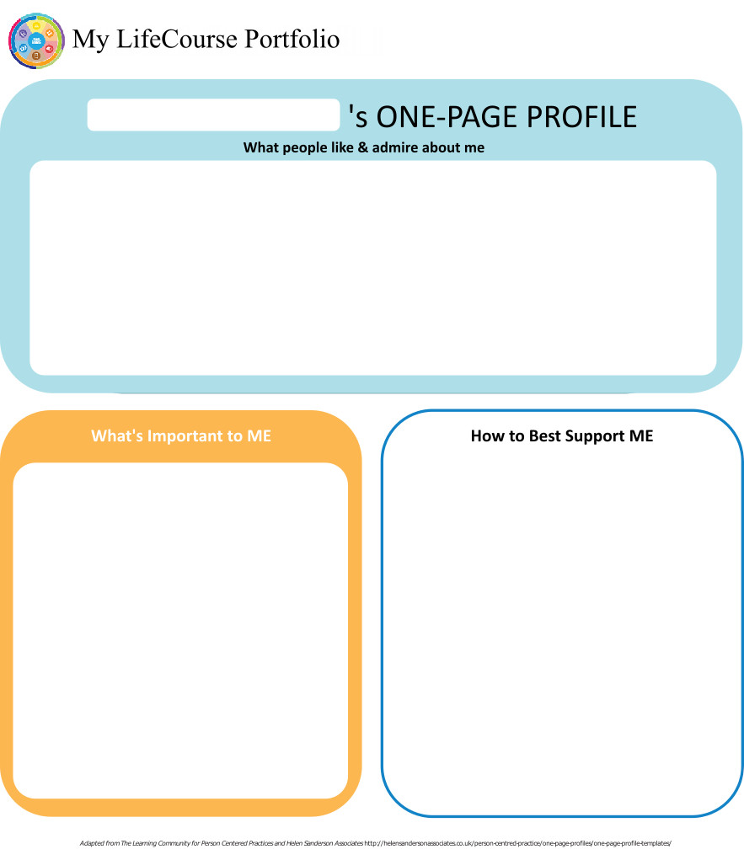
Case Manager: M…… Meeting Date: 12/13/18

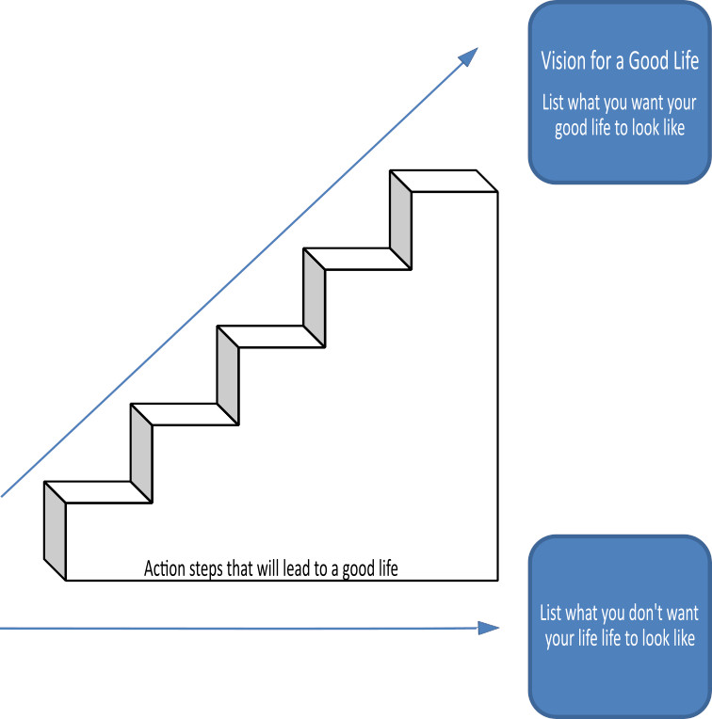

Home Life
Current Status Please include schedule, supports received, supervision needs, LON Risk areas, and accomplishments: Henry continues to live with his mother. They moved into their current home on 7/7/17. Leading up to the move, Henry demonstrated an increase in behaviors as it was determined that he did not understand that he would be remaining with his mom. Henry has seen his 2 adopted siblings move from the family home and into CLAs. It is believed that he may of thought he too was moving to a CLA. Immediately after moving to the new home these behaviors decreased and returned to baseline. In 7/2018, Mrs. C was diagnosed with breast cancer, requiring over night hospitalization for tests. Henry's sister, K… came to CT from her home in NH to support Henry during this time. To provide additional support, HHA support through ABC VNA was started, with HHA providing hours on Mondays and Tuesdays. Additionally, DDS PRAT allocated RES 1x funding to support the self-direction of IHS support. With this funding, Mrs. C was able to hire A…, and later on, I…. A… typically works with Mario Wednesdays-Fridays and I… on Saturdays. This support has been extremely beneficial to Henry and Mrs. C as it allows Henry to remain active while Mrs. C is recovering from treatments. Additionally both the HHA and IHS support are able to assist Mario with basic ADLs, such as showering and grooming. Mrs. C has noted that the HHA does not provide the level of care that IHS staff does as it is believed HHAs are not trained to work with individuals such as Henry. Request for annualized RES funding will be submitted to maintain current level of support that has proven to be beneficial to Henry and his mom.
Henry continues to be helpful around the house, completing tasks when asked. He will also participate in community activities, however prefers to take a nap upon returning home from his DSO program during the week.

- What I want my Home to be like How do you like to spend your time at home: Henry did not provide a response to this. However, from obervation, he enjoys having his personal space at home, playing with his toys, watching videos on his mom's iphone or other devices, taking photos/making videos of himself, playing specific portions of songs, movies, TV shows to hear a sound that is of interest to him (able to do this with digital files or via VCR or tapes). Should Henry one day need residential placement, team would need to advocate for him to reside in a home that would be able to support the independence he demonstrates with this feeding tube, yet provide appropriate oversight. Team members would not want to see Henry placed in an SNF or other restrictive environment.

- Would you like to live anywhere else, what’s your vision? Henry was not able to provide a direct response to the question on living anywhere else. Team showed him pictures of different setings on his tablet but he didn't understand the question. Those who know him well feel he is happy and content with his current home. When Henry was asked if he likes living in his home Henry responded "yes". He has shown a decrease in his anxiety and behaviors since moving into his new house.

- What Supports do you need to help with this? Henry was not able to provide a direct response to this, but the team feels he continues to need the assistance of IHS staff and HHAs to live at home with his mother. Henry requires the oversight of a guardian and support from his team to determine an appropriate home that will meet all of his health and safety needs.

- Do you need support with your finances?
Providers please include financial assessment and report if applicable. Do you have a representative payee? Please list.

Presently Mrs. C oversees all of Henry's financial affairs. Henry requires complete oversight and support with purchases and managing his financial affairs.
- You are required to obtain and maintain Medicaid benefits. Do you require help maintaining
Medicaid?
- If yes, who is responsible to help you? Mrs. C oversees the management of Henry's Medicaid benefits. DDS CM is available for additional support if needed.

- Financial Information:
- Earned Income $0
- Benefits Income (list programs and amounts) $788
- Bank Accountschecking - Wells Fargo
- Burial/Funeral Account? No
- Total assets:
- Are you satisfied with the supports you are receiving at home?
Describe: When asked if Henry likes living at home with mom, he responded "yes". When asked if he likes when staff A and I come to the house to work with him, he also replied "yes". Mrs. C is also extremely happy with the additional support that the RES 1x allocated 7/1/18 as provided and would like to see this maintained. Henry was able to remain at home even during times when his mother was ill. He gets the supports needed and private space he enjoys.

- Emergency contact: ( ……. ########, C…, Brother (lives in NJ) #########, K…, Sister, ##########

- Emergency Back-Up Plan:
An Emergency Back-Up plan must be completed for individuals who receive waiver services and live in their own home, family home or other settings where staff might not be continuously available, and who receive personal care and/or supervision supports and the failure of those supports to be available would lead to an immediate risk to the individual’s health and/or safety.

For immediate, after business hours emergencies, contact #1 AB at ####### then call emergency contacts in order listed above. Notify M, DDS IFS Case Manager of emergency by leaving a message at #########.

Work, Day, Retirement or School
Current Status Description/schedule of what the individual is doing, level of support and supervision needed, identify any LON Risk areas, modes of transportation, accomplishments: Henry continues to attends the DSO program and receive support of 1:1 staffing while in program. URR approved additional funding in May 2018, providing approval through 5/2021.
DSO agency continues to provide transportation to and from program.
This past year, Henry has increased his participation in group meetings and has adjusted well to a decreased amount of time in which use of the small/quiet room is available to him.
There was a recent change in his assigned 1:1 staff and Henry has appeared to adjust well to this. Please see attached IPR for more information on Henry's participation in the DSO from 5/2018-11/2018.

Additionally, DSO staff utilize a behavior plan when working with Henry. Plan addresses the target behaviors of aggression, property destruction, touching unsafe objects, wandering, inappropriate touching of others and communication of needs. Data is collected daily and reviewed by DSO behaviorist. Please see attached plan for more information.

- Do you like the job you have or the activities you do during the day? Henry did not answer the questions directly though he smiled when showed pictures of his day program. Henry appears to enjoy most activities offered to him. His favorite community outings include going to the Sports Dome and to stores, such as Target or Walmart, where he will head straight for the toy section. It is noted that Henry enjoys activities that allow him to be physically active as he does not enjoy having to sit or feel restricted.
- What do you like about it, what would you like to change? Henry was not able to report on any activities that he would like to change.
- What new skills, education or activities would you like to learn or take part in this year? Henry was shown pictures of different activities but he did not provide specific desire for new activities. Team believes he would benefit from increasing his tolerance of group activities, use of verbal communication and manners.
- What are your career goals? Vision for the future? Though shown different pictures of jobs on his tablet Henry did not show any preferences to identify as career goals. Team believes that he is happy with his current program and the level of support provided, as well as the variety of activities offered. Team would like to see Henry able to demonstrate socially appropriate behaviors when at the DSO and/or community and maintain safety as independently as possible. This would help him to increase his opportunities for other activities in the future.

- What supports do you need during work or activities? Henry requires 1:1 support, eyes on up to within arms reach when out in the community. When going through parking lots, crowded places, and/or shopping malls, Henry appears anxious or upset, he requires to be within arms reach support. When in a controlled environment, eyes on supervision is appropriate in meeting his needs.

- Do you have Transportation to get you to and from work on time?

Describe: DSO vendor provides transportation. Henry does not require 1:1 support for transportation to and from program.
- Do you make minimum wage or better? N/A

- Are you satisfied with your wages?

Describe: N/A
- Do you make enough money to do the things you want? Yes. Mrs. C provides financial assistance and is aware of DDS Grant funding that may be applied for should there be a disability related expense that would be unaffordable.

- What can you do this year to make more money? N/A

- Are you satisfied with the supports you are receiving?
Describe: When Henry was asked if he likes coming to the DSO, he responded "yes". Team remains in agreement that enhanced staffing for participation in the DSO program continues to be needed.

Health and Wellness
Current Status: How is your health? What supports are you receiving? What activities do you do to stay healthy? Please include current medications, diagnosis, doctor’s orders, dental, last physical, known allergies, adaptive equipment, brief overview of health history unless noted in Nursing Report, attach Nursing Report to plan if available. Is there a behavior plan in place? Please attach.
Henry is presently in good general health. He has no known allergies. Present diagnosis are fetal alcohol syndrome, mitral stenosis, pulmonary HTN, exotropia (legally blind), swallowing disorder, hypospadias, bronchopulmonary dysplasia, spinal fusion surgery and history of ADHD.

As Henry does not willingly allow anyone to touch or assist him with his feeding tube, he has become very careful in caring for the tube. For most instances, he is able to provide self-care to the tube, however there have been occasions that the tube has come out. Should this occur, staff should follow protocol:
• Notify Mrs. C at ########
• Verbally prompt Henry to put the tube back in.
• Staff should offer Henry a towel to clean if needed.
• Should Henry not be able to put the tube back in, staff should provide him with a towel and verbally prompt him to hold the towel over the area. Staff should then notify Mrs. C.
• Should there be a medical emergency, staff should call 911.

Additionally, Henry will hook himself up to his feeding tube at night. He may require assistance with applying the feed. Mrs. C will assist Mario when needed.

On 5/11/15, Henry was seen by an APRN at CT Center for Behavioral Health (CCBH). APRN started Henry on Risperdone to address aggressive-type behaviors. Due to resignation of APRN and change in clinic, team assisted Mrs. C with securing appointment with Dr. P…, psychiatrist who sees individuals at DSO Vendor. DSO PM informs Mrs. C of Henry’s scheduled appointments. This has been a positive change due to Dr. P…’s experience with working with individuals with ID.

Present physicians are:
Physician: Dr. M, …. Phone: ###########
Dentist: Dental Clinic – Main St, Phone: ############
Other: Dr. W, Gastroenterologist, …. Phone: #########
Other: Dr. P, psychiatrist (sees at DSO) Phone: #########
Other: Dr. B, Pulmonology, Health Network Phone: (203) ########
Other: Dr. K, Cardiologist, Health Network ##########

Current medication is Risperdone 2mg BID as prescribed and monitored by Dr. P.
- What’s Important to me about my health and safety Any areas you want or need to work on? Henry did not identify any areas he would like to work on, but increasing his ability to manage his feeding completely independently would be a benefit as he shows he likes to manage it himself.
2. Are you up to date on routine medical tests and visits?
Are you able to follow recommended health guidelines? List any deferrals.
Explain: Henry does require being under anesthesia for all dental care and/or any invasive procedures as he is not tolerant for examinations. The team explored support of a DDS FSW to assist with Henry getting blood drawn this past year. Unfortunately this request for support was denied to due policy of DDS personnel not being allowed to perform planned restraint an individual. Henry did undergo a thorough dental exam in 1-day OR on 11/15/17 and will be due again mid-2019. While under sedation, an echocardiogram and change of the G-Tube was also completed.
3. What supports do you need to improve your health and safety? Please include a plan to support any health risk identified in your LON. Henry requires continues support and supevision to ensure that he is healthy and safe. He requires full assistance with attending and participating in any medical appointments or following medical orders.
4. Are you satisfied with the supports you are receiving?
Describe: Mrs. C has been providing all needed support to Henry when addressing his medical needs. Henry loves his mother and living with her. The continuation of IHS support through approval of annualized RES funding would be extremely beneficial to Mrs. C and Henry with addressing medical/dental needs as they arise in the future. It is hoped that IHS staff could support Henry with increasing his tolerance and compliance while being examined, thus decreasing the need for sedation to have routine tests/procedures performed (i.e. changing feeding tube or blood work).

Friendships, Relationships and Activities

- Who do you enjoy spending time with? Family, friends, co-workers, acquaintances? Any special relationships? Henry had a hard time inderstanding the question even when shown pictures of people. Henry will gravitate to his staff when at the day program. When home, he enjoys spending time in his bedroom or with his mom. He also enjoys working with this current self-hire staff, A… and I...

- What are your interests and hobbies? Playing with his toys, especially his karaoke machine, using devices to go onto the internet (will seek out assistance from his mom to type in a website). Henry enjoys going for walks around local parks as well.

- Do you participate in any Groups? No

- Would you like to increase the time you spend with family, friends or doing hobbies or favorite activities? It is believed that Henry is currently happy with how his time is spent. It is apparent that he shows enjoyment with his toys and electronic devices.

- What help do you need to accomplish this? All caregivers in Henry's life will continue to introduce him to different activities to determine likes and interests.



Action Plan
Desired Outcome  (What Do You Hope to Accomplish?) | Why is this Important to you? | Actions and Steps | Responsible Person(s) | Date to be  Completed or  Time frame monitored
- To determine more activities that Henry enjoys partaking in. | - Doing activities Henry enjoys makes him happy. | 1A:DSO program to continue to provide opportunities for Henry to participate in a variety of activities. 1:1 staff to support Henry when engaging in the activity, providing feedback via data collection sheets. | DSO, Henry | Daily as scheduled through 6/30/19 and 12/31/19
 | - Doing activities Henry enjoys makes him happy. | 1B:Mrs. C to continue to provide assistance to Henry when he requests help to explore something on the internet. If appropriate, Mrs. C to report items/activity of interest, to DSO or IHS staff. | Mrs. C,  Henry | Daily as scheduled through 6/30/19 and 12/31/19
 | - Doing activities Henry enjoys makes him happy. | 1C: IHS staff to continue to provide support to Henry for community activities, reporting level of participation and enjoyment based on Henry's behavior. | IHS staff,  Henry | Daily as scheduled through 6/30/19 and 12/31/19
 | - Doing activities Henry enjoys makes him happy. | 1D:

- For Henry to utilize approriate manners when in the DSO or community. | - To maintain Henry's safety when in the community and with others. | 2A:Henry will review program rules daily with DSO 1:1 staff. | DSO,  Henry | Daily as scheduled through 6/30/19 and 12/31/19
 |  | 2B: DSO staff to provide verbal or physical prompts when observing Henry pushing through a crowd and/or interrupting (i.e. "Henry, please say excuse me" and/or prompt to go around the person). | DSO,  Henry | Daily as scheduled through 6/30/19 and 12/31/19
 |  | 2C: Henry will demonstrate appropriate social manners independently or after 1 prompt. | DSO,  Henry | Daily as scheduled through 6/30/19 and 12/31/19
 |  | 2D:

- For Henry to independently complete household chores that he is capable of doing. | - To increase Henry's overall independence. | 3A: IHS staff and Mrs. C will identify chores that Henry should complete. | IHS Staff/Mrs. C, Henry | Daily as scheduled through 6/30/19 and 12/31/19
 | - To increase Henry's overall independence. | 3B: IHS staff to provide instruction to Henry on identified chores through incidential teaching and determine level of independence he is able to complete them. | IHS Staff, Henry | Daily as scheduled through 6/30/19 and 12/31/19
 | - To increase Henry's overall independence. | 3C: IHS Staff and Mrs. C will determine an appropriate schedule of when Henry completes chores, providing a visual cue (i.e. calendar) for Henry to refer to. | IHS Staff/Mrs. C, Henry | Daily as scheduled through 6/30/19 and 12/31/19
 | - To increase Henry's overall independence. | 3D: Henry will complete his assigned chores independently. | Henry, (IHS staff to report progress) | Daily as scheduled through 6/30/19 and 12/31/19

- To ensure that appropriate supervision is available to Henry. | - So that Henry can remain home with mom. | 4A:DDS CM to submit request to PRAT for annualized RES funding to maintain current level of IHS support. | DDS CM | 6/30/19
 | - So that Henry can remain home with mom. | 4B: Mrs. C to work with CFC program in developing and implementing CFC budget. | Mrs. C | Upon CFC application approval
 | - So that Henry can remain home with mom. | 4C:
 | - So that Henry can remain home with mom. | 4D:

5A:
5B:
5C:
5D:

6A:
6B:
6C:
6D:

7A:
7B:
7C:
7D:

Summary of Supports and Services:
Agency/individual/Vendor | Type of Support/Service  (identify all including HCBS Waiver Services, non-waiver services and any other supports) | Amount of Support/Service  Hours per week/month/year
DSO Vendor | DSO w/ 1:1 + Transportation | $197.44/day, 5 days/wk, 45 wks/year
 |  | DAY Funding $48,168 URR last reviewed 5/2018
Self-Hire Staff | Individualized Home Support including self-hire background checks, activity fee, workers comp and CDS training | 25 hrs/wk, 26 wks  RES Funding $18,871 1x effective 7/1/18
Self-Hire | Transportation | 100 mi/wk, 26 wks
DDS | Case Management | Quarterly contact and as needed

For Extension Purposes Only
Plan remains appropriate and Team agreed to extend plan as per DDS extension procedure on:
Case Manager Signature:

Summary of Representation, Participation & Plan Monitoring

Choice and Decision Making
Would you like the assistance of a guardian (in some or many areas) or an advocate in making important decisions in your life? Does your team feel this assistance may be needed? Team should note steps to be taken in this area.

Henry’s mother, Mrs…. C is his Plenary Guardian, as deemed by the County Probate Court 4/14/09. A 3 year assessment was conducted in July 2018. Presently awaiting for issue of new decree from the court. Team feels that this level of guardianship is appropriate.

Individual’s Participation in Planning Process
Were you part of the planning for your meeting and the development of this plan? How can the team assist you with improving your participation in the future? Please identify those steps for next year’s meeting.

In the past, Henry did not enjoy attending his meetings, however he has increased in participation in meetings over the past few years. Henry now participates for the majority of his meeting, sometimes providing answers to planning questions in yes/no responses. Attempts to use pictures to assist him had limited results but team feels it is worthwhile as it kept his interest in the meeting. Prior to the 12/13/18 meeting, it was requested that Henry complete pages 1-2 of the IP with DSO staff and mom and/or IHS staff. Unfortunately both DSO and home support had difficulty due to Henry being mainly non-verbal. Both teams provided input from intimate knowledge of Henry due to working with him daily. Team will explore using devices and other ways to help Henry understand the questions for future IP meetings.

Representative’s Participation in Planning Process
Did your family/guardian/advocate/legal or personal representative take part in the planning process and meeting? Are you satisfied with their level of participation? Team should note steps to be taken in this area for any increased participation.

Mrs. C attends and participates in all meetings regarding Henry, making all decisions for him with the best intentions. Mrs. C and direct care staff will work on goals focusing on determining interests as listed in the IP.

Monitoring and Evaluation of the Plan
Contact your case manager with any concerns or progress updates throughout the year. Providers will complete and distribute an Individual Progress Review every six months. Your case manager will conduct a Quality Service Review with you once a year.

Quarterly at minimum

Aquatic Activity Screening Individual Plan and Individual Short Plan Addendum
Name: FYI | DDS#: 12345 | Date: 12/13/18
An individual’s aquatic activity screening* is effective for one year from the date on this form as part of the IP or for up to three years for an individual with an IP Short Form. Request for any changes or updates to this form shall be made through the Planning and Support Team process.
*For individuals without an IP and assigned case manager, this form shall be completed by the Helpline Case Manager and the individual’s family when access to aquatic activities at DDS-funded sites or with DDS-funded staff are planned (i.e., camp, respite centers, family support).
SECTION 1 SCREENING FOR PRESENCE AND PARTICIPATION IN AQUATIC ACTIVITIES
Definitions:
- “Aquatic Activities” means all water-related activities including swimming, boating, fishing, hot tubs, water parks and those activities that take place near to water.
- “Near To Water” means aquatic activities at any location where there is a body of water at the intended destination that is open and accessible to individuals. This means that there are no barriers to prevent access such as secure fencing or padlocked gates. Contact with the water may, or may not be intended. Bodies of water include, but are not limited to, streams, creeks, oceans, lakes, ponds, pools, hot tubs, wading pools, or natural or man-made water areas. Near to water activities include, but are not limited to, picnics in a park where there is water, feeding ducks at a pond, unrestricted access to backyard wading or swimming pools or hot tubs, or walks on the beach.
- “Shallow Water” means water at or below the height of the individual’s chest.
- “Deep Water” means water above the height of the individual’s chest.
The Planning and Support Team should assign an Aquatic Activity Code “0” to “6”for the individual Aquatic Activity Code
0 = Individual does not swim or participate in any aquatic activities.
If coded as “0”, Section 2 should have “NO” checked for all activities listed.
1= Near to Water Activities Only and Must Be With Staff
Individual participates only in activities near to water.
2 = Shallow Water Only Individual has limited or no swimming skills and does not respond to verbal redirection and may not recognize dangerous situations.
3 = Shallow Water Only Individual has limited or no swimming skills but usually responds to verbal redirection and may or may not recognize dangerous situations.
4 = Deep Water Swimmer Individual can swim in deep water with staff supervision (Comments in Section 2 may define supervision type).
5 = Aquatic Activity Level Not Known. Individual is approved only for aquatic activities as permitted in Section 2 and must be in a One-to-One enhanced staff-to-individual ratio at all of these activities until aquatic activity code is determined and approved.
6 = Independently Accesses Aquatic Activities Individual requires no supervision for aquatic activities. Do not complete Section 2.
SECTION 2 AQUATIC ACTIVITIES - SUPERVISION NEEDS
Complete this section for individuals with an Aquatic Activity Code of “0” to “5”only.
NOTE: If you check off ‘yes’ for any of the activities below, there must be a “staff-to-individual” ratio included. These ratios are for staff to ensure they provide adequate supervision. Safe staff ratios cannot exceed 1 staff to 7 individuals for any of the activities listed. If supervision needs are unknown due to lack of previous participation, the individual must be in a 1:1 staff to individual ratio at all aquatic activities, until a safe appropriate ratio can be determined and approved.
AQUATIC ACTIVITY | ABLE TO  PARTICIPATE | SUPERVISION NEEDS | COMMENTS (arms-length, line of sight, seizures, lifejacket, etc.)
Activities Near to Water |  | # 1 staff to # 3 individuals
Boating: follow site directions for life jacket use. |  | # 1 staff to # 3 individuals
Swimming |  | # 1 staff to # 1 individuals
Water Parks |  | # 1 staff to # 3 individuals
Hot Tub Use |  | # staff to # individuals

Individual’s Name: FYI DDS # 12345

Provider: Submitted By:

Case Manager: M…… Date: Period Covered: to

Six Month Annual Other: Date of next Review Meeting :

Are there any significant updates or changes regarding the person’s status in any of the following areas?

What’s important to me? Vision for a Good Life Home Life Finances Work, Day, Retirement or School
Health and Wellness Friendships, Relationships and Activities Integrated Support Star

Updates/Changes:

Copies should be sent to: Individual/Family/Guardian, Case Manager, Residential Provider, Day Provider
Waiver Service(s) (from Summary of Supports and Services): DSO and IHS

#1 Desired Outcome: To determine more activities that Henry enjoys partaking in.
Progress made towards Actions and Steps Yes No Outcome not addressed (must comment below)
Include information about progress, whether steps should continue or be modified.
A: DSO program to continue to provide opportunities for Henry to participate in a variety of activities. 1:1 staff to support Henry when engaging in the activity, providing feedback via data collection sheets.
B: Mrs. C to continue to provide assistance to Henry when he requests help to explore something on the internet. If appropriate, Mrs. C to report items/activity of interest, to DSO or IHS staff.
C: IHS staff to continue to provide support to Henry for community activities, reporting level of participation and enjoyment based on Henry's behavior.
D:

See Attached

Concerns/Comments/Recommendations:
Waiver Service(s) (from Summary of Supports and Services): DSO

#2 Desired Outcome: For Henry to utilize approriate manners when in the DSO or community.
Progress made towards Actions and Steps Yes No Outcome not addressed (must comment below)
Include information about progress, whether steps should continue or be modified.
A: Henry will review program rules daily with DSO 1:1 staff.
B: DSO staff to provide verbal or physical prompts when observing Henry pushing through a crowd and/or interrupting (i.e. "Henry, please say excuse me" and/or prompt to go around the person).
C: Henry will demonstrate appropriate social manners independently or after 1 prompt.
D:

See Attached
Concerns/Comments/Recommendations:

Individual’s Name: FYI DDS # 12345
Waiver Service(s) (from Summary of Supports and Services): IHS

#3Desired Outcome: For Henry to independently complete household chores that he is capable of doing.
Progress made towards Actions and Steps Yes No Outcome not addressed (must comment below)
Include information about progress, whether steps should continue or be modified.
A: IHS staff and Mrs. C will identify chores that Henry should complete.
B: IHS staff to provide instruction to Henry on identified chores through incidential teaching and determine level of independence he is able to complete them.
C: IHS Staff and Mrs. C will determine an appropriate schedule of when Henry completes chores, providing a visual cue (i.e. calendar) for Henry to refer to.
D: Henry will complete his assigned chores independently.

See Attached
Concerns/Comments/Recommendations:
Waiver Service(s) (from Summary of Supports and Services):

#4 Desired Outcome: To ensure that appropriate supervision is available to Henry.
Progress made towards Actions and Steps Yes No Outcome not addressed (must comment below)
Include information about progress, whether steps should continue or be modified.
A: DDS CM to submit request to PRAT for annualized RES funding to maintain current level of IHS support.
B: Mrs. C to work with CFC program in developing and implementing CFC budget.
C:
D:

See Attached
Concerns/Comments/Recommendations:

Waiver Service(s) (from Summary of Supports and Services):

#5 Desired Outcome:
Progress made towards Actions and Steps Yes No Outcome not addressed (must comment below)
Include information about progress, whether steps should continue or be modified.
A:
B:
C:
D:

See Attached
Concerns/Comments/Recommendations:

Individual’s Name: FYI DDS # 12345
Waiver Service(s) (from Summary of Supports and Services):

#6 Desired Outcome:
Progress made towards Actions and Steps Yes No Outcome not addressed (must comment below)
Include information about progress, whether steps should continue or be modified.
A:
B:
C:
D:

See Attached
Concerns/Comments/Recommendations:
Waiver Service(s) (from Summary of Supports and Services):

#7 Desired Outcome:
Progress made towards Actions and Steps Yes No Outcome not addressed (must comment below)
Include information about progress, whether steps should continue or be modified.
A:
B:
C:
D:

See Attached
Concerns/Comments/Recommendations:

