

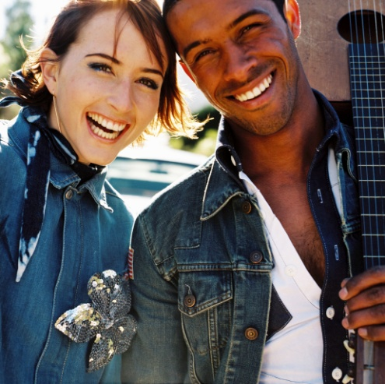
Healthy relationships

In collaboration with Planned Parenthood of Southern New England and DDS Self Advocate Coordinators; the Healthy Relationship Series will be held in the West Region. The Relationship series is a 6 session course on making, developing and having relationships. Consumers need to plan to participate in all 6 sessions. The first session of the series will include an overview of the consumer’s support staff. This will assist everyone in knowing what to expect in the series.

The 6 session series will be held in each of the 3 regions two times during FY12.

The WR Relationship Series will be held in Stratford at the Ella Grasso Center, 300 Armory Road from 4:30-7:30 p.m.

Monday 10/24/11
Wednesday 10/26/11
Wednesday 11/9/11
Tuesday 11/15/11
Tuesday 11/22/11
Wednesday 11/23/11

To register: Please complete the attached application
Each session will have a potluck. Participants will be asked to bring a healthy dish to share.
COME JOIN US!

Potluck
- It IS REQUIRED to participate in the series. send to Bethaura.miller@ct.gov or fax to: 860-622-2743 by October 21, 2011
Only 25 participants per region

HEALTHY RELATIONSHIPS AND SEXUALITY GROUP

REFERRAL FORM

Participant’s Name:

Case Manager:

Why are you interested in participating in the healthy relationship training?

Describe how you communicate and what your learning style is:

Please describe what your familiarity with the following concepts are on a scale of 1 to 10:

(1 = knows very little information and 10 = knows lots of information)

- Body parts and functions:

- Intimacy:

- Differentiating between types of relationships:

- Consent and illegal sexual activities:

- Public/Private:

- Are there any risk factors and/or personal history relating to relationships and sexuality that the facilitators should be aware of?

(If you are supporting someone to complete this form, please ask the person before sharing any confidential information. If the person chooses to share his or her story, please provide the person with the opportunity to speak directly to the facilitators.)

Relationship Training – Individual Agreement

In this training we will talk about relationships and sexuality. We will cover different topics including:

- Understanding who you are as a person – interests, likes/dislikes, communication style

- How to be in different kinds of relationships (friendships, employer/employee, intimate)

- How to start a relationship, how to stay in one and hot to decide what is okay in relationships

- How to communicate with others

- Sexuality and sexual health

- Male and female body parts

- What can go wrong in a sexual and romantic relationship? And how to make things go right (consent, safe expression, legal issues)

In addition to talking, we will do role-plays, play games, and do small group activities to help us understand and learn about relationships and sexuality.

As educators we will:

1. Provide a safe and respectful place to talk about relationships and sexuality

2. Be honest and responsible about the information we share

3. Listen to group members’ concerns and need for information and respond to the best of our ability.

4. Help group members find other resources as needed

Maintain confidentiality Unless there are safety concerns or reports of abuse

As a participant, you agree to:

1. Help develop and follow all group agreements during class (as developed within the
group)

2. Be honest, respectful, and responsible in your communication

3. Name a safe person who you can talk to about feelings or questions that come up
during group. (Note: The educators can help in thinking of possible safe people.)

4. Keep the information shared by other group members private

5. Commit to be at every class and on time whenever possible

I understand and agree to the above.

Participant’s Signature: ____________________________________________

Name of “Safe Person”: ____________________________________________

Telephone Number of “Safe Person”: _________________________________

Relationship to participant: _________________________________________

Comments:

________________________________________________________________________________________________________________________________________________________________________________________________________________________________________________________________________________________________________________________________________________________________________________________________________________________________________________________________________________________________________________________________________________________________________________________________________________________________________________________________________________________________________________________________________________

Form Completed by:
Consumer
Consumer with family member
Consumer with support staff
Consumer with other Relationship of other person _______________

