GUIDELINES FOR CONSISTENCY MODIFICATIONS OF FOODS AND LIQUIDS

- Alterations of the consistency of foods and liquids prepared for an individual are required to be made in accordance with the recommendations of an occupational therapist (OT) or speech and language pathologist (SLP) and implemented according to the order of the individual’s primary care provider or doctor.

- If an individual appears to have difficulty with the prescribed consistency of foods or liquids, the direct care staff should remove the food or liquid and immediately contact the registered nurse (RN) for instructions. In a situation that poses an immediate threat to the health and safety of the individual, a licensed clinician or nurse may direct staff to change the individual’s food or liquid consistency to a more appropriate one until a new order can be obtained.

- Food consistencies are described on specific consistency (whole, cut-up, chopped, ground and pureed) forms and displayed in pictures in these guidelines. A clinician may choose to use these forms or another format that contains specific information for staff about how food is to be served to an individual. The definitions of the consistencies on the consistency forms serve as general guidelines and any exceptions shall be documented under special notes by the clinician and prescribed by the individual’s primary care provider or doctor.

- Liquid consistencies are defined in these guidelines. The prescribed liquid consistency may be indicated on the food consistency form that specifies how liquids are to be served to the individual.

- Some foods such as soups, cold cereal with milk, fruits that emit liquid when chewed (oranges, watermelon, etc.) and canned fruit have a dual consistency (liquids and solids in one food item). A clinician shall provide information on the food consistency form about any special considerations staff is required to follow when serving such foods to an individual.

- When a thickened liquid is prescribed for an individual, the food consistency served shall be at least as thick as the prescribed consistency of the liquid.

- A licensed clinician or supervisory or professional staff who is a qualified trainer in safe eating and drinking and swallowing risks or a Speech Language Pathologist (SLT) or Occupational Therapist (OT) shall provide specific training to caregivers in the modification of an individual’s foods and liquids either in the region or in-home prior to the caregiver preparing a prescribed consistency.

LIQUID CONSISTENCIES

The texture of any liquid an individual receives is recommended by an Occupational Therapist or Speech Pathologist and is ordered by the individual’s primary care provider or doctor. The texture of an individual’s food should not be thinner than the prescribed liquid consistency.

- Thin consistency means any liquid and is considered non-restrictive for an individual’s intake. Thin liquid consistency requires no thickening agent.

- Nectar consistency means apricot or tomato juice consistency; some liquids will require a thickening agent to be added to reach nectar consistency.

- Honey consistency means liquids can still be poured, but are very slow. Some liquids will require a thickening agent to be added to reach honey consistency.

- Pudding consistency means liquids are “spoonable,” but when a spoon is placed upright in the liquid, it will not stay upright.

An individual who is prescribed “Thickened Liquids” should not be given gelatin, ice cream, Italian ice, sorbet, or other frozen desserts. If an individual wishes to eat gelatin, ice cream or other frozen desserts, a special exception may be allowed by the licensed clinician. A separate evaluation of the individual’s swallowing risk in consuming these items shall be done by the clinician. If the clinician deems it appropriate, the individual may have these items within the clinician’s specific written guidelines.

- Whole Food Consistency Form

- Cut Up Food Consistency Form

- Chopped Food Consistency Form

- Ground Food Consistency Form

- Pureed Food Consistency Form

WHOLE FOOD CONSISTENCY

Name: |  |  | Date:
Address: |  |  | Clinician:
Allergies:

Refer to an individual’s current, prescribed diet plan (i.e. regular, restricted calorie, low cholesterol) as a guide when planning the menu. Whole Food Consistency means that food should appear as it is served in a restaurant. An individual may need assistance with cutting his or her food.

Food Group | Allowed | Avoid | Special Notes/Information
Milk, dairy | Any allowed by prescribed diet | None
Fruits | Any allowed by prescribed diet | None
Vegetables | Any allowed by prescribed diet | None
Meat / Protein (Beef, pork, poultry, fish, dry beans, eggs, nuts, peanut butter) | Any allowed by prescribed diet | None
Starch  (Bread, cereals, rice, pasta) | Any allowed by prescribed diet | None
Fats, oils | Any allowed by prescribed diet | None
Desserts and snacks | Any allowed by prescribed diet | None

Liquid Consistency:
Dual consistency food considerations:
Other information:

Whole Food Consistency

Whole Food Consistency means that food should appear as it is served in a restaurant. An individual may need assistance with cutting his or her food.

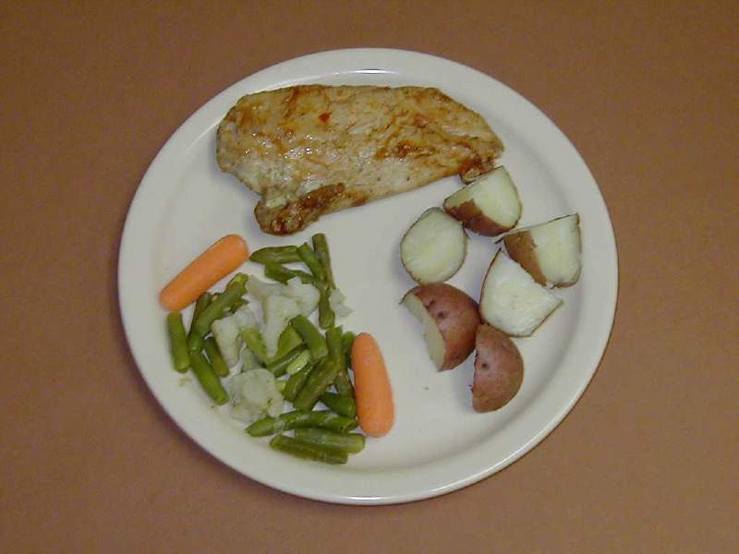

CUT UP FOOD CONSISTENCY

Name: |  |  | Date:
Address: |  |  | Clinician:
Allergies:

Refer to an individual’s current, prescribed diet plan (i.e. regular, restricted calorie, low cholesterol) as a guide when planning the menu. Cut up Food Consistency means that all foods must be cut into pieces no larger than ½”x ½” x ½”

Food Group | Allowed | Avoid | Special Notes/Information
Milk, dairy | Any allowed by prescribed diet | None
Fruits | Any allowed by prescribed diet | None | Melon balls and grapes are halved
Vegetables | Any allowed by prescribed diet  Olives halved | None
Meat/Protein  (Beef, pork, poultry, fish, dry beans, eggs, nuts, peanut butter) | Any allowed by prescribed diet  (Skinned or skinless hot dogs preferred; Kielbasa/sausage skinned preferred; Cut lengthwise into 4 strips; then cut into ½” pieces) | None
Starch  (Bread, cereals, rice, pasta) | Any allowed by prescribed diet | None
Fats, oils | Any allowed by prescribed diet | None
Desserts and snacks | Any allowed by prescribed diet | None

Liquid Consistency:
Dual consistency food considerations:
Other information:

Cut Up Food Consistency

Cut up food consistency means all foods must be cut into pieces no larger than ½” x ½” ½”
½” x x½”

(Pictures are not to scale)

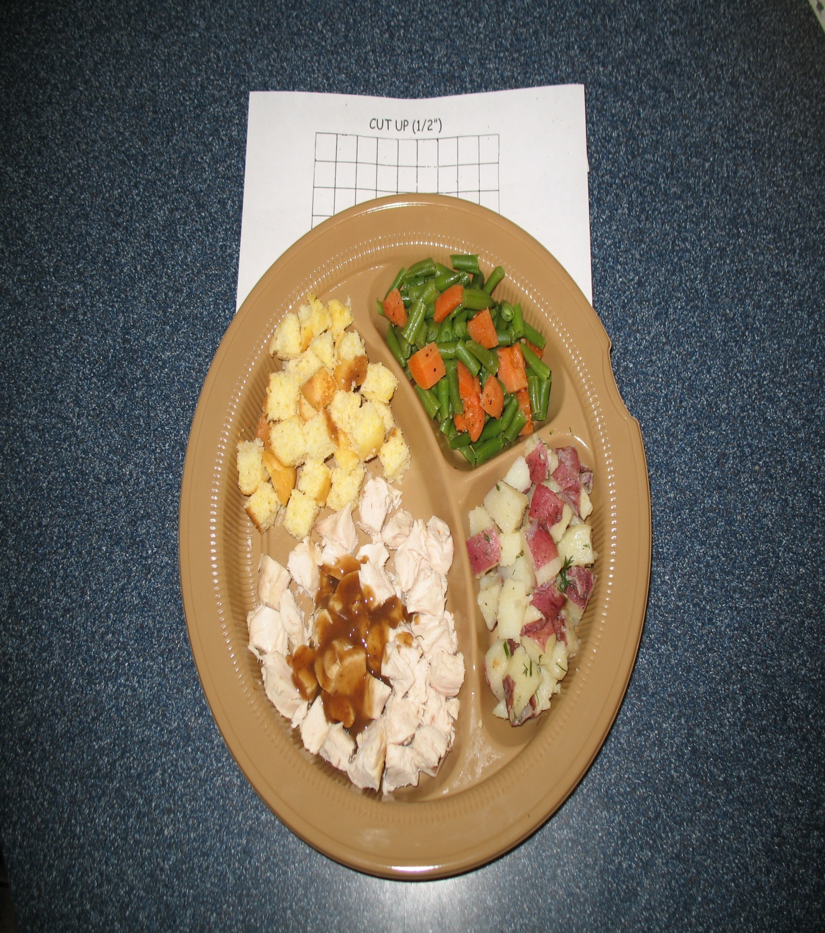

CHOPPED FOOD CONSISTENCY

Name: |  |  | Date:
Address: |  |  | Clinician:
Allergies:

Refer to the individual’s current, prescribed diet plan (i.e. regular, restricted calorie, low cholesterol) as a guide when planning the menu. Chopped Food Consistency means food is cut by hand or as directed to pea size pieces ¼”x ¼” x ¼”

Food Group | Allowed | Avoid | Special Notes/Information
Milk, dairy | Any allowed by prescribed diet | Any with nuts, seeds, or other crunchy substances
Fruits | Any allowed by prescribed diet | Fruit skin, seeds, dry fruit | Fresh fruit should be well ripened or softened in microwave
Vegetables | Any allowed by prescribed diet | Tough vegetable skin
Meat/ Protein  (Beef, pork poultry, fish, dry beans, eggs, nuts, peanut butter) | Any allowed by prescribed diet;  Hot dogs/kielbasa/ sausage- remove casing | Bacon, skin, casing, nuts | Tough meat such as pork, steak, BBQ meat, corned beef must be ground
Starch  (Bread, cereals, rice, pasta) | Remove crust from bread (none with nuts, seeds or dried fruit); Moisten cereal with milk- (no nuts, seeds or dry fruits in cereal)  Ditalini pasta can be used whole | Bagels, hard-crusted bread, nuts, seeds, skin
Fats | Any allowed by prescribed diet | Bacon
Desserts and Snacks | Any allowed by prescribed diet | Hard candy, chewy candy, popcorn, chips, pretzels

Liquid Consistency:
Dual consistency food considerations:
Other information:

Chopped Food Consistency

Chopped Food Consistency means food is cut by hand or as directed to pea size pieces ¼”x ¼” x ¼”. Food also must be moist. No “Finger Foods”.

(Pictures are not to scale)

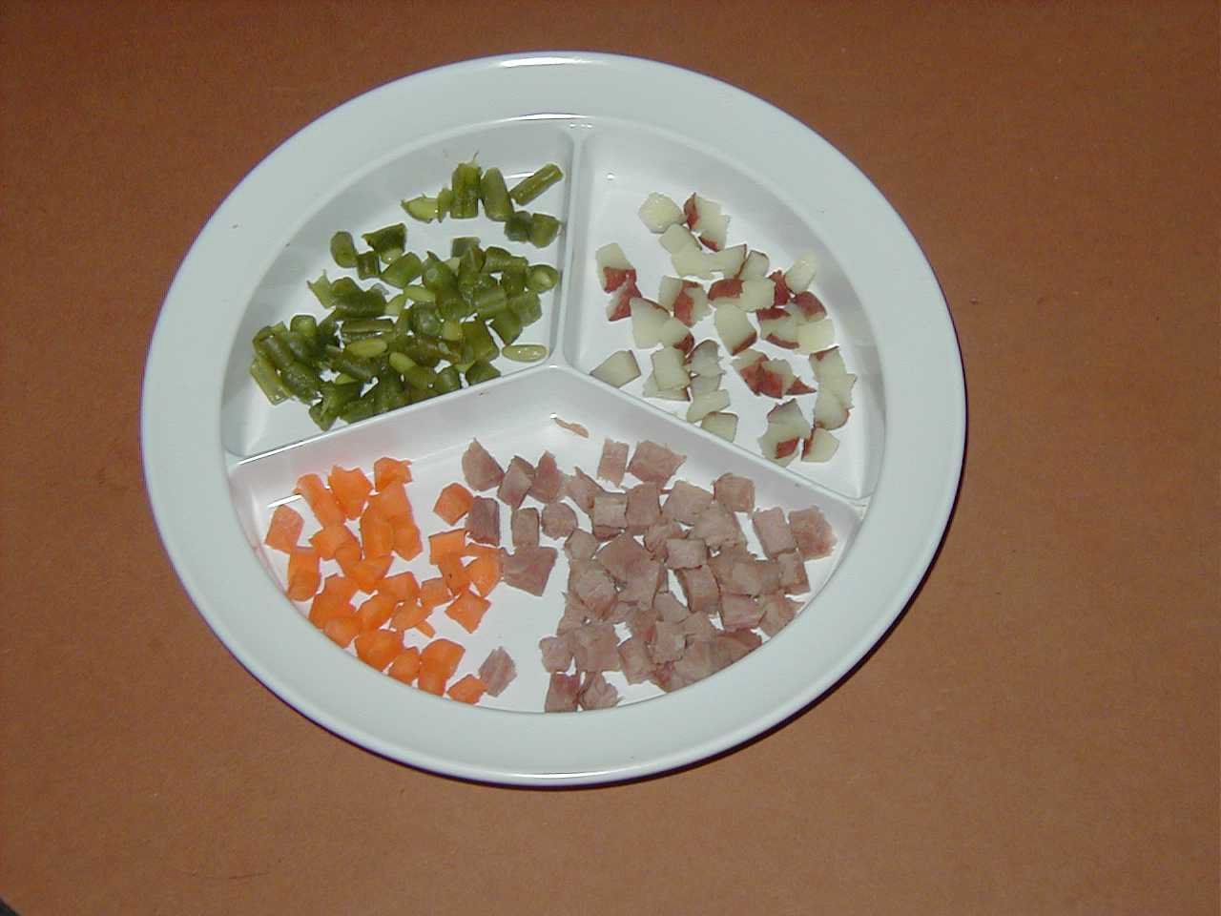

GROUND FOOD CONSISTENCY
(Revised November 2013)

Name: |  |  | Date:
Address: |  |  | Clinician:
Allergies:

Refer to the individual’s current, prescribed diet plan (i.e. regular, restricted calorie, low cholesterol) as a guide when planning the menu. Ground Food Consistency means all foods must be ground in a machine to “small curd” cottage cheese consistency. Foods must be moist and liquids may be added to get the desired consistency.

Food Group | Allowed | Avoid | Special Notes/ Information
Milk, dairy | Any allowed by  prescribed diet | Any with nuts, seeds, pieces of fruit, or other crunchy substances | Small curd cottage cheese and Ricotta cheese may be served in whole form
Fruits | Any allowed by  prescribed diet; Canned, cooked or fresh without skins; | Fruit skin, seeds, dry fruit (raisins, prunes, etc.) | Fork mash bananas or fresh ripe melon (no seeds)
Vegetables | Any allowed by  prescribed diet | Vegetables with  tough skin or strings; seeds | Remove large seeds (e.g. winter squash, pumpkin)
Meat/ Protein  (Beef, pork, poultry, fish, dry beans, eggs, nuts, peanut butter) | Any allowed by prescribed diet served with extra gravy or sauce. | Bacon, skin, casing, nuts  Breaded/ battered fish or meats
Starch  (Bread, cereals, rice, pasta) | Any allowed by  prescribed diet;  Pastina can be used whole | Nuts, seeds, skin, potato skins
Fats | Any allowed by  prescribed diet | Bacon
Desserts and snacks | Any allowed by prescribed diet. Cakes- moistened and mashed | Hard or chewy candy, gelatin, Popcorn, chips, Pretzels, raisins, Ice cream, all frozen desserts | Some cookies without nuts, may be broken, moistened and mashed  Special exceptions may occur and be noted here after evaluation

Liquid Consistency:
Dual consistency food considerations:
Other information:

Ground Food Consistency

Ground Food Consistency means all foods must be ground in a machine to “small curd” cottage cheese consistency. Foods must be moist and liquids may be added to get the desired consistency.

(Pictures are not to scale)
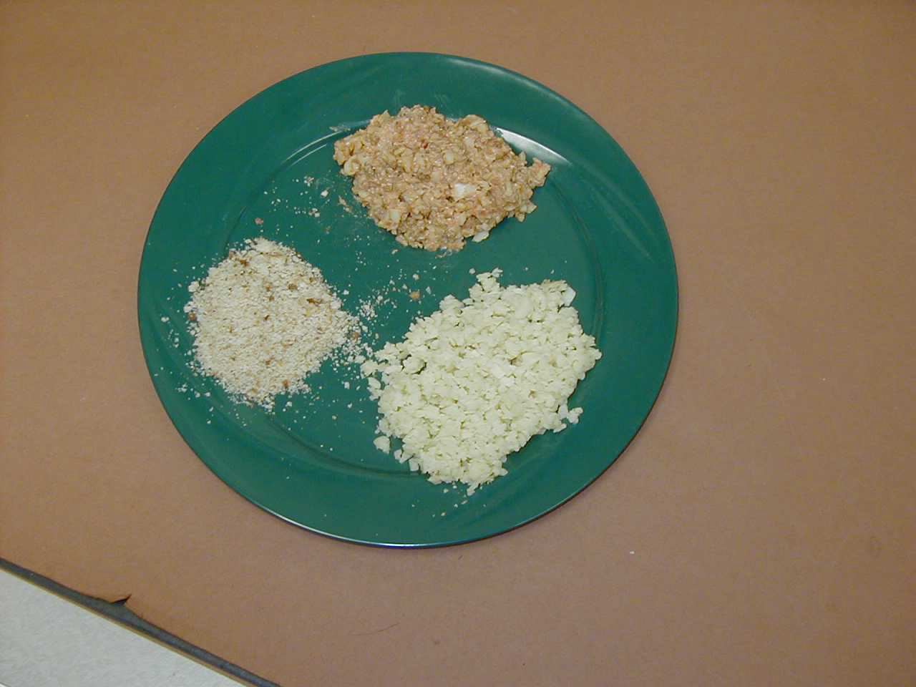

PUREED FOOD CONSISTENCY

Name: |  |  | Date:
Address: |  |  | Clinician:
Allergies:

Refer to the individual’s current, prescribed diet plan (i.e. regular, restricted calorie, low cholesterol) as a guide when planning the menu. Pureed Food Consistency means all foods are prepared to a smooth consistency by grinding and then pureeing them. Appearance is smooth like pudding.

Food Group | Allowed | Avoid | Special Notes/Information
Milk, dairy | Any allowed by prescribed diet | Any with nuts, seeds or other crunchy substances
Fruits | Any canned allowed by prescribed diet; Certain fresh fruit (melon, kiwi, mangos, strawberries, bananas) | Fruit skin, seeds, Other fresh fruit, dried fruits
Vegetables | Any allowed by prescribed diet | Vegetables with tough skin or strings; | Remove large seeds (i.e. winter squash, pumpkin) Lettuce and baby spinach may be pureed
Meat/Protein  (Beef, pork, poultry, fish, dry beans, eggs, nuts, peanut butter) | Any allowed by prescribed diet. Puree with extra gravy, sauce, bouillon or stock | Bacon, skin, casing, nuts. Breaded/ battered fish or meats
Starch  (Bread, cereals, rice, pasta) | Any allowed by prescribed diet | Nuts, seeds, skin, potato skins,
Fats | Any allowed by prescribed diet | Bacon;
Desserts and snacks  Frozen desserts | Any allowed by prescribed diet; Must be moistened | Hard or chewy candy, gelatin, popcorn, chips, pretzels, raisins, ice cream, sorbet, all frozen desserts | Special exceptions may occur and be noted here after evaluation

Liquid Consistency:
Dual consistency food considerations:
Other information: | Use only powered spices

Pureed Food Consistency

Pureed Food Consistency means all foods are prepared to a smooth consistency by grinding and then pureeing them. Appearance is smooth like pudding.

