State of Connecticut
Department of Consumer Protection
Liquor Control Commission
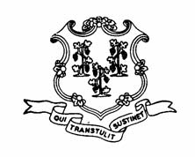
THE LIQUOR PERMIT OF:

PEREZ WINE & SPIRITS
61 NEWTOWN ROAD, STE. 4
DANBURY
LIP.14576

HAS PAID A FINE OF $500 AND HAS BEEN
SUSPENDED
for the following dates:

JANUARY 28, 2013

This suspension has been imposed for alleged violation of
the following statutes or regulations:

§30-86(b) SALE TO MINOR

