WILDERNESS SCHOOL: 2019 SUMMER EMPLOYMENT
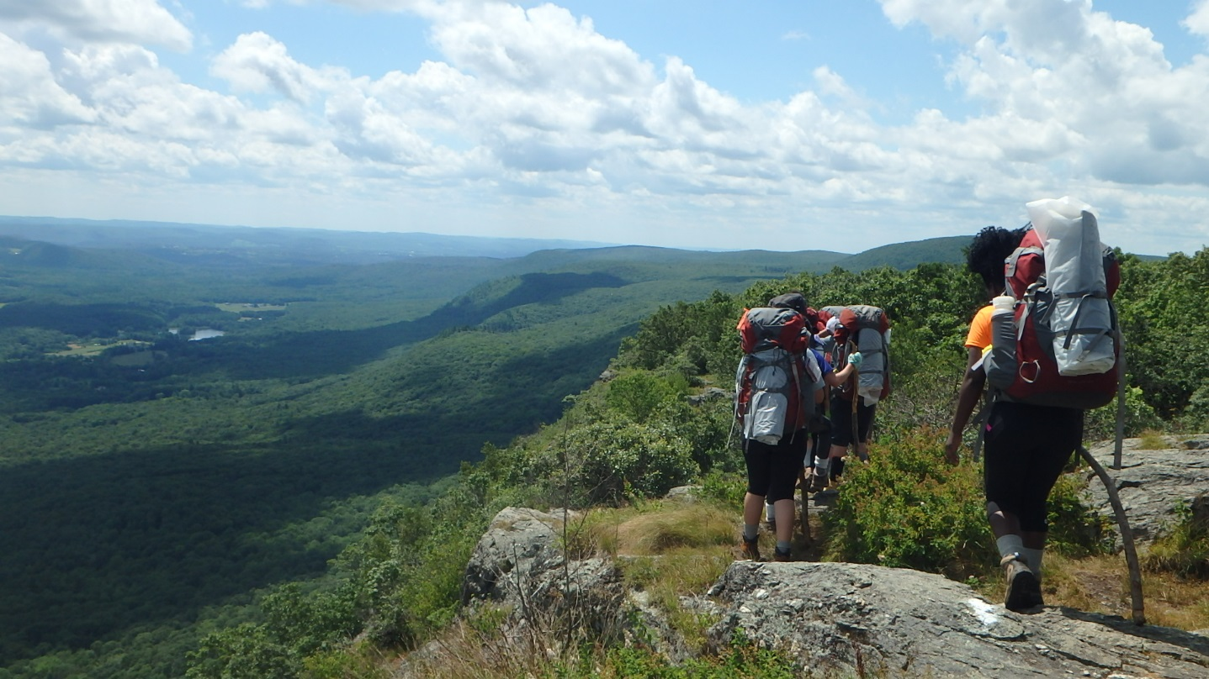

The Wilderness School provides intensive experiential programs to Connecticut youth ages thirteen to seventeen and to other children and youth with special needs. The program is supported by the State of Connecticut, Department of Children and Families (DCF). We are currently in our forty-sixth year of operations.

The Wilderness School base camp is located in East Hartland, Connecticut in the north-central part of the state. The program course area follows the Appalachian Trail corridor of the Taconic and Berkshire Mountain ranges of Connecticut and Massachusetts, as well as the adjoining areas of the Housatonic River Valley. In the summer, students attend 20-Day, 7-Day and 5-Day Expedition courses in groups of ten with two or three Instructors and with the support of several base camp staff. The Wilderness School also conducts numerous 1-3 day programs and summer camp functions for groups seeking adventure education services.

The Wilderness School is a prevention, intervention and transition program intended to assist our students to develop self-esteem, internal locus of control and interpersonal skills. Designed as journey experiences, our programs are considered therapeutic for the participant. Wilderness School activities are not viewed as an end in themselves, however, but as a tool in the service delivery of community youth agencies. Each student must pass through an Orientation phase of the Wilderness School prior to attending an Expedition course. Students who attend 20, 7, or 5-Day courses are then eligible to participate in a fall through spring Follow-Up Program. Those attending 1-3 day programs may elect to apply for Expeditions.

Wilderness School 20-day Expeditions include backpacking, a high ropes course, rock climbing, canoeing, service learning, a solo experience, a “marathon” run, and graduation, as well as small group process and individual counseling. Program 7 and 5-Day Expeditions include backpacking or canoeing and one or more selected special activities. 1-3 Day courses feature adventure based activities intended to introduce students to Wilderness School programs and opportunities for continued participation. Students are referred to the Wilderness School by many types of agencies, including DCF facilities, area offices, adolescent programs and prevention services, community youth service bureaus, school systems, child guidance clinics, independent living programs, residential facilities, and juvenile justice programs. Our student population is diverse and representative of varied ethnic and racial backgrounds.

Summer positions and Sample Compensation

 | Title: | Approximate Number of Days Scheduled (Includes 10 Days of Staff Training): | Daily Rate: (Rate of Pay Dependent on Time of Service)
1. | Seasonal Instructor Supervisors: Course Director, Logistics/Climbing, Enrollment, Outreach | 48 to 55 | $168.17 to $226.95 Per Day
2. | Instructor: Lead Instructors, Instructors, Base Camp Instructors, Logistics/Climbing Instructor | 48 to 55 | Lead Instructor: $184.45 to $246.97  Expedition Instructors: $171.10 to $233.10  Base Camp Instructors: $133.82 to $185.50  Logistics/Climbing Instructor: $133.82 to $185.50
3. | Summer Assistants: Kitchen Staff; Enrollment Staff | 48 to 52 | $10.10 to 15.00 Hourly
4. | Intern Positions: | Based on Availability | (unpaid)

WORK DATES: Staff Training: June 3rd - June 14th Summer Program: June 17th- August 15, 2019

APPLICATION PROCEDURE:
Send letter and resume to: Email: WILDERNESSJOURNEY@ct.gov Attn: Personnel

OR BY MAIL TO
Wilderness School, Attn: Personnel
240 North Hollow Rd.
East Hartland, CT 0602

FOR INFORMATION: Contact the Wilderness School at (860) 653-8059 or visit the Wilderness School Website https://portal.ct.gov/DCF/Wilderness-School/Home Please visit us on Facebook at 'State of Connecticut Wilderness School.

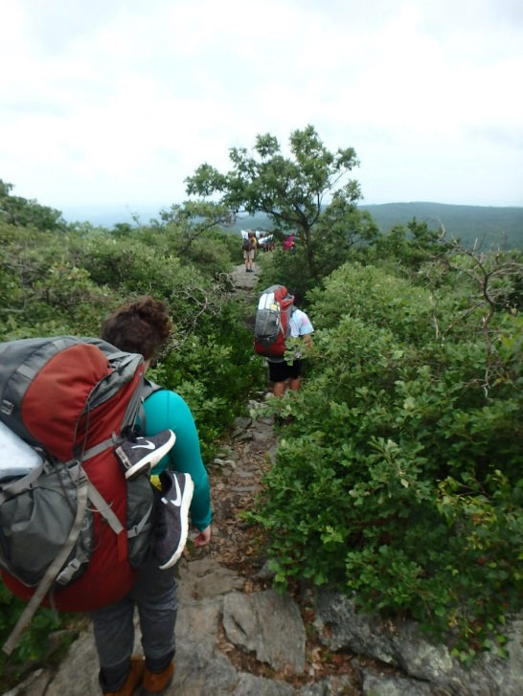

WILDERNESS SCHOOL SUMMER JOB DESCRIPTIONS

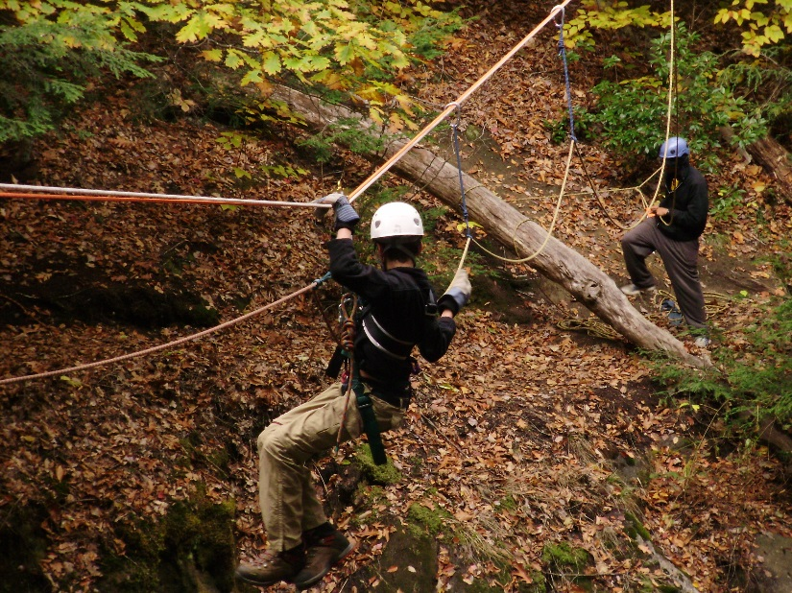

- Wilderness School Seasonal Supervisor:

EXAMPLE OF DUTIES:
Seasonal Instructor Supervisor - Course Director: Responsible for the safety and risk management of all program participants. Conducts and supervises field interventions for student behavioral and/or emotional crises during Expedition programs; supervises base camp staff engaged in officer of the day/back-up duties; assists in the supervision of instructors and students engaged in field activities (i.e. canoeing, high ropes course, or rock climbing); conducts and assists program functions including course briefings and debriefings, Marathon Day, Graduation, etc.; supervises course preparation and reporting functions; conducts orientations of the program for students, families, and referring agencies; assists the Field Program Coordinator with staff training; performs Expedition instructor duties in the event of an emergency and instructs short courses as required; supervises kitchen and other base camp functions as required; conducts officer of the day/back-up duties as required
Seasonal Instructor Supervisor - Logistics/Climbing: Responsible for the safety and risk management of all program participants. Supervises staff facilitating rock climbing and ropes course; provides technical skills training in rock climbing and ropes courses; directly facilitates rock climbing and ropes courses; provides supervision to staff that are supporting crews in the field; supervises staff providing transports of students, staff, supplies, and materials to and from local course areas and directly performs those duties; instructs courses as assigned and attends summer staff training as required; conducts and supervises field and base camp interventions for student behavioral and/or emotional crisis during programs and courses; may assist Field Coordinator in supervising logistical operations including support of staff and crews in the field, vehicle coordination and scheduling, logistical course briefings, transports, equipment issue, inventory maintenance, repairs and purchasing recommendations; conducts officer of the day/back-up duties as required.
Seasonal Instructor Supervisor - Outreach: Responsible for the safety and risk management of all program participants. Supervises one day course programs including briefings, debriefings, staffing, equipment allocation/return, food reservations and course reporting; coordinates meal preparations and cleanup for one day short course programs; designs, plans and implements multi-day programs in collaboration with participating agencies; assists in the supervision and training of instructors and interns; leads hiking, canoeing, team building, rock climbing, caving and high ropes course activities; conducts and supervises field and base camp interventions for student behavioral and/or emotional crisis during programs and courses; facilities off-site agency specific programs, adult leadership courses, and staff training components; conducts officer of the day/back-up duties as required.

MINIMUM QUALIFICATIONS REQUIRED KNOWLEDGE, SKILL AND ABILITY:
Expedition experience, group facilitation skills, supervisory skills, knowledge of strength based programming and trauma informed practice in experiential programming.
EXPERIENCE AND TRAINING:
General: A Bachelor’s Degree is preferred. Professional level training and work experience as an Experiential Educator may be considered in lieu of Bachelor’s Degree. Examples: Greenfield Community College Outdoor Leadership Program Certificate, National Outdoor Leadership School course completion, Outward Bound School course completion, or comparable significant experience as an Outdoor Education Professional or corresponding professional experience.
Special Requirements:
Incumbents hired as Course Director, Outreach, Enrollment or Logistics/Climbing must possess the following:
Current Wilderness First Responder, or equivalent (WAFA or WFA may be considered).
B. Current American Heart Association (AHA) Healthcare Provider or American Red Cross (ARC) Professional Rescuer CPR.
C. Current Wilderness School Medication Administration Training (provided).
D. Current ARC Lifeguard certification and waterfront training or equivalent preferred.
E. Driver's license preferred.
Incumbents hired as Logistics/Climbing, in addition to the above requirement, must possess current AMGA-American Mountain Guides Association, PCIA-Professional Climbing Instructors' Association or equivalent rock climbing certification.
Incumbents hired as Kitchen Summer Supervisor must possess Food Safe Certification.

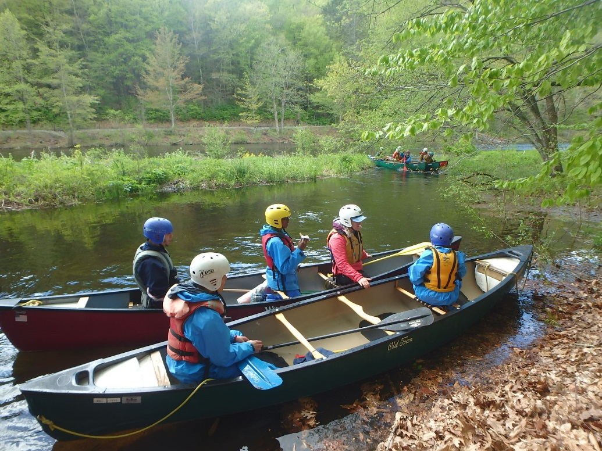

- Wilderness School Seasonal Instructor

EXAMPLE OF DUTIES:
Lead Expedition Instructor: Functions as the team leader for assigned expeditions; responsible for the overall safety and risk management of all participants; supervises and leads groups of up to ten students during the 20-Day, 8-Day or 5-Day Expedition; provides skills instruction in backpacking, wilderness camping, map and compass, flat water and white water canoeing, rock climbing and rappelling, first aid, nutrition, personal hygiene and ecology; provides small group and individual counseling for adolescents of varying backgrounds; facilitates interpersonal skill development for students; supervises all course activities; conducts Orientation programs for students, families, and referring agencies; attends summer staff training as required; and completes all course reporting in a timely manner; leads 1-Day courses for groups as available.
Expedition Instructor: Responsible for the safety and risk management of all Expedition program participants. Supervises and leads groups of up to ten students during the 20-Day, 8-Day or 5-Day Expedition; provides skills instruction in backpacking, wilderness camping, map and compass, flat water and white water canoeing, rock climbing and rappelling, first aid, nutrition, personal hygiene and ecology; provides small group and individual counseling for adolescents of varying backgrounds; facilitates interpersonal skill development for students; supervises all course activities; conducts Orientation programs for students, families, and referring agencies; attends summer staff training as required; and completes all course reporting in a timely manner; leads 1-Day courses for groups as available.
Base Camp Instructor: Responsible for the safety and risk management of all one-day course participants. Leads hiking, canoeing and team-building one day programs, including Orientation, Outreach, DCF Prevention and Adolescent Services as well as adult Leadership and Communication programs; assists in the supervision of students engaged in field activities; attends summer staff training as required; may be assigned as an Expedition Instructor as needed; conducts base camp officer of the day/back-up duties as required.

Logistics/Climbing Instructor: Supervises and instructs rock climbing and high ropes course activities; provides base camp support to groups engaged in field activities; transports students, staff, supplies and materials to and from local course areas; conducts equipment issue, repair, maintenance, and inventory duties; attends summer staff training as required; performs base camp officer of the day/back-up duties as required.
MINIMUM QUALIFICATIONS REQUIRED KNOWLEDGE, SKILL AND ABILITY:
Expedition experience required for Lead Instructors and preferred for Expedition and Base Camp Instructors, group facilitation skills, youth work experience.
EXPERIENCE AND TRAINING:
General: A Bachelor’s Degree is preferred. Professional level training and work experience as an Experiential Educator may be considered in lieu of Bachelor’s Degree. Examples: Greenfield Community College Outdoor Leadership Program Certificate, National Outdoor Leadership School course completion, Outward Bound School course completion, or comparable significant experience as an Outdoor Education Professional or corresponding professional experience.
Special Requirements:
Incumbents in this class must possess the following:
A. Current Wilderness First Responder or equivalent (WAFA or WFA may be considered).
B. Current American Heart Association (AHA) Healthcare Provider or American Red Cross (ARC) Professional Rescuer CPR.
C. Current Wilderness School Medication Administration Training (Provided).
D. Current ARC Lifeguard certification and Waterfront training, or equivalent preferred.
E. Current American Canoe Association (ACA) certification or equivalent preferred.
F. Driver's license preferred.
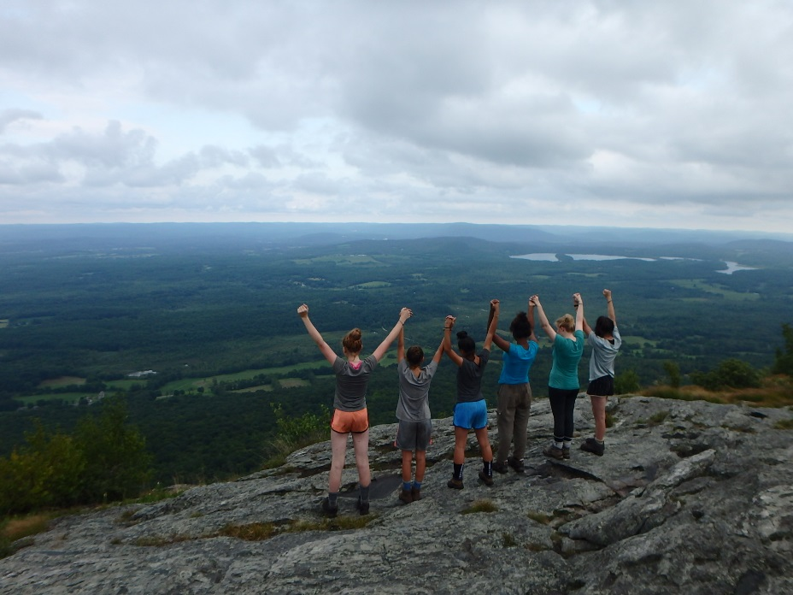

- Seasonal Summer Assistants:

EXAMPLE OF DUTIES:
Enrollment Supervisor: Responsible for the safety and risk management of all program participants; coordinates and instructs all Agency Orientation Courses and instructs Student Orientations and adult leadership and communication courses as assigned; performs expedition instructor duties as assigned; assists the Enrollment Coordinator in all aspects of screening and enrolling students on expeditions; manages student data and prepares reports; prepares files and information for student briefings; assists with approving and accepting student medications and prepares them for field administration; attends bi-weekly case reviews with Enrollment Coordinator and Director; provides instruction for students, families and referring agencies on course preparation; attends summer staff training as required; conducts and supervises field and base camp interventions for student behavioral and/or emotional crisis during programs and courses; conducts officer of the day/back-up duties as required.
Enrollment Specialist: Assists the Enrollment Coordinator and summer supervisor with all aspects of enrolling students; conducts student screening functions; provides guidance for students, families and referring agencies on course preparation; manages student files; maintains student records and statistics; instructs Orientation courses for prospective summer program participants; supervises and instructs students during course start and graduation activities; instructs one-day courses as required; provides instruction for students engaged in field activities; conducts post course communications; attends summer staff training as required; performs officer of the day/back-up duties as required.
Kitchen Summer Supervisor: Supervises food services, preparation, equipment and kitchen staff; supervises menu planning, nutritional needs and dietary restrictions of all students and staff engaged in program activities; manages food inventory and ordering required for a self-service breakfast, prepared lunch and dinner and weekend meal system for base camp staff; coordinates and Instructs celebratory picnic and banquet activities for expedition students; maintains kitchen dining, food storage, refrigeration and general use areas to required health, cleanliness and program standards; prepares meals and packs food as required; maintains a community kitchen environment; designs, coordinates and instructs all food and nutrition based curriculum; responsible for the design and instruction of chef’s challenge course activities for expedition students and staff; instructs courses as assigned; conducts officer of the day/back-up duties as required.
Assistant Cook: Prepares meals as directed by the Kitchen Summer Supervisor; assists in the daily food service operations: stocking deliveries, assisting with inventories, and maintaining food service areas to required health and cleanliness standards; supervises use of kitchen equipment; assists the food handler as required; maintains a community kitchen environment; instructs expedition students in food and nutrition topics; instructs one-day short courses as required; provides instruction of students engaged in field activities; performs officer of the day/back-up duties as required; performs related duties as required.
Food Handler: Assists in planning nutritionally balanced menus for all students engaged in field and base camp programming under the direction of the Kitchen Summer Supervisor; packs food drops and re-supplies for crews in the field; packs meals for base camp staff field activities; assists in food preparation duties as required; assists in daily food service operations: stocking deliveries, assisting with inventories, maintaining food service areas to required health and cleanliness standards, and supervises use of kitchen equipment; maintains a community kitchen environment; instructs expedition students in food and nutrition topics; instructs one-day short courses as required; provides instruction of students engaged in field activities; performs officer of the day/back-up duties as required; attends staff training as required; performs related duties as required.
MINIMUM QUALIFICATIONS REQUIRED KNOWLEDGE, SKILL AND ABILITY:
Work or life experience with youth, previous employment or volunteer work experience.
EXPERIENCE AND TRAINING:
General: Some college education or training in Outdoor Leadership preferred.
Special Requirements:
Incumbents who are assigned as Logistics/Climbing Specialist must possess the following:
A. Current Wilderness First Aid or equivalent.
B. Current American Heart Association (AHA) Healthcare Provider or American Red Cross (ARC) Professional Rescuer CPR.
C. Current ARC Lifeguard certification and waterfront training, or equivalent preferred.
D. American Mountain Guides Association (AMGA), Professional Climbing Instructor Association (PCIA) or equivalent rock climbing certification preferred.
E. Driver's license preferred.
Incumbents who are assigned as Assistant Cook, Food Handler and Enrollment Specialist must possess the following: Driver's license preferred.

- Summer Internships
Instructor Intern Positions: Instructor Interns are unpaid positions and function in a training capacity. They are assigned responsibilities commensurate with their experience and ability. Instructor Interns may be scheduled when instructing opportunities are available and function as team members of the Wilderness School three instructor model.

Base Camp Intern Positions (Logistics, Outreach, and Enrollment): Base Camp Interns are also training positions and are intended to help individuals qualify for paid positions at the Wilderness School. Intern positions are not required to possess advanced skills and experience, and must be able to demonstrate a strong interest in working with youth as well as experience and willingness to work in an outdoor setting. Base Camp Interns are unpaid positions and are intended to supplement the existing staff of the Wilderness School Base Camp staff.

