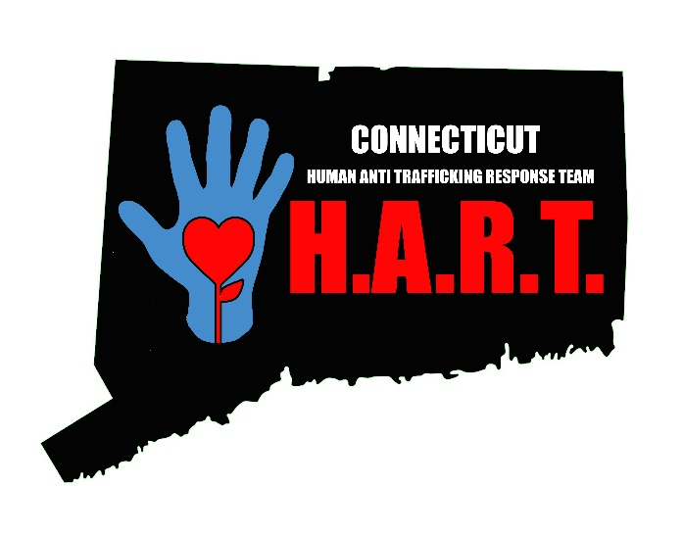

Approved Curricula on the Training of Child Trafficking in CT

DCFHART@ct.gov

Introduction to Child Trafficking in Connecticut: This curriculum is designed to enhance an individual’s understanding of Child Trafficking. The training assists participants in identifying victims of child trafficking as well as receiving tips on how best to respond and support identified trafficking victims. Participants will learn definitions, federal and state legislation related to human trafficking, prevalence of child sex and labor trafficking in CT, pathways to victimization, warning signs, impact to the victims, and who are the buyers/exploiters of this crime. The training is 2 ½ hours and materials utilized are videos and PowerPoint. CEU’s are available.

Introduction to Human Trafficking in Connecticut for Law Enforcement (POST Certified): This curriculum is like the one outlined above with the exception that it is geared for police officers (both municipal and state) and other law enforcement personnel. A law enforcement specific video is utilized to assist law enforcement with identifying victims of human trafficking during routine traffic stops. This training is 2 ½ hours and materials utilized are videos and PowerPoint.
Introduction to Human Trafficking in Connecticut for Emergency Medical Services (EMS): This curriculum is like the ones outlined above with the exception that it is geared for emergency medical services personnel (Paramedics, EMT’s, and First Responders). EMS specific information and resources are included to assist EMS with identifying victims of human trafficking during emergency responses in the community. This training is 2 hours and materials utilized are videos and PowerPoint. CME's available.
Child Trafficking Training for Medical Providers/ Emergency Medicine: This curriculum is similar to the ones outlined above with the exception that it is geared for emergency medical services personnel (physicians, nurses, social workers and any person that works within an emergency department, hospital, clinic, physician’s office, etc.). Medical specific information and resources are included to assist medical providers with identifying victims of human trafficking and opportunities to provide important medical services and support to victims. This training is offered as a 1-hour training as well as an expanded version of 2-hours. Materials utilized are videos and PowerPoint and includes brief case activity(s).
Introduction to Human Trafficking in Connecticut for Hotel/ Motel/ Lodging: This curriculum is like the ones outlined above with the exception that it is geared for hotels, motels and lodging establishments. Specific information and resources are included to assist employees with identifying victims of human trafficking that may be staying or working at such establishments. This training is 1 1/2 hours and materials utilized are videos and PowerPoint.
Child Trafficking of Boys & LGBQ/GNCT Youth: This curriculum is designed to enhance an individual’s understanding of child trafficking with emphasis on boys and LGBQ/GNCT youth. The training assists participants in identifying boys and LGBQ/ GNCT youth victims, understanding the unique warning signs and the impact on these populations. Participants will learn definitions, federal and state legislation related to human trafficking, prevalence of child trafficking in CT and who are the buyers/ exploiters of this crime. The training is 2 ½ hours and materials utilized are videos and PowerPoint.

Introduction to Labor Trafficking in Connecticut: This curriculum is designed to enhance an individual's understanding of labor trafficking. Although the various child trafficking trainings touch on labor trafficking this curriculum provides additional information to fully understand the extent of labor trafficking across the world, US and in Connecticut. This training includes a review of federal and state legislation, pathways to victimization, warning signs, impact to the victims and who are the buyers/ exploiters of this crime. The training is 2 hours and materials utilized are videos and PowerPoint.

Introduction to Labor Trafficking in Connecticut for Law Enforcement (POST Certified): This curriculum is like the one outlined above with the exception that it is geared for police officers (both municipal and state) and other law enforcement personnel. Law enforcement investigative techniques and resources are included. This training is 2 hours and materials utilized are videos and PowerPoint.

Fostering in the best & hardest of times: Helping foster parents care for high risk kids and child victims of commercial sexual exploitation: (2 or 3-day training)
This course is designed for foster parents including components from 4 targeted curricula:
1) Introduction to Child Trafficking in Connecticut
2) Caring for High Risk Youth and Child Victims of Sex Trafficking
3) Understanding Girls: A Trauma Informed Perspective
4) Child Trafficking of Boys & LGBQ/GNCY Youth
Participants must complete the entire series to receive certificate.

Child Trafficking: What is it, how to see it, and how to respond to it - Day 1: This course provides a framework for understanding the complex issue of child trafficking by providing a framework for responding in a well-prepared and collaborative manner. The roles of the Department, providers, law enforcement, as well as other systems in addressing the problem will be examined. This course explores the prevalence of child trafficking cases in Connecticut and provides an overview of national and state laws governing this work. Participants will learn what it takes to successfully manage a child trafficking case. Specific information relating to boys and LGBTQ+ youth will also be discussed. This is a full day training (6 hours) and is delivered by lecture with videos and activities. CEU’s are available. This training is offered at the DCF Academy for Workforce Development. NOTE: Day 1 & Day 2 must be taken together.

Child Trafficking: What is it; how to see it, and how to respond to it - Day 2: The second day of this course focuses on building engagement skills to work with youth and caregivers around issues of child trafficking. Focus is also given to case planning for youth and families. Participants will learn about targeted services to support youth who are at high risk of or confirmed victims of child trafficking. This course will conclude with an expert panel presentation. This is a full day training (6 hours) and is delivered by lecture with videos and activities. CEU’s are available. This training is offered in the DCF Academy for Workforce Development. NOTE: Day 1 & Day 2 must be taken together.

Youth Specific Curricula

Youth Awareness on Child Trafficking: This curriculum is a 45- 60-minute Awareness presentation to educate youth ages 12 to 18 on child trafficking. The training provides an overview of what child trafficking is, what makes children/ youth more vulnerable, red flags to watch for and what to do if you suspect they or someone else is a victim. This curriculum was vetted with youth across the state to ensure the content was impactful and relevant to youth of this age range. The Youth Awareness presentation is a one-time educational opportunity to raise awareness.

Youth Prevention - Not a #Number: Love146’s Prevention Curriculum, Not a #Number, is an interactive five-module curriculum designed to teach youth how to protect themselves from human trafficking and exploitation through information, critical thinking, and skill development. The program integrates a holistic view of the issue by focusing on respect, empathy, individual strengths, and the relationship between personal and societal pressures that create or increase vulnerabilities. Through open conversations, engaging activities, the use of media, and opportunities for disclosures, participants find ways to move beyond awareness to behavioral change. For a preview of Not a #Number, visit www.love146.org/curriculum-preview.

To schedule a training please EMAIL:
DCFHART@ct.gov

