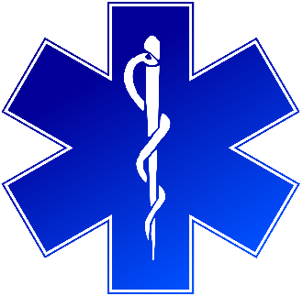
Training Announcement
Training of Trainers (TOT)
Introduction to Human Trafficking in CT for EMS

Prerequisite: Must take the 2-hour Introduction to Human Trafficking in CT for EMS mandated training (PA No. 21-103) prior to TOT.

Earn your certification to train CT EMS colleagues in the Human Trafficking mandated training
January 31st and February 2nd, 2022
9:00am to 4:00pm
*Must participate in both days*
Training will be conducted on Zoom (all participants must have cameras)

All participants must actively work in EMS
Registration will be on the Department of Public Health (DPH) TRAIN Site

