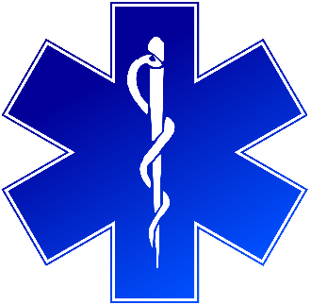
Training Announcement
Introduction to Human Trafficking in CT for EMS
Meets to new Legislative Mandate:
https://www.cga.ct.gov/2021/ACT/PA/PDF/2021PA-00103-R00HB-06657-PA.PDF
Certificate for 2 CMEs will be provided
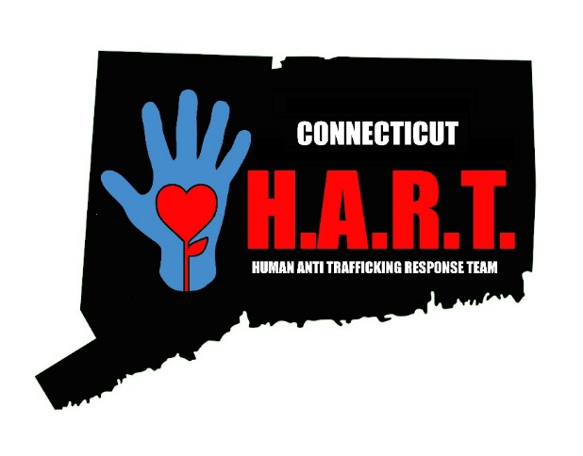
January 12th, 6pm to 8pm
Or
January 27th, 2pm to 4pm

Training will be conducted on Zoom (all participants must have cameras on)

All participants must actively work in EMS

Registration will be on the Department of Public Health (DPH) TRAIN Site

