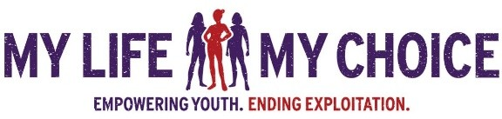
TRAINING OPPORTUNITY

PREVENTING THE COMMERCIAL SEXUAL EXPLOITATION OF ADOLESCENT GIRLS

THE MY LIFE MY CHOICE CURRICULUM FACILITATOR CERTIFICATION TRAINING
The My Life My Choice Prevention Curriculum is an evaluated and nationally‐acclaimed, ten‐session exploitation prevention curriculum aimed at changing adolescent girls' attitudes and perceptions of the commercial sex industry, as well as building self-esteem and personal empowerment.
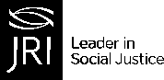
Designed to reach the most vulnerable girls (secondary and tertiary prevention), the My Life My Choice Curriculum was the first comprehensive, survivor-led curriculum in the US and has been used in more than 30 states.

PARTICIPANTS WILL:
- Understand the research behind the My Life My Choice Curriculum

- Learn how to use the Curriculum to run psycho-educational groups with vulnerable girls in a variety of settings to prevent exploitation and/or re-victimization
- Learn best practices for facilitating a prevention group and explore potential challenges
- Practice facilitation skills and receive feedback in small and large group settings
- Receive a copy of the My Life My Choice Curriculum and membership to our prevention-focused Online Community
WHEN: January 25 & 26th| 10AM-4PM SURVIVOR NETWORKING SESSION ON DAY 1 4PM-5PM

WHERE: ONLINE - ZOOM
TO APPLY: PLEASE GET PRE-APPROVED by Tammy Sneed to apply
tammy.sneed@ct.gov
REQUIREMENT: Must be able to conduct two sessions annually
CEUs: This program is approved by the National Association of Social Workers for
9.5 continuing education contact hours

A NATIONAL INSTITUTE OF JUSTICE-FUNDED THREE-YEAR EVALUATION OF THE MY LIFE MY CHOICE EXPLOITATION PREVENTION CURRICULUM FOUND THE FOLLOWING:
- Knowledge about CSEC and risks for exploitation improved for all participants.
- Experiences of commercial sexual exploitation decreased by 55%.
- Participants were 2 times less likely to report dating abuse victimization.
- 100% of youth provided CSEC-related help to a friend or peer.
- Self-reported sexually explicit behaviors were reduced by half over time.
MLMCINFO@JRI.ORG 617.779.2179
WWW.MYLIFEMYCHOICE.ORG 989 COMMONWEALTH AVE BOSTON, MA 02215

