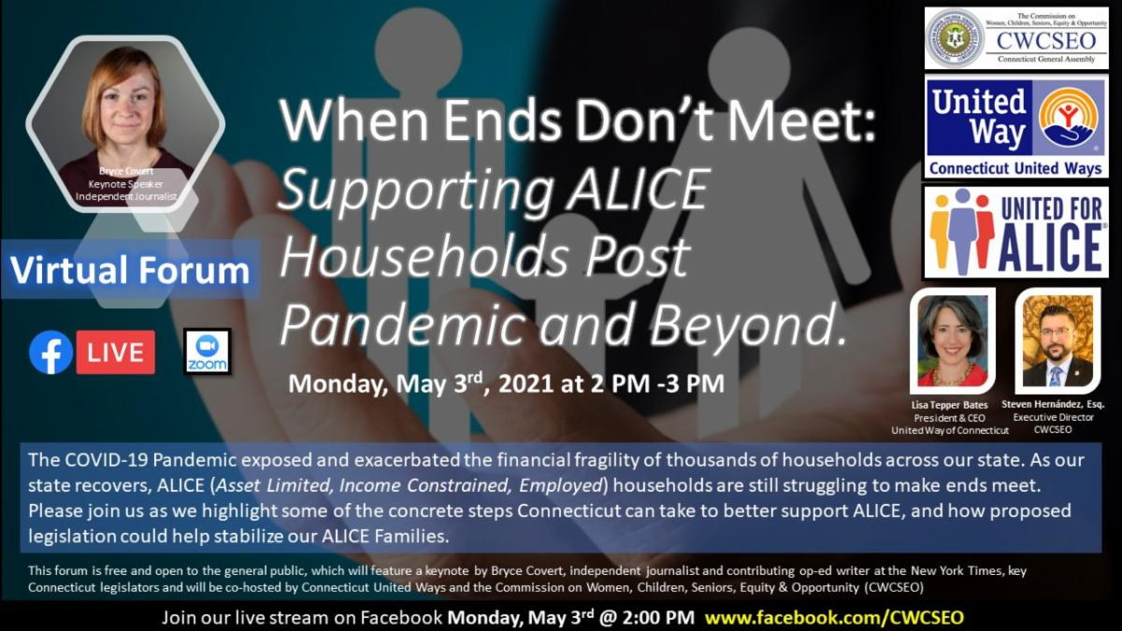
SAVE THE DATE! Register Today!

The COVID-19 Pandemic exposed and exacerbated the financial fragility of thousands of households across our state. As our state recovers, ALICE (Asset Limited, Income Constrained, Employed) households are still struggling to make ends meet.

Please join us as we highlight some of the concrete steps Connecticut can take to better support ALICE, and how proposed legislation could help stabilize our ALICE Families.

The event, which will feature a keynote by Bryce Covert, independent journalist and contributing op-ed writer at the New York Times, and key Connecticut legislators, is hosted by Connecticut United Ways and the Commission on Women, Children, Seniors, Equity & Opportunity.

Register today! Click HERE

Event Details: When Ends Don’t Meet: Supporting ALICE Households Post-Pandemic and Beyond
When: Monday, May 3rd, 2021 from 2PM- 3PM
Where: Register HERE for this virtual event
Featuring: Bryce Covert, contributing journalist at the New York Times

About Connecticut United Ways

Connecticut United Ways advance the common good by creating opportunities for all, with a particular focus on education, income/financial security, health, and basic needs – the building blocks for a good quality of life. We engage people and organizations throughout our communities who bring passion, expertise, and resources needed to get things done, and we invite everyone to be part of the change.
About the Commission on Women, Children, Seniors, Equity & Opportunity

The mission of the Commission is to inform and engage all policy makers about constituent needs for women, children and their families, seniors and the African American, Asian Pacific-American, Latino and Puerto Rican populations in Connecticut. We are a nonpartisan agency with a data driven, cross-cultural approach to policy innovation. We work to eliminate disparities by identifying opportunities, building connections and promoting change.

