"…building a better tomorrow…."
http://ct-n.com/ctnplayer.asp?odID=18055&jump=0:16:00

Those are words used today in Gov Ned Lamont's 2021 State of the State address

Our Connecticut Values are the bedrock of resilience that lead to brighter days.

Tonight, many of our hearts are heavy.

Whether it is the impact of watching the divisive attack on democracy in our nation's capitol or the passing of a colleague/friend/family member or the collective impact of this pandemic --

Hearts are heavy.

The challenges of our work as public servants are intense.
Yet we face them daily with unwavering strength.
That also means we feel all levels of emotion with intensity.
Naming fear, anxiety or loss as they manifest is healthy and as necessary as seeking help and support.
CT DCF's strength is grounded a Safe & Sound Culture that represents a cohesion of mutual understanding and care for each other.
We stand by each other and the families we encounter as we care for ourselves and CT's children.

None of us are alone …. We will get through all of this TOGETHER.
Access the Newsletter in PDF!
CLICK HERE

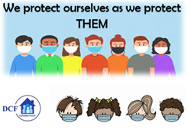
VANNESSA L. DORANTES, LMSW
COMMISSIONER
CT DEPT OF CHILDREN & FAMILIES
505 HUDSON STREET
HARTFORD, CT 06106
commissioner.dcf@ct.gov (860)550-6300
" I do my best because I'm counting on YOU counting on me…"
m angelou

