Memorandum

To:       All DCF Staff

From:  Commissioner Vannessa Dorantes

Date:  6/7/20

Re:      Update on Department Operations and Commissioner Weekly Video

_____________________________________________________________________________________

We are coming out of another very powerful week in the annals of social justice. In the midst of an international pandemic, our nation is coming face to face with a discussion on race relations.

**WHAT AN IMPORTANT TIME TO BE A SOCIAL WORKER LEADING THIS DEPARTMENT!**

At DCF, we have worked hard to work through our own understanding of the role race plays in our interactions of our work and in within our workforce. This has been at times messy, complicated and through it all — necessary.

The time has come in our department’s evolution to take a giant leap into the ***culture of safety*** we have been talking about for a few years. The framework in this visual will be the foundation to underscore the importance of our collective strategies.

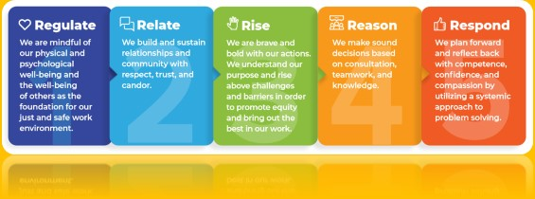

To hear more on this and to receive Department updates, please click on the links below:

* Commissioner's Weekly Video - [Commissioner's Weekly Video 6-7-20](https://youtu.be/-WcogMyjxUU)
* Parent and Child Visitation **DCF Phase 1** Triage Protocol - [Parent/Child Visitation Triage Protocol](https://portal.ct.gov/-/media/DCF/Agency/COVID-Emails/Parent-and-Child-Visitation-Triage-Protocol.docx)
* **\*Updated** Guidance on Virtual Assessments - [DCF Guidance for Virtual Assessments During COVID-19](https://portal.ct.gov/-/media/DCF/Agency/COVID-Emails/DCF-Guidance-for-Assessment-Final-2-JUNE-5.docx)

**TOGETHER** we will get through this all with **understanding**, **empathy** and **authenticity**.

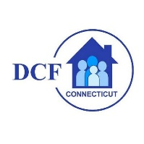**VANNESSA L. DORANTES, LMSW**

COMMISSIONER

CT DEPT OF CHILDREN & FAMILIES

505 HUDSON STREET

HARTFORD, CT 06106

[commissioner.dcf@ct.gov](mailto:commissioner.dcf@ct.gov)  (860)550-6300

*" I do my best because I'm*counting on *YOU counting on me…" m angelou*