Memorandum
To: All DCF Staff

From: Commissioner Vannessa Dorantes

Date: 7/12/2020

Re: Update on Department Operations and Commissioner's Weekly Video
___________________________________________________________________________________________________________
Click here for Commissioner's Weekly Video 7-12-20

This week's updates come at the 4-month mark when many of us pivoted to the telework environment. Think back to March 2020…WOW how our lives have changed since then!?! This edition also includes more detail on the following DCF happenings:
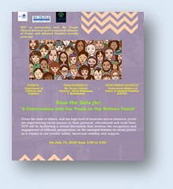
Please register youth in our care (14yo & older) for a virtual panel discussion being held THIS Wednesday July 15th! This is an opportunity to hear from and dialogue with our youth about how the attention to racial unrest in our communities has impacted them. While discussions like these may be uncomfortable at times, they are safe and necessary. All voices are welcomed & respected. For this special event, we have partnered with CT Association of Foster & Adoptive Families (CAFAF) and My People's Clinical Services. Their founder and Executive Director Abdul Rahmaan-Muhammad will be our facilitator. Other panelists include DCF Deputy Commissioner Michael Williams as well as a local Police Chief.
For meeting invite registration, click here: https://www.eventbrite.com/e/a-conversation-with-our-youth-on-our-nations-unrest-registration-111308725394

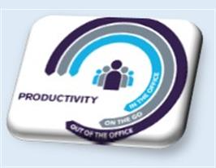
We have worked diligently over the past 4 months to continue DCF's mission critical work while balancing the health & safety of our workforce. There are growing questions about state employees working from home. We have been proud to hear creative ways you fill the gaps that the pandemic has forced against our 'normal' service delivery. Many have never even slowed, and others are doing much more than typical, we must all continue to strive for 95% productivity. This means that more of our staff will need to safely leave their homes, at times, to fulfill more of our public obligations. One example, is that over the next couple of weeks, information will be provided regarding the additional cohorts of children to be added to our in-person visitation triage process. Initial phase of adjustments to in-person visitation processes have been going well at our facilities and across the state in limited capacity. We are using lessons learned to plan cautiously. Thank you to DCF's leadership for keeping me informed of the unique work you all continue to do in the face of such trying times!

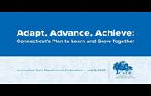
As our DCF Academy for Workforce Development (AWD) joined with our Health & Wellness Division to produce more instructional videos for our staff on safely conducting more of our mission critical work, AWD continues their virtual learning series. Click here to register for July offerings!
Distance learning for our youth is also a topic of discussion. It is important we look to ensure all the educational needs are met for youth in our care with particular attention being paid to youth with special academic needs. As school districts, including our own, feverishly plan to figure out what the Fall will look like for students and faculty, so do the rest of us.

Our entire workforce, all fully back in our buildings at the same time is still a ways away ( …if ever again. DCF-life as we knew it has changed as have all of us!)

Finally -- encourage our coworkers who have not been watching the weekly updates to get caught up on the most accurate information to date by clicking here CTDCF You Tube Playlist or Commissioner's Weekly Videos which are all here from the beginning!
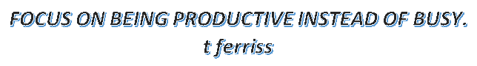
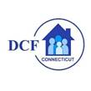VANNESSA L. DORANTES, LMSW
COMMISSIONER
CT DEPT OF CHILDREN & FAMILIES
505 HUDSON STREET
HARTFORD, CT 06106

commissioner.dcf@ct.gov (860)550-6300
" I do my best because I'm counting on YOU counting on me…"
m angelou

