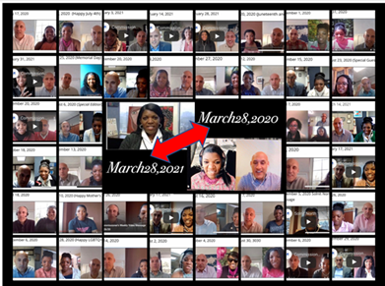
Memorandum
To: All DCF Staff

From: Commissioner Vannessa Dorantes

Date: 3/28/2021

Re: Update on Department Operations & 1 FULL Year of Pandemic Commissioner Videos
Can you believe we have been in this altered state for a full year
Chag Pesach Sameach, to the Jewish members of our workforce. I'm told this translates to "Happy Passover Holiday" The themes of Passover are: family, history, social justice and freedom-- Sounds a lot like what we have been focused on throughout this pandemic.
Our work goes on with such great results yet humble reminders of what's needed for recovery.
I cannot be prouder of you and your service to children and families.

Watch this week's à Commissioner Video 3-28-21 for more reflections on:
- Vaccination status-- Which DCF Executive Team members have gotten their shot in the arm? (Okay DCF, if you want to share yours, send us your vaccination shot shot to DCF.COVID-19@ct.gov)

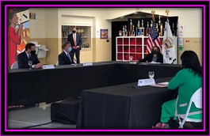
- Telework Survey 2.0 coming this week-- Tell us more about how you have continued to keep this Dept working effectively and keeping children safe.
- Who's highlighted for Social Work Appreciation Month "Spotlight on What's Right" newsletter coming out this week?
- Women's History Month culminated with my participation in a roundtable discussion with none other than the awe-inspiring Vice President of the United States Kamala Harris on The American Rescue Plan's potential impact to elevating America's children out of poverty--- She gets it!
- Updated Statistics-- A reflection on this year's data; Rest in Peace to all of the lives lost to this horrific pandemic including 4 of our foster parents.
Please continue to pay attention to your own mental health as well as the young people we serve. In Connecticut, on average, someone dies by suicide every day of the year…It doesn’t have to be this way. https://www.preventsuicidect.org/

We will get through all of this TOGETHER.

Many many THANKS to DARRELL GOHAGON, whose quick thinking has us ALL breathing easier tonight! Employing what he has been trained to do, Mr Gohagon performed the Heimlich Maneuver on a young person who was choking on a piece of food earlier today at Solnit North! Appreciation also to Lead CSW Dorette Sterling for highlighting this Everyday HERO!!!
VANNESSA L. DORANTES, LMSW
COMMISSIONER
CT DEPT OF CHILDREN & FAMILIES
505 HUDSON STREET
HARTFORD, CT 06106
commissioner.dcf@ct.gov (860)550-6300
" I do my best because I'm counting on YOU counting on me…" m angelou

