Memorandum

To:          All DCF Staff

From:    Commissioner Vannessa Dorantes

Date:     6/20/2020

Re:         Update on Department Operations and Commissioner Weekly Video

_____________________________________________________________________________________

To our staff who are Fathers and to all Father figures we appreciate the critical roles you play in the lives of children!

Over the past week, you likely noticed we deliberately paused to focus our attention on preparing a leadership framework on facilitating discussions and further developing concrete strategies regarding racial justice. Under the direction of Deputy Commissioner Jodi Hill-Lilly, this framework planning built on the foundational work of DCF's Statewide Racial Justice Workgroup and includes excerpts from the group's *COLOR OF COVID in CT* webinar held last month ( *link to this webinar is below* ) When implemented, the  **Safe & Sound framework** will guide a structured set of consistent, honest conversations to occur within the Department and with our community partners.

These leadership conversations are just one ingredient towards real change within DCF. Although discussion is important, action is imperative.  Regardless of your role/function, we need **everyone's** voice and commitment to respectfully move TOGETHER in the spirit of **empathy, understanding and authenticity**.

[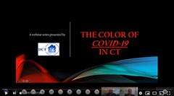](https://youtu.be/LLsyvq8g5gA)Children, families and communities of color need us focused and undistracted to contribute to a more fair and just CT.

SRJWG's  **COLOR of COVID in CT** Direct Link:  <https://youtu.be/LLsyvq8g5gA>

Also in this week's updates:

* Juneteenth and the connection to our work towards an antiRacist mission at DCF
* A teaser of the framework for Leading Racial Justice Work in this context
* Father's Day & Reunification Month Highlights from the June "Spotlight" Newsletter
* DCF Phase 1 underway: Repeat of which parent/child cohorts are being allowed consideration of in person contact via a Visitation Triage Process--
* Weekly COVID pandemic statistics

*To stay connected and informed, the expectation is that this memorandum and accompanying video are reviewed by all staff in the Department. As we continue to look for the most effective manner and to communicate, it is important those in a supervisory roles set aside time to discuss these updates with their respective staff.*

**CLICK HERE to view this week's video updates ➔** [**Commissioner's Weekly Video 6-20-2020**](https://youtu.be/cxRC3pJ2cog)

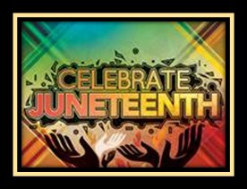***JUNETEENTH*** *celebrates the end of slavery in the United States. On June 19, 1865, Major General Gordon Granger arrived in Galveston, TX and announced the end of the Civil War and the end of slavery.  Although the Emancipation Proclamation came two and a half years earlier on January 1, 1863, many enslavers continued to hold enslaved people captive after the announcement. So, Juneteenth became a symbolic date representing African American Freedom.*

***2020*** *marks the 155th year anniversary of Juneteenth, the celebration that commemorates African American freedom and emphasizes education and achievement.  During this year's Juneteenth -- whether it is a day, all weekend, and in some areas a month marked with celebrations and family gatherings; it is a time for reflection, rejoicing and reconciling our past with our present. It is a time for assessment, self-improvement in for planning the future. Its growing popularity signifies a level of maturity and dignity in America long overdue. In cities across the country, people of all races, nationalities and religions are joining hands to truthfully acknowledge a period in our history that shaped and continues to influence our society today. (adapted from Juneteenth.com)*

***In child protective services, we must be sensitized to the conditions and experiences of others-- the families we work with as well as our workplace peers.  Only then can we*** *Many thanks to Monica Montalvo Rams DCF Director of Multicultural Affairs & Jennifer Avenia Esq. DCF Director of Immigration Services for their contributions to this piece.***make significant and lasting improvements in our Department & in society****.*

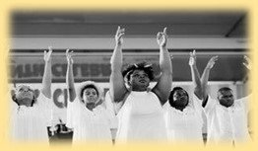

**This Is How We Juneteenth!**

<https://www.nytimes.com/article/juneteenth-celebration-history.html?auth=login-email&login=email>

*Juneteenth Celebrations in Austin, Texas in 1900 and Odessa, Texas in 2016.* Speeches, dance, parades and great food have marked Juneteenth celebrations from the very beginning.

***"*What is Juneteenth?" by Dr. Henry Louis Gates, Jr.** <https://www.pbs.org/wnet/african-americans-many-rivers-to-cross/history/what-is-juneteenth/>

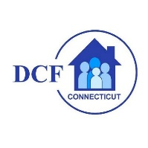**VANNESSA L. DORANTES, LMSW**

COMMISSIONER

CT DEPT OF CHILDREN & FAMILIES

505 HUDSON STREET

HARTFORD, CT 06106

[commissioner.dcf@ct.gov](mailto:commissioner.dcf@ct.gov)  (860)550-6300

*" I do my best because I'm*counting on *YOU counting on me…"*

*m angelou*