Memorandum

To: All DCF Staff

From: Commissioner Vannessa Dorantes

Date: 6/13/2021

Re: Update on Department Operations & Commissioner Video

June is Reunification Month; since the beginning of the pandemic, over 700 children have been reunified with their families! That is incredible work under these very trying times. Our primary focus is ensuring the safety of children. If they cannot remain safely at home, then children should be with relatives or someone they know-- We have kinship licensure and waiver processes to solidify these arrangements. When children cannot be placed with kin, every effort should be made to have them living in family settings. All of our collective efforts must ensure timely permanency and safe decision-making. We have a dedicated provider network and motivated stakeholders working to strengthen and improve parental capacity. It is our mission to partner with communities and empower families to raise resilient children who thrive.
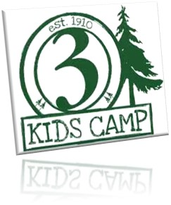
Last update, we highlighted Channel 3 KidsCamp slots available for siblings and for children 8-13years old whose families are currently open with DCF or have been recently closed. Last week, I had the pleasure of speaking to the CT Police Chief's Association to thank them for their generosity in raising the funds the will make this campership totally FREE for the children to participate.
- July 18th through July 23rd, during law enforcement week, 80 children can enjoy this outdoor camp experience at Channel 3 Kids Camp in Andover, CT.
Registration link: https://pcac3kc.campbrainregistration.com/
- The Sibling Connections Camp for youth in care at the same location will be held Sunday, August 8, 2021 through Friday, August 13, 2021.
Here's the Brochure and the Channel 3 Sibling Camp Registration. Please identify children ASAP & assist their parents ( bio & foster ) to complete the application process. We must fill every slot available to us so children will not miss out!

Watch this week's video Commissioner's Biweekly Video (6-13-21) for more updates on:
- Teleworking up to 50% of your work schedule
- Scheduling process
- Statistics and trends
This week we also kicked-off our refueled STATEWIDE F.E.L.T. Fatherhood Engagement Leadership Team -- Just in time for Father's Day!!

Thank you to our TriChairs:
- Assistant Chief of Child Welfare Chris Lau,
- Fatherhood Lead PS Steve Smith and
- Abdul-Rahmaan I. Muhammad of My People Clinical Services.
Children need fathers and father figures in their lives. Our work strives to be with the whole family. Fatherhood work is a critical component of that.

- We are also celebrating PRIDE month with the LGBTQI+ community--Diversity Action Teams across the state are sharing information and there are a myriad of statewide activities happening throughout the month.
- This week, on June 19th or Juneteenth is a recognized holiday commemorating the end of legalized slavery in the United States. It is also called Emancipation Day or Independence Day.

The more we learn about our individual and collective diversity, the better public servants we are in contributing to our collective humanity!
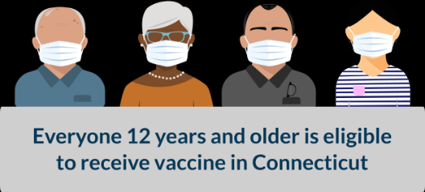
Know someone who is still deciding on the COVID-19 vaccine? Please share the latest accurate and up to date information at the https://portal.ct.gov/vaccine-portal/ or Click here to view a list of vaccine clinics that allow walk-up vaccination.

Enjoy the fabulous weather!

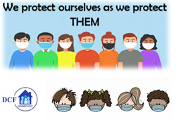
VANNESSA L. DORANTES, LMSW
COMMISSIONER
CT DEPT OF CHILDREN & FAMILIES
505 HUDSON STREET
HARTFORD, CT 06106
commissioner.dcf@ct.gov (860)550-6300
" I do my best because I'm counting on YOU counting on me…"
m angelou

