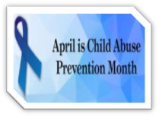
Memorandum

To: All DCF Staff

From: Commissioner Vannessa Dorantes

Date: 4/11/2021

Re Update on Department Operations & Commissioner Video

April is Child Abuse Prevention Month!

Watch for more information in the next couple of weeks on the Department's prevention work and our efforts to strengthen engagement with parents, supporting families with community partners across the state!
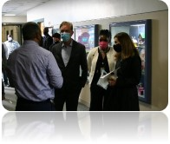
Some of our best work is happening at the Albert J. Solnit Children's Center North Campus in East Windsor. They have continued, 24/7-- at reduced capacity, throughout the pandemic to mitigate COVID transmission.
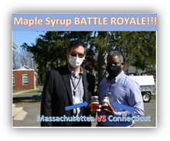
Who came to visit this week???

Governor Ned Lamont & Lieutenant Governor Susan Bysiewicz came to the campus and heard about building entrepreneurial and food safety skills from the young men there.

The tour included hearing about an enhancement to our clinical toolbox is the Sensory Integration Room.

Thank you to Dr. Rayford and staff for an excellent visit.

Watch this week's à Commissioner's Bi-Weekly Video 4-11-21 for more on this and other hot topics such as:
- Connecticut's potential increased involvement with unaccompanied minors at our country's southern border.
- Increasing the Department's in-person functions, re-entry capacity in Offices. Please help us hear more of your perspective by completing thisà DCF Teleworking Survey 2021… Planning and preparation eases anxiety created by pandemic isolation & uncertainty.
- Stats, trends and contact tracing themes as access to vaccine and variant-spread compete.

Please encourage others, who don’t watch routinely, to listen for themselves. It continues to be important to "come to the source of information" on these and other topics involving DCF - another reason why we continue to publish these videos and newsletters. This is how we stay connected and informed.

Thank you everyone…Be Safe…We will get through this TOGETHER!!!

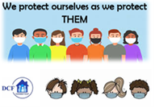
VANNESSA L. DORANTES, LMSW
COMMISSIONER
CT DEPT OF CHILDREN & FAMILIES
505 HUDSON STREET
HARTFORD, CT 06106
commissioner.dcf@ct.gov (860)550-6300
" I do my best because I'm counting on YOU counting on me…"
m angelou

