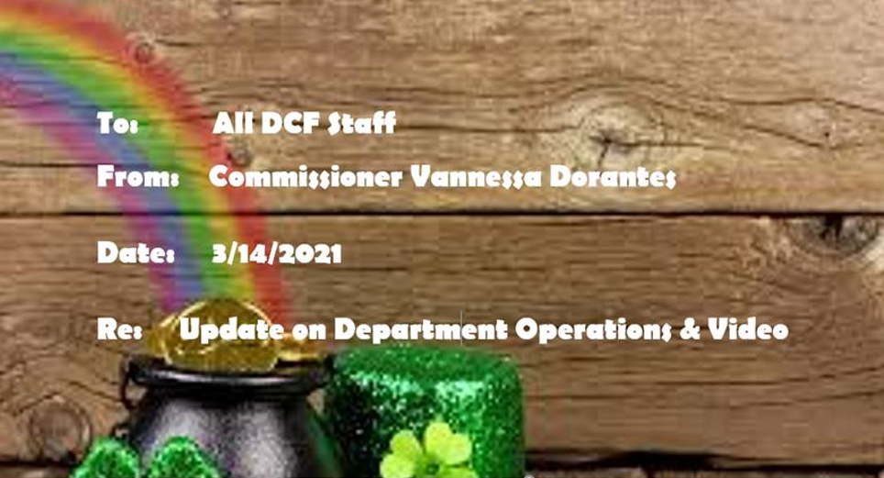

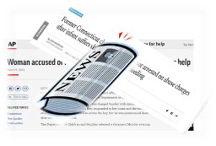

**Spring forward and watch this**➔ [Commissioner's Bi-Weekly Video 3-14-21](https://youtu.be/HeCqlaDc22g) as we reflect on approaching one full pandemic year through some recent highs & lows of:

* **COVID fatigue relay race**
* **Media representation** --
  + From Gov Lamont's signing of CROWN Act into CT law <https://www.fox61.com/video/news/local/crown-act-into-law-signed-into-law/520-8701db13-0013-4237-afea-bf50ac7747f0> ,
  + a great adoption story of an older youth in care <https://www.wtnh.com/on-air/connecticut-families/you-are-now-us-teen-finds-forever-home-with-60-year-old-adopted-parents-in-new-milford/>  to
  + Headline news stories framing the Department's role in two families experiencing negative outcomes for their respective children
* **Women's History Month & Social Worker Appreciation Month** afford the opportunity to highlight-
  + 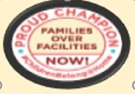permanency outcomes achieved through reunification, adoption & everything in between
  + Dept testimony at virtual legislative public hearings
* An example of our core values recognized nationally-- Children's Rights published a report entitled,  *"Families over Facilities*"

click ➔<https://bit.ly/FamiliesOverFacilitiesCR>  to read. With the tireless commitment of our community provider partners, we balance maintaining children safely within a family & using congregate settings for time-limited, treatment options.

This is very humbling work and It's all *relative* ….

STAY THE COURSE  WORK/LIFE BALANCE  REMAIN VIGILANT MISSION CRITICAL FOCUS 

I remain proud of you & the work that happens within this agency   Not by chance or luck… It is with purpose, pride & competent SKILL.

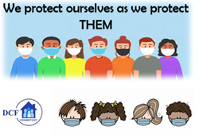VANNESSA L. DORANTES, LMSW

COMMISSIONER

CT DEPT OF CHILDREN & FAMILIES

505 HUDSON STREET

HARTFORD, CT 06106

[commissioner.dcf@ct.gov](mailto:commissioner.dcf@ct.gov)  (860)550-6300