Memorandum

To: All DCF Staff
From: Commissioner Vannessa Dorantes
Date: 12/6/2020
Re: Update on Department Operations Video

OUR WORK is ESSENTIAL.
We all have the responsibility to treat it as such.

This Commissioner's Weekly Video 12-6-20 emphasizes components of our COVID-19 planning, response and notifications.
Listen for what we mean by:
- POSITIVITY RATE
- CULTURE OF SAFETY
- CONTACT TRACING
- TRANSMISSION MITIGATION
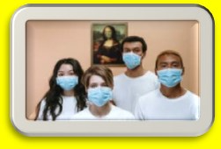
- EXPOSURE STRATEGIES

We also explain:
- COMMUNICATION
- NOTIFICATIONS
- LEADERSHIP AUDITING
- PERSONAL RESPONSIBILITY

Lastly, we talk about the workplace (wherever we conduct face to face work of the agency):
- PPE expectations
- Click to reviewè Mask Wearing and Close Contact Defined

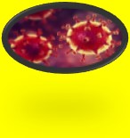
This week's data tells the story. Your personal conduct must consider the critical nature of our work and the vulnerability of the population we serve.

That consideration is owed to them and to each other.

WE WILL GET THROUGH THIS TOGETHER.

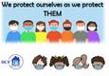VANNESSA L. DORANTES, LMSW
COMMISSIONER
CT DEPT OF CHILDREN & FAMILIES
505 HUDSON STREET
HARTFORD, CT 06106
commissioner.dcf@ct.gov (860)550-6300
" I do my best because I'm counting on YOU counting on me…"
m angelou

