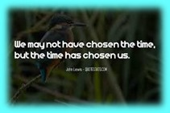
Memorandum
To: All DCF Staff

From: Commissioner Vannessa Dorantes

Date: 11/15/2020

Re: Update on Department Operations and Video

Click here to watch our mid-November Commissioner's Video 11-15-20 for updates on the following:

- Who's next? :CTDCF Mentoring program 2020 closing ceremony
- COVID holiday planning https://portal.ct.gov/Coronavirus/Covid-19-Knowledge-Base/Holiday-Guidance
- Contact Tracing lessons learned
  - Workplace expectations …Stay home if sick or awaiting potential exposure test results
  - Please limit social gatherings with coworkers
  - In person contacts & triage processes must be guided by public health science
- Fiscal responsibility and priority order
  - Can we do this ourselves?
  - Do we have contract provider slots?
  - Credentialed and WRAP services can be used if service doesn’t fit the above
- CT Adoption Day on 11/20/20
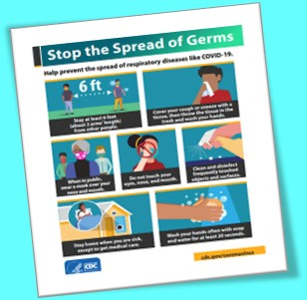
  - Permanency should expand a child's family &village
  - Court etiquette, confidentiality & professionalism
- Latest CTDCF COVID 19 stats & trends

VANNESSA L. DORANTES, LMSW
COMMISSIONER
CT DEPT OF CHILDREN & FAMILIES
505 HUDSON STREET
HARTFORD, CT 06106
commissioner.dcf@ct.gov (860)550-6300
" I do my best because I'm counting on YOU counting on me…"
m angelou
