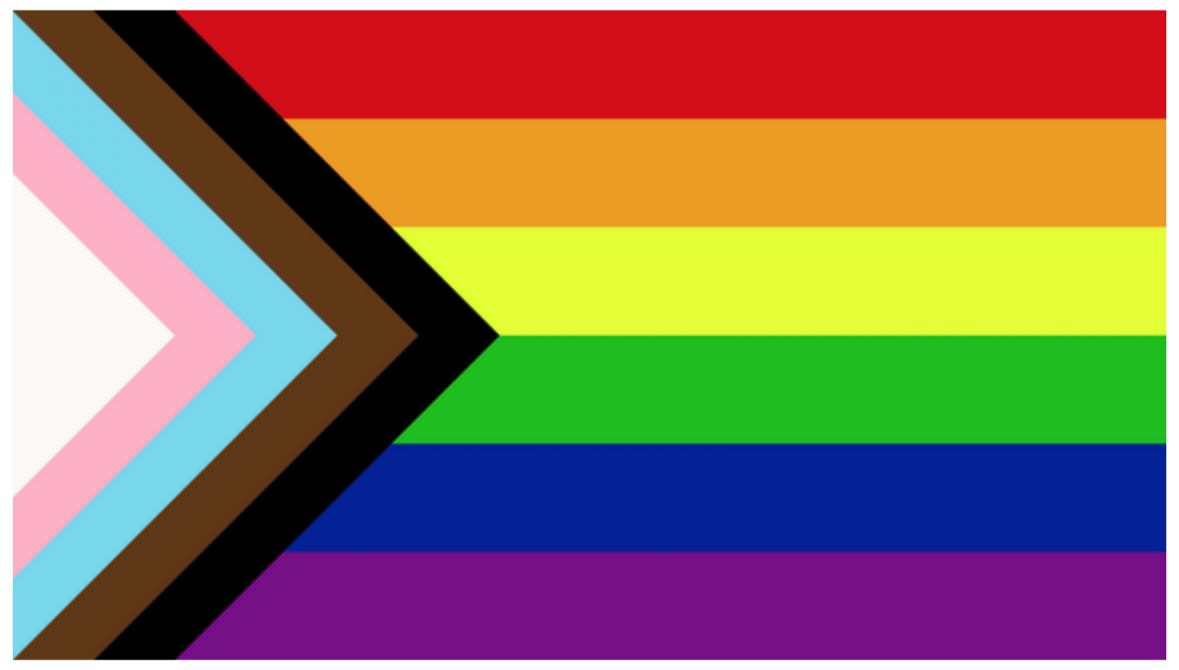
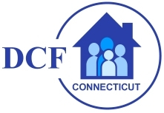

WHO I AM, by Kris Robles
June 23, 2021
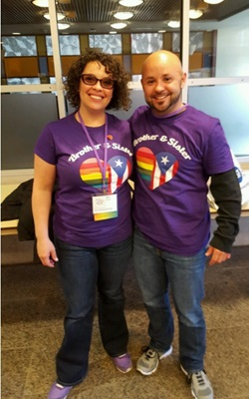
"Pride" has different meanings for different people, of course. Lesbian, Gay, Bisexual, Transgender and Queer (LGBTQ) Pride Month is currently celebrated each year in June to honor the 1969 Stonewall Uprising in Manhattan. As a Puerto Rican transgender parent, social worker and person in recovery, this month provides an opportunity to reflect not only on my life, but also the many others who came before me.

At 17 years young, I was trying to find my place in the world and living on my own. I was an adolescent battling a system that didn’t understand who I was or what I was feeling. Just like so many of our youth today in the LGBT community, I struggled to find my place in the world. I had many adults cross my path and help guide me in making better decisions in my life. It was at the age of 21 years old when I met my first transgender man who was telling his story. He was a man in recovery and a person who spoke about never feeling right in his body. When I saw that he was living his true authentic self, I recognized what I needed to do to live my true self.

However, as we all know, things are not that easy. Living in a world that did not recognize individuals as equals and not having access to pay for services made things feel impossible. Insurance did not recognize this as a medical necessity in 1998. So, I was stuck with conforming to what society thought was acceptable so that I could work and survive.

I continued to suffer. Looking at myself daily reminded me who I wasn’t. These were very hard times for me. It wasn’t until I was in graduate school at University of Connecticut School of Social Work that I began to have equal access to things. Nevertheless, insurance continued to be a barrier as it only covered limited things for transgender people such as myself.

During an internship with True Colors as I was taking classes in policy surrounding the LGBTQ community, I began to find my voice again. Feeling blessed to work alongside Robin McHaelen, the executive director and founder of True Colors, I became empowered to take the plunge and come out to the world. I was supported by my peers and nominated to speak on behalf of my UCONN graduating class in 2006.

Surprisingly, I again faced being oppressed by the dean of students in the social work program who told me not to identify in the gender that I saw for myself and to modify my speech to use non- affirming language about myself. I yet again had to conform to what society felt was safer and more comfortable for them. At the age of 29, I again experience judgment and discrimination from people in my chosen field by being told that I couldn't live in the gender with which I identified. Thankfully, my experience at True Colors helped me develop the courage and knowledge that I needed to educate and advocate for people like myself. I felt a responsibility to help those who didn’t understand and help them learn that we all deserve a voice and to be seen and affirmed for who we are.

During my transition, I continued to learn that my story wasn’t just about me. My older sister had her story regarding my transition. I learned that she had to come out as well. She still lived in my hometown and was constantly asked about me. She slowly had to find ways to tell people. She struggled with being judged and feared that family and friends would not accept who I am. With the help of her own therapist, friends and open communication between her and I, she too learned to have a voice and share her own story.

Together, we presented at the True Colors conference -- sharing our perspective of the family's transition (Brother Sister LOVE). Parents have their process and sometimes this takes a little time. I didn’t really give my parents an option. It was either they could love me for who I am, or they were not going to play a role in my life. I was at a point in my life that I was done living for others, and I was ready to finally live my true authentic self for nobody but me.

Today my wife and I struggle with sharing our story out of fear that we will be shunned, treated differently, and discriminated against in our community. We have even more fear now that we have two boys. We are cautious about with whom we share our story. I want to be treated equally and not judged that I am somehow not the same as any other man. My boys have been brought up to know about gender and that love is love regardless of sex, race, ethnicity, disability, religion, or socioeconomic class. Fear is very real for us, and it is something that we face daily. We talk with our boys about who I am and educate them to embrace who they are and who we are. We bring up our kids to not judge because we know that we have been judged and, at times, we are still judged.

It is important, as I work for DCF, to continue to educate workers and be the voice our youth and families need when they don’t have a voice themselves. Many of our youth and families are afraid. They are not sure who to turn too. It is important for staff to put aside their own misconceptions and learn. If you don’t know, just ask. I would rather be asked a question than be talked about on the floor. I know what this feels like in an office and it never feels good.

If you have youth on your case load wanting to be called different pronouns, the best thing you can do is to build rapport with that youth and to affirm them. Don’t be afraid to ask them what name they want to be called. Face your own fears because they are more scared than you are.

BE PROUD, HAVE PRIDE, STAND UP, & SPEAK UP! WE ALL WANT TO BE SEEN, UNDERSTOOD AND HEARD.
HAPPY PRIDE MONTH 2021!

Thank you for hearing my voice and seeing me as my true authentic self.

Kris Robles, LCSW
Department of Children and Families
Clinical Behavioral Health Manager for Substance Use & Intimate Partner Violence
Kris.robles@ct.gov
cell 203-228-6148

