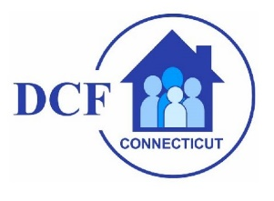

"Advancing the Children's Behavioral Health Plan" Summit
June 2, 2021
The State of Connecticut's vision is for children and their families to be connected to the care they need in order to grow up healthy and thrive.

It is important that no matter what “door” or “system” a child enters thorough, (such as pediatrics, school, juvenile justice, or child welfare), they can be matched to the treatment, services, and supports they need.

The 2014 Behavioral Health Plan for Children outlined Connecticut's vision and set goals and strategies to be implemented by the end of 2019.
The overarching goals of the plan are to:
- Promote wellbeing of all of Connecticut’s Children through prevention, early detection and access to responsive and effective services
- Provide a broad array of services through a coordinated and integrated system that maximizes available resources
- Empower and support families to raise healthy and happy children
- Reduce racial and ethnic disparities in outcomes for children and families of color

Recently, an "Advancing the Children's Behavioral Health Plan" summit occurred bringing together over 100 community partners - creating an opportunity to review the current status of the plan and move the work in Connecticut from "good to great."
Please take this opportunity to watch the summit: Children's Behavioral Health Summit

Here are the PowerPoints utilized: Advancing the Children's Behavioral Health System in Connecticut

Further information can be found at www.plan4children.org

