Task Title: Tangoe New Wireless Device/Services Ordering Process
Task Category:
☐ Invoice Processing ☒ Order Processing ☐ Internal Business Process
Task Description:
This process defines the new wireless device and services order processing steps for all wireless vendors (Sprint, ATT Mobility, Verizon Wireless, T-Mobile). It is imperative that the correct vendor’s template is selected.

Task Input Requirements:
Prior to executing a new wireless order please gather the below required information.
- Employee’s first and last name (as it appears on their employee paycheck)
- Employee’s Employment Identification Number
- Physical address of the employee work site (for the Entity field)
- Primary and Secondary Points of Contact (if available) (Full Names and contact numbers) –
- Cost Center (Formerly the Agency/Allocation code from TBMS, formatted as 3 digit agency mnemonic, “-“, and allocation code, i.e.; DAS-000).
- Shipping Destination, where delivery of initial items will be shipped to
- The agency’s wireless vendor account number
- What is the user requesting? Wireless device, plan, any additional services/features, and/or accessories.
- Product schedule for vendor you are ordering services from.

Task Steps:
- From the ‘Provisioning’ menu tab select the ‘Create New Request’ option.
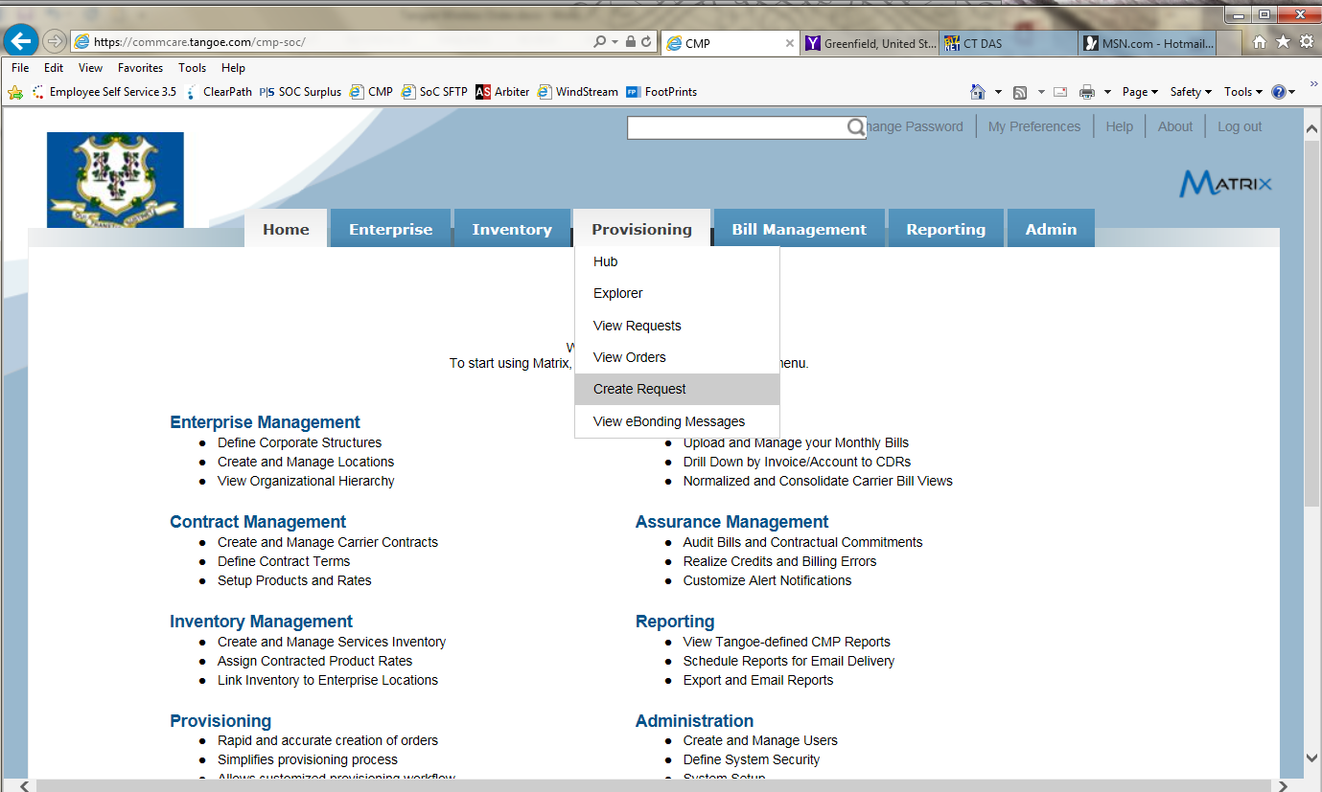
- Click on the ‘New’ radio button and then click on the appropriate wireless vendor request hyperlink. (‘Wireless - <vendor name>’).
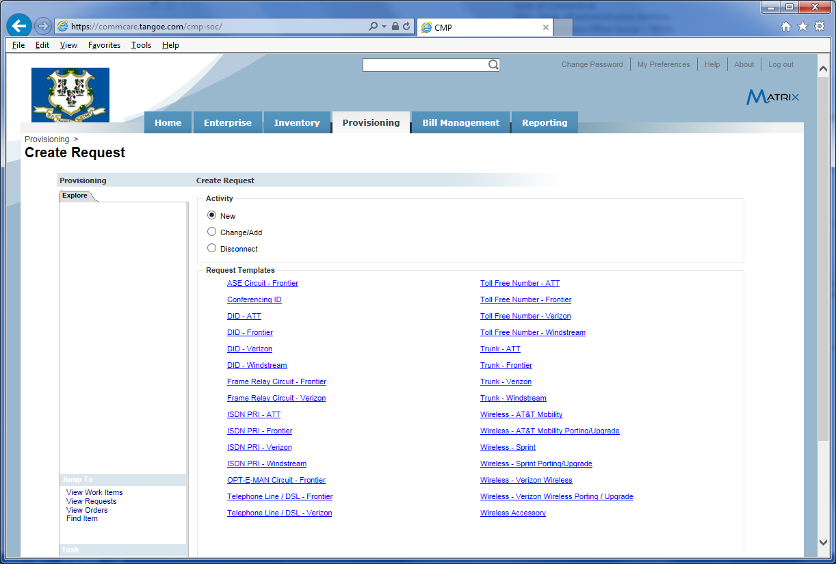

- Upon clicking the applicable wireless vendor request link, Tangoe will auto generate and assign a Request Number value (see below). Once assigned, update the quantity field if applicable but only with the understanding there will be only one employee ID number relevant for all of the number of units being requested, as well as a single cost center representation for all the items. Update the ‘Description’ field with info you feel would be useful as a reference when reviewing your requests listing. When completed click on the ‘Next’ button located at the bottom right which will take you to the next three (3) sections to be completed.
      - General
      - Location
      - Vendor Billing
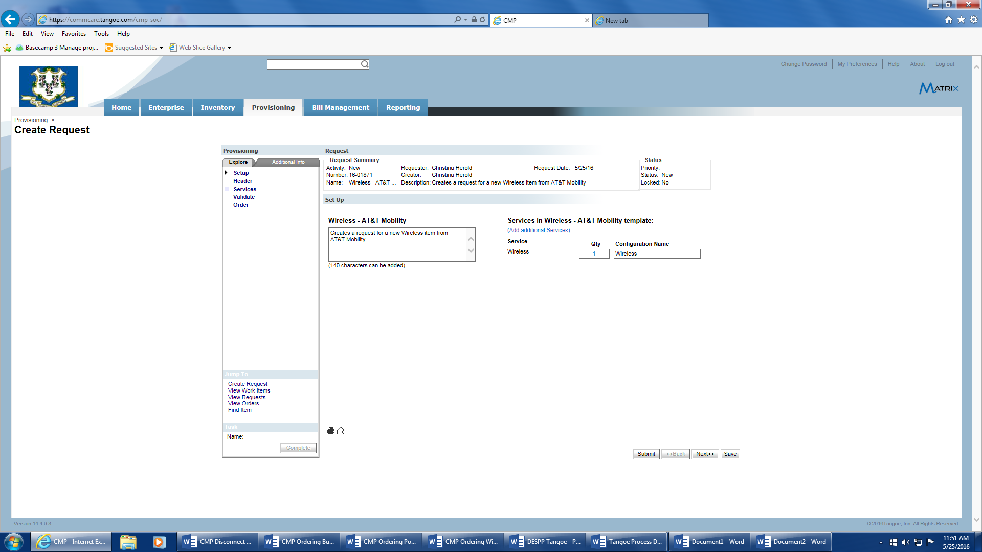
- General Section completion requires you to enter the following:
  - For Priority, choose from the drop-down menu one of four options: Critical, High, Low or Medium.
  - Request Date – will auto populate with the date the request is generated in Tangoe.
  - Requester – will auto populate with the name of the person actually entering in the request.
  - Business Justification – enter the reason for the request. This field is only required if a priority of ‘High’ or ‘Critical’ is selected.
  - Provisioning Zone – will populate with ‘Non-Enterprise Order’. This default should be used for all wireless orders.

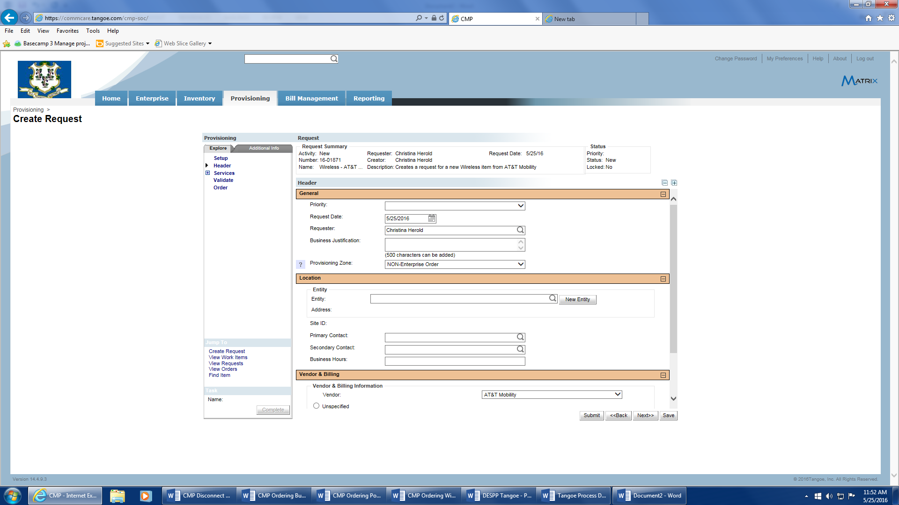

- The ‘Location’ section requires the following entries:
  - ‘Entity’ field – click on the magnifying glass and a pop up window will appear for lookup of the applicable address.
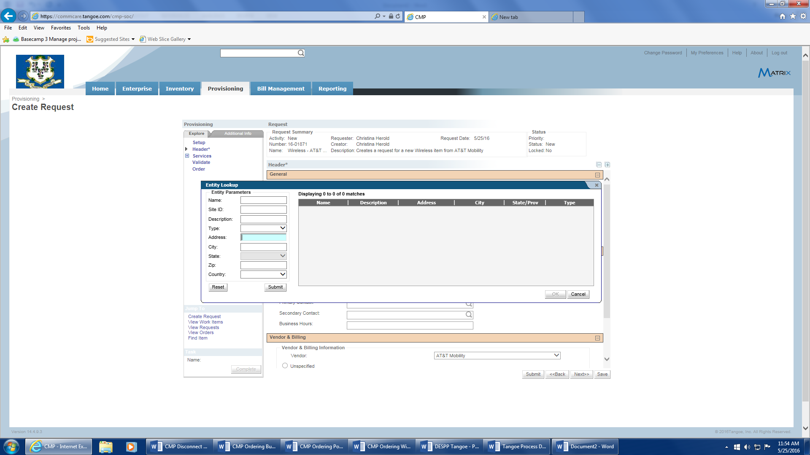
  - Enter the city and address for the location where the employee is assigned.
  - Move your mouse over the correct value and the field will turn blue. Once confirmed, click on ‘Ok’ and the data will populate the ‘Entity’ field with the site-id.
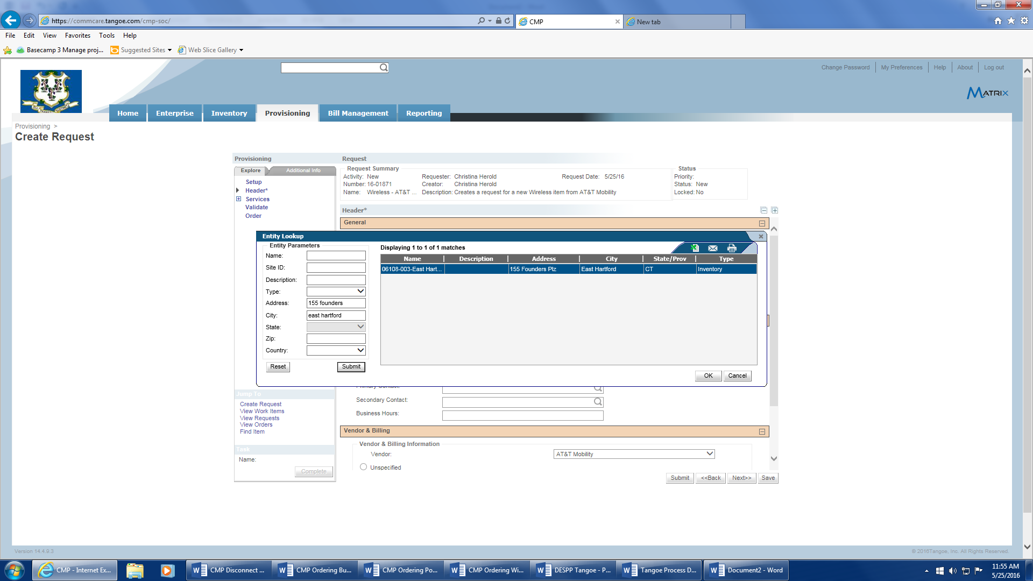
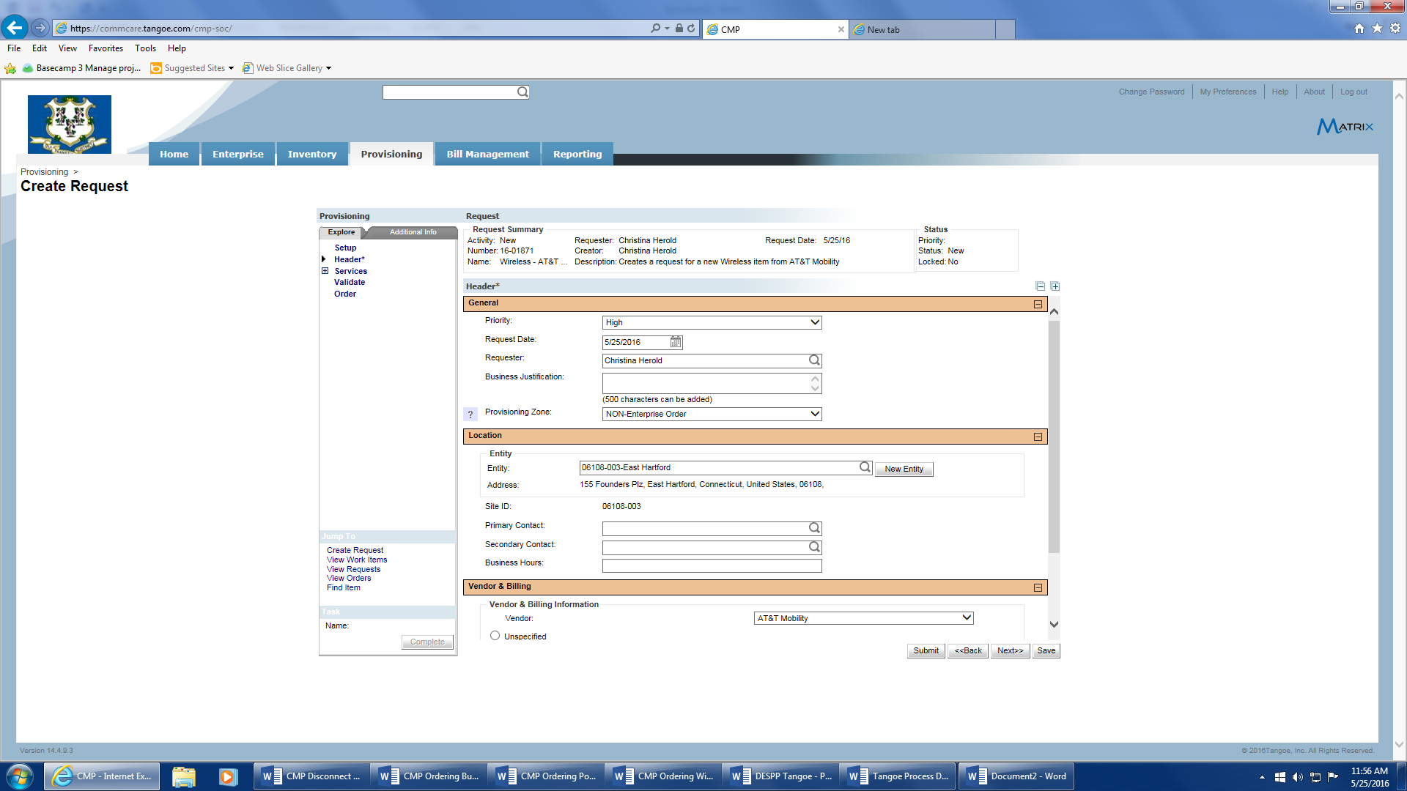

  - Primary Contact – click on the magnifying glass to initiate a pop-up window for the employee lookup. Note: Before entering name lookup info, hit the ‘Reset’ button to clear out the data pertaining to the address lookup. Then enter the first and last name. When the correct employee appears move your mouse over and click this row, then hit the ‘Ok’ button.
  - If the request requires a Secondary Contact, repeat Steps 7 thru 9.
  - Business Hours – enter the business hours of the primary contact.
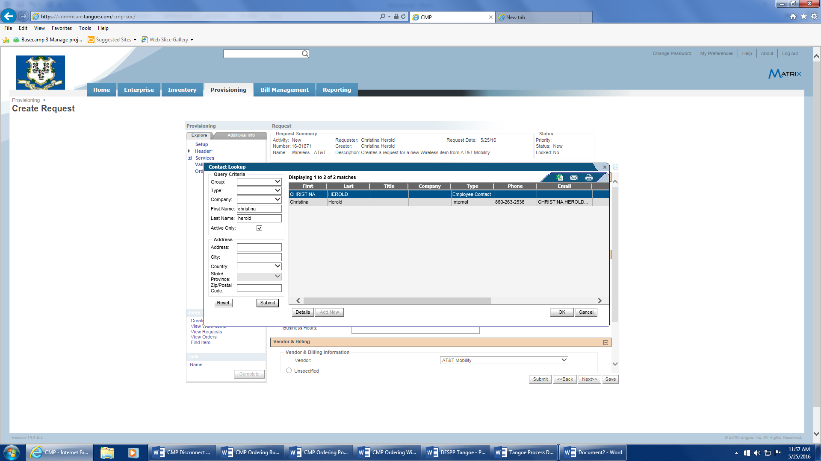
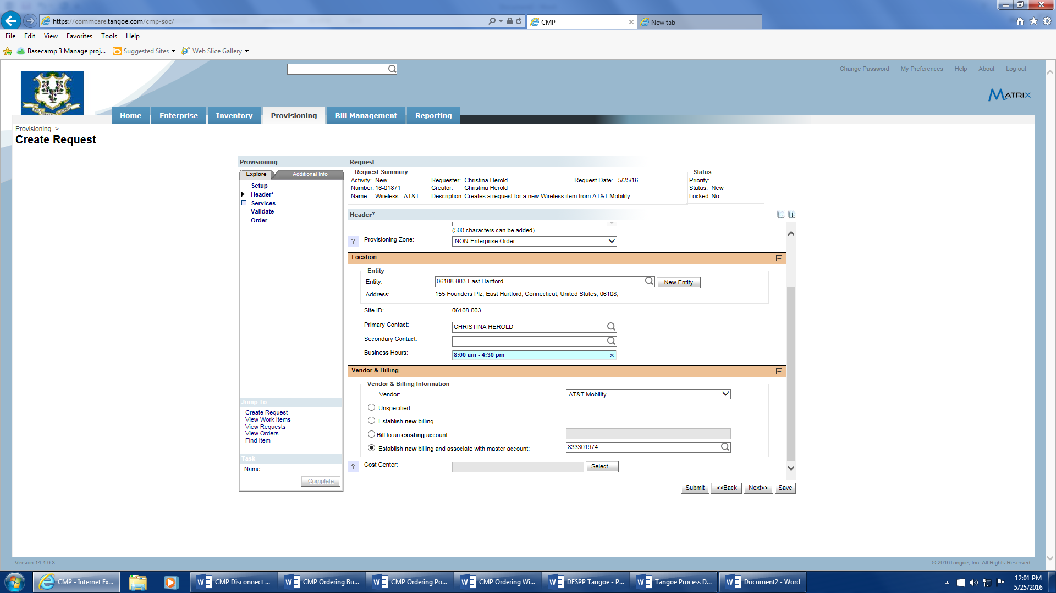
- The ‘Vendor Billing’ section requires the following:
  - The vendor id should be prefilled based on the wireless vendor request chosen.
  - Click on the ‘Bill to an existing account’ button
  - Click on the magnifying glass to the right and a pop-up window will appear. Enter your agency’s wireless vendor account number in the Account # field, highlight the account, and click ‘Ok’.
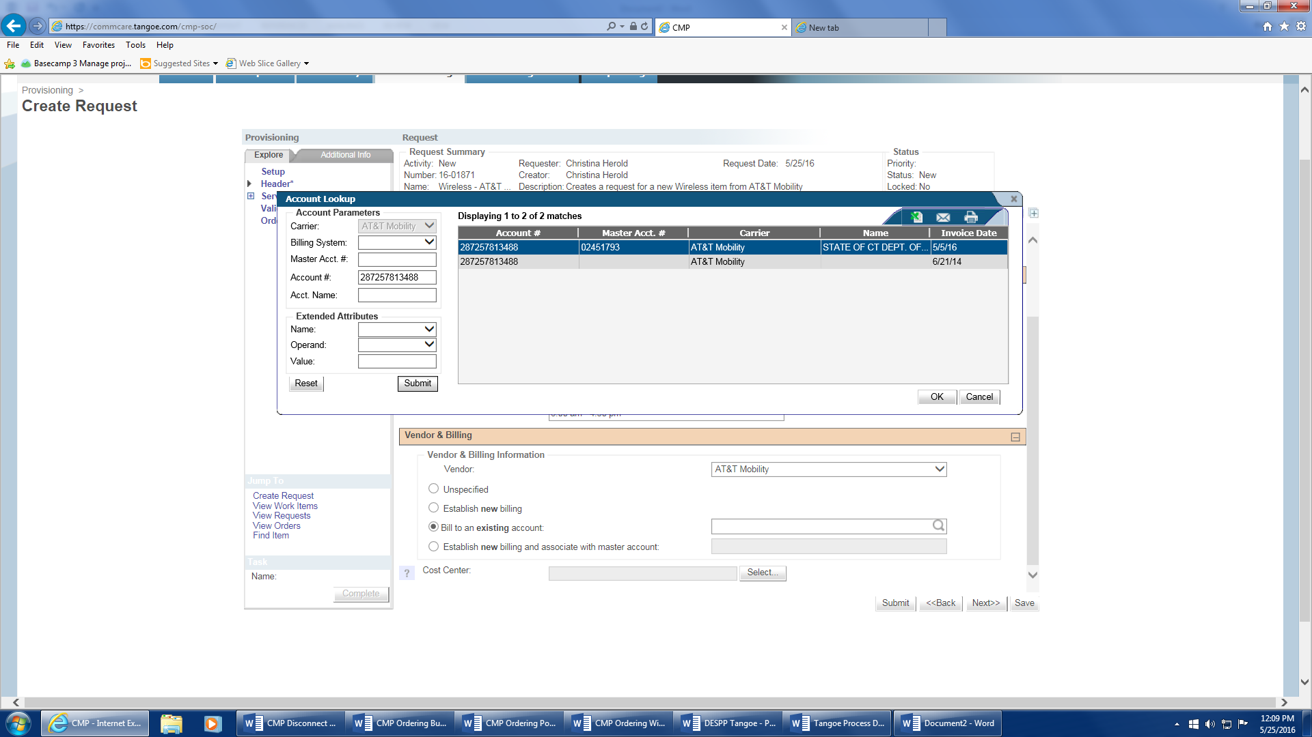
  - Hit the ‘Select’ button to start choosing the ‘Cost Center’ (Agency/allocation code). Choose the applicable cost center to be used for funding this services purchase and click ‘Ok’.
  - After confirming correct ‘Cost Center’ value is chosen, click the ‘Next’ button to go to the ‘Order Information Section’ of the request.
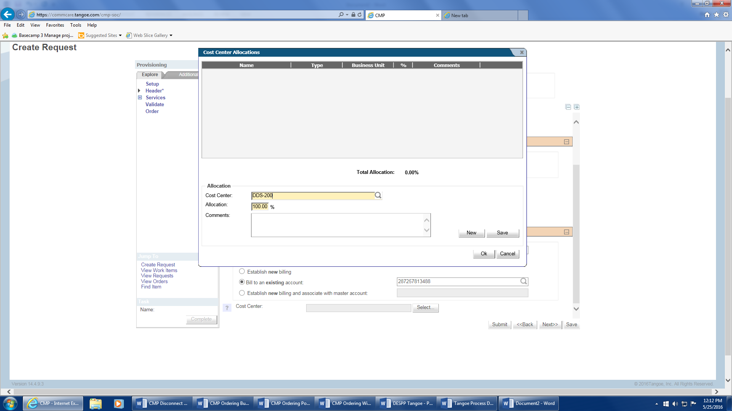

- The Order Information Section requires:
  - The Description and Quantity fields will auto populate from the initial header screen.
  - Enter the ‘Due Date’ which will depend on urgency of request.
  - If you choose the ‘Expedite’ field there may be an additional charge associated with this order option. It is recommended that pre-approval is received if this option is selected. You will be required to enter supporting info in the ‘Business Reason’ field.
  - Enter any information you feel may be pertinent to completion of the order in the ‘Special Instructions’ field. You can enter up to four thousand characters. It is recommended that you enter your agency name and a description of what is being requested.
  - Hit ‘Save’ button
  - There is a ‘Documents’ link which allows you to upload and attach applicable supporting documentation if necessary. If not needed proceed to the ‘Service Information Section’.
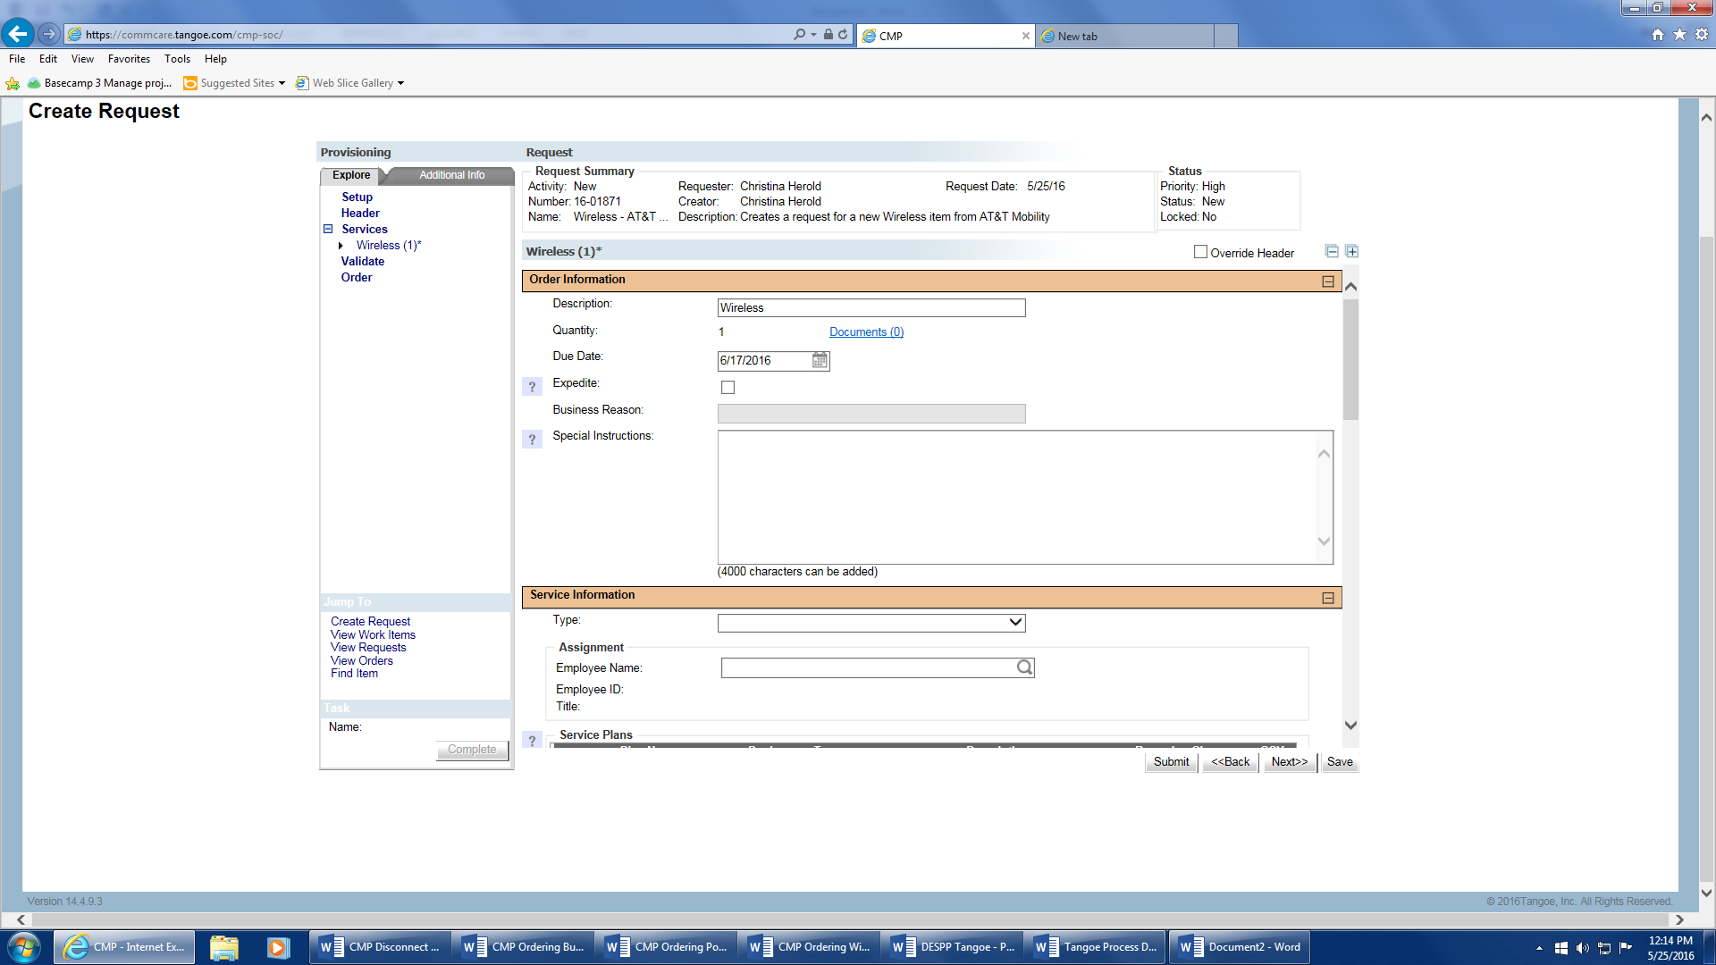
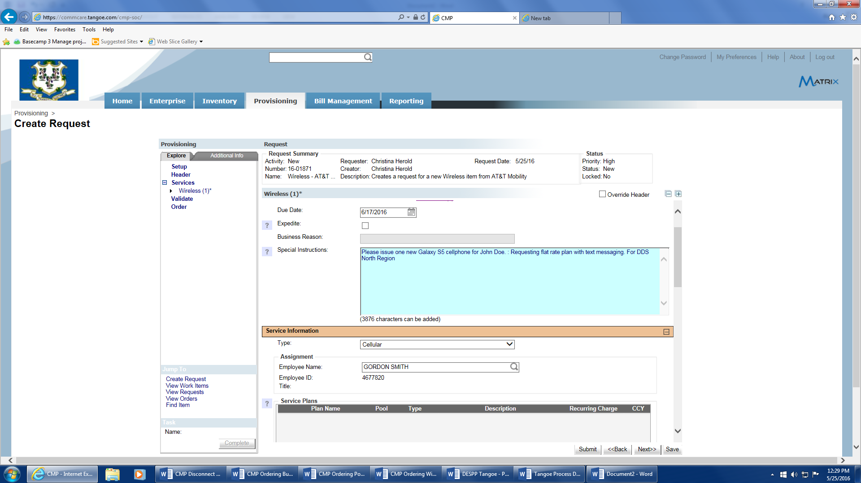
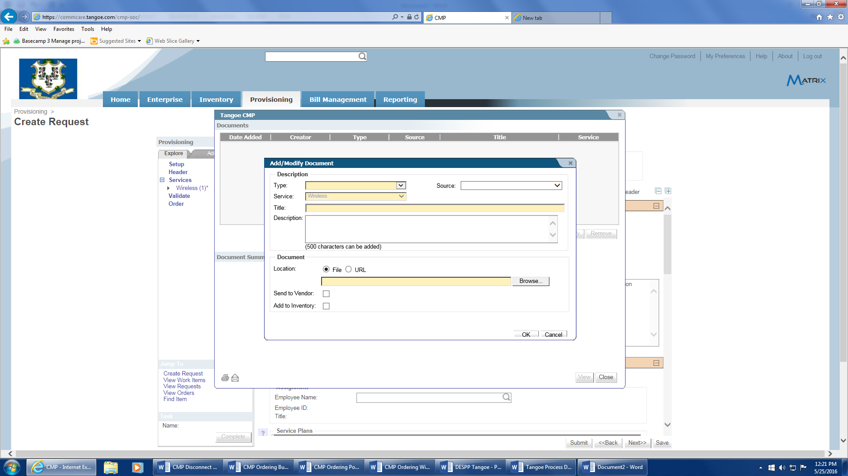
- The Service Information Section requires:
  - Choose the appropriate wireless device type (normally ‘cellular’) from the drop down filter.
  - Click the magnifying glass at the ‘Employee Name’ field to enter the employee info in the employee pop-up window.
  - Highlight the employee info and select ‘Ok’. If the employee name does not appear, hit the ‘Save’ button at the bottom of the screen and contact the Telecom business office (860-713-5520).
  - To choose a service plan hit the ‘Add’ button to activate the plan ‘Update’ selection button.
  - Use the drop down to select the Service Plan Code for this order (use the vendor’s product schedule as a reference) and hit the ‘Update’ button. You may view the plan description by clicking the ‘Plan Details’ button. You may add more service offerings if needed (i.e.; International services, etc…).
  - Hit the ‘Save’ button to save the current order info
  - For a new device choose the ‘New Device’ radio button, and enter the appropriate device manufacturer from the ‘Manufacturer’ drop down menu. Note: The vendor name is normally not the manufacturer of the device (i.e.; Apple for iPhone, Samsung for S6, LG, etc…).
  - Enter the model of the new device from the ‘Model’ drop down menu.
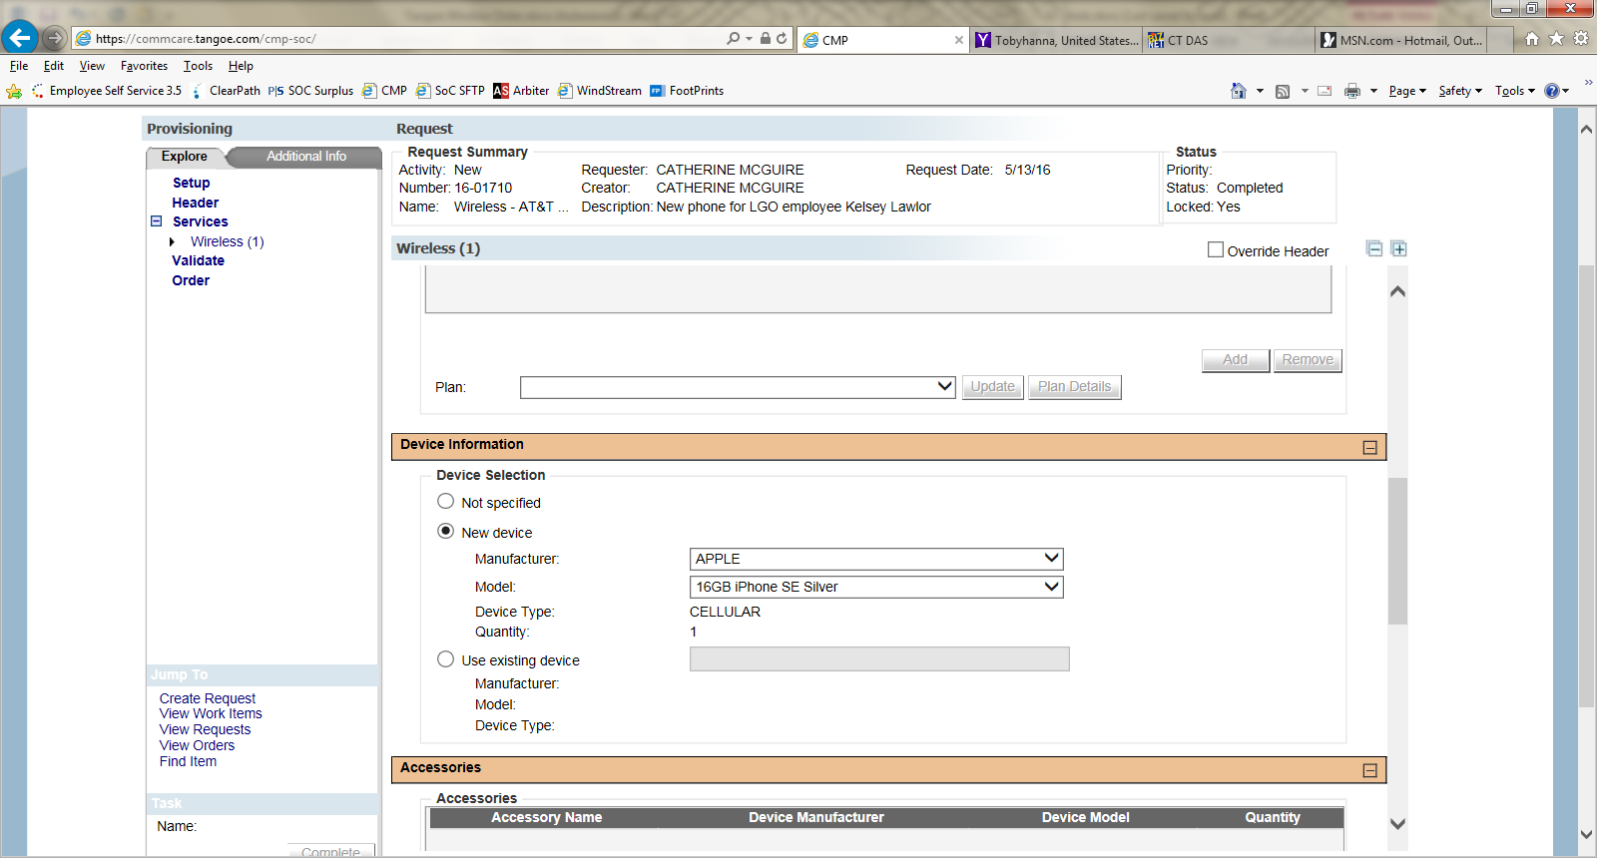
- The ‘Accessories’ section steps:
  - Hit the ‘Add’ button under this section and the ‘Update’ button at the ‘Accessory Name’ drop down will highlight.
  - Select an accessory from the ‘Accessory Name’ drop down and then click the ‘Update’ button for the item to be added to the accessories list. Multiple selections are allowed.
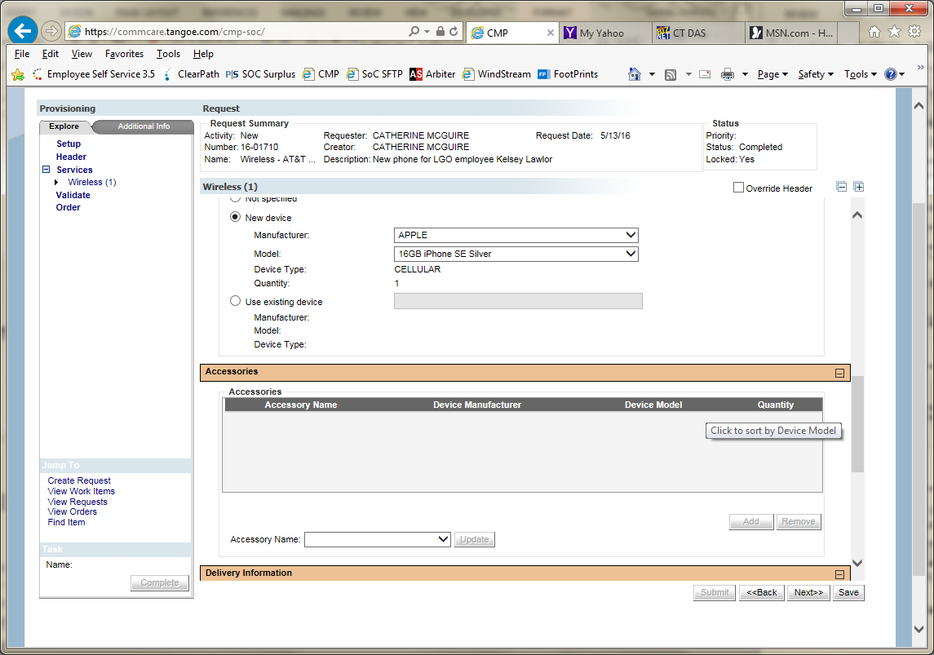
- The ‘Delivery Information’ section steps.
  - At this step selecting the ‘Employee/Contact’ radio button and clicking the magnifying glass will bring you to the employee lookup pop-up window.
  - Select the employee and note that the employee’s address appears in the delivery information address fields. If this device is to go to another site/address enter the address information directly into the related fields.
  - Be sure to add any pertinent delivery information to assist with the delivery.
  - Click ‘Save’ and then ‘Next’ to go to the ‘Validate’ section.
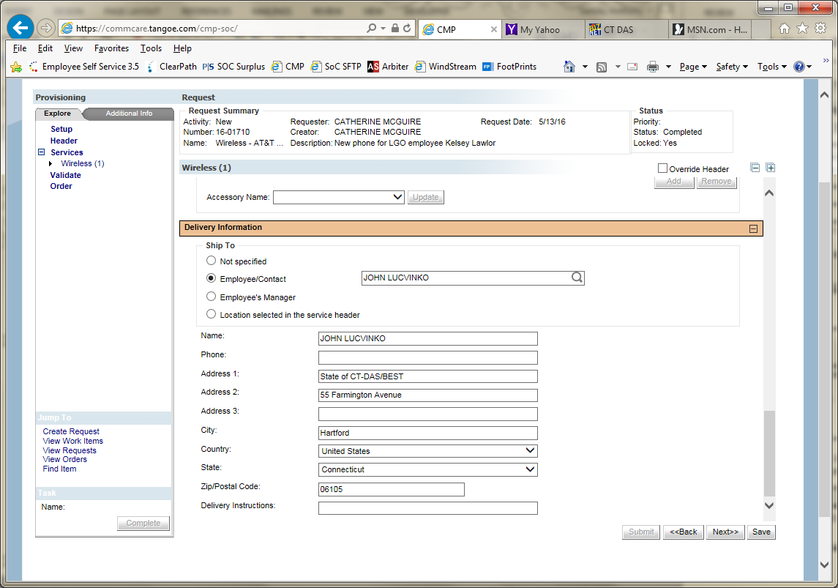
- Upon hitting the ‘Validate’ button in the ‘Validate’ section any errored or missing information that is required on the request will appear in the window with a ‘Fix’ hyperlink at the end of the error field row.
  - If validation errors, click on the ‘Fix’ hyperlink and your screen will take you to the field where the error needs to be corrected/added. The errored field will be highlight by a red background. Repeat this step for all the errors.
  - When no errors are encountered hit ‘Save’ and then ‘Next’ to go to the ‘Order’ section.
- Within the ‘Order’ section you can review the outgoing order document or the email message by clicking on the appropriate hyperlink for each.
  - Updates can be made to the email message (additional addressees or text body info) but not the order document (PDF).
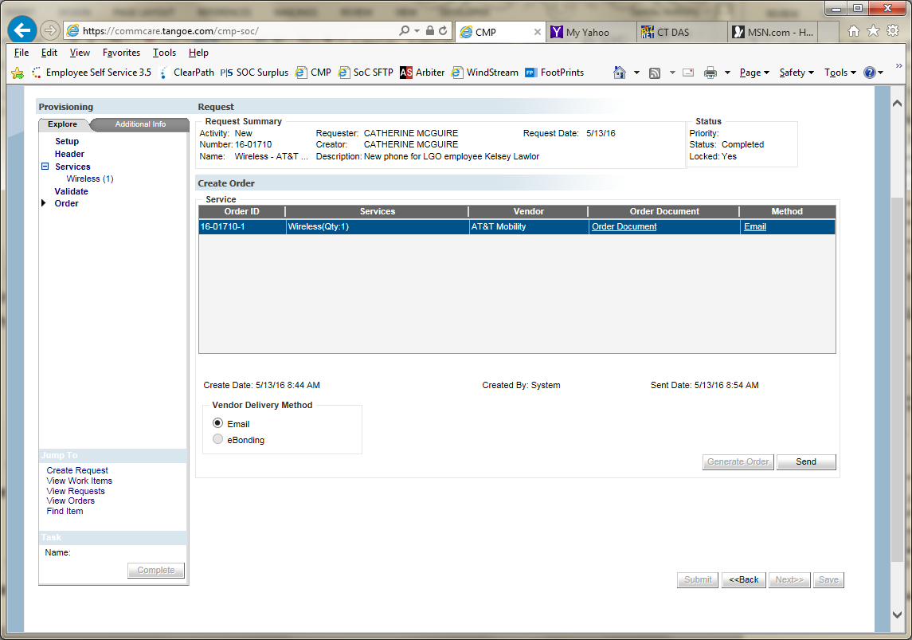
- When done click the ‘Submit’ button to submit the order via email to the vendor and the DAS Telecom business office email account.

