Petition No. 917
MetroPCS
Danbury, Connecticut
Staff Report
October 8, 2009

On September 23, 2009, the Connecticut Siting Council (Council) received a petition from MetroPCS New York, LLC for a declaratory ruling that no Certificate of Environmental Compatibility and Public Need is required for proposed modifications to an existing 96-foot monopole telecommunications tower at 48 Newtown Road in Danbury, Connecticut. Council members Brian Golembiewski and Barbara Bell visited the property with staff member David Martin on October 7, 2009 to review the proposal. Scott Muska of Brown Rudnick, Joe Falivene of URS, and Tom Shevlin of HPC Development represented MetroPCS at the field review.

MetroPCS seeks to install a 14-foot tower extension at the top of the existing tower in order to install six antennas on T-arm mounts at a centerline height of 108 feet above ground level. The proposed extension would actually bring the tower to its former height. In July 2001, the Council permitted AT&T to extend the 96-foot tower to a height of 110 feet in order to add its antennas. In 2007, following the merger between AT&T and Cingular, which also had antennas on the tower, Cingular upgraded its antennas at the 100-foot level and removed AT&T’s antennas and the extension on which they were mounted. In fact, the extension is still sitting in the compound at the base of the tower and will be re-used to mount the proposed MetroPCS antennas.

Currently, the tower hosts antennas of Cingular, Verizon, and Sprint/Nextel. The ground equipment for these three carriers is located on the second floor of an adjacent two-story commercial building. There is no more room inside the building for MetroPCS’s ground equipment, so it would be located within the base compound, which would have to be extended by 122 square feet (approximately 10 feet by 11 feet). This extension would require the removal of a deciduous tree immediately adjacent to the compound.

Newtown Road is heavily commercial in the vicinity of the proposed tower extension. There is, however, a small pocket of residences to the west of the tower. Council members Bell and Golembiewski expressed concern over the visual impact the proposed extension could have on this area. MetroPCS agreed to send letters notifying the nearest neighbors of its plans to extend the tower. The notification letter will direct residents to contact the Siting Council should they have any concerns about the tower extension.

The structural analysis submitted with the petition indicates the proposed extension would overstress the tower by three percent. After the Council’s field review, MetroPCS submitted another structural analysis that showed the tower would be within 100% of its structural capacity with the completion of planned reinforcements.

The addition of MetroPCS’ antennas would bring the power density of the tower to 59.5% of the FCC limit.

UPDATE: In its letter notifying nearby residents of its plans for the tower extension, MetroPCS asked those with concerns to contact the Siting Council by October 20. The Council did not receive any calls or any correspondence objecting to MetroPCS’ plans.

Staff recommends the petition be approved with the condition that a letter signed by a professional engineer duly licensed in Connecticut be submitted to the Council certifying that the structural modifications have been completed and that the tower is within 100% of its structural capacity.

View of existing tower from Newtown Road
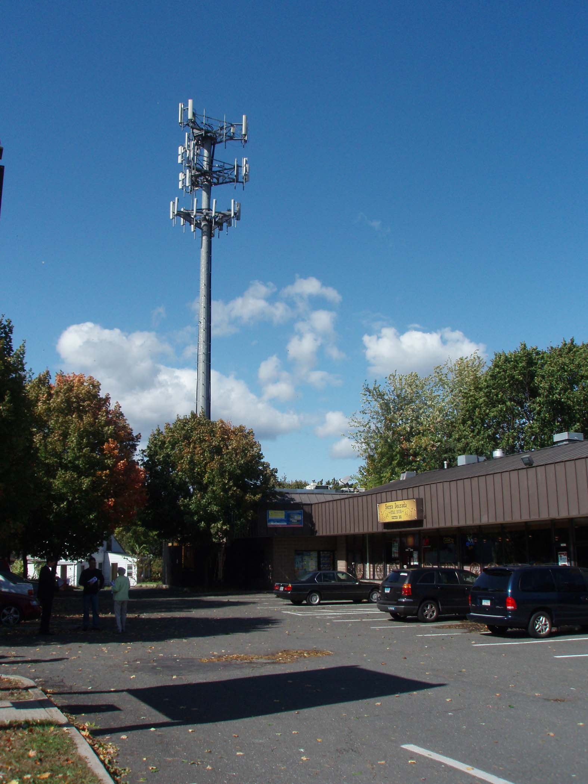

View of tower from Broad Street, looking east
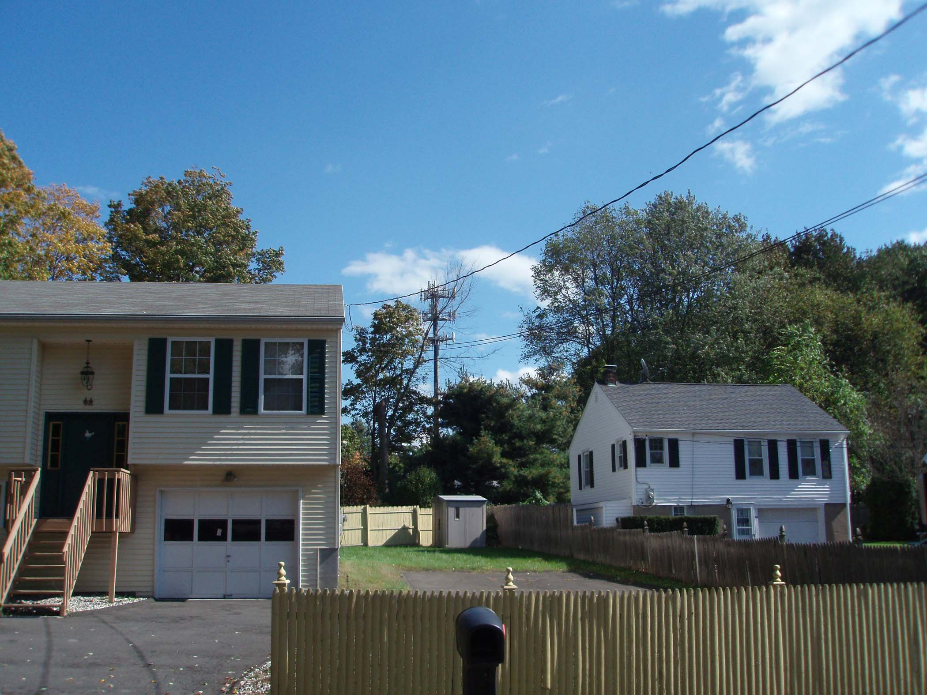

View of tower from Whitney Avenue, looking north


