PETITION NO. 831 – Waterbury Generation LLC petition for a declaratory ruling that no Certificate of Environmental Compatibility and Public Need is required for the construction of an electric generating facility and associated transmission line tap located at 725 Bank Street, Waterbury, Connecticut. | }  }  } | Connecticut  Siting  Council  April 10, 2008

Findings of Fact

Introduction

- On October 5, 2007, Waterbury Generation, LLC (WatGen), pursuant to Connecticut General Statute (CGS) §16-50k and Sections 16-50j-38 and 16-50j-39 of the Regulations of Connecticut State Agencies (RSCA), submitted a petition to the Connecticut Siting Council (Council) for a declaratory ruling that no Certificate of Environmental Compatibility and Public Need (Certificate) is required for the construction, maintenance, and operation of a 96 megawatt (net) combustion turbine peaking facility and related improvements in the City of Waterbury, Connecticut. (WatGen 1, p. 1)

- WatGen is a limited liability company with an office located at 20 Church Street in Hartford, Connecticut. WatGen is owned by FirstLight Power Resources Inc. (FirstLight), an electrical generation company based in Hartford, Connecticut, and A.W. Power Holdings and Sasco River LLC. (WatGen 1, p. 4; Tr. 3, p. 133)

- The proposed power plant is one of four projects selected by the Department of Public Utility Control (DPUC) to provide electrical capacity as set forth in Section 12 of Public Act 05-1. The project is eligible for expedited siting through the declaratory ruling process, pursuant to CGS §16-243m(g). (WatGen 1, pp. 1-2)

- The project is not subject to the Connecticut Energy Advisory Board request for proposal process. (WatGen 1, p. 2)

- The party in this proceeding is the petitioner. Intervenors to the proceeding are The Connecticut Light and Power Company (CL&P), the Naugatuck Valley Project, and the “Waterbury Neighborhood Groups” consisting of the following organizations: The Brooklyn Neighborhood Association, The Town Plot Neighborhood Association, Mohawk Park Civic Club, The Hopeville Neighborhood Association, The Gilmartin Community Club, and The Waterbury Neighborhood Council. (Transcript 1, January 8, 2008 [Tr. 1], pp. 5-13)

- Public notice of the petition was published in the Republican-American on October 1 and 2, 2007. (WatGen 1, p. 5)

- Notice of the petition was provided to all property owners abutting the generator site and the transmission line right-of-way by certified mail. (WatGen 1, p. 5)

- Pursuant to Sections 16-50j-21 and 16-50j-40 of the RCSA, the Council, after giving due notice thereof, held a public hearing on January 8, 2008, beginning at 3:15 p.m. and continuing at 7:10 p.m. at the Sovereign Bank Building, 26 Kendrick Avenue, Waterbury, Connecticut. The public hearing was continued on February 1, 2008 at the office of the Connecticut Siting Council, 10 Franklin Square, New Britain, Connecticut. (Tr. 1, p. 3; Transcript 2, January 8, 2008 [Tr. 2], Tr. 2, p. 3; Transcript 3, February 1, 2008 [Tr. 3], Tr. 3, p. 3)

- The Council and its staff inspected the proposed site on January 8, 2008. During the field review, the petitioner flew a balloon to simulate the height of the proposed exhaust stack. (Council Pre-hearing Conference memo dated November 29, 2007)

State Agency Comment

- Pursuant to CGS § 16-50j (h), on November 8, 2007 and February 4, 2008, the following state agencies were solicited by the Council to submit written comments regarding the proposed facility: Department of Environmental Protection (DEP), Department of Public Health (DPH), Council on Environmental Quality (CEQ), Department of Public Utility Control (DPUC), Office of Policy and Management (OPM), Department of Economic and Community Development (DECD), and the Department of Transportation (DOT). (Record)

- Comments were received from the Department of Transportation on January 3, 2008 and the DEP on January 8, 2008. Agency comments are referenced in this document where applicable. (Record)

- The following agencies did not respond with comment on the application: CEQ, DPUC, OPM, DPH, and the DECD. (Record)

Municipal Consultation

- WatGen commenced a community outreach effort in July 2007 that included individual meetings with City of Waterbury elected officials and department heads, legislators representing Waterbury, and the Waterbury Development Corporation. (WatGen 1, p. 10)

- WatGen held a public information session on September 12, 2007 at a Waterbury hotel. The session was publically noticed in the Republican-American. (WatGen 1, pp. 10-11)

- WatGen sent a copy of the petition to the Mayor of the City of Waterbury, Michael Jarjura, and the Mayor of the Borough of Naugatuck, Michael Bronko, on October 5, 2007. (WatGen 1, pp. 5-6)

- WatGen met with a group organized by the Waterbury Neighborhood Council on November 18, 2007 and discussed project impacts on the neighborhood south of the proposed site. (WatGen 2, Q. 4)

- WatGen met with H&B Realty, owner of the abutting property to the east at 130 Washington Avenue, on October 31, 2007 and discussed noise, stormwater run off, air emissions, security, and potential health impacts associated with the project. (WatGen 2, Q. 6)

- On December 19, 2007, WatGen attended a public information session in Waterbury at which members of various organizations and neighborhood groups, including the Naugatuck Valley Project, Waterbury Neighborhood Council, Town Plot Neighborhood Association, Hopeville Neighborhood Association, Gilmartin Community Club, and Brooklyn Neighborhood Association were present. At that session, WatGen presented information about the project and responded to questions from the community. (WatGen 6, pp. 8-9)

- Mayor Jarjura provided correspondence in support of the project on November 28, 2007. Additionally, the Mayor made a limited appearance statement into the record at the January 8, 2008 hearing expressing support for the project. Mr. Jarjura expressed concern regarding the height of the exhaust stack in regards to neighborhood visibility and potential health effects from exhaust emissions. (Tr. 2, pp. 7-12)

- Honorable Joan Hartley, representing the 15th Senatorial District, made a limited appearance statement into the record at the January 8, 2008 hearing stating that the project must be fully vetted before any decision is rendered, use local labor during construction, and be limited to peaking generation only. (Tr. 2, pp. 60-70)

- The Waterbury Board of Education and Waterbury Board of Aldermen each submitted written statements opposing the proposed facility. (Letter from Waterbury Board of Education, dated February 27, 2008; Letter from Waterbury Board of Aldermen, dated February 27, 2008)

Proposed Project

Site and Facility Description

- The proposed site is located on a 2.25-acre leased area of the Ansonia Copper and Brass, Inc. (ACB) property at 725 Bank Street in Waterbury. The ACB property comprises 9.3-acres and is developed with a mill building, ancillary buildings, and associated parking areas. (WatGen 1, p. 6; WatGen 12 Tr. 1, p. 26)

- The ACB property is zoned industrial. (WatGen 1, p. 6)

- The WatGen site is bordered by the Naugatuck River and property owned by H&B Realty to the east, Washington Street to the south, the Boston and Maine Railway to the west, and the ACB facility to the north. (WatGen 1, p. 6; WatGen 2, Q. 4; Tr. 3, p. 23)

- The site is located in the southern portion of the ACB property and includes a portion of the existing ACB mill building and parking areas south and east of the mill building. (WatGen 12)

- The generating facility would be a simple-cycle combustion turbine peaking generator with a net summer electric output of 96 megawatts (MW). (WatGen 1, p. 6)

- The generator would have dual-fuel capability of natural gas and ultra-low sulfur distillate oil (ULSD). (WatGen 1, p. 6)

- The generating facility components include the following:
- One General Electric LMS 100 Combustion Turbine Generator;
- Generator exhaust stack with a preliminary height of 213 feet;
- One 364,000 gallon oil tank (44-foot diameter x 34-foot height);
- One 200,000 gallon demineralized water storage tank (30-foot diameter, 40-foot height);
- Small hold-and-haul tanks and oil-water separators for wastewater management;
- A 3,000 square foot switchyard containing a control house, service transformer, circuit breaker, and disconnect switches;
- One 13.8/115 kV generator step-up transformer;
- One 15,000 gallon ammonia storage tank (8-foot diameter x 40-foot length);
- Electrical and power control modules;
- A variable bleed valve exhaust stack with a height of 48 feet;
- Four cooling tower units;
- A gas fuel metering station; and
- A gas compressor unit.
(WatGen 1, pp. 7, 9; WatGen 12; WatGen 15, Q. 28; Tr. 3, pp. 121-122)

- A majority of the facility components would be located in a paved area south of the existing ACB mill building. (WatGen 1, p. 18; WatGen 12)

- The electrical and control modules and demineralized water module would be located within the leased area of the mill building, separated from the remaining ACB facility by an eight-foot high chain link fence. (WatGen 1, p. 20; WatGen 12; Tr. 3, pp. 32, 47, 49-50)

- Other generator components could not be placed within the building due to the nature and/or size of the equipment. (Tr. 3, p. 32)

- The center of the fuel storage tank would be located 41 feet from a retaining wall along the west bank of the Naugatuck River. The outer edge of the tank containment wall would be approximately 14 feet from the retaining wall. (WatGen 15, Q. 35)

- The outer edge of the tank containment wall would be approximately six feet from the property boundary at 130 Washington Street. (WatGen 12)

- Land use in the immediate surrounding area is industrial. Residentially zoned areas are located primarily to the east and west, approximately 1,000 to 1,200 feet from the site. (WatGen 1, Exhibit 5, p. 3, Exhibit 14, p. 4; WatGen 2, Q. 1, Q. 14; Tr. 1, pp. 21-22)

- Approximately 80 residential parcels are located within a quarter-mile of the site. The nearest residential structure is approximately 1,200 feet to the west. (WatGen 1, Exhibit 14, p. 4; WatGen 2, Q. 14; Tr. 1, p. 21)

- The facility would be enclosed by an eight-foot architectural wall along the west, south and east property boundaries. The final design of the wall has not been determined but it may have recessed barbed wire or some other access prevention barrier at the top. (Tr. 3, pp. 27-30)

- Permanent access to the site would be from Washington Street. During construction, access to the site would also be from Bank Street. (WatGen 1, p. 18; Tr. 3, p. 141)

- Subject to approval, WatGen expects to begin construction in the spring of 2008 with operation scheduled for July 1, 2009. Construction of the facility would take approximately 15 months with 125 workers on-site during the peak construction period. (WatGen 6, p. 6; Tr. 3, p. 83)

- If the plant were not operational by July 1, 2009, WatGen could be fined under terms contained within the DPUC Master Agreement. (WatGen 6, p. 6)

- The estimated cost of the facility is $120,000,000. (WatGen 1, Exhibit 1; Tr. 2, pp. 8-9, 23-24)

115-kV Transmission Line

- An overhead 115-kV transmission line tap would connect the generating facility with the Baldwin Street Substation, located approximately 1.8 miles south of the site on Baldwin Street in Waterbury. (WatGen 1, pp. 7, 9; WatGen 2, Q. 10)

- The line would exit the site and cross Washington Street to the Metro-North right-of-way. The transmission line would follow the right-of-way south to the Waterbury Water Pollution Control Plant (WPCP) on Municipal Road to an existing CL&P right-of-way that crosses the Naugatuck River and enters the substation. (WatGen 2, Q. 10, Q. 12; Tr. 3, p. 24)

- WatGen expects to install 23 structures along the Metro-North right-of-way and three to four structures on the WPCP property. (WatGen 15, Q. 20; Tr. 3, p. 38)

- The heights of the transmission structures would primarily range from 77 to 82 feet, except for two structures that would attain a height of 125 feet to provide adequate clearance over CL&P’s distribution circuits on the South Leonard Street overpass. (WatGen 15, Q. 20)

- The minimum conductor height on the line would be 32 feet above ground level (agl). (Tr. 3, pp. 40-41)

- The width of the transmission line right-of-way would be 50 feet. The width of the right-of-way may necessitate WatGen to design the line in a zigzag configuration over the existing Metro-North railway to avoid buildings or other structures adjacent to the railway. The DOT does not object to a zigzag design. (Tr. 1, pp. 23-24; Tr. 3, pp. 38-39)

- There are no existing pole or tower type structures within the portion of Metro-North right-of-way proposed for the transmission line. (WatGen 2, Q. 8)

- A 165-foot steel lattice structure exists within the CL&P right-of-way at the WPCP. The structure supports two 115-kV lines and three distribution circuits. (WatGen 2, Q. 9)

- CL&P’s existing transmission lines at the WPCP have a long span over the Naugatuck River, with considerable sag. To assure WatGen’s lines cross at a point where clearances are adequate, WatGen designed the route to pass under the existing CL&P lines before crossing the river and entering the Baldwin Street Substation. (Tr. 3, pp. 35-36)

- The transmission line right-of-way is entirely within an industrially zoned area. (WatGen 1, Exhibit 5)

- The estimated cost of the proposed overhead interconnection is $3 to $4 million dollars. (WatGen 15, Q. 20)

Alternative Transmission Route

- WatGen considered extending the transmission line to the Freight Street Substation, located approximately 0.8 northwest of the site. WatGen determined Freight Street Substation was unacceptable due to construction issues associated with the transmission route traversing the Interstate 84 corridor and potential impacts associated with a planned major reconstruction project associated with Interstate 84 and Route 8. (WatGen 1, p.9-10, Exhibit 8)

- Undergrounding the transmission line to the Freight Street Substation north of the site would cost between $9 and $12 million dollars depending on the route. Two possible routes are 1.14 miles and 1.48 miles in length. Either route would require an interconnection study by ISO New England and CL&P, which will add months to the approval process and delay the project beyond the July 2009 contractual operation date. The delay would result in the loss of ratepayer benefits during the peak load season in the summer of 2009. (WatGen 15, Q. 40)

Fuel Supply

- The generator is designed to burn natural gas and ULSD. Gas would be the primary fuel source. (WatGen 1, p. 8; WatGen 2, Q. 3)

- WatGen is currently negotiating the terms of a natural gas interconnection agreement with Yankee Gas for the provision of natural gas would be provided from the existing Yankee Gas LNG facility off Railroad Hill Street in Waterbury, approximately 4,700 feet south of the site. (WatGen 2, Q. 7)

- The gas would be transported by an underground high-pressure gas pipeline installed within Railroad Hill Street from the Yankee Gas facility to the site. Yankee Gas would install the gas pipeline. (WatGen 2, Q. 7; Tr. 1, p. 43)

- Gas pressure would be increased from 475 psig to 980 psig at the site. (Tr. 3, p. 128)

- ULSD would be a secondary fuel source, as required by the DPUC Master Agreement. The proposed oil tank would provide capacity for 40 hours of continuous operation. (WatGen 1, p. 8; WatGen 2, Q. 3)

- Oil would be delivered by tanker truck. Fifty-five truckloads would be required to fill the oil tank initially. A fuel oil unloading area would be located on the east side of the site, adjacent to the mill building. A WatGen employee would be stationed on site during fuel deliveries. (WatGen 1, p. 8; WatGen 12; WatGen 15, Q. 17)

- Stored fuel oil would not degrade over time or affect plant operations when used. (WatGen 15, Q. 32)

- The oil tank and associated piping would be of double wall construction with an interstitial monitoring system to detect leaks. A containment wall designed to contain 110% of the tank’s volume would surround the tank. (Tr. 3, p. 41)

Site Operation

- WatGen expects the plant to operate four to six weeks per year, depending on load requirements. (WatGen 6, p. 7)

- WatGen’s DEP air permit application requests an operation schedule of 365 days per year to allow for the maximum amount of operating flexibility. (Tr. 3, pp. 106-107)

- The DPUC Master Agreement requires the plant to operate as a peaking facility for the first ten years of operation. (WatGen 6, p. 7)

- Market conditions after ten years may result in higher operating rates. Current market conditions would not allow the plant to operate economically as an intermediate or baseload unit due to the plant’s comparatively high heat rate. (WatGen 1, Exhibit 10, p. 1; WatGen 6, p. 7; Tr. 3, pp. 107-108)

- The plant is projected to have an annual capacity factor of two to 15 percent. (Tr. 3, p. 108)

- WatGen would operate the plant remotely from FirstLight’s New Milford Connecticut dispatch office. One or two workers would be stationed at the plant during operation. (WatGen 15, Q. 17)

- Facility maintenance would be based on hours of operation. Routine inspections would be conducted of the combustion systems, pumps and filters, and air pollution control equipment. The generator would be removed for a thorough inspection after 20,000 hours of operation. (WatGen 15, Q. 18)

- The service life of the generator at full operation is 40 years. WatGen expects the generator to last well beyond this period due to the expected low number of hours of operation. (WatGen 15, Q. 19; Tr. 3, pp. 112-113)

Environmental Considerations

Inland Wetlands and Watercourses

- Construction of the generating unit would not affect any wetland resources. (WatGen 1, pp. 19-20)

- The proposed generator site is located within a 500-year flood plain. (WatGen 1, p. 19)

- The fuel oil storage tank is within the Naugatuck River 100-year flood zone. (WatGen 1, p. 19, Exhibit 15; WatGen 15, Q. 35)

- The structural load from the tank would not affect the retaining wall. (WatGen 15, Q. 36)

- WatGen reviewed the soil conditions at the oil tank location and determined the soil is adequate to support the tank. (WatGen 15, Q. 35)

- Construction of the transmission line and gas pipeline would not permanently affect any wetland resources. (WatGen 1, p. 19; WatGen 2, Q. 11; WatGen 5; Tr. 3, pp. 34-35)

Water Resources

- The transmission line is located in an upland area except where the line crosses the Naugatuck River. Two transmission line support structures would be placed within the 100-foot buffer zone along the river. (WatGen 5, p. 2; Tr. 3, pp. 34-35)

- Water for plant operations would be obtained from the City of Waterbury’s municipal water supply system. The water would be used in the inlet air-cooling system, nitrogen oxide control system, and mechanical draft-cooling tower. (WatGen 1, p. 20)

- WatGen would use approximately 320 gallons per minute during plant operation. (WatGen 1, Exhibit 18)

- The City of Waterbury would be able to provide WatGens projected water requirements. (WatGen 1, Exhibit 18)

- Approximately 37 gallons per minute of wastewater would be discharged to the Waterbury wastewater system. Oil/water separators would be installed to remove any petroleum products from the effluent stream. Wastewater would be monitored under a DEP wastewater discharge permit and would comply with City of Waterbury sewer discharge requirements. (WatGen 1, p. 21, Exhibit 18, p. 13; Tr. 1, p. 27; Tr. 3, p. 129)

Air Emissions

- The DEP is currently reviewing WatGen’s air permit application. The air permit requires WatGen to comply with the National Ambient Air Quality Standards (NAAQS), standards established by the U.S. Environmental Protection Agency and the DEP to protect public health and welfare. (WatGen 1, Exhibit 10, p. 6; Tr. 3, pp. 12-14)

- The air permit contains dispersion modeling that sums together proposed air emissions from the plant with current measured air quality present in the affected area for a cumulative measure of air quality. (Tr. 3, p. 115)

- WatGen could not operate the plant if exhaust emissions did not comply with the NAAQS. (Tr. 3, pp. 121-123)

- Waterbury is in New Haven County, an area classified as a nonattainment zone for ozone and particulate matter with a diameter less than 2.5 micrometers (PM_{2.5}). (WatGen 1, Exhibit 10, p. 9)

- Ozone is created in the atmosphere from the reaction of nitrogen oxides (NO_{x}) and volatile organic compounds (VOCs). Particulate matter is emitted directly from many sources and from reactions in the atmosphere between NO_{x} and sulfur oxides (SO_{x}). (WatGen 1, Exhibit 10, p. 9)

- The project would be regulated under the New Source Review (NSR) regulations, as set forth by RCSA Section 22a-174-3a. (WatGen 1, Exhibit 10, p. 9)

- The estimated maximum potential pollutant emissions from plant operations (assuming operation for 365 days/yr at full capacity, including 720 hours of operation using ULSD oil) is presented in the table below:

Pollutant | NO_{x} | SO₂ | CO | VOC | PM_{2.5} | PM₁₀
Emissions from Project (tpy) | 39.5 | 7.5 | 86.4 | 17.6 | 44.3 | 44.3
(WatGen 1, Exhibit 10, pp. 12-13)

- Under NSR, the project is subject to Best Available Control Technology for emissions of PM_{2.5,} PM₁₀, carbon monoxide (CO), NO_{x} and VOC since emissions of these pollutants would each exceed 15 tons per year. (WatGen Exhibit 10, p. 10)

- NO_{x} would be controlled selective catalytic reduction (SCR) and water injection, depending on the type of fuel used. (WatGen 1, Exhibit 10, pp. 13-14; Tr. 3, pp. 10-11)

- SCR injects ammonia into the exhaust gases before the gases pass through a catalytic material. This process converts NO_{x} into nitrogen and water vapor. (WatGen 1, Exhibit 10, pp. 13-14)

- The use of natural gas as a fuel would limit SO_{x} since natural gas has low sulfur content. Since ULSD oil also has low sulfur, it would control SO_{x} emissions when used. (WatGen 1, Exhibit 10, p. 13)

- CO and VOC both result from incomplete combustion when burning either oil or gas. An oxidation catalyst would be used to minimize the production of these pollutants. (WatGen 1, Exhibit 10, p. 15)

- Particulate matter originates from non-combustibles in the fuel, as well as from the use of SCR and catalysts for the control of NO_{x}. These emissions can be minimized by burning natural gas or ULSD oil. (WatGen 1, Exhibit 10, p. 15)

- The preliminary ambient air modeling determined that an exhaust stack height of 213 feet would be required to meet NAAQS criteria. Based on the information submitted in support of the permit, the DEP may determine that a shorter stack height may be sufficient. (DEP comments of January 7, 2008; Tr. 3, pp. 119-123)

- The DEP air permit requires performance stack testing of the exhaust at the initial start of plant operations and testing of all permitted pollutants every five years thereafter. A continuous emissions monitoring system would be installed to monitor emissions during operations. Alarms in the control system would notify the plant operator if emissions were approaching permit limits. Diagnostics would be performed to identify the source of the problem. If emissions reached or exceeded air permit levels, the generator would be shut down. (WatGen 15, Q. 31)

- Emission data would be uploaded to an Environmental Protection Agency (EPA) website on a quarterly basis where the data can be examined by the both the EPA and DEP. The air permit requires WatGen to report any air permit violations immediately. (WatGen 15, Q. 31)

Visibility

- The Federal Aviation Administration (FAA) determined the 213-foot exhaust stack, would have to be obstruction marked and/or lighted in accordance with FAA criteria. (WatGen 3)

- WatGen initially proposed to both obstruction mark and light the exhaust stack but later determined to either mark or light the tower rather than do both. (WatGen 3; Tr. 3 pp. 100-104)

- If the DEP determines a shorter stack is sufficient to meet air quality criteria, WatGen would resubmit an air hazard determination to the FAA for the shorter stack height to determine if obstruction marking and/or lighting would be required. (DEP comments of January 7, 2008; WatGen 3; Tr. 3, pp. 19-22)

- The exhaust stack would be visible from most of the area within a two-mile radius of the site. The exhaust stack is located at the bottom of a river valley with developed hillsides rising to the west and east. Areas north and south of the plant within the valley are also highly developed. (WatGen 1, Exhibit 5; WatGen 2, Q. 14)

- Land uses within a quarter-mile of the site are residential, commercial, and industrial. All areas within a quarter-mile may have visibility of the stack except for localized areas where trees, buildings and other objects may obstruct the view. (WatGen 2, Q. 14)

- Approximately 80 residential parcels are within a quarter-mile of the site. (WatGen 2, Q. 14)

- Other tall structures in the general area are as follows:
- Brick exhaust stack immediately east of site – 136 feet agl;
- Height of ACB mill building at south end – 71 feet agl;
- Waterbury Republican American Clock Tower (3,960 feet to north) – 240 feet agl;
- Yankee Gas LNG tank (3,840 feet to south) – 153 feet agl;
- Allegheny Ludlum tower (2,600 feet to south) – 127 feet agl.
(WatGen 15, Q. 15)

- No landscaping is proposed along the lease area boundary. (Tr. 3, pp. 31, 33-34, 97-98)

- Most of the generator components located south of the mill building range in height from 25 to 50 feet and would be visible above the proposed eight-foot architectural wall. Views of these components would be primarily from Washington Avenue and the surrounding industrially developed parcels, including the abutting H&B Realty parcel. (WatGen 1, Exhibit 15; WatGen 15, Q. 38; Tr. 3, p. 30)

- WatGen cannot relocate the switchyard to create additional space along Washington Avenue for an earthen berm or landscaping along the wall due to electrical clearance concerns associated with switchyard components. (WatGen 12, Tr. 3, pp. 31, 33-34, 97-98)

- The transmission line right-of-way along the Metro North line is located entirely within an industrial area. Developed industrial parcels are east and west of the rail line. Trees border the rail line in some areas. (WatGen 2, Q. 12, Q. 13, Q. 14, WatGen 5)

Vegetation/Wildlife

- WatGen would clear an approximately 30-foot wide access way through a line of trees located along the Boston and Maine Railway right-of-way to provide for access between the site and the adjacent construction laydown area, located west of the railbed. (Tr. 3, pp. 23-25)

- The transmission line route would use open areas of the Metro-North right-of-way. No tree clearing would be necessary for construction. (Tr. 3, pp. 39-40)

- There are no known populations of federal or state endangered, threatened or special concern species within the project area. (WatGen 1, p. 16)

Historic Resources

- The State Historic Preservation Office (SHPO) noted that the ACB facility has historic and industrial importance but determined the proposed project would not have an adverse affect on the ACB facility. (WatGen 1, p. 16)

- SHPO does not recommended archeological monitoring during site construction. (WatGen 14)

Noise

- The project would be designed to meet State of Connecticut and City of Waterbury noise regulations. (WatGen 15, Q. 33)

- The site parcel and adjacent parcels are zoned industrial. Noise levels at bordering industrially zoned property cannot exceed 70 dBA. (WatGen 1, Exhibit 14)

- Noise levels at the property lines would not exceed 70 dBA. The expected noise level at the H&B Realty property line is projected to be 67 dBA. (WatGen 15, Q. 33)

- Noise levels in residential areas as a result of plant operation cannot exceed 61 dBA during the daytime or 51 dBA during the nighttime. (WatGen 1, Exhibit 14)

- Existing nighttime background noise levels in residential areas around the site parcel range from 38-45 dBA. (WatGen 1, Exhibit 14)

- Projected nighttime noise levels from plant operations in residential areas around the site are expected to range from 47 to 51 dBA. (WatGen 1, Exhibit 14)

- Noise mitigation techniques to achieve compliance with state and local criteria include an exhaust silencer and the installation of a solid fence at the property lines. (WatGen 15, Q. 33, Q. 34)

Magnetic Fields

- The transmission line connecting the proposed generator to the Baldwin Street Substation would be a source of magnetic fields. The transmission line is located entirely within an industrially developed area, at some distance from schools, playgrounds, healthcare facilities and residential areas. (WatGen 1, pp. 12-13)

- Magnetic fields along the transmission line right-of-way are projected to be 42.9 mG on the side with the conductors and 29.6 mG on the opposite side. The actual magnetic fields will be lower than the projected ones, since the actual conductor heights will be 32 feet agl, not 25 feet agl, the height used in the calculations. The more conservative height of 25 feet was chosen for projecting the magnetic fields because the calculations were done at an early stage of the design before the actual conductor height was established. (WatGen 1, p. 13-14; WatGen 15, Q. 21, Q. 22)

- The projected maximum magnetic fields produced by the transmission line where the right-of-way crosses area roads is as follows:
  - Washington Avenue with a conductor height of 32 feet – 42.5 mG;
  - South Leonard Street with a conductor height of 65 feet – 12.5 mG;
  - Municipal Road with a conductor height of 32 feet – 42.5 mG.
(WatGen 15, Q. 22)

Ammonia

- A 19% solution of aqueous ammonia would be utilized for the on-site SCR system to control NO_{x} emissions. (WatGen 15, Q. 26)

- The ammonia solution is non-flammable and has a low vapor pressure. (WatGen 15, Q. 26)

- The ammonia solution would be stored within a 15,000-gallon steel tank designed to applicable codes, and at ambient temperature and pressure, conditions that render the solution non-explosive. (WatGen 15, Q. 26)

- At full load, 22 gallons of the ammonia solution would be consumed per hour. (WatGen 15, Q. 26)

- The tank could support 26 days of usable supply at full load. (WatGen 15, Q. 26)

- Deliveries of ammonia would be infrequent and would likely be once every few months during peak load times. (WatGen 15, Q. 26)

- Ammonia would be unloaded in an area designed to prevent the escape of liquid in the event of a ruptured hose. (WatGen 15, Q. 26)

- The ammonia storage tank would have a containment system designed to capture 110% of the amount of the tank. The containment system consists of a concrete dike around the tank filled with hollow plastic balls designed to limit the amount of ammonia evaporation. (WatGen 15, Q. 26)

- The City of Waterbury Fire Marshall expressed no concerns regarding the use of ammonia at the site. No special training of emergency response personnel would be required. (WatGen 15, Q. 27)

- WatGen would meet with the Fire Marshall once construction is complete to review site layout and establish emergency response protocols prior to plant operation. (WatGen 15, Q. 27)

APPENDIX A

SITE LOCATION
APPENDIX B

SITE PLAN

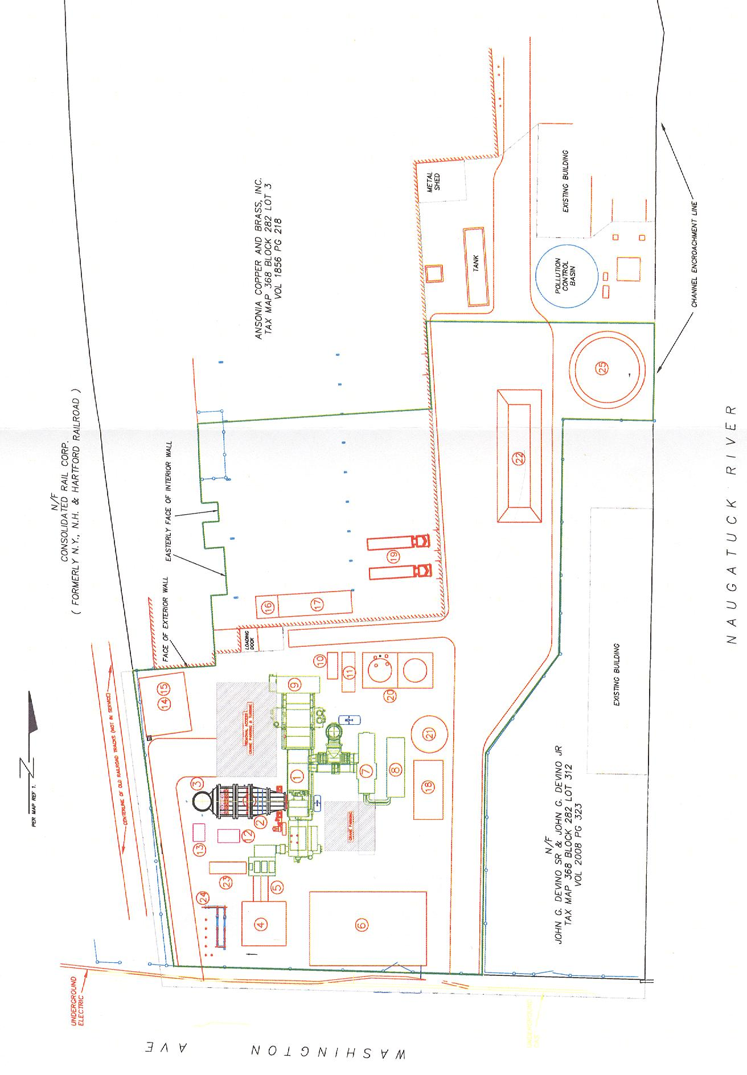
APPENDIX C

PROJECT PHOTOSIMULATIONS

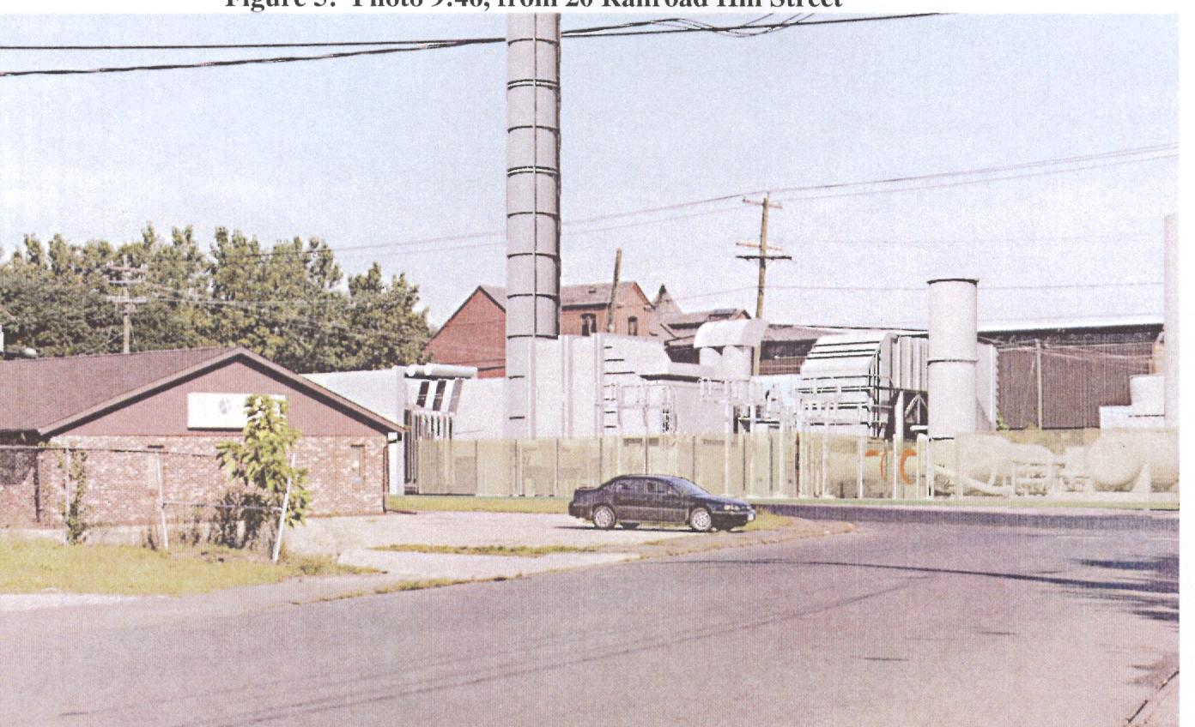
Main portion of proposed facility from Railroad Hill Street.

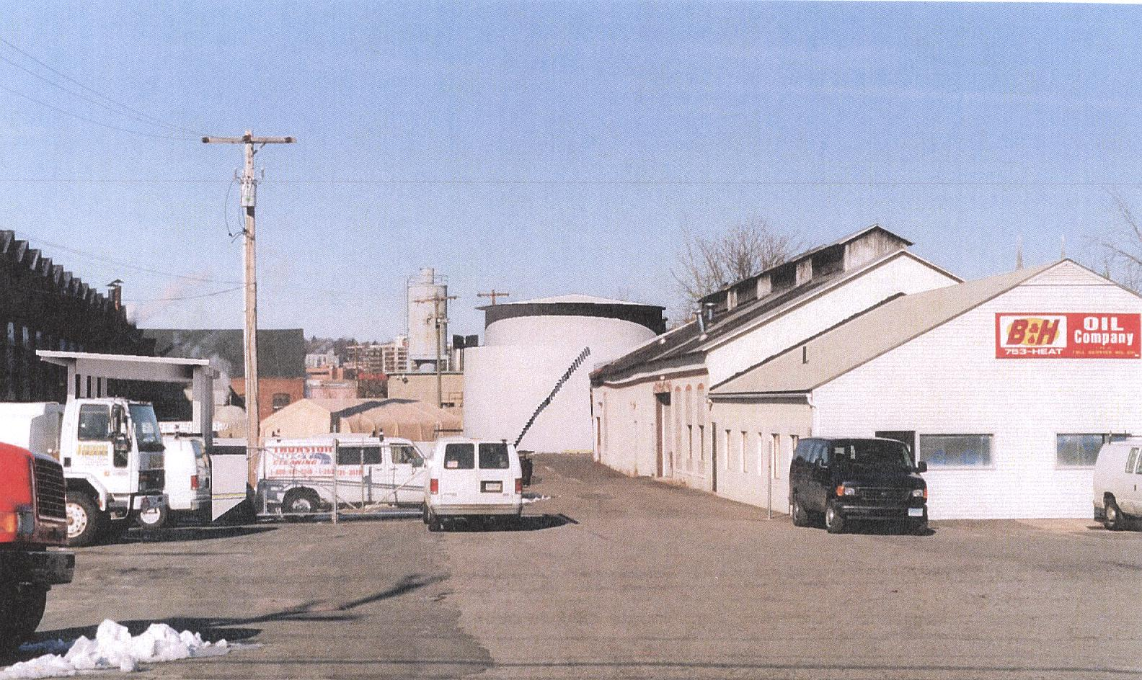
Proposed oil tank from Washington Street.

