Petition No. 751 – Request for Modification
Manchester Methane
East Windsor, Connecticut
Staff Report
June 23, 2006; rev. July 26, 2006

On February 22, 2006, the Council approved a petition submitted by Manchester Methane to install a landfill gas-to-energy facility at the NORCAP landfill in East Windsor. The facility was to have consisted of a 40-foot by 80-foot building that would house two low emission Caterpillar turbines. The electricity generated by the turbines was to have been transmitted to CL&P’s distribution system.

Subsequent discussions among CL&P and project planners have resulted in changes to the plans approved by the Council. Since filing its revised plans with the Council, Manchester Methane has also made some recent modifications based on meetings with the East Windsor Planning and Zoning Commission. Manchester Methane is now requesting the Council’s approval for these modifications.

Council member Daniel Lynch and staff member David Martin revisited the landfill on June 22, 2006 to assess the proposed changes. They were joined by Scott Atkin, an engineer with Anchor Engineering representing Manchester Methane.

The original plans called for the gas-to-energy facility to be located behind the landfill at the site of the existing landfill gas collection system’s flare. The revised plans call for a larger facility (50 feet by 100 feet versus 40 feet by 80 feet) to be located near the landfill’s scalehouse on the site of an existing transfer station. A larger structure to house the two turbines is being proposed to provide more space for maintenance and storage.

Scott Atkin explained there were several additional reasons for this relocation. CL&P expressed a concern about access to the facility if it were located in the back of the landfill. This would have been especially problematic during snowy conditions. In addition, there have been some minor vandalism problems at the flare site in the rear of the landfill. These problems would be minimized with the facility in a location that could be more easily monitored.

The new location of the facility would require a new connection with the gas collection system’s header pipe. This connection would be made at an existing pump station located just to the west of the landfill’s scale.

David Martin talked with Joseph Debs of CL&P’s distribution section to confirm that the utility did not have any concerns about the project’s relocation and that the interconnection agreement with Manchester Methane was almost imminent. His section has reviewed the project and has no technical issues with the plans. Mr. Debs acknowledged that the cost of installing 1800 feet of connection lines to the original location was quite expensive. The cost of the facility in the currently proposed location would be $200,000 to $250,000 less than its original location.

According to Scott Atkin, the project has received its draft DEP air permit.

The most recent changes to the plans for this project are the result of meetings with the town’s planning and zoning commission. They consist of reorienting the building ninety degrees and placing the silencers and radiators to the west of the building between it and the landfill. This change is expected to reduce noise levels 10 to 15 dBs to levels below background nighttime noise.

The change in building orientation would result in a 100-foot by 100-foot paved apron on the east side of the building. The road accessing the existing, but unused transfer station would be improved, and two parking spaces would be created in the existing island between the transfer station road and the scale. A short portion of the existing gravel access road to the back of the landfill would be realigned for approximately 130 feet.

The interconnection to the electrical distribution system would be through overhead lines traversing approximately 355 feet from a utility pole near the entrance of the landfill to a transformer just to the east of the project building.

The landfill is located in a sparsely settled area of East Windsor. Directly across the street is a tobacco farm. There are several houses to the east of the landfill, but they are effectively screened by existing vegetation and distance. There is an expansive amount of nursery land to the south of the landfill, much of which was purchased by the landfill owners as part of a consent order from DEP. The proposed facility should have no visual impact on the nearest residential neighbors.

View of proposed facility’s new location taken from landfill entrance road

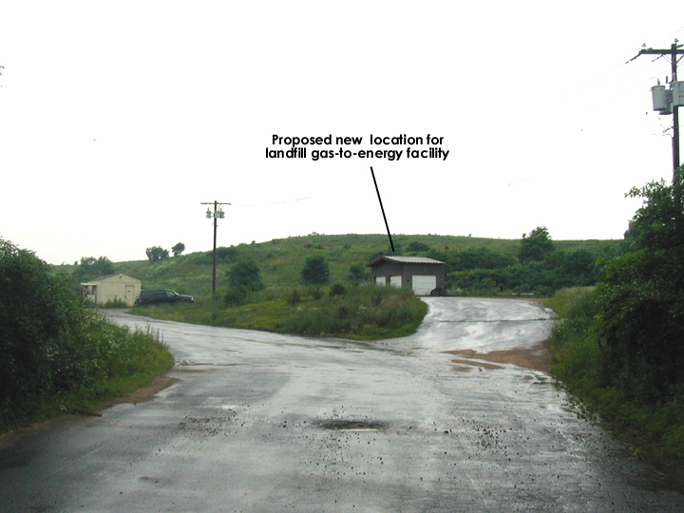

Looking out the landfill entrance
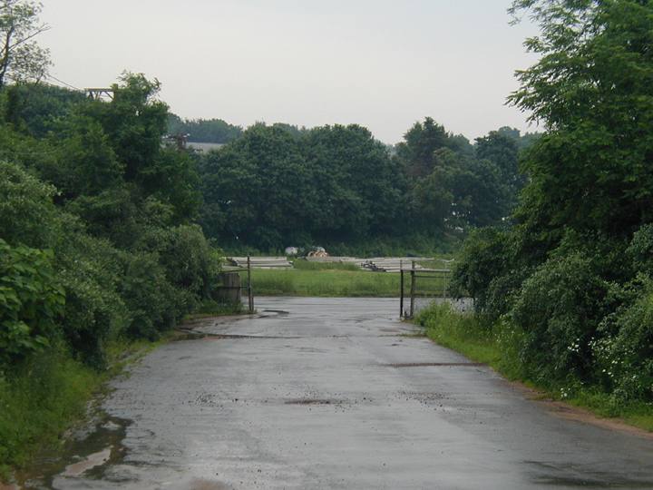

View toward the northeast, existing transfer station in foreground
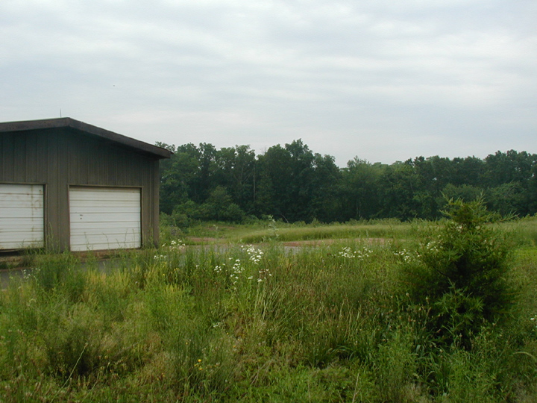

View toward the southwest, small building is the landfill scalehouse


