Petition No. 704
Connecticut Light & Power
Norwalk, Connecticut
Staff Report
March 3, 2005

With this petition, CL&P is seeking to expand an existing substation at Manresa Island in South Norwalk located adjacent to the Norwalk Harbor Generating Station. Council member Brian O’Neill and staff person David Martin met CL&P representatives Helen Wong and Bob Piscatelli on February 22, 2005 to review the proposed changes.

The existing substation covers two acres and includes the equipment to interconnect three 115 kV underground cable transmission lines, accept the power output of the power station’s generators, and connects to the 138 kV submarines cables that extend across Long Island to LIPA’s Northport Substation. The proposed expansion would cover 0.5 acres in a triangle between an existing paved access road and the existing substation. The area to be affected currently has a gravel surface, and there are several trailers parked here. The expanded area would accommodate circuit breakers, switches, and bus modifications that would provide a termination for the submarine cables (approved in Docket 224) that will replace the existing, leaking cables. CL&P also intends to double the size of a small control building in order to relocate the existing switchyard controls out from the Generating Station’s control room and to house the controls for the replacement cables.

The substation and Generating Station are at the end of a narrow peninsula that extends into Norwalk Harbor. Access to the area is controlled, and all traffic must pass through a guard gate.

The nearest residences are over 2,000 feet away. Some residences have a view of the substation across water. But the proposed expansion should have an insignificant impact on their existing view because of the distance to the substation and the screening of intervening vegetation.

There is a tidal wetland area just north of the proposed expansion area. However, no construction activity would occur within this area.

Because of the other permits CL&P is required to obtain before construction on the cable project can begin, work on the substation expansion is not expected to commence 2006.

The improvements being proposed by CL&P to this site should have no significant adverse environmental impacts.

Area of Proposed Substation Expansion

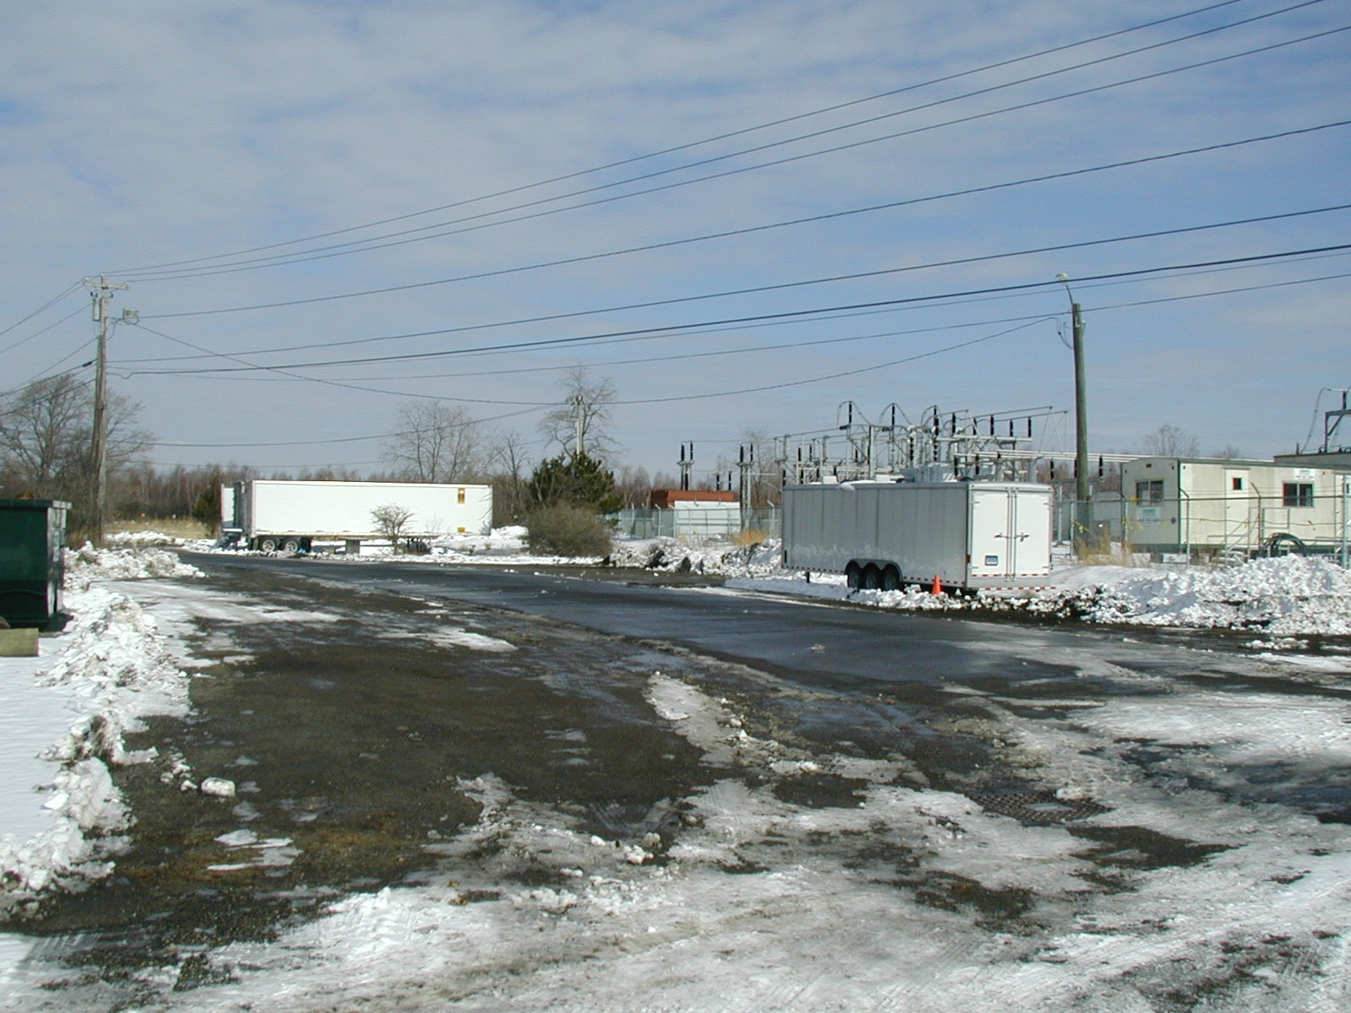

View of Proposed Expansion Area with Generating Station in Background

