PETITION NO. 841 – Bridgeport Energy II, LLC petition for a declaratory ruling that no Certificate of Environmental Compatibility and Public Need is required for the construction, maintenance, an operation of a 350 MW Peaking Facility located at 10 Atlantic Street, Bridgeport, Connecticut. | }  }  } | Connecticut  Siting  Council  June 5, 2008
Findings of Fact
Introduction

1. On December 14, 2007, Bridgeport Energy II, LLC (BEII or Petitioner) pursuant to Connecticut General Statutes (CGS) §16-50k as amended by Section 18 of Public Act 05-1, submitted a petition (Petition) to the Connecticut Siting Council (Council) for a declaratory ruling that no Certificate of Environmental Compatibility and Public Need (Certificate) is required for the construction, maintenance, and operation of a 350 MW natural gas-fired peaking facility at the existing Bridgeport Energy facility at 10 Atlantic Street, Bridgeport, Connecticut. (BEII 1, p. 1)

2. The existing 520 MW natural gas-fired Bridgeport Energy facility was approved by the Council as part of Petition No. 377 and began commercial operation on August 1, 1998. (BEII 1, pp. 3-4; Administrative Notice Item No. 7)

3. The BEII project is eligible for approval by declaratory ruling pursuant to CGS 16-50k(a) because it is an electric generating facility that would be located at a site where an electric generating facility existed prior to July 1, 2004. (BEII 1, p. 1)

4. BEII is a wholly-owned subsidiary of DLS Power Holdings, LLC (DLS). DLS is a joint venture of LS Power Associates, L.P., together with its affiliates LS Power and Dynegy, Inc. (Dynegy). LS Power is a fully integrated development, investment and asset management group of companies focused on the power industry. Dynegy is an energy wholesaler, with over 20,000 MW of generating capacity in the Northeast, Midwest, and West. (BEII 1, pp. 2-3)

5. The parties in this proceeding are the Petitioner and 60 Main Street et al., (60 Main Street) which includes an abutting property owner, and Michael Mauzerall of the abutting M&M Fence and Wire Works. The intervenor in this proceeding is The United Illuminating Company (UI). (Transcript 1 – March 4, 2008, 3:00 p.m. [Tr. 1], pp. 1-6 ; Transcript 2 – March 4, 2008, 7:10 p.m. [Tr. 2], pp. 1-5 and 79)

6. 60 Main Street owns 12 acres of abutting and/or nearby property, including parcels numbered 37, 51, 57 and 97 Henry Street and 12, 50, 60, 76, 110 and 122 Main Street, Bridgeport. (60 Main Street 1, p. 1)

7. Notice of the Petition was provided to all abutting property owners by certified mail. (BEII 2, response 1)

8. On February 19, 2008, BEII placed a sign at the site at 10 Atlantic Street stating the name of the Petitioner and the date, time and location of the public hearing on the Petition. BEII posted a second sign at The United Illuminating Company’s Singer Substation on February 22, 2008, providing similar information. (BEII 3, pp. 7-8; BEII 14)

9. Pursuant to Section 16-50j-21 and 16-50j-40 of the Regulations of Connecticut State Agencies, the Council, after giving due notice thereof, held a public hearing on March 4, 2008, beginning at 3:00 p.m. and continuing at 7:10 p.m. at the Bridgeport City Hall Council Chambers, 45 Lyon Terrace, Bridgeport, Connecticut. (Council's Hearing Notice dated February 6, 2008; Tr. 1, p. 3; Tr. 2, p. 3)
10. The Council and its staff conducted an inspection of the proposed site on March 4, 2008. During the field inspection, the Petitioner flew a red balloon at the proposed site to simulate the height of the proposed southern exhaust stack. The facility would have two exhaust stacks approximately 213 feet high and approximately 115 feet apart. Weather conditions during the field review were rainy and windy. The balloon reached a height of 213 feet above ground level (agl). The balloon was aloft from 8:00 a.m. to approximately 2:00 p.m. for the convenience of the public. The balloon had to be taken down shortly before 2:00 p.m. for safety considerations due to the inclement weather and was not aloft during the field review. (Council’s Hearing Notice dated February 6, 2008; Tr. 1, pp. 20-21 and 27-28)

State Agency Comment

11. Pursuant to General Statutes § 16-50j (h), on February 6, 2008 and March 5, 2008, the following State agencies were solicited by the Council to submit written comments regarding the proposed facility; Department of Environmental Protection (DEP), Department of Public Health (DPH), Council on Environmental Quality (CEQ), Department of Public Utility Control (DPUC), Office of Policy and Management (OPM), Department of Economic and Community Development (DECD), and the Department of Transportation (DOT). (Record)

12. The Council received a response from the DEP on February 26, 2008. (DEP Comments dated February 26, 2008)

13. In its comments, DEP notes that the Petitioner proposes General Electric (GE) model 7FA or 7B, or Siemens model SGT6-5000F combustion turbines; however, the GE model 7B combustion turbine is not listed in the Petitioner’s air application. (DEP Comments dated February 26, 2008; BEII 1, pp. 5 and 12)

14. In its comments, DEP recommends that all hazardous materials (including but not limited to the fuel oil storage tank and the aqueous ammonia storage area) be located above the 100-year flood elevation in order to ensure compliance with the Federal flood management regulations. (DEP Comments dated February 26, 2008)

15. DEP also notes that two general permits for stormwater would be required:
- General Permit for the Discharge of Stormwater and Dewatering Wastewaters Associated with Construction Activities
- General Permit for the Discharge of Stormwater Associated with Industrial Activity. (DEP Comments dated February 26, 2008)

16. The following agencies did not respond with comment on the application: CEQ, DPUC, OPM, DPH, DOT and the DECD. (Record)

Municipal Consultation

17. BEII first met with the City of Bridgeport (City) Office of Planning and Economic Development and Land Use and Construction regarding the proposed project on November 16, 2006. (BEII 1, Attachment J)

18. After submitting preliminary site plans to the Bridgeport Zoning Department on August 1, 2007, BEII met with representatives of Bridgeport’s Design Review Committee on August 23, 2007. BEII incorporated comments into the plans and submitted revised plans to the City on December 14, 2007. (BEII 1, p. 17)

19. BEII held a public meeting at the University of Bridgeport (UB) on September 18, 2007 to present the proposed project to the South End Neighborhood Revitalization Zone. (BEII 1, Attachment J)

20. On September 19, 2007, a representative from BEII met with representatives of a real estate development company considering the development of a mixed residential and commercial project on the Remington Shaver site owned by 60 Main Street, to exchange information on each of the proposed developments. (BEII 1, p. 17)

21. On November 16, 2007, BEII submitted its application to the Bridgeport Port Authority for its review. (BEII 1, p. 17)

22. By letter dated January 28, 2008, the South End Neighborhood Council (SENC) notes that during the meeting at UB concerns were expressed regarding the height of the proposed stacks, and it was pointed out that the existing Bridgeport Energy facility has a lower profile. Due to current air emissions requirements, the proposed stack heights could not be adjusted. Nonetheless, the SENC supports the BEII project. (BEII 10)

23. By letter dated January 28, 2008, Nancy Hadley, Director of the Office of Planning and Economic Development of the City of Bridgeport, expressed support for BEII’s Coastal Area Management application. Ms. Hadley also notes that BEII has been in communication with the developer of the adjoining 60 Main Street mixed-use waterfront development and they have asked that the project incorporate the following elements into their design:

- Add “green” roofs to the structure.
- Add large trees (as large as possible) to the landscaping, in addition to the evergreens that are shown.
- Keep all fuel and delivery trucks off of Henry Street, allowing ingress and egress off of Atlantic Street only. (BEII 20)

24. On January 28, 2008, the City Planning and Zoning Commission approved BEII’s preliminary site plan application with the following conditions:
- That additional trees as large as practicable shall be planted in all areas of the site.
- That the landscaping area around the storage tank shall be enlarged in proportion to the size reduction in the tank when reduced from the originally proposed 1.2 million gallons to 800,000 gallons consistent with DPUC’s implementation of Section 50 of Public Act 07-242.
- That street trees shall be planted (one every 25 feet) along both sides of the street.
- That this facility not be expanded in the future. (BEII 3, p. 4; BEII 9)

25. By letter dated February 21, 2008, the Bridgeport Port Authority (BPA) expressed support for the proposed project. The BPA believes that the project would provide a reliable source of electric power to businesses in the Port District. (BEII 18)

26. By letter dated March 4, 2008, Bridgeport Mayor Bill Finch expressed his support for the proposed project. Mayor Finch notes that BEII met with him, City staff, and local organizations on several occasions to discuss the project. Mayor Finch believes that 350 MW of fast-start peaking capacity would benefit the citizens of Bridgeport and southwest Connecticut. (Tr. 1, pp. 81-83)

Site Description

27. The site is an approximately 2.16-acre parcel of land on the southern portion of the existing Bridgeport Energy facility at 10 Atlantic Street in Bridgeport, Connecticut. The site is located southeast of the intersection of Russell and Atlantic Streets in the Heavy Industrial (I-HI) zone. (BEII 1, pp. 4-5 and Attachment G)

28. The site contains Bridgeport Energy gas metering facilities and two aqueous ammonia tanks. (BEII 1, pp. 3-4 and Attachment G, p. 2-1)

29. Land use and zoning in all four directions surrounding the site have historically been industrial. (BEII 1, p. 4)

30. To the north of the site is the existing Bridgeport Energy power plant and to east of the site is the Bridgeport Harbor Station, a nominal 657 MW oil and coal-fired power plant owned by Public Service Electric & Gas (PSEG). To the west of the site is an undeveloped parcel of land owned by PSEG and a parcel of land owned by the United Illuminating Company, which is the site of the new Singer Substation. Directly south of the site is the abandoned Remington shaver manufacturing complex now owned by 60 Main Street. (BEII 1, p. 4; 60 Main Street 1, p. 1)

31. The existing Bridgeport Energy facility is a combined cycle plant and has two primary stacks approximately 135 feet high. (BEII 1, p. 4)

32. The former Remington site and location of the proposed 60 Main Street development project has recently been rezoned to Mixed Use Waterfront to support a mixed residential and commercial development. The change in zoning is currently the subject of two appeals before the Connecticut Superior Court, including Michael Mauzerall of M&M Fence and Wire Works. (BEII 1, p. 4; Tr. 1, p. 56; Tr. 2, pp. 59-60, 88)

33. 60 Main Street intends to develop its property at that address with a high rise building, residential condominiums, commercial uses, and a proposed marina. (60 Main Street 1, p. 2)

Power Plant Description

34. BEII would be a nominal 350 MW, two-unit gas-fired combustion turbine peaking facility intended to serve the peak loads in Connecticut. (BEII 1, p. 5)

35. The plant would be quick start, i.e. capable of starting in less than 30 minutes. The plant would not have black start capability. (BEII 2, response 3)

36. The plant would also provide reserve capacity in the event a major baseload generating unit or transmission line is lost. (Tr. 1, pp. 61-62)

37. The plant is not expected to operate more than 10 percent of the hours of a year. (Tr. 1, p. 63)

38. The plant would operate with a thermal efficiency of between 30 and 33 percent. (Tr. 1, pp. 73-74)
39. The project would utilize two combustion turbines, either General Electric’s 7FA/7FB or Siemens’ SGT6-5000F. Both turbine types have extensive operating experience in applications around the world. (BEII 1, p. 5)

40. BEII would provide the Council and the DEP with the selected model prior to commencing construction. (BEII 1, p. 12)

41. The plant would operate on natural gas and would be equipped to use ultra-low sulfur (15 parts per million or less) fuel oil in the event natural gas is unavailable or uneconomic. (BEII 1, p. 2; Tr. 1, pp. 16-17)

42. The proposed power plant would not be combined-cycle due to insufficient space on the subject property. (Tr. 1, p. 29)

43. The proposed project would use fin fan coolers, rather than non-contact cooling water to minimize water consumption. (BEII 1, p. 2)

44. The turbine building would be approximately 198 feet long, 140 feet wide, and 80 feet tall. The two exhaust stacks would each be 24 feet in diameter and 213 feet tall. The switchgear/control building would be approximately 71 feet long by 50 feet wide. The fin fan cooler would be approximately 61 feet long and 23 feet wide. The aqueous ammonia storage area would be approximately 46 feet long by 23 feet wide. The aforementioned dimensions are preliminary in nature and subject to change during detailed design of the facility. (BEII 1, p. 7 and Attachment D)

45. The site would be accessed directly from Russell Street via the main entrance, a 90-foot long access drive. The main entrance would be paved. (Tr. 1, p. 28; BEII 1, Attachment D; BEII 15(a),(b))

46. There would be a separate 200-foot long access drive for trucks to serve the fuel oil storage tank. Trucks would enter from Russell Street, travel around the fuel oil storage tank, and then exit on Henry Street. (Tr. 1, pp. 28-29; BEII 1, Attachment D; BEII 15(a), (b))

47. The main entrance would also allow trucks to enter, go through the main building and exit onto Henry Street. (Tr. 1, p. 29; BEII 15(a), (b))

48. A 10-foot high chain link fence with one or two feet of barbed wire would surround the proposed site. (Tr. 1, p. 34)

49. If approved, BEII anticipates commencing site construction the first quarter of 2009, interconnecting with Singer Substation by the end of the third quarter of 2010, with commercial operation approximately November 30, 2010. (BEII 3; Tr. 1, p. 11)

50. The proposed power plant would have an estimated service life of 30 years or more. (Tr. 1, p. 36)

Transmission Interconnection

51. The electricity generated by the proposed power plant would be stepped up to 345-kV by two on-site step-up transformers. (BEII 1, p. 6)

52. The 345-kV output would be transmitted to UI’s Singer Substation, located approximately one block west of the site, via an approximately 750-foot underground transmission line. (BEII 1, p. 6)

53. The underground transmission line would likely be a solid dielectric cable. (Tr. 2, p. 19)

54. BEII filed an Interconnection Study request with ISO New England, Inc. (ISO-NE) to determine whether the peaking station project could be interconnected without transmission upgrades. (This was based on the General Electric turbines, not the Siemens turbines.) ISO-NE determined that the project could be interconnected without transmission upgrades. (BEII 1, pp. 6-7; BEII 3, p. 4; Tr. 2, pp. 21-22)

55. BEII filed a second application with ISO-NE requesting a study to determine whether incremental capacities associated with Siemens’ turbines would require a transmission upgrade. BEII anticipates the results of the studies to be completed in the spring of 2008 and expects that no upgrades to the transmission system would be required. (BEII 1, pp. 6-7; BEII 3, p. 4; Tr. 2, pp. 21-22)

56. BEII is currently in discussions with UI regarding the transmission line connection. The transmission line connection is not part of this Petition. It is anticipated that a petition will be filed with respect to the transmission line connection, but no agreement has yet been reached between BEII and UI. (BEII 1, 6; Tr. 1, p. 11)

Fuel Supply and Storage

57. Southern Connecticut Gas provides natural gas to the existing Bridgeport Energy facility via an 11-mile lateral that interconnects with the Iroquois Gas Transportation System in Shelton. Bridgeport Energy is currently the only user of this lateral. Since it was built to accommodate an additional flow approximately equal to the proposed project, it could be used to supply BEII. (BEII 1, pp. 4-5)

58. Supplying BEII may require the addition of a compressor station along the Southern Connecticut Gas Line within one mile of the project site. Such a new compressor station may be owned and operated by Southern Connecticut Gas or by Bridgeport Energy, LLC and/or Bridgeport Energy II, LLC. (BEII 1, p. 6; BEII 3, p. 3; Tr. 1, pp. 42-44)

59. BEII is working closely with Southern Connecticut Gas to determine the most appropriate plan to add compression if it is determined to be necessary. (BEII 3, p. 3)

60. The compressor station would have a footprint of approximately 50 feet by 50 feet and would be constructed to comply with all noise and zoning regulations. (Tr. 1, p. 43)

61. Ultra low sulfur fuel oil is the back-up fuel supply for the proposed facility and would be used when natural gas cannot be reasonably obtained. (Pipeline companies typically curtail the supply of natural gas for electric generating facilities during the coldest days of winter to enable the continued service of home heating loads.) (BEII 19, response 5)

62. The fuel oil storage tank would be approximately 67 feet in diameter and 42 feet tall and would contain 800,000 gallons, allowing the plant to operate up to 24 hours on this alternate fuel. (BEII 1, p. 6 and Attachment D; BEII 2, response 6; BEII 3; Tr. 1, p. 40)

63. A typical anticipated profile of fuel oil use would be one or two 4-6 hour runs over a period of 3-5 consecutive very cold days. Two daily runs might be necessary to cover both the morning peak (6 – 10 am) and the evening peak (4 – 8 pm). Operation of both units in this manner would consume up to 32,000 gallons of fuel oil per hour, or the capacity of approximately four 8,000 gallon fuel oil trucks per hour. (BEII 19, response 5)

64. Fuel delivery by barge would be complicated and would require PSEG’s consent because it would require access to their property. Additionally, fuel delivery by barge would not provide for the quick delivery the plant would need when required to operate on fuel oil for extended periods of time. (Tr. 2, p. 26)

Traffic

65. Although a formal traffic study has not been performed to analyze the traffic associated with fuel oil deliveries, BEII’s consultant indicated that the effects on traffic associated with fuel deliveries are expected to be insignificant because of the few trips expected. Additionally, there would be no new permanent employees, as the facility would be operated and maintained from the existing Bridgeport Energy facility. (BE II, response 7; Tr. 1, pp. 69-70)

66. The closest fuel oil terminal is the Motiva terminal located in the City of Bridgeport. BEII anticipates a Motiva truck would travel from the terminal on Interstate 95 (I-95) and exit onto Lafayette Street. The truck would then travel south on Lafayette Street to Atlantic Street, east on Atlantic to Russell Street, and south to the Russell Street entrance. (BEII 19, response 8)

67. After transferring its fuel oil to BEII’s storage tank, the truck would exit onto Henry Street and turn immediately north onto Russell Street. The truck would then head west on Atlantic Street to Main Street, north on Main Street, west on Whiting Street, north on Broad Street, west on Allen Street and finally north on Lafayette Street, where it could return to the terminal via I-95. (BEII 19, response 8)

68. Given the existing pattern of one-way roads in the vicinity of the proposed plant combined with site constraints on the location of the fuel storage tank, it would be impossible for fuel trucks to avoid Henry Street entirely. (BEII 19, response 10)

69. Due to unloading capacity, approximately two fuel trucks per hour could be unloaded when needed to refill the tank. (Tr. 1, p. 85; BEII 19, response 5)

Water Requirements

70. Potable water supplied by Aquarion (the local public water source) would be the source of water for the evaporative coolers, which would only be used during higher ambient temperatures. The evaporative coolers cool down the air entering the turbines to increase the power output and the efficiency. Under typical operating conditions (using natural gas and operating 12 hours during a summer day), water use would be approximately 29,000 gallons/day. (BEII 1, p. 14 and Attachment G, p. 1-2; Tr. 1, p. 45)

71. On ultra-low sulfur fuel oil, up to 885,000 gallons of water per day could be used if the proposed plant operated continuously over a 24-hour period. This would reduce NOx emissions. However, this is an unlikely and infrequent scenario. (BEII 1, p. 14).

72. The water would have to be de-mineralized in mobile trailers to a high purity before being injected into the combustor of the turbine to reduce NOx during oil firing. (Tr. 1, pp. 45-46)

73. Aquarion has indicated it could provide up to 885,000 gallons of water per day to BEII. (Tr. 1, p. 47)

74. Process wastewater from the plant, comprised of mostly evaporative cooler blowdown, would be directed to the Bridgeport sewer system. When evaporative coolers are in service, process wastewater should not exceed 22,000 gallons per day. Although this amount of discharge is small, BEII would obtain a general permit from DEP to cover it. (BEII 1, p. 14)

Environmental Considerations

Wetland Impacts

75. There are no wetlands or watercourses on or in the vicinity of the proposed site. (BEII 1, Attachment G, p. 2-8; Tr. 1, p. 33))

Site Clearing

76. The site is already cleared, with the exception of some evergreen street trees around the perimeter of the site, which would be replaced in accordance with the landscaping plan after construction. No trees with a diameter of 6 inches or greater at breast height would be removed. (Tr. 1, p. 33; BEII 1, Attachment D)

Air Emissions

77. The turbines would utilize low NOx combustion technology and selective catalytic reduction (SCR) for the reduction of NOx emissions. (BEII 1, p. 6)

78. An initial application for an air permit to construct and operate the turbines was submitted to the DEP on January 30, 2007. A revised application was submitted to DEP on June 8, 2007. (BEII 1, pp. 6-8)

79. The General Electric 7B turbine was not specifically mentioned in the DEP air permit application. BEII would amend its air permit application to include this turbine if it is selected for the project. Nonetheless, the air emissions from the General Electric unit are similar to that of the Siemens unit. (Tr. 1, pp. 24-25)

80. Although the air permit has not yet been finalized, the project is expected to have a restriction on the number of annual operating hours. It is anticipated that the air permit would restrict the operations of each combustion turbine to 2,500 hours annually, up to 500 of which may be used for oil firing, at the plant’s maximum firing rate. (BEII 1, p. 6; BEII 5, p. 3)

81. The use of an SCR and the limit on operating hours would limit emissions of all pollutants below the Prevention of Significant Deterioration major source thresholds with the exception of CO and NOx. BEII would be a new major source for NOx emissions with potential emissions above 25 tons per year and be subject to nonattainment new source review (NNSR). (BEII 1, pp. 12-13)

82. The NNSR regulations require that a new major source install Lowest Achievable Emission Rate technology to reduce emissions to the lowest level technically feasible. BEII would achieve this through the use of dry low NOx combustion technology and SCR on the proposed simple-cycle F class turbines. (BEII 1, p. 13)

83. A Best Available Control Technology analysis was also provided for emissions of sulfur dioxide, particulate matter, carbon monoxide and ammonia. (BEII 1, p. 13)

84. The plant would require 184 NOx offsets. BEII has had discussions with a broker of offsets and does not anticipate any problems associated with obtaining the offsets. (Tr. 1, p. 41)

85. The proposed stack heights of 213 feet are estimated per an Environmental Protection Agency good engineering practice of 65 meters. This is a maximum estimate since no air quality benefits would be associated with stacks taller than 213 feet. Once the actual engineering designs for the plant are drawn up, however, the stack height may possibly decrease. (Tr. 1, p. 65)

86. The two proposed combustion turbines would be the primary source of air pollutant emissions. The 800,000 gallon fuel oil tank would have minor VOC emissions. The project would not support any diesel-fired emergency engines or cooling towers. (BEII 1, p. 13)

87. Potential annual air emissions and applicable regulatory criteria are provided in the tables below for the two types of turbines:

Pollutant Emissions for GE-7FA | PM/PM₁₀ | NO_{x} | SO₂ | CO | VOC | H₂SO₄ | NH₃
Baseload Emissions from Project (tpy) | 47.0 | 101.5 | 5.72 | 106.0 | 12.5 | 1.0 | 39.0
Starup/Shutdown Increase (tpy) | 0 | 34.2 | 0 | 129.1 | 12.2 | 0 | 0
Total Potential Emissions (tpy) | 47.0 | 135.7 | 5.72 | 235.1 | 24.8 | 1.0 | 39.0
PSD Significant Emission Rate Thresholds (tpy)  (where applicable) | PM – 25  PM₁₀ – 15 | 25 | - | 100 | - | - | -

Pollutant Emissions for  SGT6-5000F | PM/PM₁₀ | NO_{x} | SO₂ | CO | VOC | H₂SO₄ | NH₃
Baseload Emissions from Project (tpy) | 49.2 | 98.3 | 6.18 | 68.5 | 12.1 | 0.8 | 41.7
Startup/Shutdown Increase (tpy) | 0 | 10.4 | 0 | 262.1 | 12.4 | 0 | 0
Total Potential Emissions (tpy) | 49.2 | 108.7 | 6.2 | 330.6 | 24.7 | 0.8 | 41.7
PSD Significant Emission Rate Thresholds (tpy)  (where applicable) | PM – 25  PM₁₀ – 15 | 25 | - | 100 | - | - | -
(See Glossary of Acronyms) (BEII 1, Attachment F, pp. 2-5 and 3-3)

88. The project would comply with all applicable air quality standards and requirements. (BEII 5, p. 4)

89. The prevailing direction of the exhaust plumes would be toward the east and southeast. (Late Filed Exhibit No. 21)

90. In addition to filing applications for the permits to construct and operate, BEII has filed an Acid Rain Permit application with DEP (July 27, 2007). DEP has acknowledged receipt of such application. (BEII 1, p. 13)

Coastal Resources

91. The project is located within 1,000 feet of the high tide line of Bridgeport Harbor, placing it under the jurisdiction of the Coastal Management Act. (BEII 1, p. 13)
92. The proposed power plant would be located on a parcel of land physically isolated from the shore. The parcel is part of a larger area that has been dedicated to the generation of electricity for decades. The project is buffered from the Pequonnock River by the Bridgeport Harbor power station. (BEII 1, pp. 13-14)

93. Beaches and dunes do not exist on or adjacent to the proposed facility. The entire facility would be surrounded by city streets, existing power generating facilities, commercial buildings and/or vacant lots. (BEII 1, Attachment G, p. 2-5)

94. Developed shorefronts do not exist on or immediately adjacent to the proposed facility. (BEII 1, Attachment G, p. 2-8)

95. Development of the proposed facility would not require any dredging in tidal, coastal or navigable waters or the placement of any structures in such areas. Development of the proposed facility would not impact any fish or saltwater circulation in the area. (BEII 1, Attachment G, p. 3-6)

96. Development of the proposed facility would not require consultation with the Army Corps of Engineers. (Tr. 1, pp. 34-35)

Flood Plain

97. The proposed facility would be located within the 100-year flood plain. (BEII 1, Attachment G, p. 2-6)

98. BEII would place all structures on the site one foot above the identified flood plain elevation and would design the plant in accordance with the Federal Emergency Management Agency, the State of Connecticut, and the City of Bridgeport flood-proofing requirements, as applicable. (Tr. 1, p. 23; BEII 1, Attachment G, p. 2-6)

Stormwater

99. Stormwater from the facility would be retained onsite and infiltrated to the ground with the use of dry wells and underground stormwater detention and recharge systems. Overflow caused by excessive stormwater events would be directed to Henry Street, consistent with the Water Pollution Control Authority recommendations. (BEII 1, p. 16)

100. The design of the stormwater system has been revised based on comments from the Bridgeport City Engineer. (BEII 1, p. 16)

Wildlife Impacts

101. There are no known existing populations of federal or state endangered or threatened species or state special concern species at the proposed site. (BEII 8)

Cultural Resources

102. The proposed facility would not be located in a historic district. (BEII 1, Attachment G, p. 3-7)

103. The State Historic Preservation Officer (SHPO) reviewed the previous Bridgeport Energy project and determined that no further archaelogical investigations are warranted with the condition that if plans for the proposed outfall location change to extend outside of previously dredged areas, Bridgeport Energy shall consult with the SHPO’s office. The site was fully developed by Bridgeport Energy. (BEII 1, Attachment G; Tr. 1, p. 39)

Noise

104. The combustion turbines would be placed in an acoustically treated building to substantially reduce noise and also to improve the aesthetics of the project. (BEII 1, p. 7)

105. Silencers would be placed on the inlet to the combustion turbines and within the exhaust stacks to further mitigate noise emission from the plant. (BEII 1, p. 7)

106. The applicable DEP and City noise regulations have the same standard for this site: 51 dBA for nighttime at the property boundary. (Tr. 1, pp. 29-30)

107. In the event that the background noise is greater than 51 dBA, the noise limit would be no more than 5 dBA above background noise. (Tr. 1, pp. 31-32; Tr. 1, pp. 97-98)

108. BEII would comply with applicable noise regulations. If noise levels exceed the regulatory standards applicable for the area, BEII would implement noise mitigation techniques. (Tr. 1, pp. 97-98)

Visibility

109. The proposed power plant would be visible from the proposed 60 Main Street development. (60 Main Street 1, p. 2)

110. Portions of the power plant would be visible from the University of Bridgeport. (Tr. 1, p. 41)

111. Portions of the power plant stacks would be visible from Seaside Park. However, if the 60 Main Street facility were constructed, it would block the view of the plant from Seaside Park. (Tr. 1, p. 60)

112. BEII would include a landscape plan in the final design. (BEII 1, p. 7)

113. BEII is willing to work with the developers of 60 Main Street to further discuss practical enhancements to the proposed power plant regarding landscaping and aesthetics. (BEII 3, p. 6; Tr. 1, pp. 101-102)

114. The proposed building and exhaust stacks were moved approximately 20 feet to the north and east to increase the distance of most equipment from the proposed 60 Main Street development. This has increased the available area for landscaping. (BEII 3, p. 7)

115. BEII has considered a “green roof” that includes plantings and/or other green features. Such a design is not practical because the building roof must be capable of being disassembled in the future to allow access to the generating equipment within. (BEII 19, response 3)

116. The views of the fuel oil storage tank could be obstructed with the installation of a wall. (Tr. 1, p. 95)
117. The side of the power plant that would be visible from Russell Street could not be blocked with a wall because it would interfere with the air intakes for the facility. (Tr. 1, p. 96)

118. 60 Main Street is opposed to barbed wire of any kind. (Tr. 2, p. 57)

119. BEII has considered seeking the abandonment of Russell Street to provide additional space for the facility, but initial discussions with the City were not favorable. The City has required 60 Main Street to use Russell Street as one of its main entrances. (Tr. 1, p.74-75; Tr. 2, p. 57)

120. If Russell Street were to be abandoned, Atlantic Street would become a driveway and the PSEG guardhouse could be moved 300 feet to the west on Atlantic Street. (Tr. 1, p. 77)

121. If the fuel oil storage tank were moved to the current location of the PSEG guardhouse, it would reduce visibility of the fuel oil storage tank and allow for additional landscaping. This would require PSEG’s permission, who is a competitor of BEII in the energy market, and cooperation from the City. It is not known if PSEG would consent to such a modification. (Tr. pp. 75-77)

122. There are slightly fewer than 100 residences within a 1,000-foot radius of the proposed power plant. (Tr. 2, p. 90)

123. The tallest existing object in the vicinity of the site is the 498-foot exhaust stack associated with the PSEG Bridgeport Harbor power plant, approximately 920 feet to the north of the proposed facility. (BEII 2, response 6; BEII 1, Attachment C)

Safety and Reliability

124. With stack heights of 213 feet and the need for a 263-foot crane for construction, BEII submitted notices of the proposed construction to the Federal Aviation Administration (FAA) on August 1, 2007. The FAA has since issued Determinations of No Hazard to Air Navigation for the stacks and crane with the condition that the stacks and the crane be marked and/or lit. BEII intends to light the stacks 24 hours per day. (BEII 1, p. 15; BEII 2, response 7; Tr. 1, p. 66)

125. The fuel oil storage tank would be double-walled to provide secondary containment capability of 110 percent of the tank’s total capacity. (BEII 1, Attachment G, p. 3-15)

126. During operation, the fuel oil storage tank and unloading area would be continuously monitored for tank overfill and spill conditions. An audible and visual high-level alarm and overfill sensor would be provided for the fuel oil storage tank. An audible and visual high level sensor would be provided for the fuel oil unloading area to detect a spillage. (BEII 1, Attachment G, p. 3-15)

127. The aqueous ammonia (29 percent solution) storage tank would have secondary containment capable of holding 110 percent of the tank’s total capacity. This would be either a double-walled tank or a concrete berm around the tank. BEII would likely utilize the concrete berm. However, the final design would be included in the Development and Management Plan. (BEII 1, Attachment G, p. 3-15; Tr. 1, pp. 37-38, 41)

128. The ammonia storage and unloading area would be continuously monitored for tank overfill and any leakage. The ammonia storage tank overfill detection system would consist of an audible and visual alarm. (BEII 1, Attachment G, p. 3-15)

129. The proposed power plant would be unmanned and would be operated from the existing Bridgeport Energy power plant. (BEII 19, response 11)

130. In the event of a fire or catastrophic event, emergency vehicles would access the plant via its primary entrance on Russell Street. (BEII 19, response 12)

Glossary of Acronyms and Chemical Formulae associated with Emissions

CO = carbon monoxide

H₂SO₄ = sulfuric acid

NH₃ = ammonia

NOx = oxides of nitrogen

PM = particulate matter

PSD = prevention of significant deterioration

SO₂ = sulfur dioxide

TPY = tons per year (of emissions)

VOC = volatile organic compounds

MAP
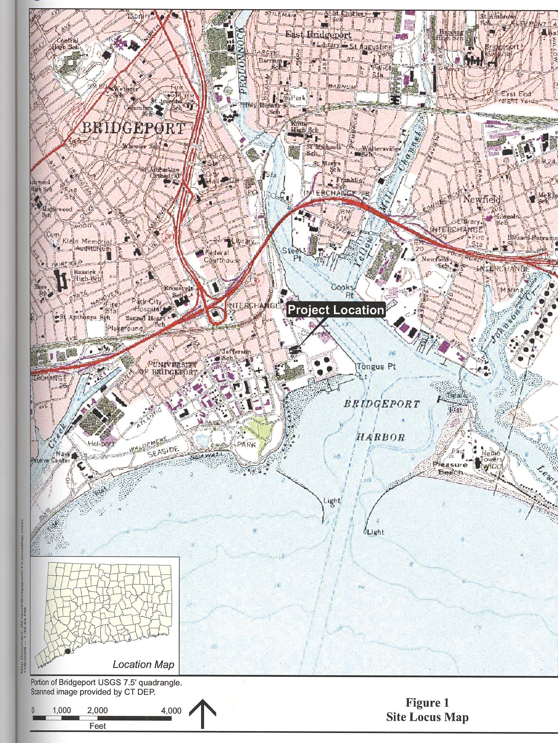
(BEII 1, Attachment A)

SITE DRAWING

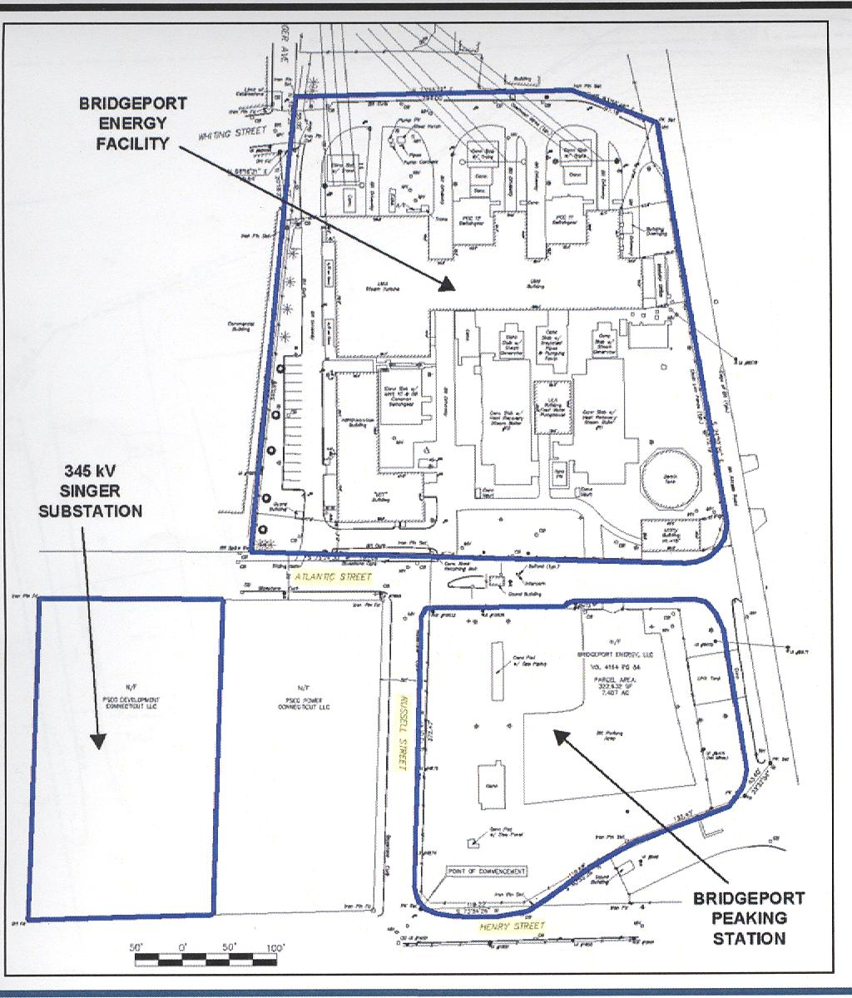
(BEII 1, Attachment B)

FACILITY DRAWING

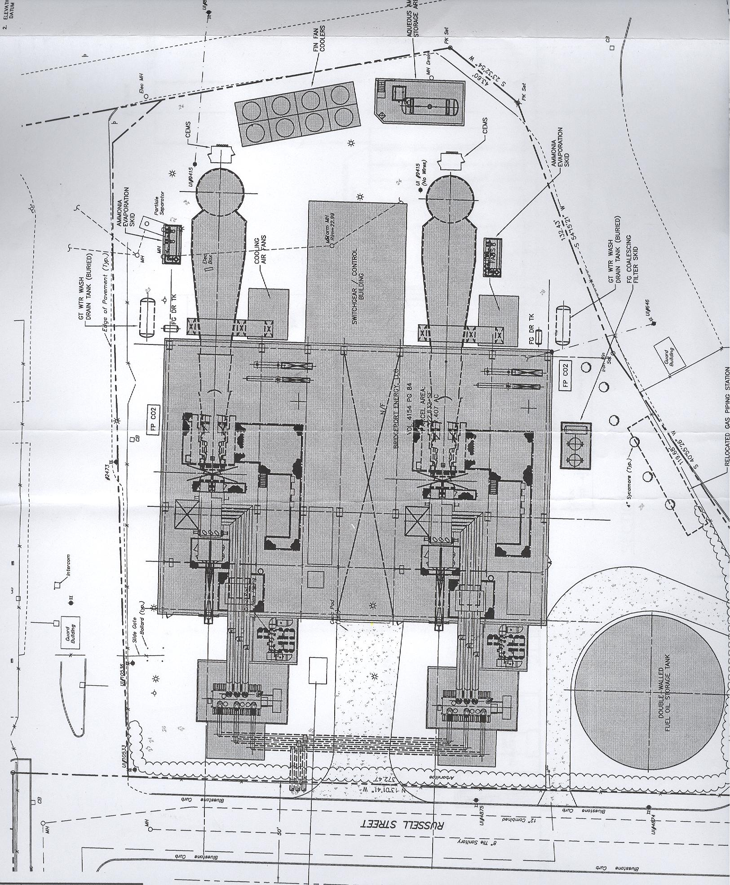
(BEII 1, Attachment D)

