State of Connecticut Department of Rehabilitation Services (DORS)
Careers in Vocational Rehabilitation Counseling
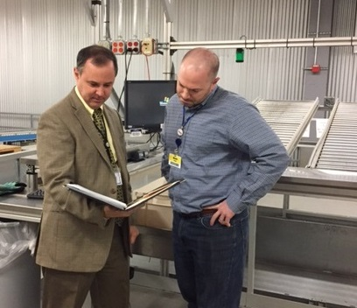
Helping to make a difference in the lives of individuals with disabilities, Vocational Rehabilitation Counselors at DORS work with job seekers, employers and training providers to develop and coordinate a plan that results in employment success.
Do you enjoy helping employers to find the right person for their job openings? Do you have strong skills in evaluating job requirements and then identifying the training programs and services to help job seekers with disabilities or work-related injuries obtain the skills to meet these requirements? Are you creative in your approach to challenges?
If so, then a career in Vocational Rehabilitation Counseling at DORS may be the perfect fit for you. While a Master’s Degree in Rehabilitation Counseling and some prior related work experience will qualify you to seek employment at higher levels in the Vocational Rehabilitation Counselor series, there are other opportunities at the entry level that require only a Bachelor’s degree in related fields. For more information on the rewarding field of Vocational Rehabilitation Counseling, please visit www.ct.gov/dors or contact the Human Resources unit at (860) 424- 4985.

