DOCKET NO. 363 – Crown Communications Inc. application for a Certificate of Environmental Compatibility and Public Need for the construction, maintenance and operation of a telecommunications facility located at 258 Ridge Road, Madison, Connecticut. | }  }  } | Connecticut  Siting  Council  October 30, 2008

Findings of Fact

Introduction

- Crown Communications Inc. (Crown), in accordance with the provisions of Connecticut General Statutes (CGS) §§ 16-50g through 16-50aa, applied to the Connecticut Siting Council (Council) on May 30, 2008 for the construction, operation, and maintenance of a 150-foot wireless telecommunications facility at 258 Ridge Road in Madison, Connecticut. (Crown 1, p. 1)

- Crown is a Delaware corporation based in Canonsburg, Pennsylvania. Crown develops, owns, manages and markets communications facilities to telecommunication carriers throughout the United States. (Crown 1, p. 4, Bulk File E, F)

3. The party in this proceeding is the applicant. An intervenor is Omnipoint Communications, Inc. (T-Mobile). (Transcript 1 – 08/26/08, 3:00 p.m. [Tr. 1], p. 6)

- The purpose of the proposed facility is to provide wireless service for T-Mobile to Route 79 and adjacent areas between Route 80 and Interstate 95 in the Town of Madison. (T-Mobile 1, Q. 1, Q. 5)

- New Cingular Wireless PCS LLC (AT&T) submitted a letter to the Council on August 5, 2008 expressing interest in locating at the 140-foot level of the proposed facility. AT&T did not participate in the proceeding. (Record)

- Pursuant to CGS § 16-50m, the Council, after giving due notice thereof, held a public hearing on August 26, 2008, beginning at 3:00 p.m. and continuing at 7:00 p.m. at the Memorial Town Hall, 8 Meetinghouse Lane, Madison, Connecticut. (Council's Hearing Notice dated July 11, 2008; Tr. 1, p. 3; Transcript 2 – 08/26/08, 7:00 p.m. [Tr. 2], p. 3)

- The Council and its staff conducted an inspection of the proposed site on August 26, 2008, beginning at 2:00 p.m. The applicant flew a four-foot diameter balloon at the site from 10:30 a.m. to 7:00 p.m. to simulate the height of the proposed tower. Favorable weather conditions were present during the evening hours. Windy condition prevailed during the afternoon, preventing the balloon from reaching its intended height of 150 feet above ground level (agl). (Council's Hearing Notice dated July 11, 2008; Tr. 1, p. 30; Tr. 2, pp. 17-19)

- Notice of the application was provided to all abutting property owners by certified mail. Public notice of the application was published in The Source on May 22 and May 29, 2008. (Crown 1, p. 5; Crown 2, Q. 7)

- Crown installed a four-foot by six-foot sign that described the proposed project on August 12, 2008 at the intersection of Ridge Road and Green Hill Road. The sign also contained hearing and contact information. (Tr. 1, p. 12)

- Pursuant to CGS § 16-50l(b), Crown provided notice to all federal, state and local officials and agencies listed therein. (Crown 1, p. 5, Tab 8)

State Agency Comment

- Pursuant to General Statutes § 16-50j (h), on July 11, 2008 and August 27, 2008, the following State agencies were solicited to submit written comments regarding the proposed facility: Department of Environmental Protection (DEP), Department of Public Health (DPH), Council on Environmental Quality (CEQ), Department of Public Utility Control (DPUC), Office of Policy and Management (OPM), Department of Economic and Community Development (DECD), and the Department of Transportation (DOT). The Department of Agriculture (DOAG) was solicited on August 27, 2008. (Record)

- The Council received written responses from the DPH’s Drinking Water Division on July 22, 2008 and the DOT’s Bureau of Engineering and Highway Operations on August 11, 2008, both stating that they have no comment. (Record)

- No response was received from the DOAG, DEP, CEQ, DPUC, OPM, or DECD. (Record)

Municipal Consultation

- In early 2007, Crown contacted the Town of Madison to begin the municipal consultation process for a site at 99 Summer Hill Road. During the consultation, Crown became aware of the Town’s desire to develop facilities on town land, including the bulky waste facility. (Crown 1, p. 9, Tab 2)

- Crown submitted a technical report to the town on August 30, 2007 that proposed constructing a tower either at the town’s bulky waste facility or on a residential parcel on Summer Hill Road. (Crown 1, p. 3)

- In September of 2007, the Town’s Planning and Zoning Commission conducted two separate hearings on the proposal. The Commission recommended selecting the bulky waste facility for telecommunications use to the Town’s Board of Selectmen. (Crown 1, p. 3)

- The Board of Selectmen convened a Town Meeting on January 30, 2008, attended by approximately 460 residents, to consider the Crown proposal. The residents voted at the hearing to authorize a lease agreement between the town and Crown for a telecommunications tower at the bulky waste facility. The First Selectman, Alfred Goldberg, thereafter completed lease negotiations with Crown. (Crown 1, pp. 3-4, Tab 6)

Public Need for Service

- In 1996, the United States Congress recognized a nationwide need for high quality wireless telecommunications services, including cellular telephone service. Through the Federal Telecommunications Act of 1996, Congress seeks to promote competition, encourage technical innovations, and foster lower prices for telecommunications services. (Council Administrative Notice Item No. 7)

- In issuing cellular licenses, the Federal government has preempted the determination of public need for cellular service by the states, and has established design standards to ensure technical integrity and nationwide compatibility among all systems. (Council Administrative Notice Item No. 7)

- The Telecommunications Act of 1996 prohibits local and state entities from discriminating among providers of functionally equivalent services. (Council Administrative Notice Item No. 7)

- The Telecommunications Act of 1996, a Federal law passed by the United States Congress, prohibits any state or local entity from regulating telecommunications towers on the basis of the environmental effects of radio frequency emissions to the extent that such towers and equipment comply with FCC’s regulations concerning such emissions. This Act also blocks the Council from prohibiting or acting with the effect of prohibiting the provision of personal wireless service. (Council Administrative Notice Item No. 7)

- In an effort to ensure the benefits of wireless technologies to all Americans, Congress enacted the Wireless Communications and Public Safety Act of 1999 (the 911 Act). The purpose of this legislation was to promote public safety through the deployment of a seamless, nationwide emergency communications infrastructure that includes wireless communications services. (Crown 1 1, pp. 7-8)

- Telecommunication carriers located on the proposed tower would be able to provide enhanced 911 services to the surrounding area. (Crown 1, p. 7)

Site Selection

24. Crown established a search area in 2006. The search included identification of potential structures that could be used for telecommunications purposes and radio frequency testing of existing structures and raw land sites to identify the best areas for placement of a telecommunications site. (Crown 1, pp. 8-9; Tr. 1, pp. 31-33)

- The nearest existing tower facilities to the proposed site are a 180-foot tower at the Madison Volunteer Fire Department, 864 Opening Hill Road, a 150-foot tower at the town’s former Police Department, 8 Old Road, and a 180-foot tower at 135 New Road. All three towers support the four major wireless carriers in the market, including T-Mobile. (Crown 1, p. 9; T-Mobile 1, Q. 5; Tr. 1, pp. 35-37)

- Crown and T-Mobile did not identify any structures suitable to provide coverage to the target service area. (Crown 1, p. 9)

- After determining there were no viable structures for telecommunications use within the search area, Crown entered into an agreement for use of a residential parcel at 99 Summer Hill Road in Madison for a tower site. (Crown 1, p. 9, Tab 2)

- In early 2007, Crown became aware of the Town’s desire to develop telecommunications facilities on town land, including the bulky waste facility. Crown developed a proposal for the town that included the site at 99 Summer Hill Road and a site at the town’s bulky waste facility. (Crown 1, p. 9, Tab 2)

- Crown abandoned the Summer Hill Road site after town residents voted at a town meeting on January 30, 2008 in favor of the bulky waste site. (Crown 1, pp. 8-9, Tab 2)
Site Description

- The proposed facility is located on an 11-acre parcel identified as Map 78, Lot 1 (refer to Figure 1). (Crown 1, Tab 3, Tab 4; Crown 2, Q. 5)

- The parcel is one of several adjoining parcels that comprise the Town’s 100-acre bulky waste facility at 258 Ridge Road. (Crown 2, Q. 5, Q. 6)

- The parcel is zoned Rural, RU-2. (Crown 1, p. 12)

- The tower site is located on the east side of the 11-acre parcel, adjacent to the entrance gate of the bulky waste facility. The bulky waste facility is located at the north end of Ridge Road and approximately 2,100 feet west of Route 79. The tower site is wooded with a large rock pile at one end. (Crown 2, Q. 8, Q. 10; Tr. 1, p. 20)

- Crown proposes to construct a 150-foot monopole at the site. The tower would be constructed in accordance with the Electronic Industries Association Standard ANSI/TIA-222-G “Structural Standards for Steel Antenna Towers and Antenna Support Structures”. (Crown 1 p. 10; Tab 3)

- The tower would be designed to support four levels of antennas, and Town of Madison public safety antennas. (Crown 1 p. 10; Tab 3)

- The tower and foundation would be designed to support an extension to 180 feet. Crown’s lease agreement limits the tower height to 150 feet. If a telecommunications carrier requests an antenna height above 150 feet, Crown would have to obtain Town approval to extend the tower. Crown would also require Council approval for a tower extension. (Tr. 1, pp. 21-27)

- Crown proposes to construct a 90-foot by 90-foot equipment compound within a 100-foot by 100-foot lease area at the base of the tower. (Crown 1, Tab 3)

- Access to the compound would be from a 50-foot long gravel drive extending from Ridge Road. (Crown 1, Tab 3)

- Underground utilities would service the compound. (Crown 1, Tab 3)

- T-Mobile proposes to install nine panel antennas on a platform at a centerline height of 147 feet agl. (T-Mobile 1, Q. 3; Tr. 1, pp. 81-82)

- T-Mobile proposes to install four equipment cabinets within the compound. Emergency power would be provided by battery. (T-Mobile 1, Q. 7; Tr. 1, p. 85)

- The Town has not yet developed any specific plan to locate on the facility although the Town has lease rights to locate municipal whip antennas at the top of the tower. (Tr. 1, p. 40; Tr. 2, pp. 27-28)

- The nearest abutting property from the tower site, not owned by the town, is approximately 315 feet to the south, owned by the State of Connecticut. (Crown 2, Q. 5; Tr. 1, pp. 14-15)

- The tower radius would be contained within town property. (Crown 2, Q. 5)

- The nearest residence to the proposed tower site is approximately 742 feet to the southeast, owned by Kenneth and Sharyl Jacobs. (Crown 2, Q. 3)

- There are three residences within 1,000 feet of the tower site. (Crown 2, Q. 4)

- Land use within a quarter-mile of the site consists of the bulky waste facility, state forest, and low and medium density residential development. (Crown 1, Tab 3)

- The estimated construction cost of the facility, not including T-Mobile’s equipment, is:

Tower and foundation 100,000.
Site development 92,000.
Utilities 33,000.

Total estimated cost $225,000.
(Crown 1, pp. 17-18; Tr. 1, p. 53)

Environmental Concerns

- The proposed facility would have no effect on historic, architectural, or archaeological resources listed on or eligible for the National Register of Historic Places. (Crown 1, Tab 7)

- No Federally threatened or endangered species or State endangered, threatened or special concern species are present at the site. (Crown 1, p. 15, Tab 5; Crown 2, Q. 11; Tr. 1, pp. 42-44)

- Approximately 17 trees with a diameter of six inches or greater at breast height would be removed to develop the site. (Tr. 1, p. 20)

- To reduce clearing, Crown could shift the tower site 50 feet to the north to an area presently used for brush storage. (Tr. 1, pp. 39-40; Late file letter dated September 24, 2008)

- No wetlands or watercourses are within or near the project development area. (Crown 1, p. 17)

- Minimal filling and grading would be required. Estimated volumes of cut and fill are 25 cubic feet and 40 cubic feet, respectively. (Crown 1, Tab 3)

- The tower would not require aircraft hazard obstruction marking or lighting. (Crown 1, Tab 3)

- The cumulative maximum power density from the radio frequency emissions of the proposed T-Mobile antennas is calculated to be 2.2% of the standard for Maximum Permissible Exposure, as adopted by the FCC, at the base of the proposed tower. This calculation was based on methodology prescribed by the FCC Office of Engineering and Technology Bulletin No. 65E, Edition 97-01 (August 1997) that assumes all antennas would be pointed at the base of the tower and all channels would be operating simultaneously. (T-Mobile 1, Q. 9)
Visibility

- A tree canopy height of 50 feet was used to generate the visibility analysis. (Crown 1, Tab 4)

- The proposed tower would be visible year-round from approximately 4 acres of the surrounding bulky waste facility. No other areas of year-round visibility would occur within a two-mile radius of the site (refer to Figure 2). The tower would be seasonally visible from an additional 7 acres, mainly from Ridge Road and Green Springs Drive. (Crown 2, Q. 6)

- The tower would be seasonally visible from four residentially developed properties on Green Springs Drive, approximately 0.5 miles northeast of the site. (Crown 1, Tab 4; Tr. 1, p. 17; Tr. 2, pp. 19-21)

- The tower would not be visible from any known hiking trails maintained by the DEP or the Connecticut Forest and Parks Association. No formal trails or developed recreation areas are present within the adjacent state forest and conservation parcels. (Crown 2, Q. 6; Tr. 1, pp. 19-20) )

T-Mobile - Existing and Proposed Wireless Coverage

- T-Mobile proposes to operate 1900 MHz (PCS) equipment at this site. T-Mobile is designing the site using a signal level threshold of -84 dBm, sufficient for in-vehicle coverage. (T-Mobile 1, Q. 1, Q. 2)

- T-Mobile currently has no reliable, continuous coverage on a four mile section of Route 79 between Route 80 and Interstate 95 (refer to Figure 3). T-Mobile’s existing signal level in this area ranges from -85 dBm to -110 dBm. (T-Mobile 1, Q. 1, Q. 5)

- T-Mobile conducted a drive test on February 4, 2008, which included use of a crane-mounted omni-directional antenna raised to a specific height and vehicle mounted handsets that collect data, at heights of 137 feet agl, 147 feet agl, and 177 feet agl. T-Mobile determined antennas mounted at 177-feet would not be capable of providing continuous coverage between Interstate 95 and Route 80. A future site along Route 79 between Chestnut Hill Road and Route 80 would be required. (Crown 1, Tab 1; T-Mobile 1, Q. 4; Tr. 1, pp. 61-62, 66-73)

- Installing antennas at the 147 feet agl would provide 2.5 miles of reliable coverage on Route 79 (refer to Figure 4). Coverage would also be provided to Green Hill Road, Ridge Road, and Warpas Road. (Crown 1, Tab 1; T-Mobile 1, Q. 4, Q. 6)

- Although the site would provide 2.5 miles of coverage to Route 79, an approximate 2.25-mile coverage gap would remain on Route 79, north of Chestnut Hill Road. (Crown 1, Tab 1; T-Mobile 1, Q. 4)

- Lowering the antenna height to 137 feet agl would cause coverage to degrade for a tenth of a mile on Route 79 south of Chestnut Hill Road and along sections of Warpas Road and Green Hill Road (refer to Figure 5). (Crown 1, Tab 1; T-Mobile 1, Q. 4, Q. 6)

- If T-Mobile deployed antennas in a flush mount configuration rather than on a platform at 147 feet agl, future expansion for capacity or data services would be compromised. T-Mobile would seek to install at least two antennas per sector as opposed to one in a flush mount configuration to maintain site flexibility. Installing a second set of flush mounted antennas at 137 feet agl would compromise coverage objectives. (Tr. 2, pp. 23-25)

68. Adjacent T-Mobile facilities that would interact with the proposed facility are as follows:

Location | Antenna Height agl | Approximate Distance/Direction from Site
8 Old Route 79, Madison | 120 feet - monopole | 1.75 miles south
119 Tanner Road, Guilford | 163 feet - monopole | 2.6 miles east
135 New Road, Madison | 162 feet - building | 2.2 miles west
(T-Mobile 1, Q. 5)
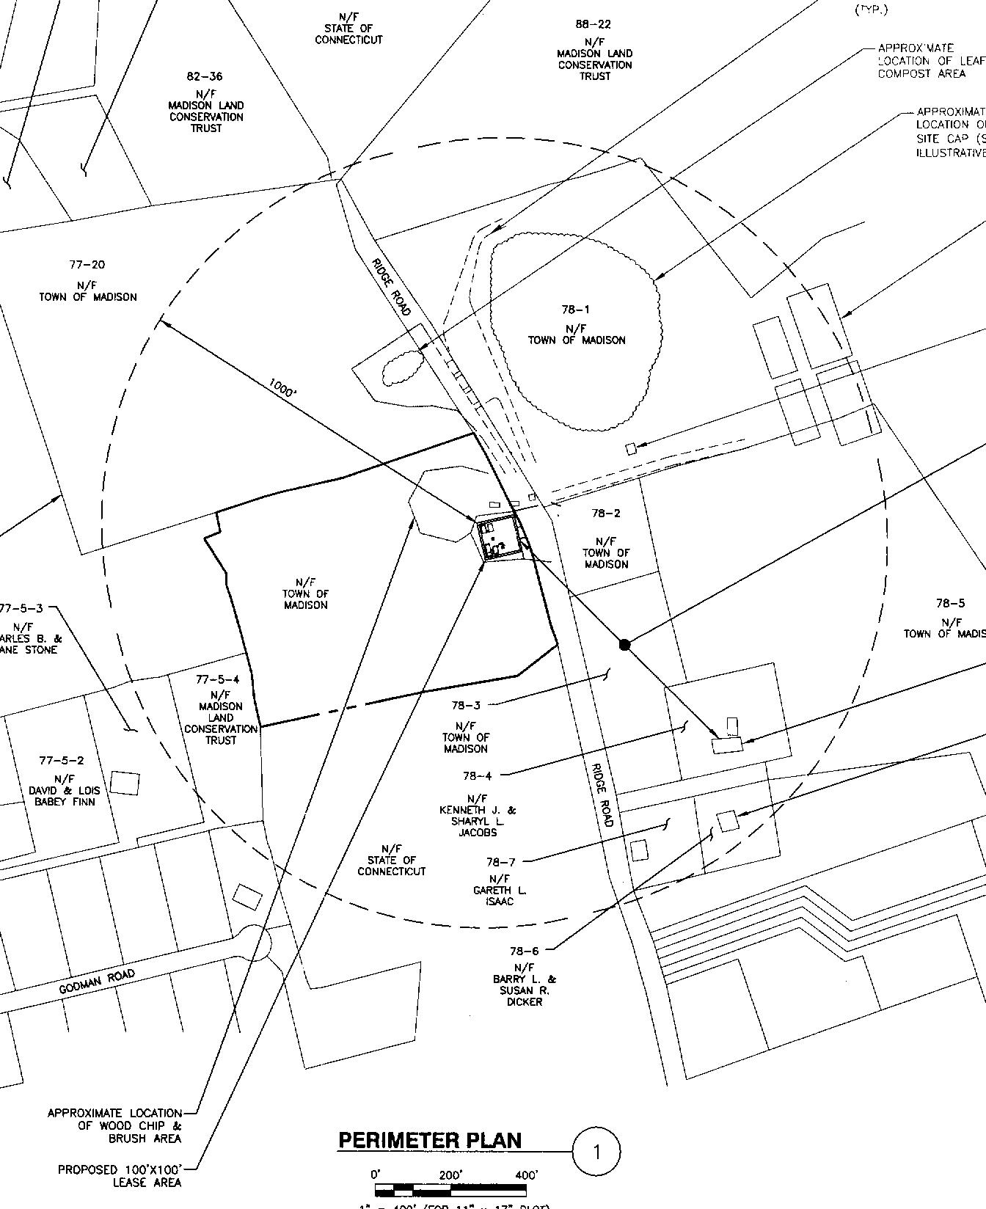

Figure 1: Location of site at Town’s Transfer Station, 258 Ridge Road, Madison.
(Crown 2, Tab A)

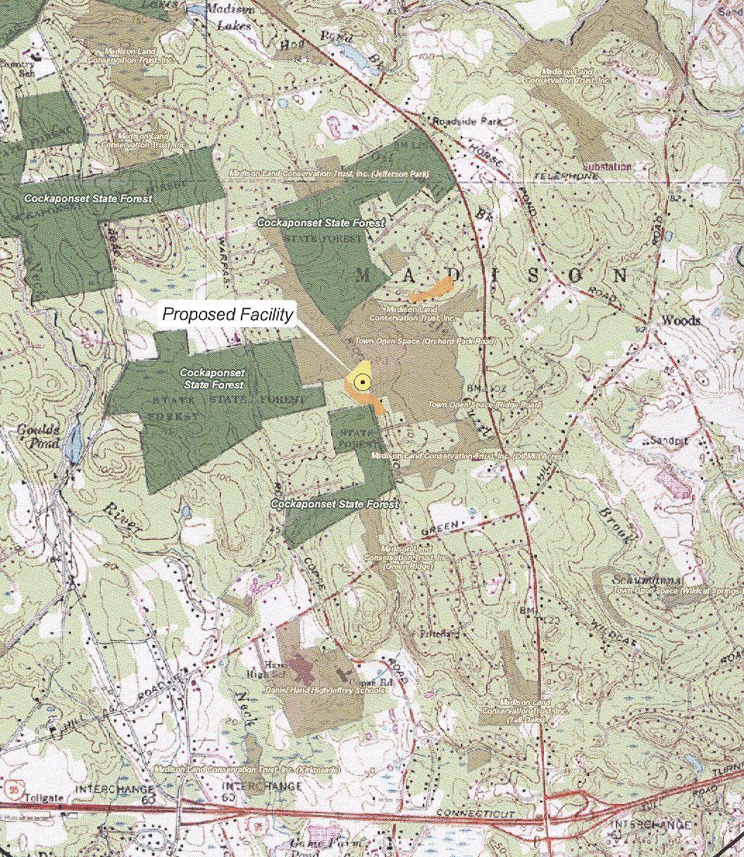
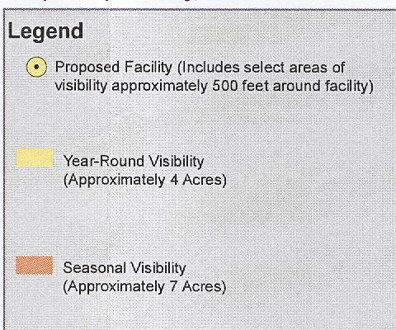

Figure 2: Visibility of proposed site. (Crown 2, Tab B)

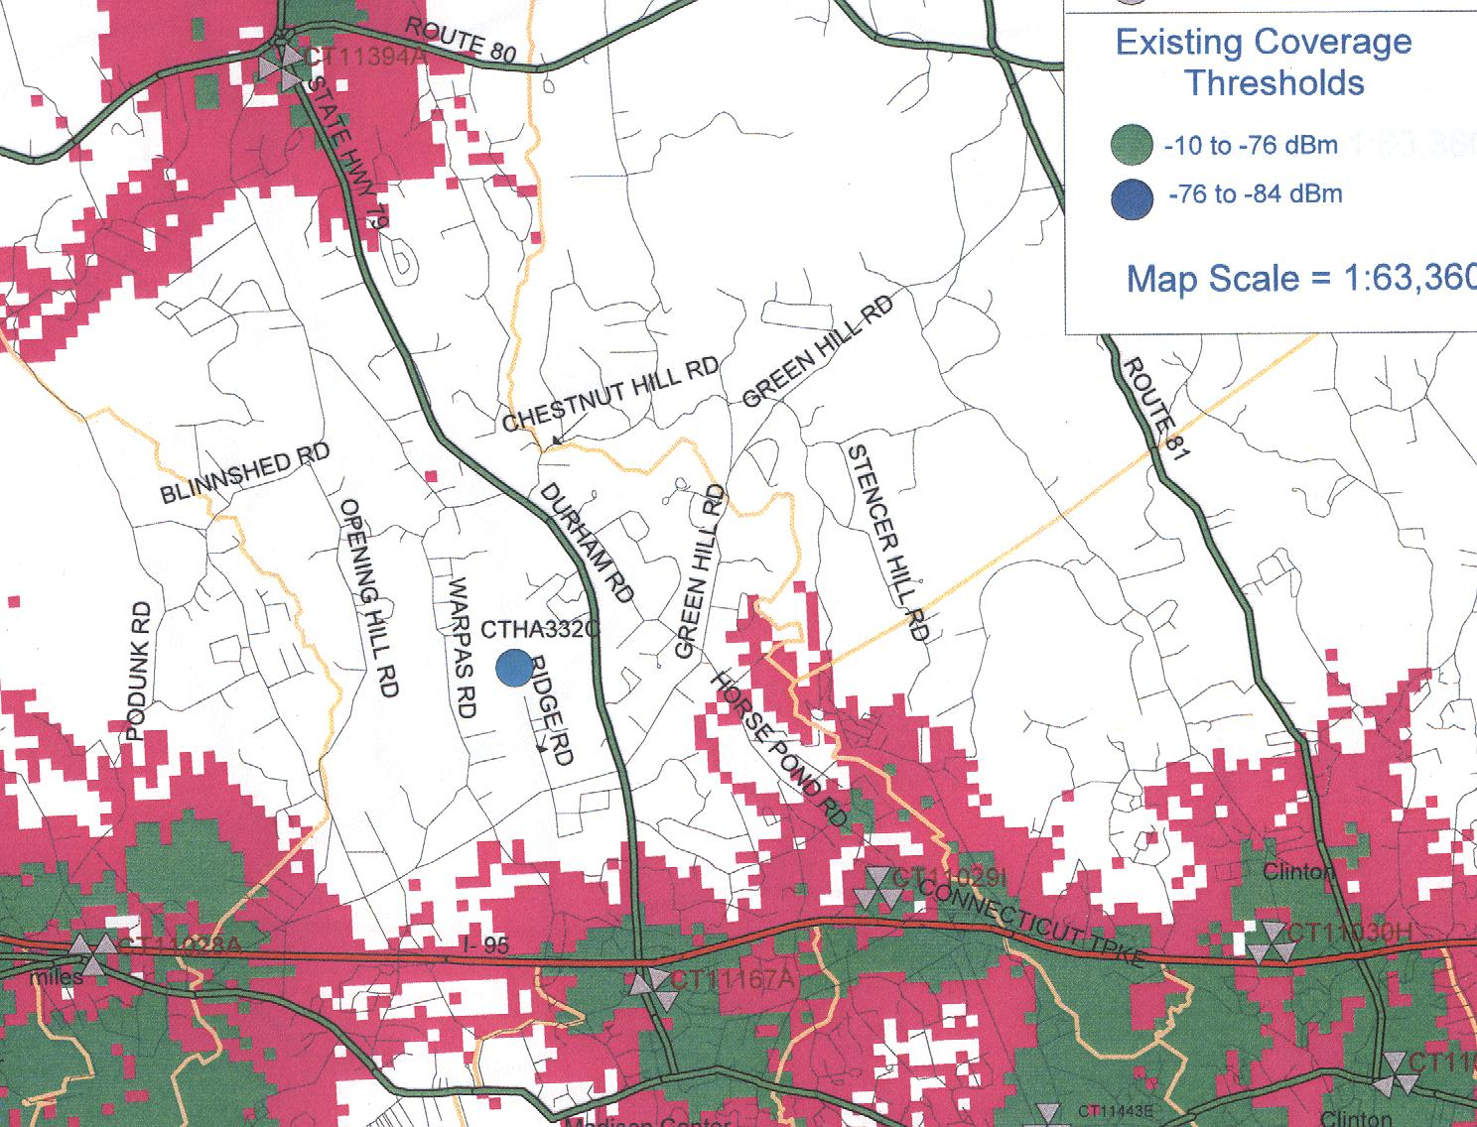
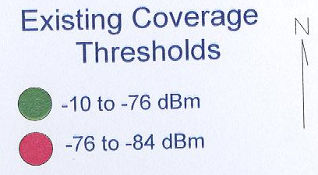

Figure 3: T-Mobile existing coverage. (Crown 1, Tab 1)

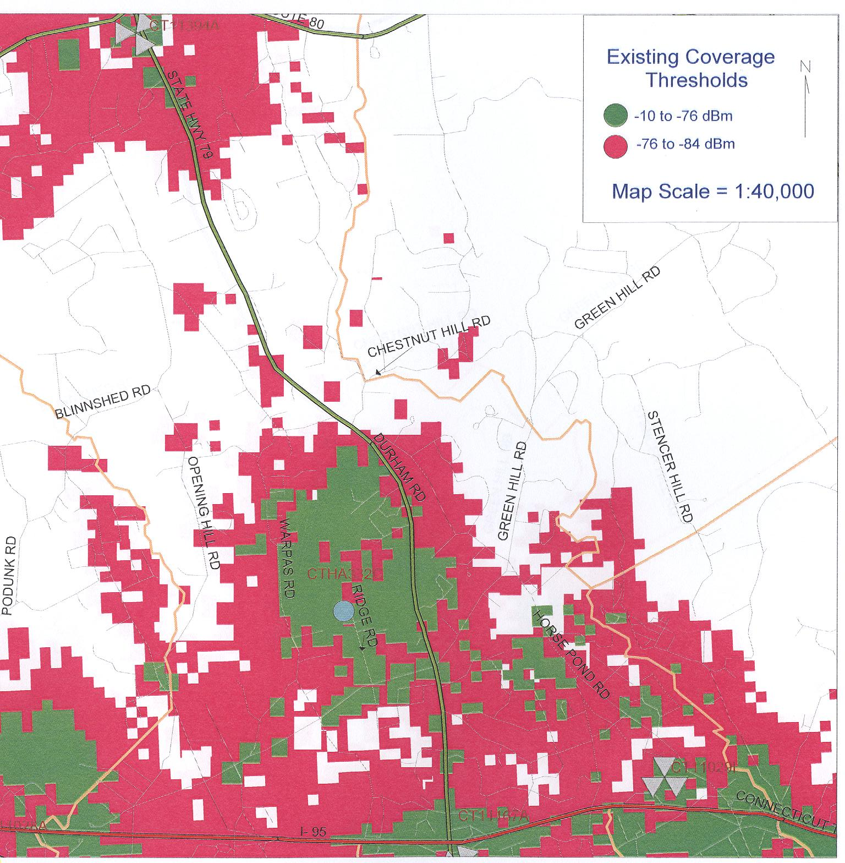

Figure 4: T-Mobile proposed coverage with antennas mounted at 147 feet agl. (T-Mobile 1, Q. 5)

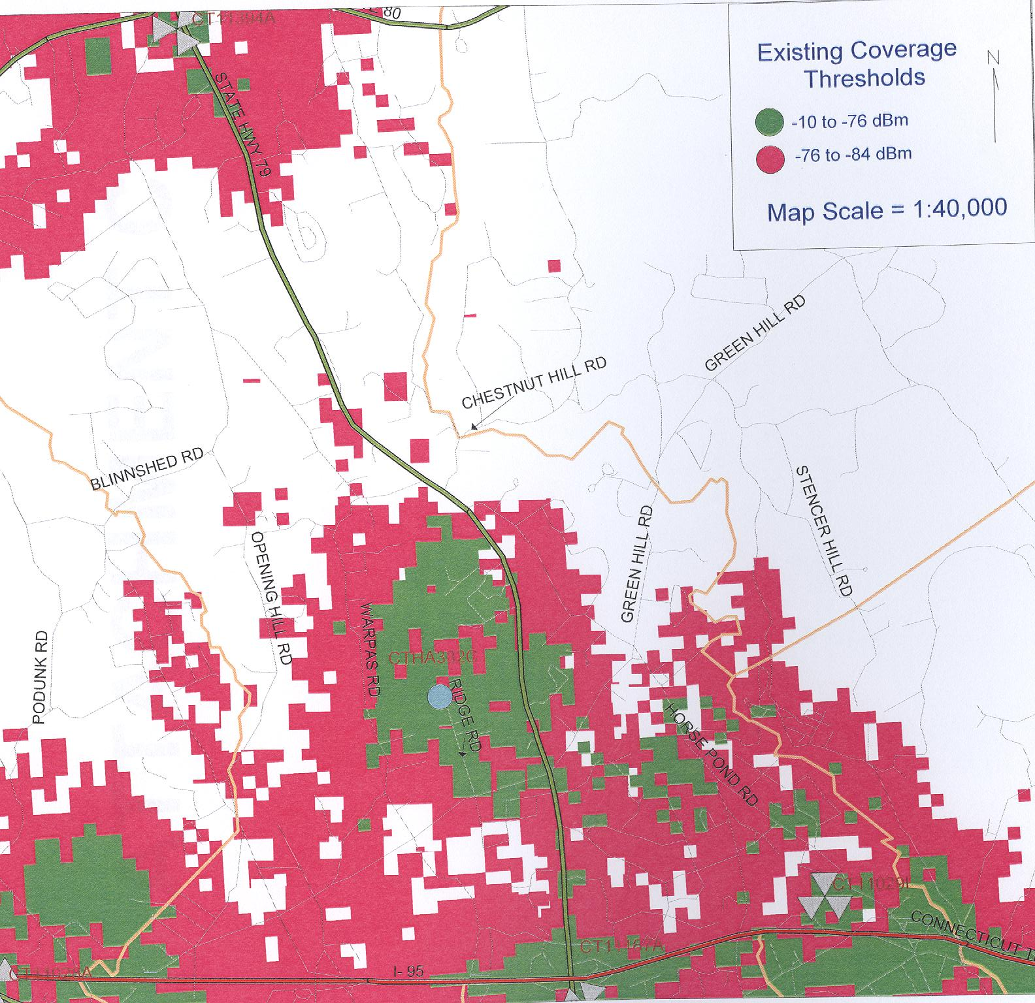
X
X

Figure 5: T-Mobile coverage with antennas mounted at 137 feet agl.

X Area on Route 79 where coverage would degrade by 0.1 mile.
X Area on Warpas and Green Hill Road where coverage would degrade.
(T-Mobile 1, Q. 5)

