DOCKET NO. 263 – AT&T Wireless PCS, LLC d/b/a AT&T Wireless application for a Certificate of Environmental Compatibility and Public Need for the construction, maintenance and operation of two telecommunications facilities in the West Granby section of the Town of Granby, Connecticut. | }  }  } | Connecticut  Siting  Council  December 22, 2003

Findings of Fact:

Granby Site CT-812

Introduction

- Pursuant to Chapter 277a, Sections 16-50g et seq. of the Connecticut General Statutes (CGS), as amended, and Section 16-50j-1 et. seq. of the Regulations of Connecticut State Agencies (RCSA), AT&T Wireless PCS, LLC d/b/a AT&T Wireless (AT&T) applied to the Connecticut Siting Council (Council) on July 1, 2003 for the construction, operation, and maintenance of two telecommunications facilities to be located in the West Granby section of the Town of Granby, Connecticut. (AT&T 1, p. 1)

- AT&T Wireless PCS, LLC d/b/a AT&T Wireless, is a Delaware limited liability company with an office at 12 Omega Drive, Stamford, Connecticut. The company’s member corporation, AT&T Wireless PCS, Inc. is licensed by the Federal Communications Commission (FCC) to construct and operate a personal wireless services system within the meaning of CGS Section 16-50(a)(6). (AT&T 1, p. 4)

- In this proceeding, AT&T proposed two telecommunications facilities each of which had two alternative sites. The two proposed facilities were identified as CT-810 and CT-812. The CT-810 facility is proposed for a property on Higley Road that contains both alternative sites (See Docket 263 Findings of Fact: Granby Site CT-810). The CT-812 facility would be at one of two sites proposed in the vicinity of Route 20 and Day Street. (AT&T 1, p. 2)

- The party in this proceeding is the applicant. (Transcript, October 8, 2003, 3:00 p.m. [Tr. 1], p. 5)

- Pursuant to CGS § 16-50l(b), notice of AT&T’s intent to submit this application was published on June 26 and June 27, 2003 in the Hartford Courant. (AT&T 2, Response 1)

- In accordance with CGS § 16-50l(b), AT&T sent notices of its intent to file an application with the Council to each person appearing of record as owner of property abutting the properties on which the two proposed CT-812 sites are located. Certificates of service were returned from all abutting property owners. (AT&T 1, p. 5; Attachment 13; AT&T 2, Response 3)

- Pursuant to CGS § 16-50l(b), AT&T sent copies of its application in July 1, 2003 to the following municipal, regional, state, and federal agencies and officials: Connecticut Attorney General; Department of Environmental Protection; Department of Public Health; Council on Environmental Quality; Department of Public Utility Control; of Policy and Management; Department of Economic and Community Development; Department of Transportation; Capitol Region Council of Governments; Thomas J. Herlihy, State Senator from the 8th Senatorial District; Richard F. Ferrari, State Representative from the 62rd Assembly District; Federal Aviation Administration; Federal Communications Commission; William J. Simanski, Town of Granby First Selectman; Paula H. Johnson, Granby Planning and Zoning Commission Chairman; J. Holden Camp, Jr., Granby Zoning Board of Appeals Chairman; Charles J. Katan, Granby Inland Wetlands Commission Chairman; Natica G. Jones, Granby Conservation Commission Chairman. (AT&T 1, p. 5; Attachment 11)

- Pursuant to CGS § 16-50l, the Council solicited comments on AT&T’s application from the following state departments and agencies: Department of Environmental Protection (DEP), Department of Public Health, Council on Environmental Quality, Department of Public Utility Control, Office of Policy and Management, Department of Economic and Community Development, and the Department of Transportation. The Council’s letter requesting comments was sent on July 25, 2003. (CSC Hearing Package dated July 25, 2003)

- Of the state agencies and departments whose comments were solicited, the Department of Transportation and the Department of Environmental Protection responded. (Facsimile Transmission received from Connecticut Department of Transportation, August 5, 2003; DEP letter dated October 3, 2003)

- Other than the Department of Transportation and the Department of Environmental Protection, no state agencies responded to the Council’s solicitation of comments.

- The Connecticut Department of Transportation stated that AT&T’s proposed facilities were not expected to be detrimental to its planning program. (Facsimile Transmission received from Connecticut Department of Transportation, August 5, 2003)

- Pursuant to CGS § 16-50m, the Council, after giving due notice thereof, held a public hearing on October 8, 2003, beginning at 3:00 p.m. and continuing at 7:00 p.m. in Granby, Connecticut. (Tr. 1, p. 3 ff.)

- During the field review of the proposed sites held on October 8, 2003, the applicant flew balloons to simulate the height of the proposed tower at each of the respective candidate sites. Balloons were flown from 12:00 to 6:00 pm. Wind conditions were gusty and prevented the balloons from flying to their full proposed heights for much of the time they were flown. The balloons did reach their full heights between gusts. (Tr. 1, pp. 17-18)

Public Need for Service

- The Telecommunications Act of 1996, a Federal law passed by the United States Congress, prohibits any state or local agency from regulating telecommunications towers on the basis of the environmental effects of radio frequency emissions to the extent that such towers and equipment comply with FCC’s regulations concerning such emissions. This Act also blocks the Council from prohibiting or acting with the effect of prohibiting the provision of personal wireless service. (Telecommunications Act of 1996; Tr. 1, p. 4)

- The Telecommunications Act of 1996 prohibits local and state bodies from discriminating among providers of functionally equivalent services. (Telecommunications Act of 1996)

- In passing the Telecommunications Act of 1996, the U.S. Congress, in part, sought to “provide for a competitive, deregulatory national policy framework designed to accelerate rapidly private sector deployment of advanced telecommunications and information technologies to all Americans.” (AT&T 1, p. 5)

- According to section 16-50aa of the Connecticut General Statutes, the “sharing of towers for fair consideration whenever technically, legally, environmentally and economically feasible, and whenever such sharing meets public safety concerns, will avoid the unnecessary proliferation of towers and is in the public interest.” (Connecticut General Statutes §16-50aa)

- The FCC formally issued licenses to AT&T to provide personal communications services (PCS) for the Hartford Basic Trading Area, which includes Hartford County, in June of 1997. The facilities AT&T proposes to develop in this application would be integral components of AT&T’s network in the areas it is licensed to serve by the FCC. (AT&T 1, pp. 6, Attachment 14)

- Congress enacted the Wireless Communications and Public Safety Act of 1999 (the “911 Act). The purpose of this legislation was to promote public safety through the deployment of a seamless, nationwide emergency communications infrastructure that includes wireless communications services. In passing the 911 Act, Congress found that the establishment of a network that provided for the rapid, efficient deployment of emergency services would result in many public benefits, including faster delivery of emergency care with reduced fatalities and severity of injuries and improved service in rural areas. (AT&T 1, pp. 7-8)

- As part of the 911 Act, the FCC mandated wireless carriers, such as AT&T, to provide enhanced 911 services (E911), which would allow 911 public safety dispatchers to identify a wireless caller’s geographical location within several hundred feet. AT&T’s proposed facility would be an integral component of AT&T’s E911 services in Granby. (AT&T 1, p. 8)

- At the time of application, AT&T had coverage gaps in its network in the West Granby section of Granby, specifically along Route 20 and adjacent areas in this portion of Hartford County. (AT&T 1, pp. 6-7)

- At the time of application, AT&T’s signal strength in the vicinity of the proposed CT-812 Site A and Site B was at an unacceptable level. (AT&T 2, Response 4)

- AT&T’s closest site (identified as CT-294; Granby Police Department) to the east of its proposed site CT-812, experiences a daily average of 19.4% dropped calls. AT&T’s service objective is to experience no more than 2% dropped calls. AT&T’s statistics do not account for the number of failed call attempts that originate from the no-service area that CT-812 would cover. (AT&T 2, Response 5)

- If the Town of Granby had a need to use the proposed towers for municipal antennas it could do so at no charge. (Tr. 1, p. 18)

Service Design

- At CT-812, AT&T would install a three-sector configuration with a maximum of twelve channels for the site. Initially AT&T would install a total of six panel antennas — two antennas per sector. (AT&T 2, Response 13)

- The minimum height AT&T would require to meet its coverage objectives at CT-812 is 150 feet. The additional height (20 feet) of the proposed towers is to accommodate Verizon’s desired use of the site at 160 feet AGL and to allow AT&T to be at the top of the tower at 170 feet. (Tr. 1, p. 16, p. 36 ff.)

- The minimum signal strength needed to meet AT&T’s coverage objectives in the areas of CT-812 is –85 dBm. (AT&T 2, Response 10)

- AT&T’s proposed facility CT-812 would hand off traffic to its site identified as CT-294, located at the Granby Police Department at 15 North Granby Street, to the east, and to the other facility proposed as part of this Docket and identified as CT-810 to the west. (AT&T 2, Response 9)

- Each of the two proposed alternative sites, Site A and Site B, for CT-812 would cover approximately two miles along Route 20. (AT&T 2, Response 15)

- CT-812 Site A at 170 feet would have slightly better coverage than Site B at 170 feet. (Tr. 1, p. 85)

- Micro cells and/or repeaters are not viable technological alternatives for providing coverage for the area AT&T seeks to cover. Micro cells and repeaters are low power and used mainly for small “hole-filling” applications. Numerous micro cells would be needed to fill AT&T’s coverage gap. Repeaters also require line-of-sight access to on-air “donor”
facilities and provide no added capacity in a network. AT&T’s network could not support repeaters because it has no existing donor sites in this area. (AT&T 2, Response 6)

- Verizon has a long-term interest in using CT-812 at either of the proposed sites if this facility is approved. (AT&T 1, p. 3)

Municipal Consultation

- On November 26, 2002, AT&T submitted a letter and a technical report to the First Selectman of the Town of Granby. The letter introduced AT&T’s plans for Site A of the CT-812 facility in Granby and invited town officials to discuss any comments or questions about the facility with AT&T. The technical report explained specifics about the site under consideration, the site selection process, and the likely environmental effects of the proposed facility. (AT&T 1, p. 25)

- On April 9, 2003, AT&T submitted a letter and technical report to the Granby First Selectman for Site B of CT-812. (AT&T 1, p. 25)

- On April 22, 2003, the Granby Planning and Zoning Commission reviewed the proposals for the two CT-812 sites and did not voice a preference for either of the two proposed alternative locations. (AT&T 1, p. 25, Attachment 10)

Site Search

- For CT-812, AT&T established a search ring with a radius of approximately .5 mile in the vicinity of Route 20. This search ring was centered at latitude 41° 57’ 28.44” N and longitude 72° 50’ 8.88” W. (AT&T 1, Attachment 4)

- During its site search AT&T identified only one existing communications tower within approximately two miles of its CT-812 search ring. The tower is located at the Granby Police Department and is being used by AT&T as one of its sites. (AT&T 1, Attachment 4)

- AT&T considered eleven different properties as potential locations for its CT-812 facility. The addresses of these properties and the final determination of their suitability are listed below.

- 8 Upper Meadow Road. This property is the proposed Site A location.

- 10 Day Street South. This property is the proposed Site B location.

- Lost Acres Fire Department, 246 West Granby Road. The Fire Department was not interested in making its property available for a tower location.

- 173R West Granby Road. This property was not considered due to inconsistencies concerning ownership.

- 197 West Granby Road. The property owner stated that access to the rear of this property would be difficult. AT&T was still investigating this site at the time of application.

- Town of Granby/Holcomb Farm, Day Street. Town of Granby is not interested in making space for a tower site available on this property.

- 185R West Granby Road. This property owner was not interested in making space available for a tower site.

- 166 West Granby Road. The property owners were not interested in making space available for a tower site.

- 170 West Granby Road. The property owner was not interested in making space available for a tower site.

- 60 Broad Hill Road. This property is part of the McLean Refuge conservation properties; therefore AT&T did not pursue lease possibilities.

- Haleview Drive. One person owns several properties on this street and is not interested in making space available for a tower site.
(AT&T 1, Attachment 4)

Project Description

- AT&T submitted two alternative locations for its CT-812 facility identified, respectively, as Site A and Site B. AT&T’s two alternative sites are on different properties. Site A is located at 8 Upper Meadow Road (formerly 207 West Granby Road). Site B is located at 10 Day Street South. (AT&T 1, pp. 1-2)

- AT&T’s would build a monopole in accordance with Electronic Industries Association Standard EIA/TIA-222-E “Structural Standards for Steel Antenna Towers and Antenna Support Structures” for its CT-812 facility. (AT&T 1, Attachments 5, 6, 7, 8)

- For each proposed alternative site, AT&T utilized the FCC’s TOWAIR program to determine if the sites would require registration with the Federal Air Administration (FAA). The program results indicated that neither location would require FAA registration or FAA lighting or marking. (AT&T 1, p. 26)

- The CT-812 facility would be equipped with an eight-hour battery back-up system. AT&T could bring in a portable diesel generator in the case of long-term power outages. (AT&T 2, Response 21)

- Verizon Wireless has expressed interest in using a tower at the CT-812 site for its coverage needs. To support its antennas, Verizon would place its ground equipment in a 12-foot by 30-foot shelter. It would also have a diesel generator in the shelter to provide
power in the case of a power outage. The generator would be equipped with UL approved belly tanks with leak detection. (Tr. 1, p. 66 ff.)

Proposed Site CT-812 A

- The property on which CT-812 Site A is located is owned by Elaine J. Girard and comprises 5.8 acres. This property is part of a recently approved three lot residential subdivision. It is located in an R2A zoning district in which wireless telecommunication facilities are allowed as a Special Permit use. (AT&T 1, Attachment 7, p. 3; AT&T 2, Town of Granby Zoning Regulations, p. 96 ff.)

- At Site A, AT&T would lease a 100-foot by 100-foot parcel in the northern section of the property on which it would construct a 170-foot tall monopole tower capable of supporting up to five other carriers. AT&T would install up to 12 panel antennas on a platform at the top of the proposed tower. Verizon would install up to 12 panel antennas at the 160-foot level of the tower. The compound for associated ground equipment would be 80 feet by 80 feet and would be enclosed by an 8-foot tall security fence. AT&T’s ground equipment would consist of equipment cabinets on a concrete pad. (AT&T 1, p. 13)

- The monopole tower at Site A would be constructed at latitude 41º 57’ 12.08” N and longitude 72º 49’ 47.43 W. The ground elevation at the base of the tower would be 441 feet AMSL. (AT&T 1, Attachment 7)

- The tower setback radius at Site A would encompass portions of three adjacent properties. (AT&T 1, Attachment 7 – Site Access Map)

- AT&T would be willing to design a yield point in its tower that would effectively reduce its setback radius. (AT&T 2, Response 19)

- The tower at Site A could be relocated approximately 20 to 25 feet in a southerly or southeasterly direction within the proposed lease area to decrease the amount of area of the abutting property to the north that would be encompassed by the setback radius. (Tr. 1, p. 49)

- AT&T’s equipment compound at Site A would be surrounded by evergreen plantings. (AT&T 1, p. 13)

- Vehicular access to Site A would extend from Upper Meadow Road along a new gravel drive a distance of approximately 98 feet to the proposed equipment compound. (AT&T 1, p. 13)

- Utility connections for Site A would extend underground from Upper Meadow Road and would generally follow the gravel access drive. (AT&T 1, p. 13)

- The closest residence to Site A is 518 feet away on property owned by Steven and Andrea Galuska. (AT&T 1, Attachment 7)

- There are approximately 12 residences located within 1,000 feet of this proposed site. (AT&T 1, p. 18)

- The estimated construction cost for Site A is as follows:

Electronic equipment costs $ 90,000
Tower and antenna costs $152,000
Site development costs $ 68,000
Total costs $310,000
(AT&T 1, p. 27)

Proposed Site CT-812 B

- The property at 10 Day Street South on which CT-812 Site B is located is owned by Charles A. Warren, Jr. and comprises 9.47 acres in a R2A zoning district. (AT&T 1, p. 15, Attachment 8)

- AT&T would lease a 100-foot by 100-foot parcel in the center of the property and construct a 170-foot tall monopole tower capable of supporting up to five additional carriers at Site B. AT&T would install up to 12 panel antennas at the top of the tower, and Verizon would install up to 12 panel antennas at the 160-foot level. AT&T would develop an 80-foot by 80-foot compound for associated ground equipment within which AT&T would install equipment cabinets on a concrete pad. The compound would be enclosed by an 8-foot tall chain link security fence. (AT&T 1, pp. 14-15)

- The tower at Site B would be located at latitude 41º 57’ 12.98” N and longitude 72º 49’ 58.67” W. The ground elevation at the base of the tower would be 428 feet AMSL. (AT&T 1, Attachment 8)

- The tower setback radius at Site B would encompass a small portion of an adjacent property. (AT&T 1, Attachment 8 – Site Access Map)

- The property owner would be willing to allow AT&T to relocate the tower location to keep the setback radius within his property. (Tr. 2, pp. 14-15)

- AT&T would be willing to design a yield point into the tower to effectively reduce the tower setback radius. (AT&T 2, Response 19)

- Vehicular access to Site B would extend from Day Street South along an existing paved driveway for a distance of approximately 250 feet and then along a new 12-foot wide gravel drive approximately 435 feet to the equipment compound. (AT&T 1, p. 15)

- Utility connections to Site B would extend underground from Day Street South and generally follow the access drive to the proposed compound. (AT&T 1, p. 15)

- The closest residence to Site B is 485 feet away and is owned by the property owner, Charles Warren. There are approximately 20 residences within 1,000 feet of the proposed facility. (AT&T 1, p. 18)

- The estimated construction costs for Site B are:

Electronic equipment costs $126,500
Tower and antenna costs $152,000
Site development costs $195,500
Total costs $474,000
(AT&T 1, p. 27)

Environmental Considerations

- During construction of CT-812, AT&T would establish and maintain soil erosion control measures and other best management practices in accordance with the Connecticut Soil Erosion Control Guidelines, as established by the Council of Soil and Water Conservation. (AT&T 1, pp. 24-25)

- There are no National Parks, National Forests, National Parkways or Scenic Rivers, State Designated Scenic Rivers, or State Gamelands located in the vicinity of CT-812. (AT&T 1, p. 17)

- Based on the assumption that antennas mounted on the proposed facility were pointed at the base of the respective towers and all channels were operating simultaneously, the power density for CT-812 Site A or Site B was calculated to be 0.142667 mW/cm² or 14.27% of the FCC standard for maximum permissible exposure for AT&T and Verizon antennas. (AT&T 1, p. 19)

- The boundaries of the West Granby Historic District would be approximately 570 feet from CT-812 Site A and 404 feet from CT-812 Site B. (AT&T 2, Response 20)

- The proposed CT-812 Site A is located on a level, wooded portion of a subdivision lot that supports white birch, hickory, tupelo, red oak, and mountain laurel. (DEP letter dated October 3, 2003)

- A watercourse flows just off the northeast corner and northern boundary of CT-812 Site A and leads to a crossing under Upper Meadow Road. (DEP letter dated October 3, 2003)

- The proposed CT-812 Site B is located in a wooded area with a mix of red oak, chestnut oak, white oak, tupelo, and mountain laurel. (DEP letter dated October 3, 2003)

- The access road to the proposed CT-812 Site B could not avoid crossing a wetlands area without leaving the lessor’s property. (DEP letter dated October 3, 2003)

- A facility at CT-812 Site A would be within 25 feet of a designated wetland. (AT&T 1, Attachment 7 – Site Access Map)

- The 12-foot wide gravel access drive to CT-812 Site B would have to cross a wetlands area for a distance of 70 feet. (AT&T 1, p. 24; Attachment 8 – Site Access Map)

- A 75-foot trench would have to be dug through the wetlands to provide underground utilities to CT-812 Site B. The finished grade of the trench would match adjoining grades and would be replanted to match the surrounding area. (AT&T 2, Response 18)

- Approximately 1,600 square feet of wetlands would be impacted by developing CT-812 Site B. This could be reduced to approximately 1,000 square feet by installing the utilities underneath the access drive. (Tr. 1, pp. 45-46)

- No blasting would be anticipated at either of the proposed sites. (AT&T 2, Response 14)

- Developing a facility and access road would require the removal of the following number of trees with diameters greater than 12 inches at breast height (dbh) at each of the respective sites:

At CT-812 Site A – 15 trees
At CT-812 Site B – 31 trees
(AT&T 2, Response 16; Tr. 1, p. 15)

- There are no known extant populations of Federal or State Endangered, Threatened or Special Concerns species that occur in the vicinity of the two possible sites proposed by AT&T for CT-812. (AT&T 1, Attachment 9)

- Neither Site A nor Site B proposed for CT-812 would have any effect on Connecticut’s cultural resources. (AT&T 1, Attachment 9)

- The closest airport to any of the proposed sites is located in Simsbury approximately 3.3 miles from CT-812’s proposed Site A. (AT&T 1, Attachments 5, 6, 7, 8)

Visibility

- The balloon simulation indicates that CT-812 Site B would be more visible in the local area than CT-812 Site A. (DEP letter dated October 3, 2003)

- A tower at CT-812 Site A or B would be visible from portions of Route 20 and Day Street and the top of Barndoor Hill. (AT&T 1, pp. 17-18)

- The proposed tower at CT-812 Site A would be obscured from view from most locations within the West Granby Historic District. The top of the proposed tower at Site B would be visible from certain locations within the West Granby Historic District. (AT&T pp. 17-18; Tr. 1, p. 24)

- CT-812 Site B would be visible from more surrounding locations than CT-812 Site A. (Tr. 1, p. 54 ff.)

Map 1
CT-812 Location Map

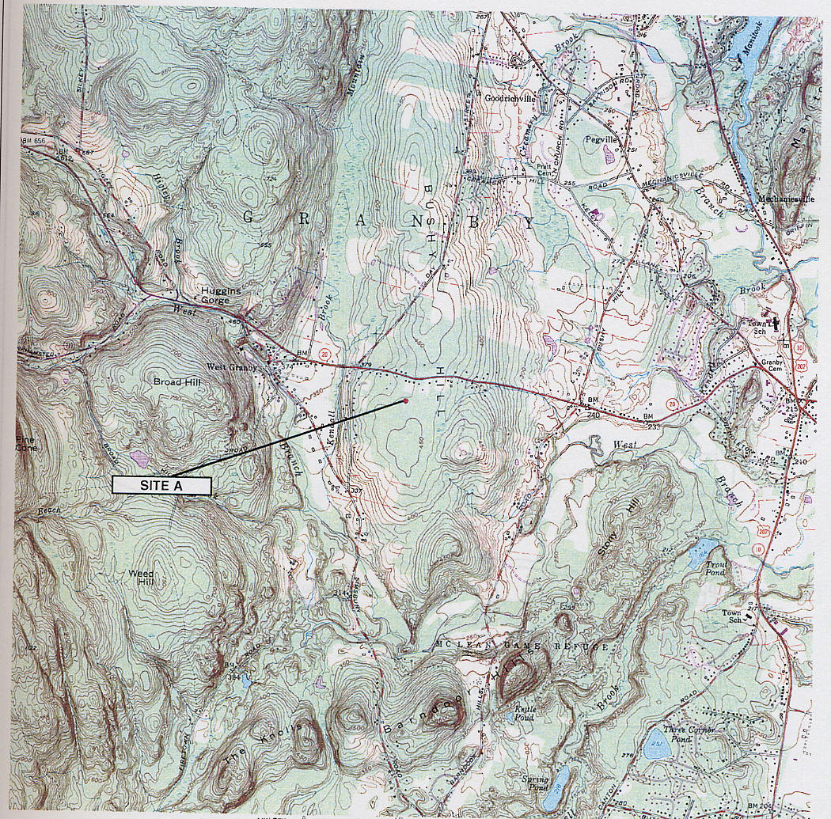
●
SITE B
(AT&T 1, Attachment 7)

Map 2
Existing Coverage

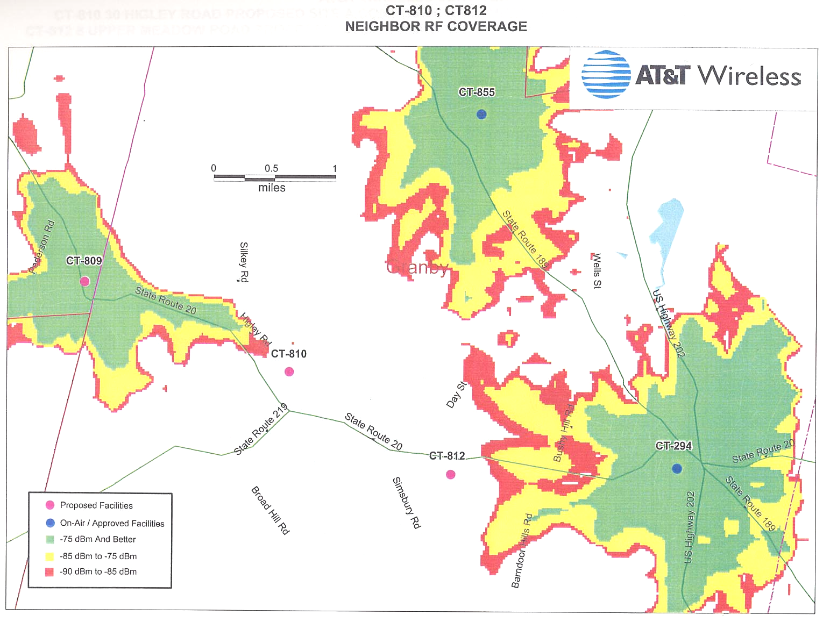
(AT&T 1, Attachment 3)

Map 3
Coverage from CT-812 Site A
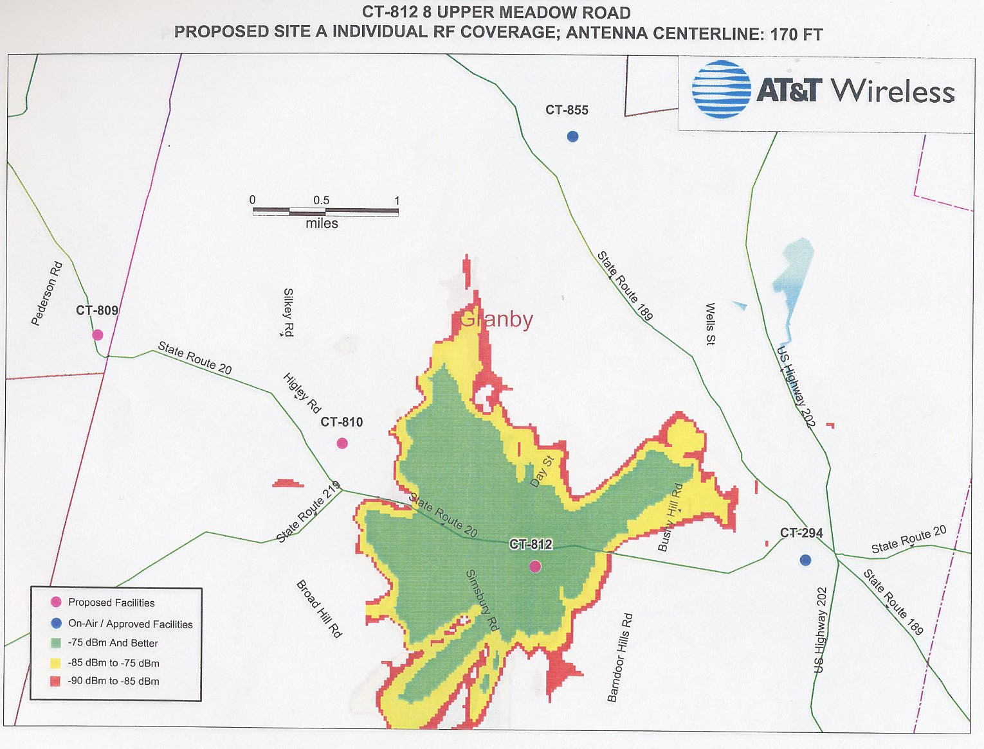
(AT&T 1, Attachment 3)
Map 4
Coverage from CT-812 Site B
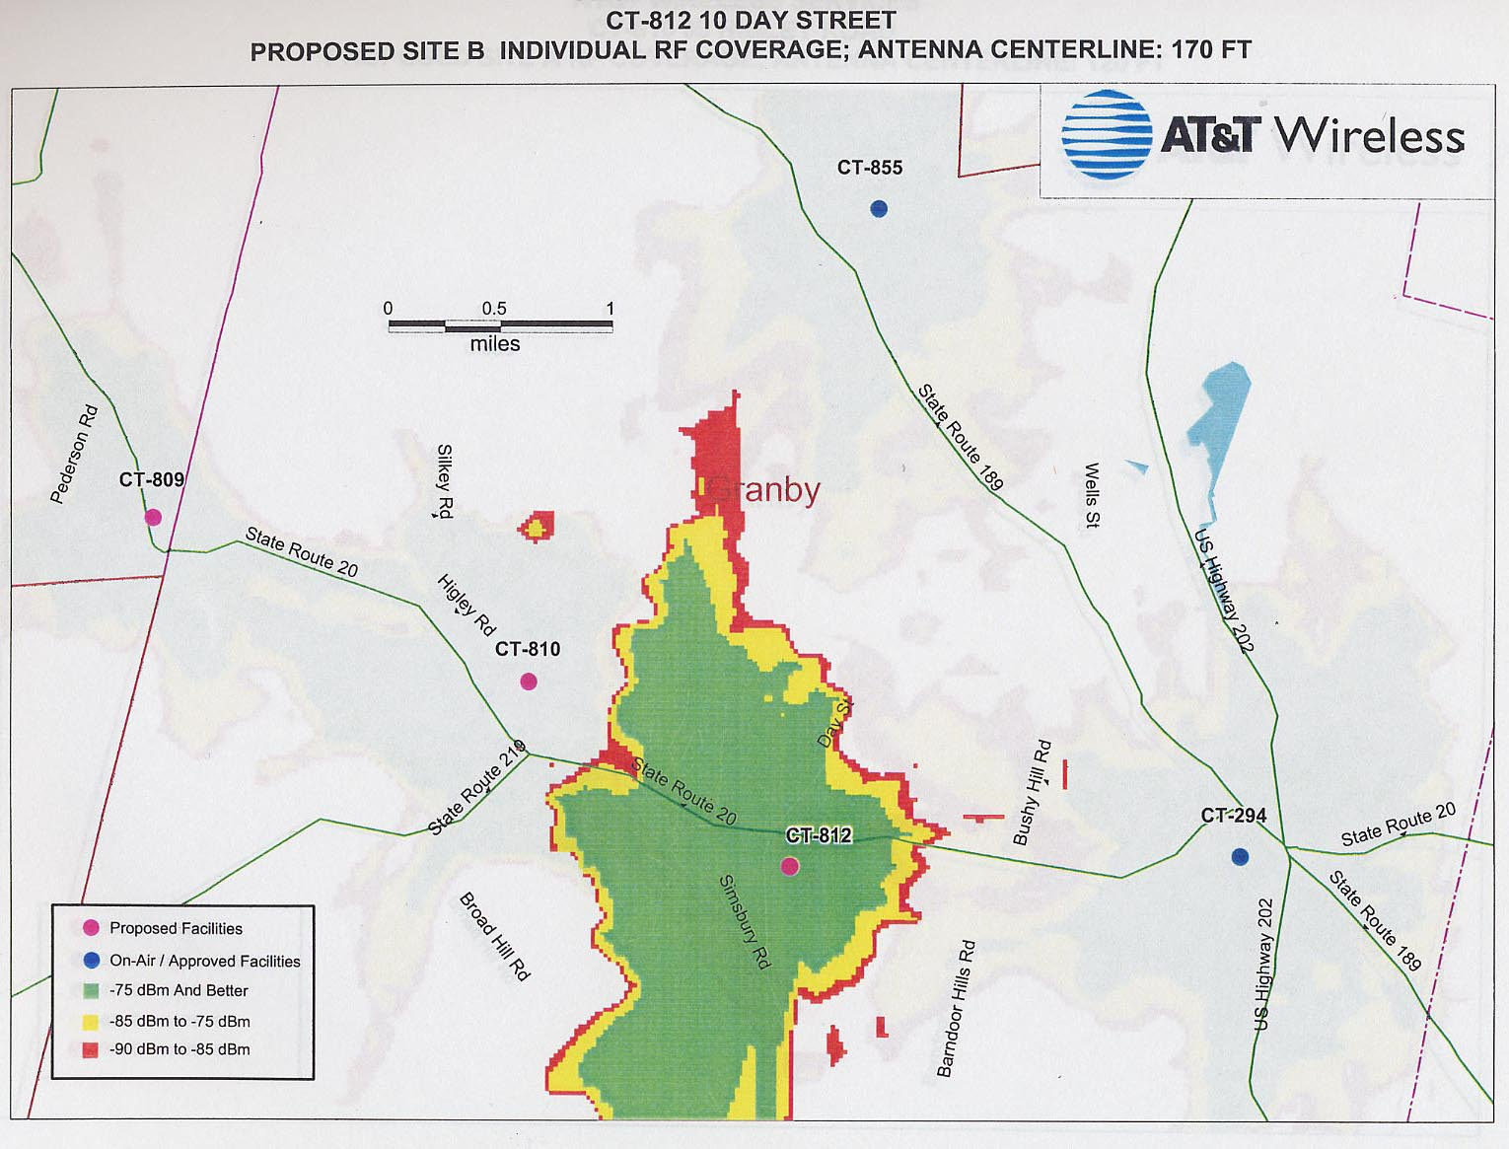
(AT&T 1, Attachment 3)
Map 5
Composite Coverage with CT-810 Site A and CT-812 Site A
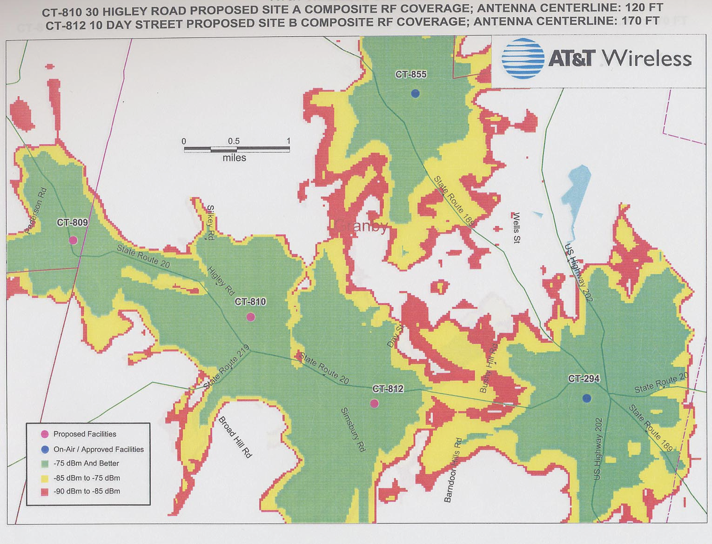
(AT&T 1, Attachment 3)
Map 6
Composite Coverage with CT-810 Site A and CT-812 Site B
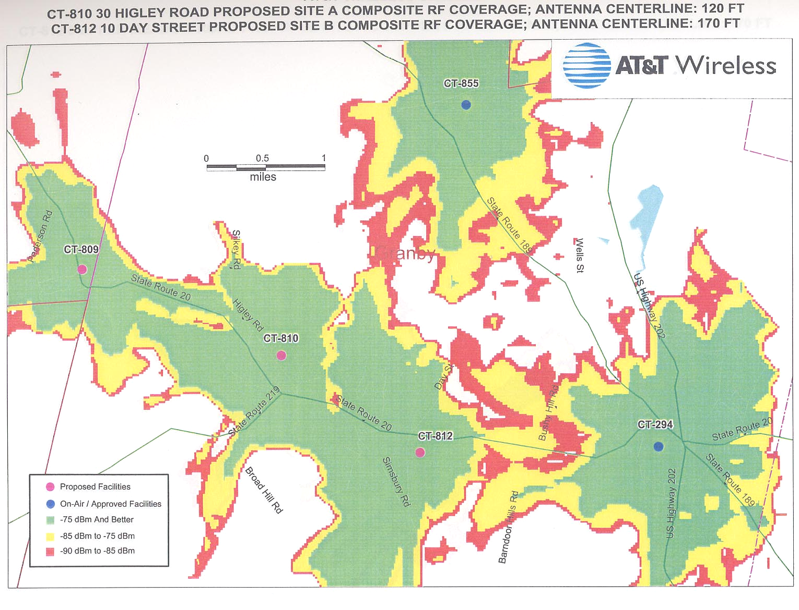
(AT&T 1, Attachment 3)
Map 7
Composite Coverage with CT-810 Site B and CT-812 Site A
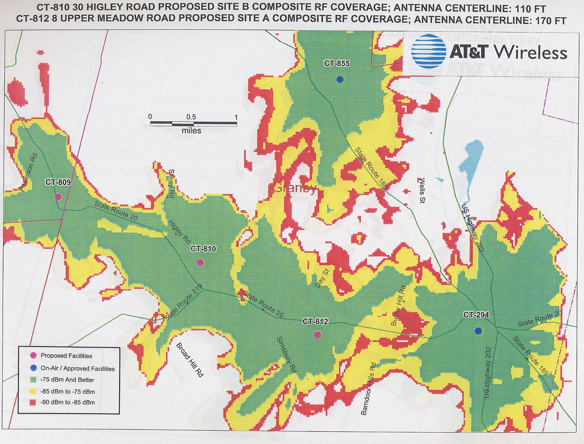
(AT&T 1, Attachment 3)
Map 8
Composite Coverage with CT-810 Site B and CT-812 Site B
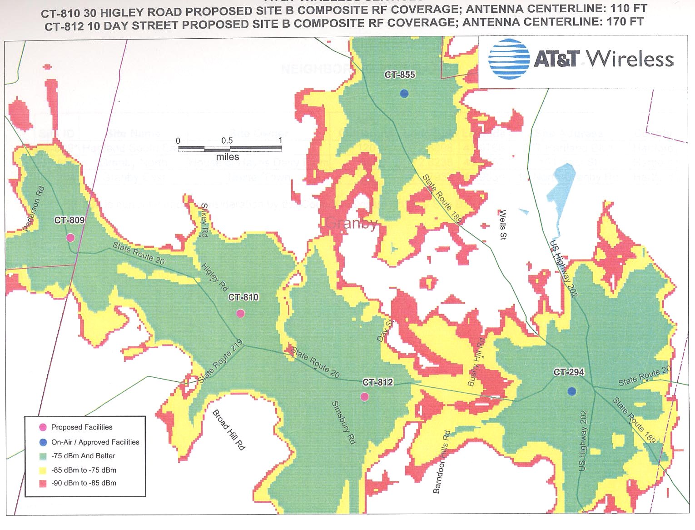
(AT&T 1, Attachment 3)

