DOCKET NO. 202 - Crown Atlantic Company LLC and Cellco Partnership d/b/a Cellco Wireless application for a Certificate of Environmental Compatibility and Public Need for the construction, maintenance, and operation of a cellular telecommunications facility off of Buttonball Road, located approximately 1,000 feet south of the intersection of Buttonball Road and the Amtrak railroad right-of-way, Old Lyme; or at 125 Mile Creek Road, Old Lyme, Connecticut. | }  }  } | Connecticut  Siting  Council  September 12, 2001

Findings of Fact

Introduction

- Crown Atlantic Company LLC (Crown) and Cellco Partnership (Cellco) d/b/a Verizon Wireless in accordance with provisions of Connecticut General Statutes (C.G.S.) §§ 16-50g through 16-50aa applied to the Connecticut Siting Council (Council) on April 13, 2001, for the construction, operation, and maintenance of a cellular telecommunications facility in Old Lyme, Connecticut, to provide cellular coverage within the New London County, New England County Metropolitan Area (NECMA). (Crown/Cellco 1, pp. 1, 2, 7, 8; Crown/Cellco 1, Sec. 7)

- Parties and intervenors in this proceeding include the applicant, the Town of Old Lyme Zoning Commission, John P. and Judith A. McCarthy, and James B. Blair. (Transcript, June 21, 2001, 3:00 p.m., (Tr. 1), p. 5; Transcript, June 21, 2001, 7:00 p.m., (Tr. 1.1), p. 5)

- On May 16, 2001, the applicant submitted a supplement to the application for an alternative tower site (alternative #2) at 71 Buttonball Road, in Old Lyme, Connecticut. On June 5, 2001, the applicant withdrew the proposed Alternate #2 site from future consideration. (Crown/Cellco 8; Crown/Cellco 11; Tr. 1, pp. 12, 13)

- Pursuant to C.G.S. § 16-50m, the Council, after giving due notice thereof, held a public hearing on June 21, 2001, beginning at 3:00 p.m. and continuing at 7:00 p.m. in the Community Room of the Old Lyme Public Library, 2 Library Lane, Old Lyme, Connecticut. (Council's Hearing Notice dated May 25, 2001; Tr. 1, p. 3)

- The Council and its staff made an inspection of the proposed prime and alternate sites on June 21, 2001. During the field inspection, the applicant flew balloons at the proposed sites to simulate the height of the proposed towers. The applicant also flew balloons at the proposed sites on June 9, 2001, from 10:00 a.m. to 3:00 p.m. to simulate the height of the proposed towers. (Crown/Cellco 1, p. 14; Tr. 1, pp. 13, 14, 47; Tr. 1.1, pp. 74, 75)

- Pursuant to C.G.S. § 16-50l(e), on January 19, 2001, the applicant met with and provided copies of the Technical Report to the Town of Old Lyme's First Selectman and Town Planner for the development of a cell site in the Town of Old Lyme. Following the 60-day consultation period, the Town of Old Lyme requested that the applicant consider the alternative #2 tower site, located at 71 Buttonball Road in Old Lyme, Connecticut. (Crown/Cellco 1, p. 19; Crown/Cellco 8, pp. 1, 3)

- There are no adjoining municipal boundaries within 2,500 feet of the proposed prime or alternate site. (Crown/Cellco 1, Sec. 3, p. 2; Crown/Cellco 1, Sec. 4, p. 2)

- The applicant certified that copies of the application for a Certificate were sent via certified mail, return receipt requested, to municipal, regional, state, and federal officials, pursuant to C.G.S. § 16-50l(b). Notice of the application was published in The Day on April 11, 2001 and April 12, 2001. Notice of the filing of the supplement to the application was published in The Day on May 14, 2001 and May 15, 2001. The applicant certified that notice of the application, and the supplement to the application was sent to each owner of property which abut the proposed prime or alternate site, pursuant to C.G.S. § 16-50l(b). (Crown/Cellco 1, pp. 5, 6; Crown/Cellco 1, Sec. 6; Crown/Cellco 1, Sec. 8; Crown/Cellco 2; Crown/Cellco 3; Crown/Cellco 7; Letter from Kenneth C. Baldwin to Joel M. Rinebold dated April 18, 2001; Crown/Cellco 8, pp. 2, 3; Crown/Cellco 8, Sec. 5)

- The Town of Old Lyme Zoning Commission has directed previous applicants for a telecommunications tower be responsible for its removal if and when it becomes obsolete and unused. The Zoning Commission requests that the Council consider a similar requirement for the removal of obsolete or unused towers. The Zoning Commission would also prefer a single equipment building with suitable architectural treatment and landscaping. (Crown/Cellco 1b, Zoning Regulations, p. 22-10; Town of Old Lyme Zoning Commission 1; Tr. 1.1, pp. 64, 65)

Cellular Service Design

- In 1981, the Federal Communications Commission (FCC) recognized a public need for technical improvement, wide-area coverage, high-quality service, and competition in the provision of mobile telephone service. This included the issuance of two licenses for the provision of cellular service at the wholesale level in each market area. (Crown/Cellco 1, p. 6)

- In 1996, the United States Congress recognized a nationwide need for high quality wireless telecommunications services, including cellular telephone service. The Federal Telecommunications Act of 1996 seeks to promote competition, encourage technical innovations, and foster lower prices for telecommunications services. Furthermore, the Federal government has preempted the determination of public need for wireless service by the states, and has established design standards to ensure technical integrity and nationwide compatibility among all systems. (Crown/Cellco 1, pp. 6, 7)

- Cellco is licensed by the Federal Communications Commission (FCC) to operate a cellular system. Cellco's cellular system design provides for frequency reuse and handoff, is capable of orderly expansion, is compatible with other cellular systems, and is in conformity with Code of Federal Regulations 47 C.F.R. Part 22, Subpart K. (Crown/Cellco 1, pp. 4, 7, 8, 9)

- Cellco would only provide digital cellular service from the proposed Old Lyme sites. Adjacent Cellco facilities located in Old Saybrook and Old Lyme currently provide both analog and digital cellular service. A Cellco subscriber with an analog only phone would not notice any improvement in service by the additional coverage provided by the proposed facilities. (Crown/Cellco 5, RPHQ #5; Tr. 1, p. 24)

- The minimal signal level threshold required by Cellco to provide acceptable service in and around the Old Lyme area is -85 dBm. The minimal signal level threshold is determined by several factors including the amount of interference in the area, the projected traffic usage, and the extent of development of the area. The level of interference in the Old Lyme area is considered higher than normal because of the proximity of the Long Island "A" band cellular system. (Crown/Cellco 5, RPHQ #6; Tr. 1, pp. 53, 54)

Need

- The primary purpose of this application is to provide cellular coverage to existing gaps in coverage along Interstate 95 (I-95), Route 156, the Amtrak railroad right-of-way (ROW), and local roads in the Old Lyme area; and to provide additional traffic handling capacity in the Old Lyme area. (Crown/Cellco 1, pp. 2, 8; Crown/Cellco 1, Sec. 1, pp. 1 to 4; Crown/Cellco 1, Sec. 2, p. 2; Tr. 1, p. 42)

- Existing cellular coverage in the Old Lyme area is provided by facilities at 38 Hatchetts Hill Road in Old Lyme, and 2 Ferry Place in Old Saybrook. Cellco's existing cellular coverage along I-95, Route 156, and the Amtrak ROW, within a two mile radius of the intersection of the Amtrak ROW and Buttonball Road at a signal level threshold greater than -85 dBm, is as follows:

Existing Coverage

 | Coverage (miles)  ≥ -85 dBm | Total Road  Miles
I-95 | 1.8 | 2.2
Route 156 | 1.5 | 4.4
Amtrak ROW | 0.8 | 4.0
(Crown/Cellco 1, p. 8; Crown/Cellco 1, Sec. 1, pp. 1, 2; Crown/Cellco 5, RPHQ #9)

*See Appendix A
Cellco

- Cellco's existing and proposed coverage on the proposed prime tower at 150, 130, and 110 feet above ground level (AGL) within a two mile radius of the intersection of the Amtrak ROW and Buttonball Road, would be as follows:

Coverage from the Proposed Prime Site Tower

 | Coverage (miles)*  ≥ -85 dBm at 150 ft  AGL | Coverage (miles)  ≥ -85 dBm at 130 ft  AGL | Coverage (miles)  ≥ -85 dBm at 110 ft  AGL | Total Road  Miles
I-95 | 2.0 | 1.8 | 1.7 | 2.2
Route 156 | 4.0 | 3.9 | 3.3 | 4.4
Amtrak ROW | 3.5 | 3.1 | 2.7 | 4.0
(Crown/Cellco 1, Sec. 1, p. 3; Crown/Cellco 5, RPHQ #10, Attachment D; Crown/Cellco 10, RPHQ #34, Attachment 6; Crown/Cellco 10, RPHQ #35, Attachment 7)

*See Appendix B

- Cellco's existing and proposed coverage on the proposed alternate tower at 160, 150, and 140 feet AGL within a two mile radius of the intersection of the Amtrak ROW and Buttonball Road, would be as follows:

Coverage from the Proposed Alternate Site Tower

 | Coverage (miles)*  ≥ -85 dBm at 160 ft AGL | Coverage (miles)  ≥ -85 dBm at 150 ft AGL | Coverage (miles)  ≥ -85 dBm at 140 ft AGL | Total Road  Miles
I-95 | 2.0 | 1.9 | 1.9 | 2.2
Route 156 | 4.4 | 4.3 | 3.9 | 4.4
Amtrak ROW | 4.0 | 3.6 | 3.3 | 4.0
(Crown/Cellco 1, Sec. 1, p. 4; Crown/Cellco 5, RPHQ #10, Attachment D; Crown/Cellco 12, RPHQ #38, Attachment 1; Crown/Cellco 12, RPHQ #39, Attachment 2)

*See Appendix C

- A coverage gap located along I-95, west of the proposed sites, could prevent the successful hand-off of a call between Cellco's existing sites in Old Saybrook and Old Lyme, even if a telecommunications facility was developed at either proposed site. Cellco has initiated a new search for another tower west of the proposed sites (Old Lyme West site) to provide service to the coverage gaps along I-95. Cellco has also initiated a new search for another tower located southeast of the proposed sites (Rocky Neck site) to provide service to the coverage gaps south of I-95 and to the east. (Crown/Cellco 5, RPHQ #11, RPHQ #12; Crown/Cellco 10, RPHQ #36; Tr. 1, pp. 31, 32, 34, 35, 83)

- Cellco would seek to place their antennas at the 120-foot level on the tower to be developed at the Old Lyme West site, and at the 70-foot level on the tower to be developed at the Rocky Neck site, depending on the selected site elevation above mean sea level (AMSL). If Cellco's proposed antennas at the Old Lyme West site and the Rocky Neck site were raised in height, antennas on the proposed towers could be lowered in height. (Tr. 1, pp. 35, 65)

- Sprint PCS indicated that they may seek to co-locate on either of the proposed towers; however, Sprint PCS was not a party or intervenor to this proceeding, did not commit to co-locate on either of the proposed towers, did not submit radio-frequency propagation plots to demonstrate need for co-locating on the proposed facilities, and could not definitively indicate an antenna height that would satisfy their coverage requirements. (Tr. 1, pp. 10, 11, 22, 28, 29, 46; Tr. 1.1, pp. 84, 85)

- The proposed tower would be designed, and made available to accommodate at least three additional wireless telecommunications providers. The applicant would also make space available on either of the proposed towers for the Town of Old Lyme's public safety entities. No other telecommunications entity has committed to sharing either of the proposed towers. Space is available on the proposed towers for the placement of antennas for up to five telecommunications providers below Cellco's proposed antennas. (Crown/Cellco 1, pp. 2, 11, 12, 18; Crown/Cellco 1, Sec. 3, p. 9; Crown/Cellco 1, Sec. 4, p. 9; Crown/Cellco 10, RPHQ #20; Tr. 1, pp. 28, 30, 38, 40, 41, 69)

Site Search

- Cellco identified four existing telecommunications towers located within approximately three miles of the site search area including: a 90-foot tower, owned by Machnik Construction Co., located at 125 Mile Creek Road, Old Lyme; a 190-foot tower, owned by the Omnipoint Communications, located at 38 Hatchetts Hill Road, Old Lyme; a 180-foot tower, owned by Sprint, located at 30 Short Hills Road, Old Lyme; and a 115-foot smokestack serving as a Verizon Wireless facility, located at 2 Ferry Place, Old Saybrook. Existing towers and facilities would not provide adequate service to coverage gaps in the Old Lyme area because they are located too far from existing coverage gaps, would provide duplicate coverage as existing facilities, or do not offer adequate height. (Crown/Cellco 1, Sec. 2, pp. 1, 2; Crown/Cellco 5, RPHQ #9; Crown/Cellco 10, RPHQ #18, Attachment 1; Crown/Cellco 10, RPHQ #19, Attachment 2)

- The existing 90-foot tall tower, owned by Machnik Construction Co., located at 125 Mile Creek Road could be increased in height by 15 feet in compliance with the Town of Old Lyme's Zoning Regulations. (Town of Old Lyme Zoning Commission 1; Tr. 1.1, pp. 68, 69, 70)

- Cellco identified and investigated seven potential sites near the site search area located at the intersection of Buttonball Road and the Amtrak ROW, in Old Lyme. Five sites were rejected due to topography, proximity to a new residential subdivision, and the landowners' reluctance to sell or lease property. Two of the sites were proposed as the proposed prime and alternate sites. (Crown/Cellco 1, Sec. 2, pp. 2, 3, 4)

Proposed Equipment

- Crown/Cellco would lease a 100-foot by 100-foot parcel on which Crown would develop a 190-foot tall steel monopole tower, and a 12-foot by 30-foot equipment building on either the proposed prime or alternate site. The proposed compound would be enclosed by an 8-foot high security fence and gate. (Crown/Cellco 1, pp. 2, 3, 12, 18; Crown/Cellco 1, Sec. 3, pp. 1, 6, 8, 9; Crown/Cellco 1, Sec. 4, pp. 1, 6, 8, 9)

- A single equipment building could be constructed at either proposed site to accommodate the telecommunications equipment for at least three other telecommunications providers. (Tr. 1, pp. 15, 71, 72)

- Cellco proposes to attach twelve approximately four-foot tall cellular panel antennas on a triangular platform at approximately 150 feet AGL at the proposed prime site, or at approximately 160 feet AGL at the proposed alternate #1 site. A global positioning system (GPS) antenna would be attached at approximately 70 feet AGL on either the proposed prime or alternate towers. (Crown/Cellco 1, pp. 12; Crown/Cellco 1, Sec. 3, p. 8, 9; Crown/Cellco 1, Sec. 4, pp. 8, 9; Tr. 1, pp. 37, 38)

- The proposed 190-foot tall monopole tower at either the proposed prime or alternate #1 site would be approximately six feet in diameter at the base and three feet in diameter at the top, and designed to withstand pressures equivalent to a 90 miles per hour wind load with one-half inch solid ice accumulation in accordance with Electronic Industries Association Standard EIA/TIA 222-E, Structural Standards for Steel Antenna Towers and Support Structures. (Crown/Cellco 1, Sec. 3, p. 8 Crown/Cellco 1, Sec. 4, p. 8)

- Cellco could utilize a stealth flagpole tower; however, Cellco may need to occupy multiple mounting locations within the flagpole structure to provide adequate capacity for Cellco's projected level of service. (Tr. 1, pp. 19, 20, 23)

- The applicant could design and construct a tower base and foundation capable of being extended from 150 feet AGL to 190 feet AGL. (Tr. 1, pp. 38, 39)

- The applicant could install netting at the top of the proposed tower to deter the nesting of Osprey and other birds on the proposed tower. The nesting of Osprey or other birds on the proposed tower would prohibit maintenance work or the addition of antennas, until the nests are vacated. (Tr. 1, pp. 15, 56, 84, 85)

- The proposed equipment building would house Cellco's radio equipment, automatic heating and cooling equipment, and a 40-kilowatt diesel-fueled emergency generator. The proposed generator would run only during the interruption of electrical service and for maintenance. The proposed generator would have a 275-gallon belly tank that would be double-walled and equipped with leak detection alarms. Cellco would need to obtain a permit from the Connecticut Department of Environmental Protection (DEP) for the operation of the proposed generator. (Crown/Cellco 1, pp. 2, 3, 12; Crown/Cellco 1, Sec. 3, pp. 1, 10; Crown/Cellco 1, Sec. 4, pp. 1, 10; Crown/Cellco 1, Sec. 10; Crown/Cellco 5, RPHQ #13)

Proposed Prime/Alternate Site

- The proposed prime site would be located on an approximately 32-acre parcel, owned by the Black Hall Club, Inc., off of Buttonball Road, approximately 1,000 feet south of the Amtrak ROW in Old Lyme. The parcel is located north of a former quarry operation, west of the Black Hall Golf Club, and north and east of low density residential development. The proposed lease area is located at 41º-17'-37.9" North and 72º-18'-16.8' West, and has an elevation of approximately 10 feet AMSL. The lease parcel at the proposed prime site is generally level, and would require minimal clearing and grading for the development of the prime access road and site compound. Vehicular access to the proposed prime site compound would extend westerly from Buttonball Road along an existing driveway a distance of approximately 410 feet. The proposed access driveway would be approximately 12 feet wide. (Crown/Cellco 1, pp. 2, 17; Crown/Cellco 1, Sec. 3, pp. 1, 2, 4, 6, 7, 10; Tr. 1, pp. 14, 15)

- There are approximately eleven homes within a 1,000-foot radius of the proposed prime site. The nearest residential structure is located approximately 340 feet east of the proposed tower. (Crown/Cellco 1, p. 14; Crown/Cellco 1, Sec. 3, p. 11; Crown/Cellco 5, RPHQ #1, Attachment A Prime Site; Crown/Cellco 5, RPHQ #14)

- The fall zone of the proposed 190-foot tall tower would encroach upon two properties located approximately 90 feet north of the proposed prime site lease area boundary. The fall zone of a tower constructed 150 feet tall or less, located in the southern portion of the proposed prime site lease area, would not encroach upon other nearby properties. Alternatively, the proposed prime site compound could be relocated approximately 165 feet south of its current location; however, the proposed prime site compound would be closer to on-site wetland areas. (Crown/Cellco 5, RPHQ #2, Attachment B, Flood Zone Exhibit - Prime Site; Crown/Cellco 10, RPHQ #22)

- The proposed alternate #1 site would be located on an approximately 62-acre parcel located at 125 Mile Creek Road in Old Lyme, owned by Leon Machnik, Todd J. and Rebecca L. Machnik. The 62-acre parcel is used as the base of operations for the Machnik Construction Company. Low density residential development is located to the east, west, and north of the proposed alternative #1 site. The proposed lease area is located at 41º-18'-20.0" North and 72º-17'-50.5'' West, and has an elevation of approximately 49 feet AMSL. The lease parcel at the proposed alternate site slopes gently up from the north to the south toward the alternate site compound. Minimal clearing and grading would be required for the use of the proposed alternate access road and site compound. Vehicular access to the proposed alternate site compound would extend southerly from Mile Creek Road along an existing driveway a distance of approximately 450 feet. (Crown/Cellco 1, pp. 2, 3, 17; Crown/Cellco 1, Sec. 4, pp. 1, 2, 4, 6, 7, 10; Tr. 1, p. 23)

- There are approximately five homes within a 1,000-foot radius of the proposed alternate #1 site. The nearest residence is located approximately 550 feet north of the proposed alternate #1 site. (Crown/Cellco 1, p. 14; Crown/Cellco 1, Sec. 4, p. 11; Crown/Cellco 5, RPHQ #1, Attachment A, Proposed Alternate Site Plan)

- The fall zone of the proposed tower at the proposed alternate #1 site would not extend beyond the boundaries of the proposed alternate #1 site. (Crown/Cellco 5, RPHQ #1, Attachment A, Proposed Alternate Site Plan)

- A private airstrip, which is owned by the proposed lessors, is located on the proposed alternate #1 site. The proposed tower on the proposed alternate #1 site would not require marking and lighting because the airstrip is private. (Crown/Cellco 6; Tr. 1, pp. 48, 57)

- The proposed prime and alternate sites are located within a residential RU-40 zone. According to the Town of Old Lyme Zoning Regulations, telecommunications facilities are permitted by special exception in Light Industry (LI-80S) zones only. The only LI-80S zone in the Town of Old Lyme is located in the eastern portion of the Town immediately south of Interstate 95, a distance of between 2.3 miles and 1.6 miles from the proposed prime and alternate sites, respectively. Cellco already shares an existing telecommunications facility within the LI-80S zone at 38 Hatchells Hill Road. (Crown/Cellco 1, p. 2, 18; Crown/Cellco 1, Sec. 3, p. 6; Crown/Cellco 1, Sec. 4, p. 6; Crown/Cellco 1b, Zoning Map revised 8-1-96; Crown/Cellco 1b, Zoning Regulations of the Town of Old Lyme)

- According to the Old Lyme Zoning Regulations, telecommunications towers shall be limited to a maximum height of 199 feet AGL; designed to accommodate tower sharing; preferred as a monopole tower with a galvanized or painted finish; prohibited to support signage; and set back at least 500 feet from any existing residential structure, and at least 75 feet from a property line. Telecommunications equipment shelters shall not exceed a gross floor area of 750 square feet; be designed to be compatible with other buildings in the area; arranged in a cluster around the proposed tower; and setback 50 feet from a street line and 35 feet from the property line. The maximum building or structure height in an RU-40 zone is 35 feet. (Crown/Cellco 1b, Zoning Regulations of the Town of Old Lyme, Schedule A-2, pp. 22-7 to 22-10)

- According to the Old Lyme Plan of Conservation & Development adopted August 10, 2000, the proposed prime and alternate sites are located in areas that are designated for Rural Residential land use. The area immediately north and west of the proposed prime site has been designated as an area of Conservation Interest. The State of Connecticut Conservation and Development Policies Plan identifies the proposed prime and alternate sites as being Rural land near Conservation Areas. (Crown/Cellco 1, p. 18; Crown/Cellco 1a; Connecticut Conservation and Development Policies Plan 1998-2003)

- According to the Town of Old Lyme Wetlands and Water Courses Regulations, a Regulated Activity is any activity taking place in, or within 100 feet of a wetland or watercourse involving the removal or deposition of any materials; the placement or construction of any structure or building; or any activity that may be detrimental to wetlands or watercourses. (Crown/Cellco 1c, Wetlands and Water Courses Regulations, p. 2)

- According to the Federal Emergency Management Agency Flood Insurance Rate Map, the proposed prime site is located within Flood Zone C, characterized as areas of minimal flooding. (Crown/Cellco 1, p. 19; Crown/Cellco 5, RPHQ #2, Attachment B; Crown/Cellco 5, RPHQ #3)

- The approximate cost of construction for the development of the proposed prime and alternate sites is estimated to be approximately $1,010,000, and $1,020,000 respectively, as follows:

 | Prime | Alternate #1
Cell site radio equipment | 650,000 | 650,000
Tower and antennas | 100,000 | 100,000
Power Systems | 45,000 | 45,000
Building Costs | 65,000 | 65,000
Miscellaneous Costs (including  site preparation and installation) | 150,000 | 160,000
Total Costs | $$1,010,000 | $1,020,000
(Crown/Cellco 1, pp. 21, 22)

- Crown believes that the proposed alternate #1 site would be preferable to the proposed prime site because the proposed telecommunications facility at the proposed alternate #1 site would be less visible, and would have the least environmental effect, given the nature of the development and current uses of the property. (Tr. 1, pp. 54, 55, 101; Tr. 1.1, p. 86)

Environmental Considerations

- According to the Connecticut DEP, neither the proposed prime or alternate #1 site contain known extant populations of Federal or State Endangered, Threatened or Special Concern Species. (Crown/Cellco 1, pp. 15, 20; Crown/Cellco 1, Sec. 5)

- No wetlands or watercourses exist within the proposed compound or proposed access road at the proposed sites. The proposed prime site compound and access road would be located approximately 100 feet and 42 feet north of a large pond, respectively. (Crown/Cellco 1, Sec. 3, pp. 6, 10; Crown/Cellco 1, Sec. 4, pp. 6, 10; Crown/Cellco 5, RPHQ #2, Attachment A, Proposed Site Plan; Crown/Cellco 10, RPHQ #21; Tr. 1, pp. 98, 99)

- The trees in the vicinity of the proposed sites are predominantly deciduous and approximately 75 feet in height. (Connecticut DEP Comments dated June 15, 2001; Tr. 1, pp. 41, 97)

- The State Historic Preservation Office (SHPO) has determined that construction of the proposed prime or alternate #1 site would have no effect on historic, architectural, or archaeological resources listed on or eligible for the National Register of Historic Places. The SHPO's review is conditioned upon all construction related activities, including trenching for the proposed access drive at 125 Mile Creek Road, being located to its western extent in order to avoid physical impact to the J. Brown historical archaeological site. (Crown/Cellco 1, pp. 15, 21; Crown/Cellco 1, Sec. 5, Letter from Dawn Maddox to Rachel A. Mayo dated February 14, 2001; Crown/Cellco 1e; Crown/Cellco 10, RPHQ #24)

- Crown would install soil erosion and sedimentation control measures throughout the proposed construction period in accordance with the Connecticut Guidelines for Soil Erosion and Sediment Control. (Crown/Cellco 1, p. 19)

- The applicant did not determine if subsurface blasting would be required for the construction of the proposed tower foundation at the proposed sites. (Crown/Cellco 10, RPHQ #23)

- Crown uses an airspace program to determine if the proposed towers would be a hazard to air navigation. No obstruction or notice standards were exceeded in this analysis; therefore, notification to the Federal Aviation Administration is not required. Neither the prime or alternate tower would require marking or lighting. (Crown/Cellco 1, pp. 18, 20; Crown/Cellco 6)

- The electromagnetic radiofrequency power densities, calculated using the FCC Office of Engineering and Technology Bulletin 65, August 1997, using conservative worst-case approximation of radiofrequency power density levels at the base of each tower would be 5.2 percent of the American National Standards Institute (ANSI) Standard for the proposed prime site, or 4.6 percent of the applicable ANSI standard for the proposed alternate #1 site. An antenna height of 130 feet AGL would produce a worst-case of radiofrequency power density level at the base of the tower of 6.9 percent of the applicable ANSI standard. (Crown/Cellco 1, p. 16; Crown/Cellco 1, Sec. 3, p. 11; Crown/Cellco 1, Sec. 4, p. 11; Crown/Cellco 10, RPHQ #32)

- Neither proposed facility would generate noise, except for the operation of the heating and air conditioning systems, and the emergency back-up generator. (Crown/Cellco 1, Sec. 3, p. 10; Crown/Cellco 1, Sec. 4, p. 10)

Visibility

- The visibility of the proposed prime site tower from various locations in the area would be as follows:

Visibility of Proposed Prime Tower

Location | 190 ft  Visible | Distance and Direction  To Tower
South End of Tinker Pond | No | 3,600 feet north
Flat Rock Hill Rd at Mile Creek Rd | No | 5,500 feet northeast
Mile Creek Rd. 4,000 feet south of  Flat Rock Hill Rd. | No | 5,000 feet east-northeast
Route 156 at Dogwood Drive | Yes | 4,600 feet southwest
Route 156 at Buttonball Rd. | No | 2,800 feet south
Route 156 at Pine Rd. | Yes | 3,200 feet west
Buttonball Rd | Yes | 1,000 feet north and south
Amtrak ROW | Yes | 2,400 feet east-northeast
5 Strawberry Lane cul-de-sac | Yes | 2,500 feet southwest
Homestead Circle | Yes | 2,100 feet southwest

(Crown/Cellco 1, Sec. 3, pp. 11-19; Tr. 1.1, p. 82)

- The visibility of the proposed alternate tower from various locations in the area would be as follows:

Visibility of Proposed Alternate #1 Tower

Location | 190-foot Visible | Distance and Direction  to Tower
Interstate 95 (I-95) at Whippoorwill Rd. | Yes | 4,800 feet northwest
Rowland Rd. 600 feet south of I-95 | No | 2,800 feet north
Flat Rock Hill Rd. at Browns Lane | No | 3,000 feet east
Mile Creek Rd. at Waite Cemetery | No | 5,100 feet southeast
Amtrak ROW at Buttonball Rd. | No | 4,000 feet southwest
Buttonball Rd. at Mile Creek Rd. | No | 2,300 feet west
Mile Creek Rd. at Whippoorwill Rd. | Yes | 3,600 feet west
Rowland Rd. at Flat Rock Hill Rd. | Yes | 1,050 feet northwest

(Crown/Cellco 1, Sec. 4, pp. 11-21)

APPENDIX A

Existing Coverage (≥ -85 dBm)

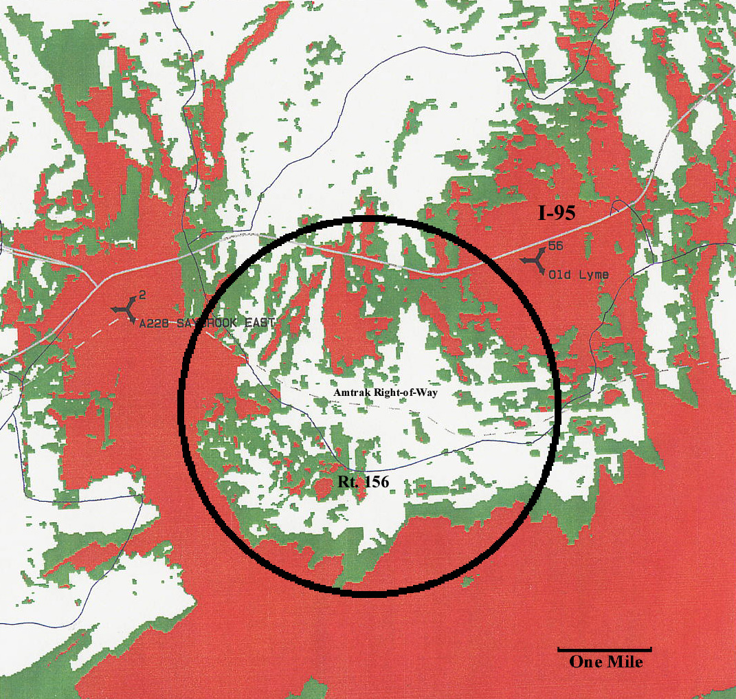
(Crown/Cellco 1, p. 8; Crown/Cellco 1, Sec. 1, p. 2)

APPENDIX B

Coverage from the Proposed Prime Site Tower (≥ -85 dBm)

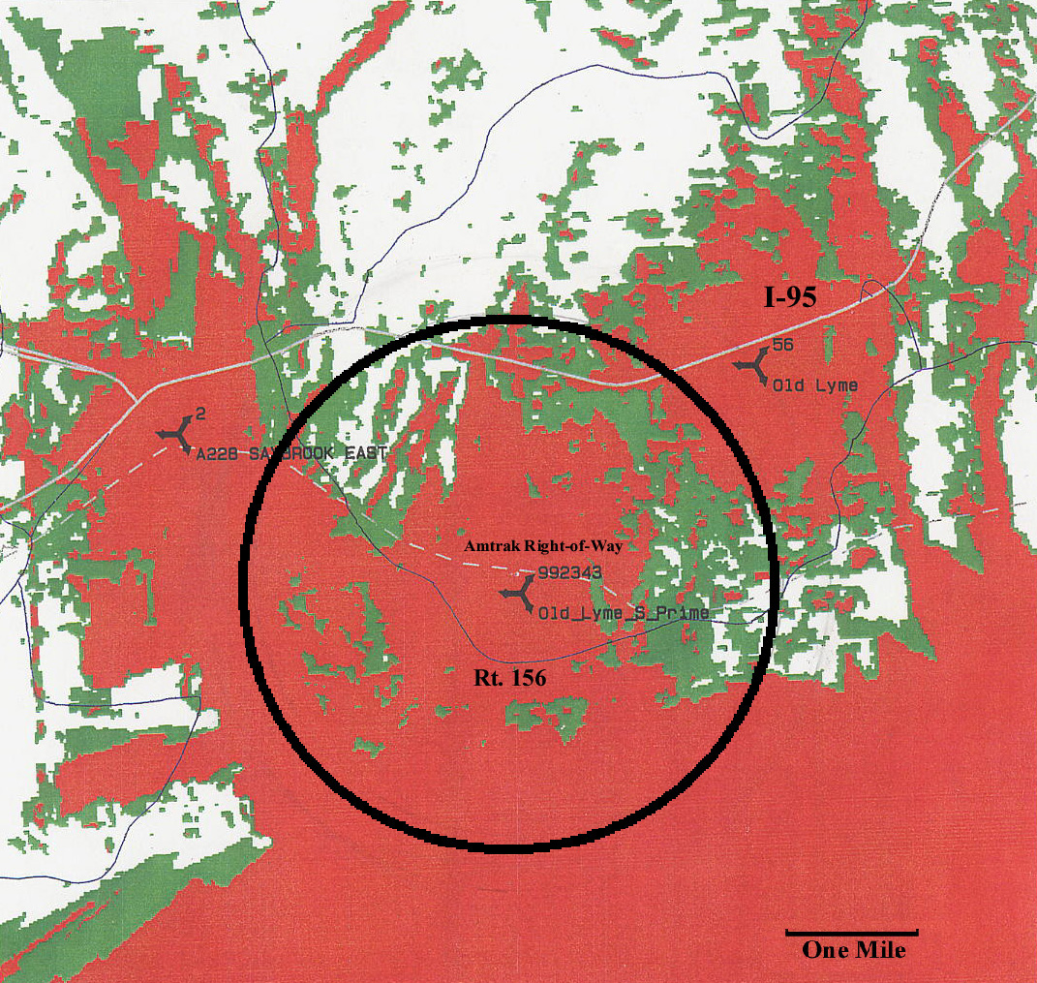
(Crown/Cellco 5, RPHQ #10, Attach. D; Crown/Cellco 10, RPHQ #34, Attachment 6; Crown/Cellco 10, RPHQ #35, Attachment 7)

APPENDIX C

Coverage from the Proposed Alternate Site Tower (≥ -85 dBm)

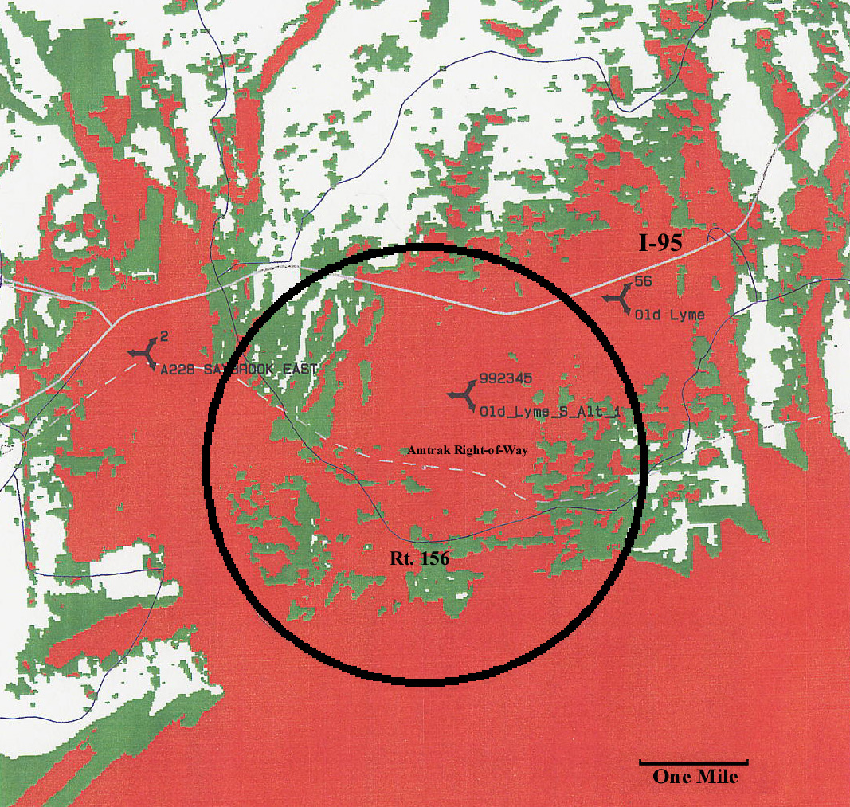
(Crown/Cellco 5, RPHQ #10, Attach. D; Crown/Cellco 10, RPHQ #34, Attachment 6; Crown/Cellco 10, RPHQ #35, Attachment 7)

