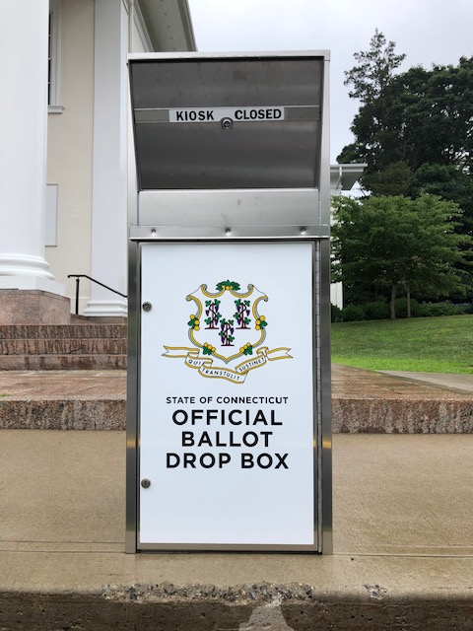
IMPORTANT! TO ENSURE THAT YOUR BALLOT WILL BE RECEIVED ON TIME, PLEASE PLACE YOUR BALLOT INTO BOTH THE INNER AND OUT ENVELOPES AND PLACE YOUR BALLOT INTO THE SECURE DROP BOX LOCATED IN YOUR MUNICIPALITY. ONCE DEPOSITED IN THE SECURE DROP BOX YOUR BALLOT IS CONSIDERED RECEIVED BY YOUR MUNICIPALITY. YOUR BALLOT SHOULD BE DEPOSITED IN THE SECURE DROP BOX NO LATER THAN 8 P.M. ON AUGUST 11, 2020.
[INSERT TOWN NAME AND LOCATION OF YOUR DROP BOX]

