### Personal Finance Showcase of Appreciation and Innovation

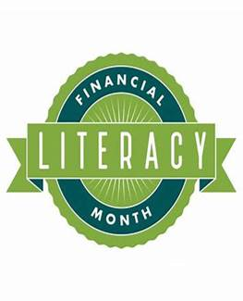Every year Financial Literacy is celebrated in April. It is said that the foundation of a bright future begins with developing a family budget and increasing your financial knowledge.   Let’s work together to use Financial Literacy as an opportunity for schools to encourage students and their families to engage in learning more about their finances. This is not only a celebration but a challenge!

Highlights from Connecticut CTE Teachers of Personal Finance

**3 Connecticut High School CTE Teachers Receive NGPF Gold Standard Challenge Grants for Ensuring All Students Receive A Personal Finance Course**

Palo Alto, Calif., UPDATED: Jan 12, 2022 - Next Gen Personal Finance (NGPF), a non-profit committed to ensuring that ALL students leave high school with the skills needed to thrive in an increasingly complex financial world, is pleased to announce 165 recipients of NGPF Gold Standard Challenge grants. Together, these schools serve over 145,000 high schoolers who will soon graduate with the financial education they deserve.

The [**NGPF Gold Standard Challenge**](https://www.ngpf.org/goldstandardchallenge) rewards and recognizes high schools that commit to ensuring that all students receive a one semester personal finance course before crossing the graduation stage. The 3 Connecticut CTE Teachers who led these efforts are Barbara Angelicola-Manzolli from Lewis Mills High School, Dan Clement from Somers High School, and Kimberly LaDuke from Ellington High School.  These three educators received board approval for a one semester personal finance course to be taken by ALL students with implementation to take place over the coming school years.

Read the published guest posts on the NGPF Blog from Connecticut’s winning teachers.  These short posts tell the story of how each grantee accomplished the personal finance guarantee in their high school:

[Barbara Angelicola-Manzolli: My 10-Year Advocacy Journey - Blog (ngpf.org)](https://www.ngpf.org/blog/advocacy/mission-2030-barbara-angelicola-manzollis-10-year-journey-create-high-school-personal-finance-graduation-requirement/)

[Dan Clement: The Answer to "Why Isn't This Course A Requirement?" - Blog (ngpf.org)](https://www.ngpf.org/blog/advocacy/mission-2030-dan-clement-best-answer-why-isnt-this-course-requirement/)

[Kimberly LaDuke Reinstates a Finance Graduation Requirement - Blog (ngpf.org)](https://www.ngpf.org/blog/advocacy/mission-2030-kimberly-laduke-reinstates-personal-finance-graduation-requirement/)