Bloomfield Public Schools
Presents
Using Children’s Literature to Navigate the Science & Engineering Practices
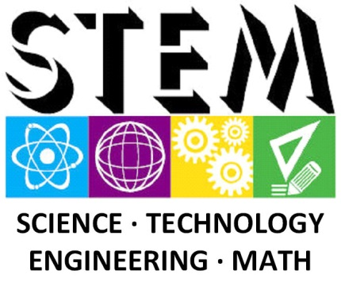
Stacey McCann, Chief Academic Officer, BPS
Dr. Beryl Irene Bailey, Director of Literacy
September 27, 2017
Purpose: To provide all educators with a functional and knowledgeable understanding of the K-12 Science and Engineering Practices.
Process: Engage educators in a CLOSE read and collaborative discussion of the K-12 Science & Engineering Practices and authentic science oriented children’s literature for the purpose of promoting a common understanding and clarity to facilitate interdisciplinary classroom instruction and knowledge of the K-12 Science and Engineering Practices.
Payoff:
- Participants will be engaged in strategic instruction in the science & engineering practices through the context of authentic children’s literature and/or science content.
- An inquiry, numeracy, and problem solving mindset and written communication skills within students through the CLOSE reading of science related mentor text and text dependent questions.
- Non-science educators supporting the science & engineering practices through their content using the Piece of the PIE chart. (Promoting Interdisciplinary Education)
- Science teams leading interdisciplinary school-wide planning sessions
PD Resources:
- PD handouts
- Text: Solving the Puzzle Under the Sea: Marie Tharp Maps the Ocean Floor
- Meta-textual Markers (Highlighters 5 colors- yellow, orange, green, pink, blue)

