Activity 6.7.3 Three-Dimensional Modeling: Designing a Model

Eleanor used 1-2-3D Design to make a virtual mock-up of the couch. She kept the colors of the different parts different so that she could keep track of them. If possible ask your teacher to run this page on a color printer or project it on a screen that shows color.
Note that the red legs are hemispheres. The purple and orange rounded parts are cylinders cut lengthwise at the diameter of the base. The yellow, green and blue parts are rectangular solids. She originally measured her picture in inches and then converted her inches to centimeters because the software 1-2-3D Design does all of its computations using metric units. The figure at the left shows what she saw in 1-2-3D design, the picture at the right is the result of combining the parts and exporting the .stl file [Note, this is a file extension like .docx – it stands for Stereo Lithography and is a standard file format for software created by 3D systems] to the MakerBot software.

The MakerBot software quickly created a virtual mock-up which she could measure in the software. The diagram printed from the MakerBot software showed the measurements of the couch.

1. Does this seem reasonable given the size of the people? Why, or why not?

As you noticed on the previous page, the couch was really large for such small people! Eleanor had made a mistake in her conversions from inches to centimeters. The proportions of the couch are correct, but there is a problem with her scale. Fortunately the MakerBot software lets her scale her couch down to a more appropriate size.

Before she can print out her model, she needs to know the volume of the couch so that she can see if there is enough plastic in the printer to print the couch at 10% fill. Note, 3-D printers usually do not print out solid models. The models they print out have a dense shell and are filled with a “honey-comb” hexagonal structure in the interior of the shape that keeps the shape stable, but doesn’t use too much material.

2. The next step is to find the volume of your version of her couch in cubic centimeters. Remember that each inch equals 2.54 centimeters. Find the volumes of the pieces to find the volume of the couch.

a. The rectangular solid for the seat (blue):

b. The rectangular couch arms (green): c. And their curved tops (purple):

d. The rectangular couch back (yellow): e. And its curved top (orange):

f. The hemispheric feet (red):

g. Now find the total volume:

3. Now we need to figure out if there is enough filament in the MakerBot to be able to print it out. The printer has about half a reel of filament left of 2 pounds on a full reel. There are 2.2 pounds in a kilogram. Each cubic centimeter of plastic weighs about 1.24g and a kilogram of filament is about 800 cubic cm. of solid plastic. Eleanor plans to print it at about 10% fill. It is made of PLA filament that is a nontoxic resin made of sugar derived from field corn.

- About how much filament does she have? Be certain to decide what units you are using!

- How much filament will she need? Recall that she will print the couch at about 10%. Be careful how you choose your units.

- Will she have enough filament?
- What is the density of the plastic (in grams per cubic centimeter)?
- What is density of the material used to make the couch?
- The density of water is 1 g/cm³. Objects that are denser than water will sink in water. Those that are less dense will float. Will Eleanor’s couch sink or float when placed in water? Explain.

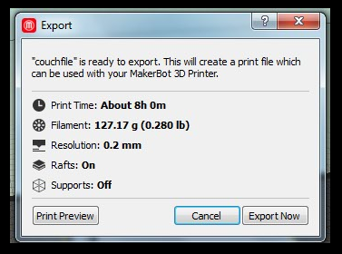
4. Before Eleanor rescaled her couch, the MakerBot software did a calculation of how much time it would take to print it out and how much filament would be needed to print it. How does your calculation compare with this?

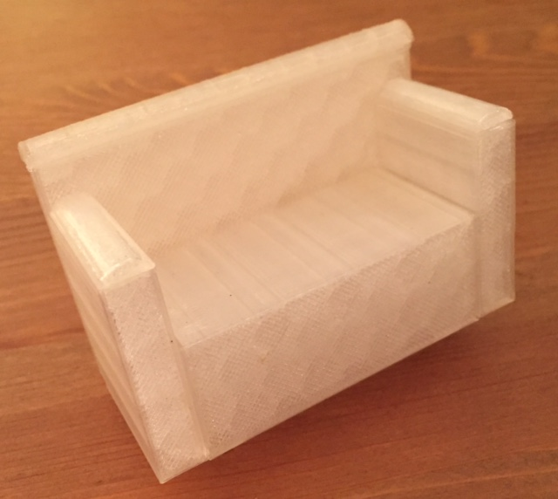
After she rescaled it she used 34.11 g of material and it took her 2 hours and 13 minutes to print it out. A picture of her final printed couch is shown at the right.

5. Is the amount of time it takes the MakerBot to print an object proportional to the amount of material in the object? Use the data given above to support your answer.

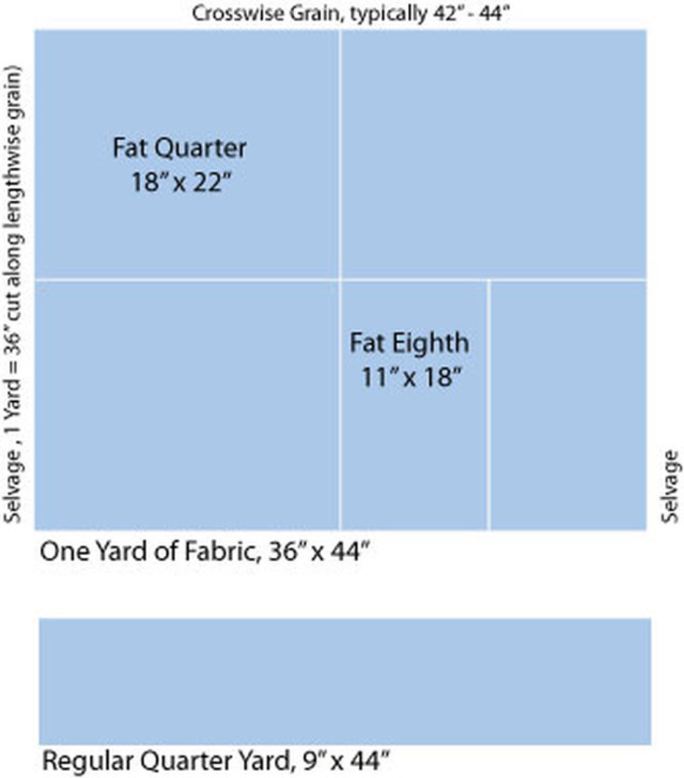

A couch will be little fun for her cousin, if it cannot be customized with fabric covering. Eleanor decides to take her cousin to the fabric store to purchase her cousin’s choice of fabric. She can buy the fabric in one of several ways. She can buy a “fat quarter”, a fat eighth or a regular quarter of a yard. Typically a fat quarter costs about $1.99, a fat eighth $1.77 and a regular quarter of a yard $2.49.

She figures that she won’t need to cover the bottom of the couch, but all of the other parts will be visible. So she makes nets with as few cuts as possible that will cover her couch.
6. Make a quick sketch of a possible net for your couch:

- Now make a more precise net for a cover for the couch you designed. Show how you calculate the area of your net. You may want to use graph paper. Attach your paper to this sheet.

- Use your net and the figure on the previous page to decide which kind of fabric cut would be best to cover your couch. Describe how you make your decision.

