Activity 5.2.6b Circumscribing a Circle about a Triangle (with GeoGebra)

Concurrent lines –3 or more lines that intersect at a single point.
Point of concurrency – The point where concurrent lines intersect.
Circumcenter – The point of concurrency of the perpendicular bisectors in a triangle.

Part 1 – Find the circumcenter of the triangle.
- Open a new Geogebra document

- Draw a triangle
- Press the “Polygon” icon. 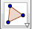
- Click three points on the screen and end by clicking back on the first point.

- Draw the perpendicular bisector of each side.
- Press the down-arrow button on the bottom right of the “Perpendicular Line” icon. 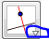
- Click on the “Perpendicualar Bisector” option
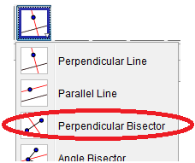
- Click on $\overline{AB}$
- Click on $\overline{BC}$
- Click on $\overline{AC}$

- Plot a point at the center of the circle.
- Press the down-arrow button on the Point icon. 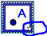
- Click on the “Intersect” option
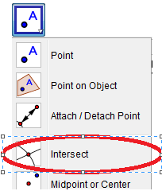
- Click once on each of the perpendicular bisectors.
- By definition, the result is the circumcenter!

- Move the points of the triangle.
- Move the vertices of the triangle to form an acute triangle. What did you notice about the location of the circumcenter?

- Move the vertices of the triangle to form an obtuse triangle. What did you notice about the location of the circumcenter?

- Move the vertices of the triangle to form a right triangle. What did you notice about the location of the circumcenter?

Part 2 – Draw a circle that passes through the vertices of the triangle

- Draw a circle
- Press the “Circle with Center through Point” icon.
- Click on the circumcenter and then on one vertex of the triangle. Notice that the circle passes through the other vertices of the triangle.
- We say that the circle that passes through points A, B, and C is circumscribed about ∆ABC.

Part 3 – Measure the distance from the circumcenter to each vertex

- Draw segments
- Press the down arrow of the “Line” icon. 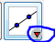
- Click on the “segment” option.
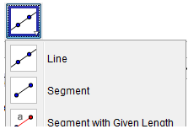
- Click on the circumcenter and then point A.
- Click on the circumcenter and then point B.
- Click on the circumcenter and then point C.

- Measure the length of the segments
- Find the length of the radius by clicking the down-arrow of the Angle button 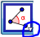
- Select “Distance or Length” button
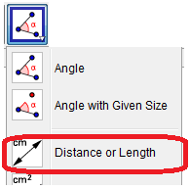
- Click on the circumcenter and then point A.
- Click on the circumcenter and then point B.
- Click on the circumcenter and then point C.
- The results show that the circumcenter is equidistant (the same distance) from each vertex in the triangle.

Part 4 – Explain what you learned

- The circumcenter is found by constructing the ___________________ ________________ of each side of the triangle.

- The circumcenter of a triangle is equidistant from the ___________________ of the triangle.

- The perpendicular bisectors of the sides of an ____________ triangle intersect outside the triangle.

- The perpendicular bisectors of the sides of an ____________ triangle intersect inside the triangle.

- The perpendicular bisectors of the sides of a ____________ triangle intersect on the hypotenuse of the triangle.

Part 5: Applying what you learned
Point G is the circumcenter of ΔABC. List any segment(s) congruent to each segment below.  (Not all segments are shown on the figure.)  - $\overline{AE}$  - $\overline{AG}$  - $\overline{BD}$  - $\overline{CF}$ | 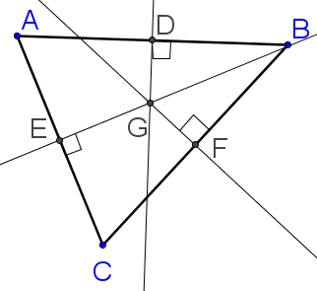

Error analysis: In the picture below, point G is the circumcenter. Explain why the student’s conclusions are false. Then state the correct conclusion that can be drawn

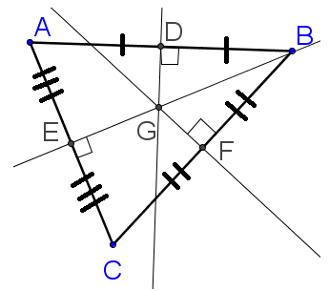

- ΔABC is an obtuse triangle

- $\overline{GD}≅\overline{GE}≅\overline{GF}$

- $\overline{BD}≅\overline{BF}$
Background: Many people forget that in November 1998, the New England Patriots signed an agreement with the governor of Connecticut to move the team from Massachusetts to the Nutmeg State. Unfortunately, the team backed out of the deal when the state of Massachusetts kicked in $70 million in highway improvements, NFL Loan guarantees, and commitments for luxury suits for Boston businesses.
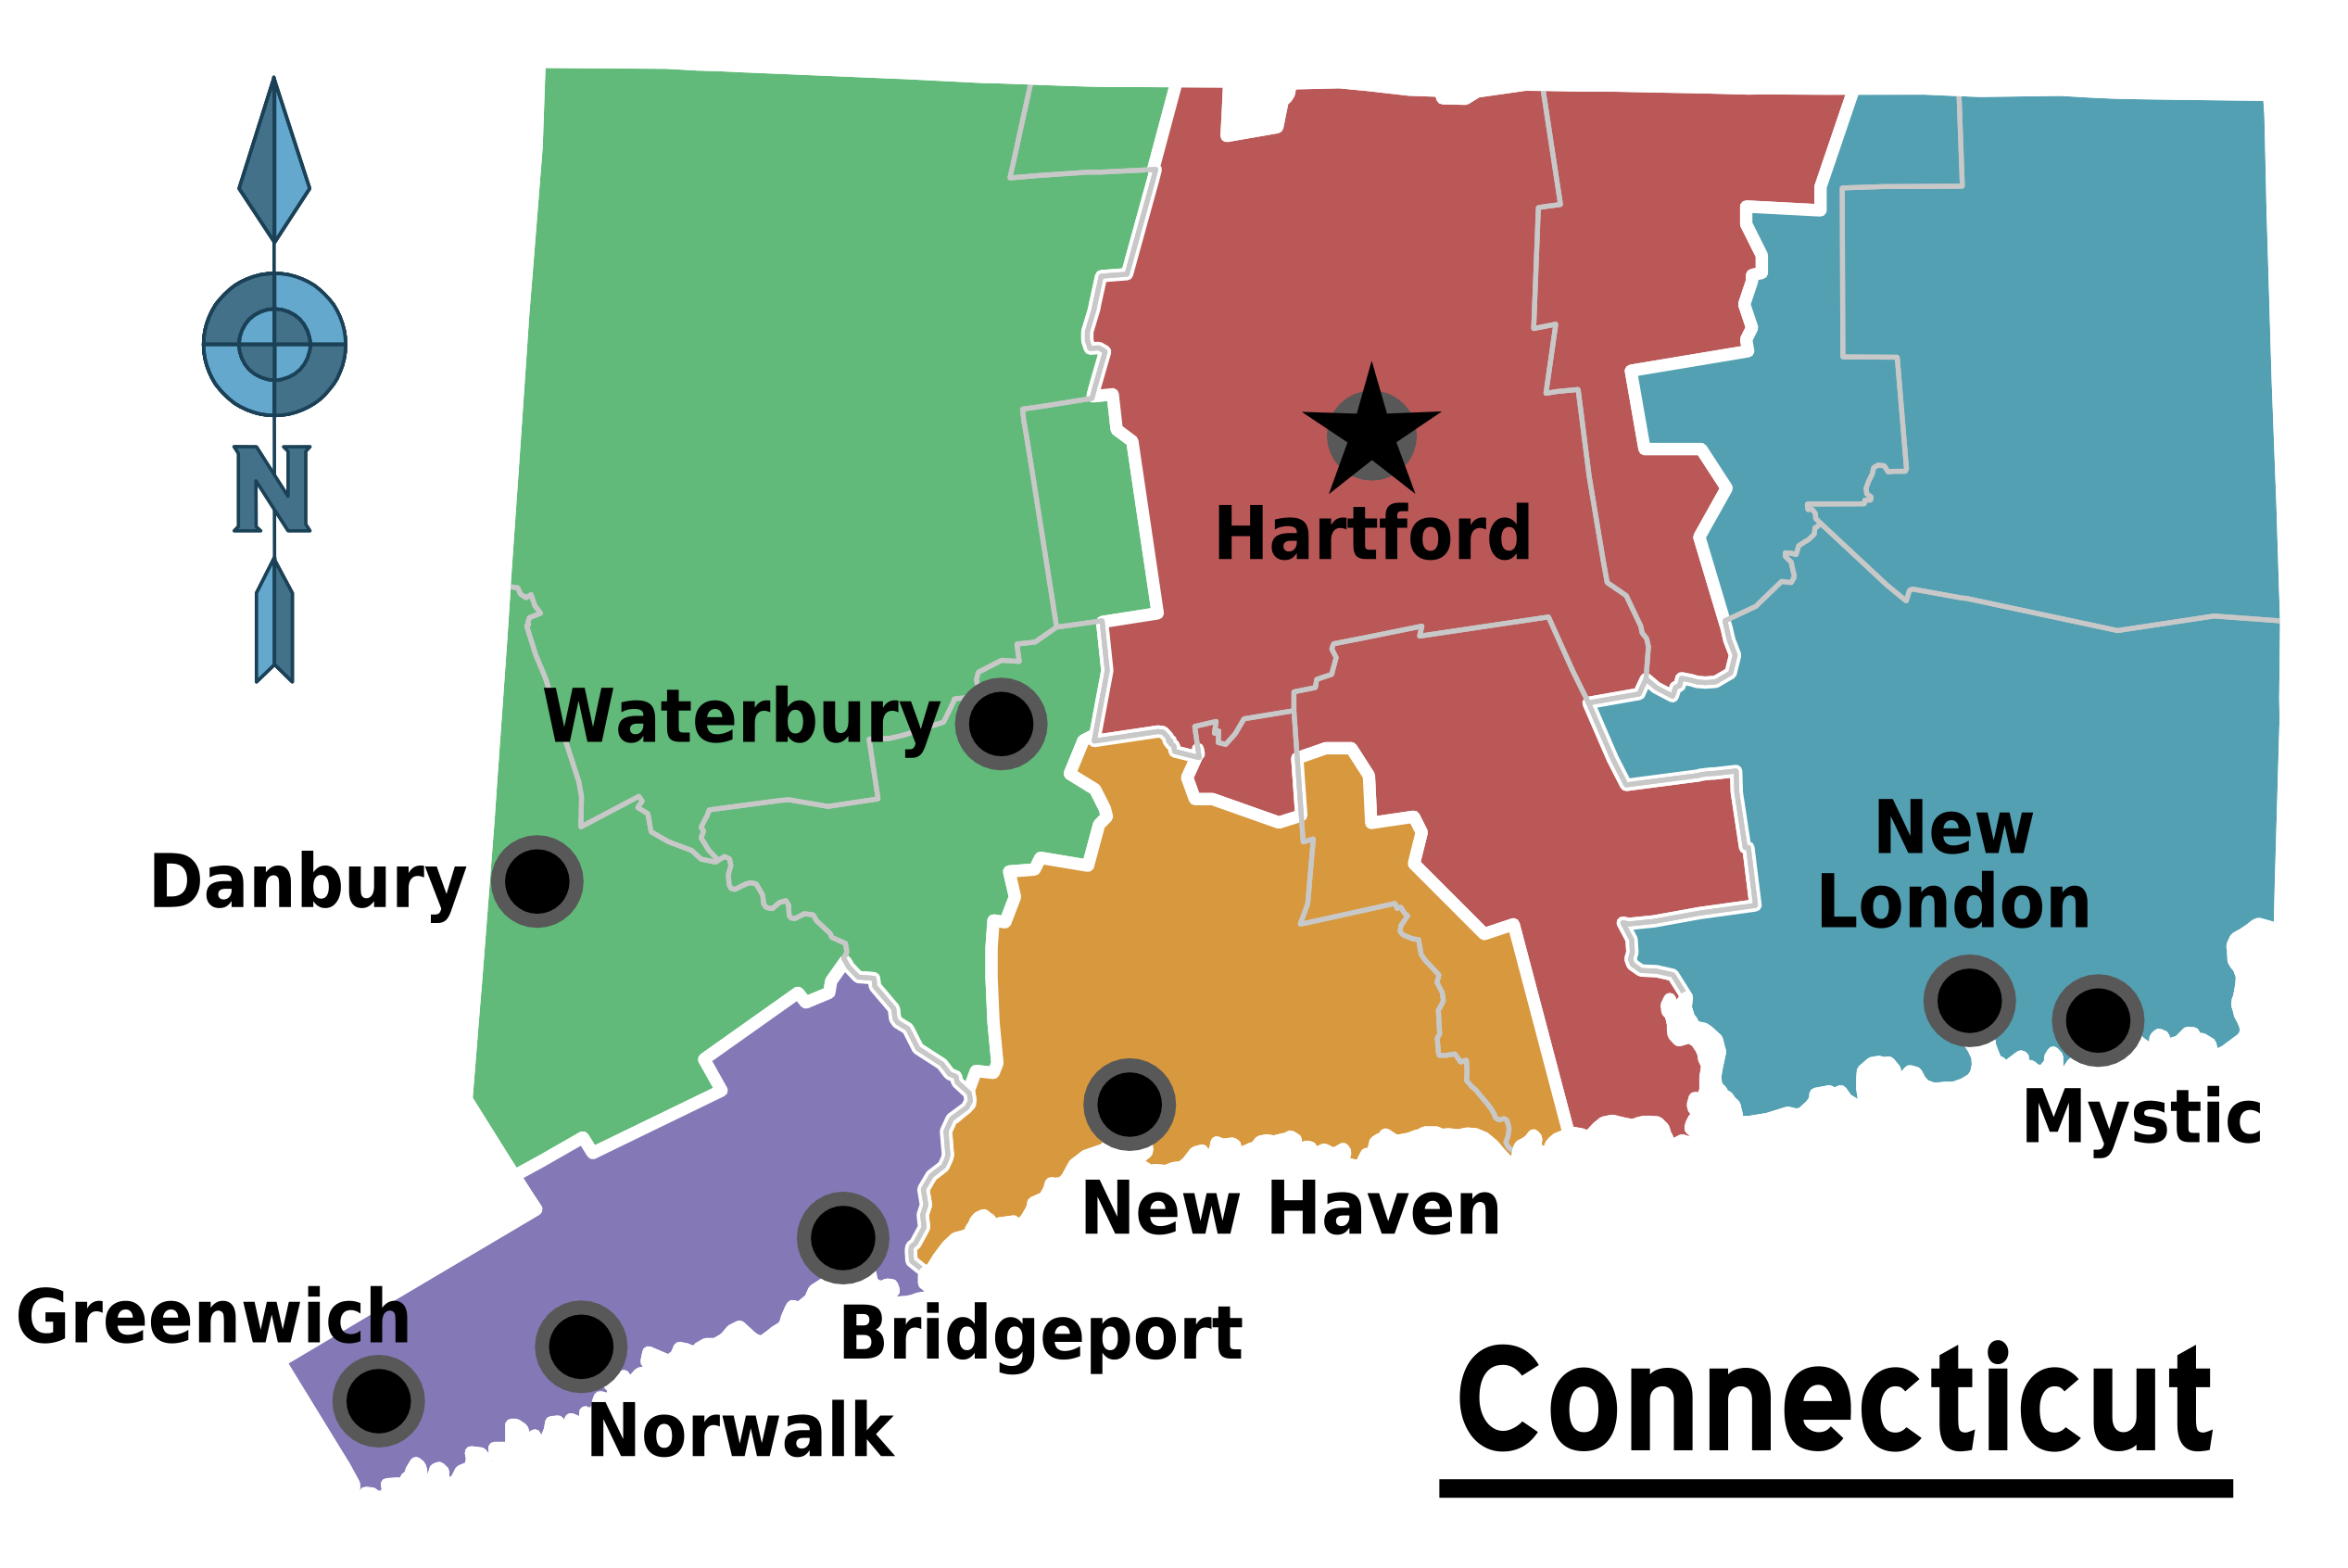
http://wikitravel.org/en/Connecticut

- In case a team does decide to come to Connecticut, you have been given the task to find the location of a brand new stadium. This stadium should be equidistant from three major cities. Choose any three cities on the map. (a) List them below and (b) connect the cities on the map by drawing a triangle.

- The building planners found the circumcenter of the triangle formed. Explain why using the circumcenter as the location of the stadium would be convenient for all the cities.

- Find the location of the stadium on the map. Explain the steps you took.

- How can you tell from the location of your stadium whether your three cities form a right, acute or obtuse triangle?

- Is the stadium located inside or outside of Connecticut?
Part 6: Proof

- Prove that the perpendicular bisectors of the sides of a triangle are concurrent.

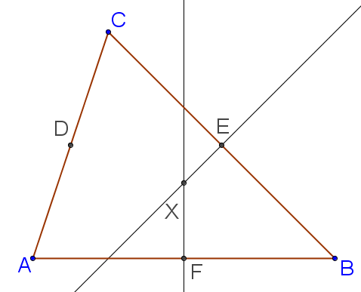
Given: ∆$ABC$
$\overset{⃡}{XE}$ is the perpendicular bisector of $\overline{BC}$
$\overset{⃡}{XF}$ is the perpendicular bisector of $\overline{AB}$

Prove: X lies on the perpendicular bisector of $\overline{AC}$. (Thus the three perpendicular bisectors are concurrent at X.)

