Activity 3.2.2 Exterior Angles of Polygons

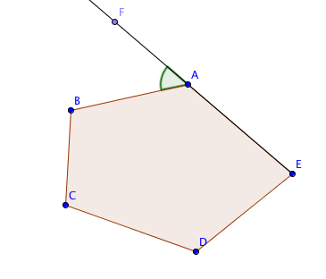
When one side of a convex polygon is extended beyond a vertex, the angle formed with the adjacent side is called an exterior angle of the polygon. In the figure at the right$∠$FAB is an exterior angle of pentagon ABCDE.

The exterior angle of a polygon and its adjacent angle form a linear pair. Recall that the definition of a linear pair: two angles that have a common side and whose other sides are opposite rays. In the diagram below $∠CAD and ∠ BAD$ form a linear pair. The Linear Pair Postulate states that the angles in a linear pair are supplementary, that is, the sum of their measures is 180°.

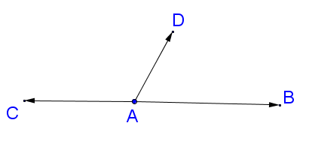

We will use this information to make a conjecture about relationships between exterior angles and the non-adjacent angles in a triangle.

- Using the definition of supplementary angles and linear pairs, what is the measure of $∠$NMP ?
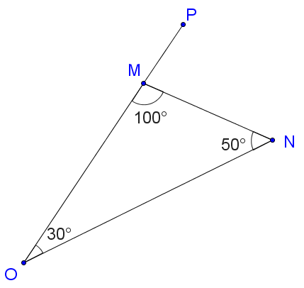

- What do you notice about the relationship between $∠$NMP and angles MON and ONM?

- Using the definition of supplementary angles and linear pairs, what is the measure of $∠$LIJ ?
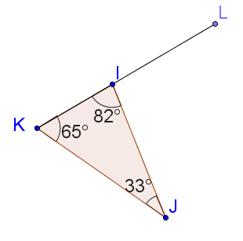

- What do you notice about the relationship between $∠$LIJ and angles IKJ and IJK?

- Using the definition of supplementary angles and linear pairs, what is the measure of $∠$EFH ?
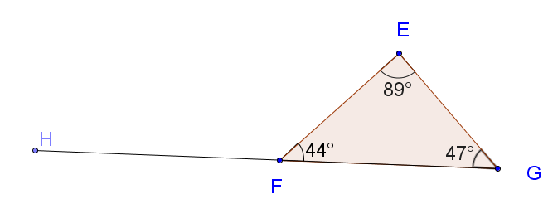

- What do you notice about the relationship between $∠$EFH and angles FEG and EGF?

- Based on what you have observed, make one or more conjectures.

- Ask a friend: Turn to your neighbor and write down their answer to question 7?

- Are you and your neighbor in agreement? If not, try to resolve any differences.

- Combine your thoughts from your answers to questions 7 and 8 to make final conjectures.

- After discussion with the entire class, prove your conjecture(s).

