Connecticut Department of Public Health
DPH FLIS Events Report Tracking System – Reportable Events User Manual

Connecticut Department of Public Health
Facility Licensing & Investigation Section
410 Capitol Ave, MS#12HSR
Hartford, CT 06134-0308

Telephone #: (860) 509-7400
Website: https://dphflisevents.ct.gov

Table of Contents

Chapter 1: DPH FLIS Events Report Tracking System - Getting Started
- Introduction
- Log into DPH FLIS Events Report Tracking System - Reportable Events
- Forgot/Reset Password

Chapter 2: Home Page and Filter Options
- Home Page
- Filter Options

Chapter 3: Initiate New Reportable Event
- Initiate New Reportable Event

Chapter 4: Summary Submission
- Summary Submission
- How to Attach Files to Summary Form
- Communicating with DPH FLIS Team

Chapter 5: Facility Administrator
- Facility Administrator Registration
- Create a New User for your facility
- Edit/Delete a user account
- Facility Roles

Chapter 1: DPH FLIS Events Report Tracking System- Getting Started

Introduction

DPH - Facility Licensing and Investigation Section (FLIS) is the agency that has regulatory oversight for all the licensed healthcare entities in the state. This manual will guide you through the Reportable Events website and its functionalities.
Welcome to the DPH FLIS Events Report Tracking System – Reportable Events user’s manual. This manual introduces you to the features of the DPH FLIS Events web application and provides detailed instructions on how to navigate through the website.
The DPH FLIS Events Report Tracking System – Reportable Events is a web-based application that has been developed to assist Chronic & Convalescent Nursing Homes to report and track the reportable events in an efficient and effective manner.
The following capabilities are available to facilities on this easy-to-use, automated system:
- Initiating Reportable Events online
- Tracking the submitted Reportable Events
- Communicating with DPH-FLIS team through Reportable Events website
- Facility Administrative users to view and manage the user accounts associated with your Facility.

Prerequisites
You will need Internet Explorer version 8.0 or higher or Google Chrome for the system to run properly on your computer. The Reportable Events Tracking website can be accessed through different browsers and tablets.

Log into DPH FLIS Events Report Tracking System – Reportable Events

Website: https://dphflisevents.ct.gov
- Once your Facility administrator creates your user account, you will receive an automated email notification to create your password. Click the “create your password” link in the email to create one.
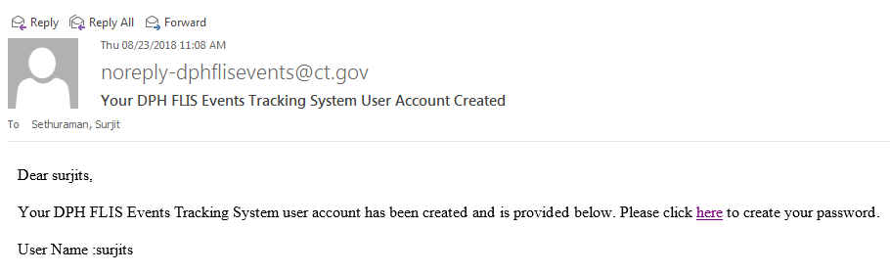
- Go to https://dphflisevents.ct.gov and click “Reportable Events” button
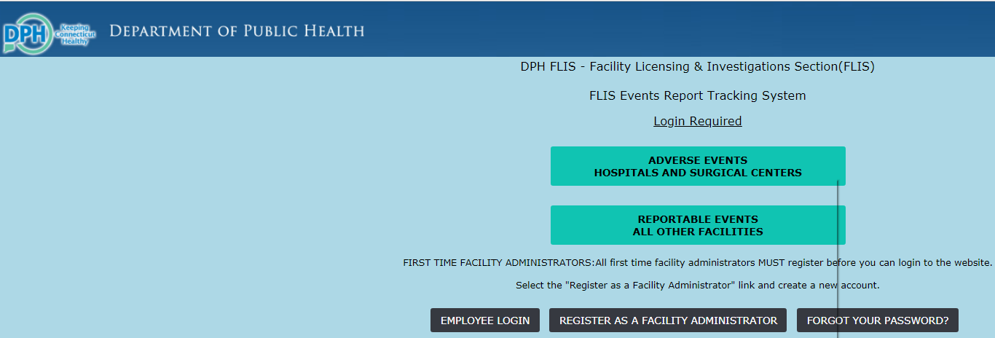

- You may now logon to the website with your username and password.
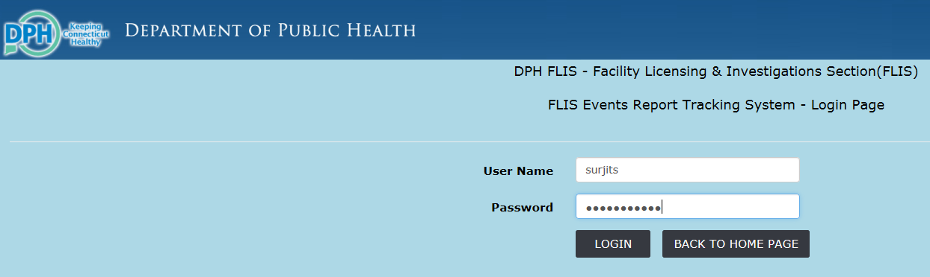

Forgot/Reset Password

- From the DPH FLIS Events Report Tracking System Login Page, please click “Forgot your password” button as shown in the pic below,

- Enter your “User Name” in the Forgot Password Page and click Submit button.
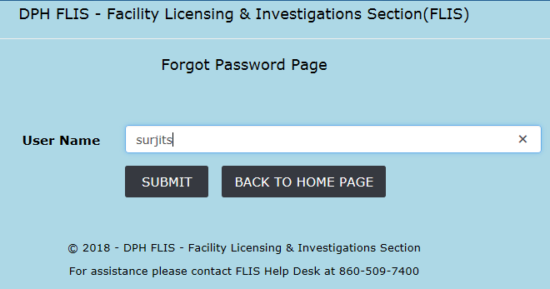
- Once submitted you will see the password reset confirmation message.
- An automated email notification will be sent to the email account associated to the “User name” with the reset password link.
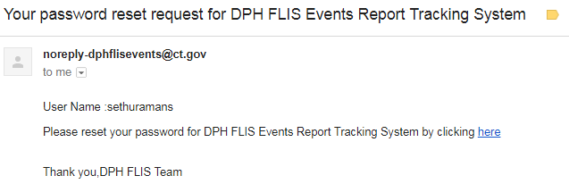

- Enter your user name and your new password and click the “Reset” button.
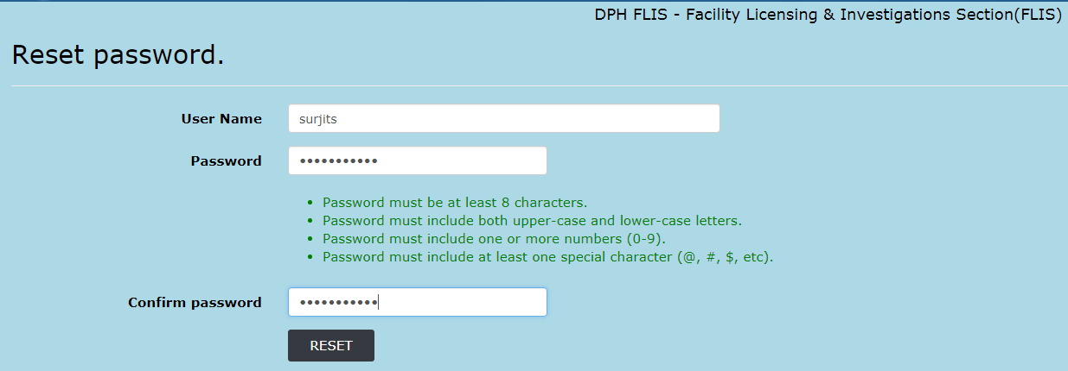
- Once the new password is accepted you will receive the following conformation. Click the “Click here to login” button and you will be directed to the login page.
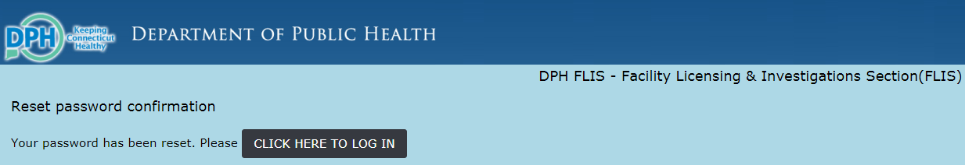
- You can enter the user name and the new password and login to the DPH FLIS Events Tracking System – Reportable Events.
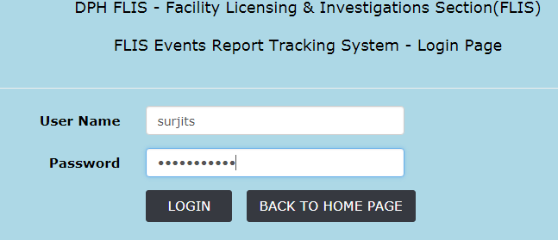
Chapter 2: Home Page and Filter Options

Home Page

This chapter focusses on the Home page once you logged in to the DPH FLIS Events Tracking System – Reportable Events website. 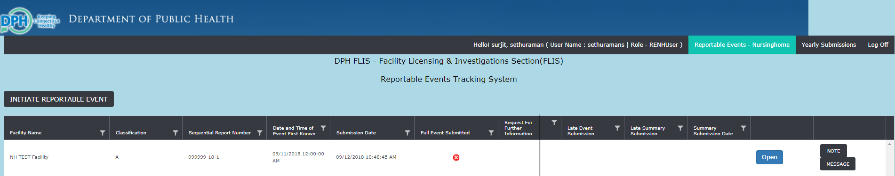

- On the top Right Corner you will see your Full name, User Name, Role and log off link.
- Underneath the banner you will find “Initiate Reportable Event” button to initiate a new reportable event for your facility. This will open up the reportable event form page.
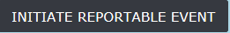
- The body of the page will have 10 columns as given below,
Facility Name – Name of facility submitting the event
Classification – A, B, C, or D
Sequential Report Number – System generated sequential report number for each submitted event (License#-Year-##)
Date & Time of Event First Known – Date and time of event first known to the facility
Submission Date – Reportable Event submission date
Full Event Submitted – Flag denotes whether the event is just initiated or full reportable event submitted.
Request for Further Information – Red Flag represents if there is an open communication with DPH FLIS Team. This column is blank when there is no communication with DPH FLIS team for this reportable event.
Late Event Submission – This column denotes if the reportable event is submitted on time. This column will be blank if the event is submitted on time i.e.; within 72hrs of date and time of event first known to the facility. Red flag denotes if it’s submitted late i.e.; after 72hrs of date and time of event first known to the facility.
Late Summary Submission – This column denotes if the summary for the reportable event is submitted on time. This column is blank if the summary is submitted on time i.e.; within 5 business days from the date and time of event first known to the facility. Red flag denotes it’s a late summary submission time i.e.; after 5 days from the date and time of event first known to the facility.
Summary Submission Date – Date and time of summary submission for the reported event
- - To open an already initiated/submitted reportable event click the “open” button of the corresponding event.
- 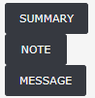
SUMMARY – To open the Summary form for a reported event.
NOTE – Internal notes between the facilities users for a reported event.
MESSAGE – Communication between DPH FLIS Team – Nursing Home Facility users

All of the submitted reportable events will be displayed in the home page and you can use “Open” and “Summary” buttons for each event to view the details.
This will also help you reconcile the submitted events for your facility and other tracking purposes. These events will stay forever in the website and will not be deleted or moved anywhere.

Filter Options

This section will describe the filter options in the home page so to narrow down the reportable events. All the columns in the home page are filterable as to give a wide range of options to search for an event.
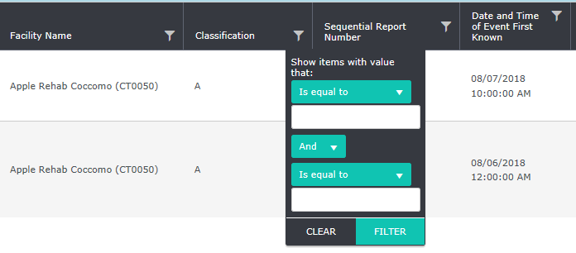
As shown in the above screenshot the filter sign is next to the column name. You can filter reportable events for your facility on any of the home page columns. You can either filter for the exact values or strings that contain in a statement. This will help narrow down your search and find the reportable event quickly to view it.

Note | To clear the filter and display the complete reportable events listing in the home page you can either user the clear option in the filter or click the “Home” link at the top right corner. Both will reset all the filters and gives you the complete view of events.

Chapter 3: Initiate New Reportable Event

Initiate Report New Reportable Event

This chapter takes you the step by step process of initiating a new reportable event.
- Click the “Initiate Reportable Event” button from the home page and it will open the event form page.

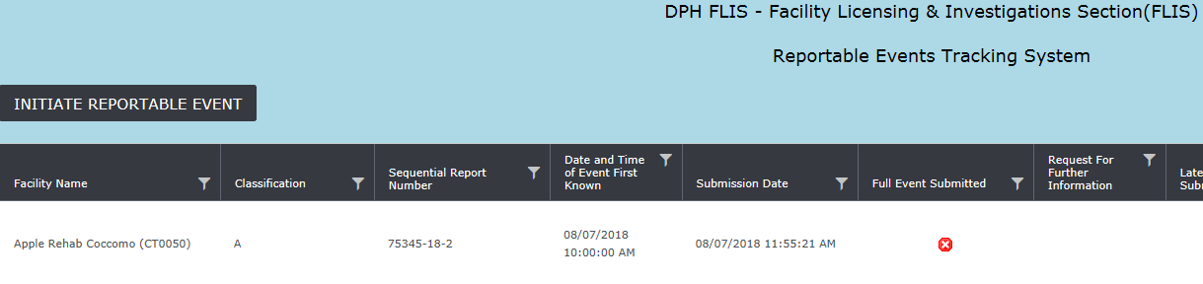
- Choose the “Facility Name” from the drop down field in the Initiate Reportable Event form. (Multi facility users can choose the facility they are reporting the event)
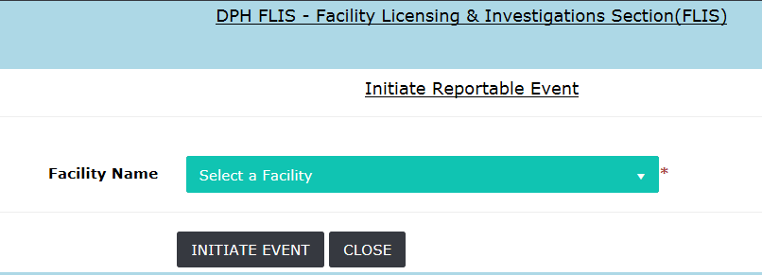

- Once the facility is chosen from the drop down, the reportable event form expands with initial form for the event. Once the initial form is completed click “Initiate Event” button at the bottom of the page.
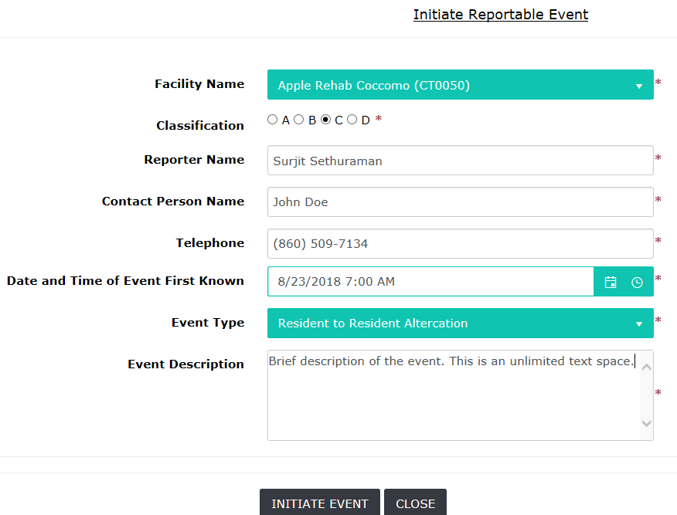

Initiate Reportable Event Form - *(Denotes required Field).

- Upon clicking “Initiate Event” a pop up message is displayed. Click “Ok” to continue to enter the full event or “Cancel” to complete the full event form at a later time.
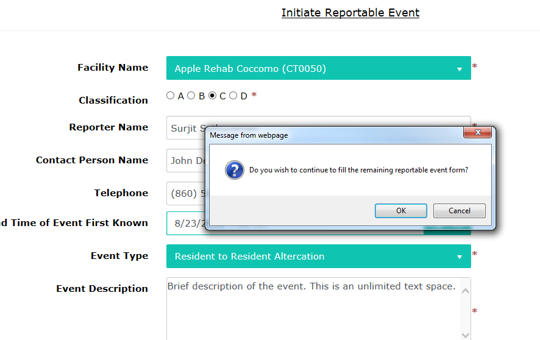

- CANCEL Option: Complete and submit the reportable event at a later time. The initial form has been submitted to DPH-FLIS and waiting for the full form to be completed.
- Upon clicking “Cancel” another pop up message is displayed with the note “Reportable Event Initiated. Please open the event from the main page to complete the form within 72 hrs.”. Click ok and the home page is displayed.
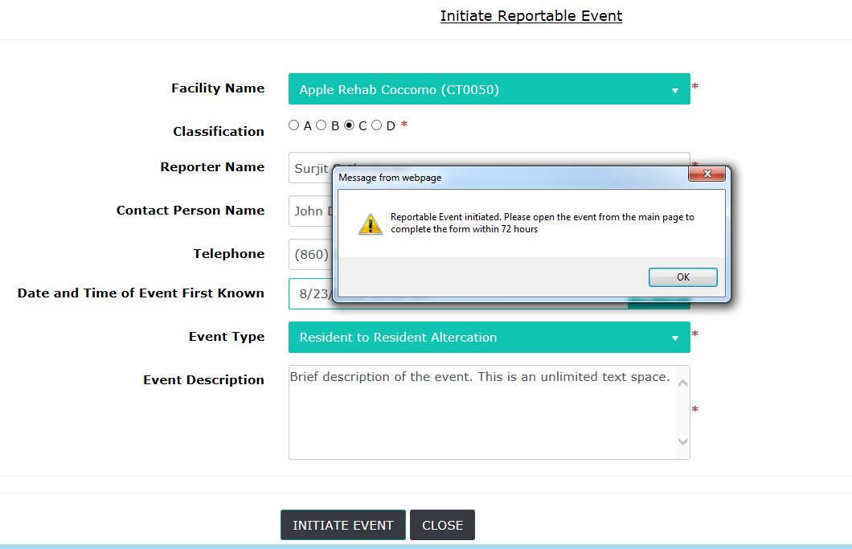
- The home page displays the initiated event and the “Full Event Submitted” column has a Red flag to denote the full form hasn’t been submitted. To open the initiated event click the “Open” button corresponding to the event. Once the full form is submitted the red flag will turn green.

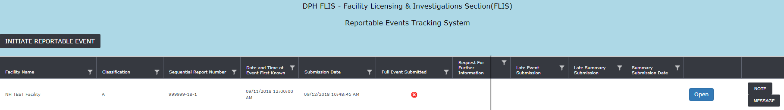
Upon Initiating an Reportable Event:
- The system will auto generate Sequential Report Numbers to avoid manual calculation and errors. Once the new reportable event is initiated the sequential report number is displayed for the corresponding event (Lic# - Year- ##)
- The system auto calculates the late submission of the event based on the submission date and date and time of event first known to the facility.
- The list of all initiated/submitted events for your facility will always stay in your home page for easy tracking. You will be able to use the filter options in the home page for other reporting purposes.
- Make sure to double check the data entry in the form before initiating/submitting the event. Once submitted you will not be able to cancel or close the event. You will have to contact DPH FLIS to rescind the event.

- OKAY option while initiating the event: To continue completing the full event form upon initiating an event, click “okay” in the pop up message and it will display the full form to be completed.
Reportable Event Full form (- *(Denotes required Field).
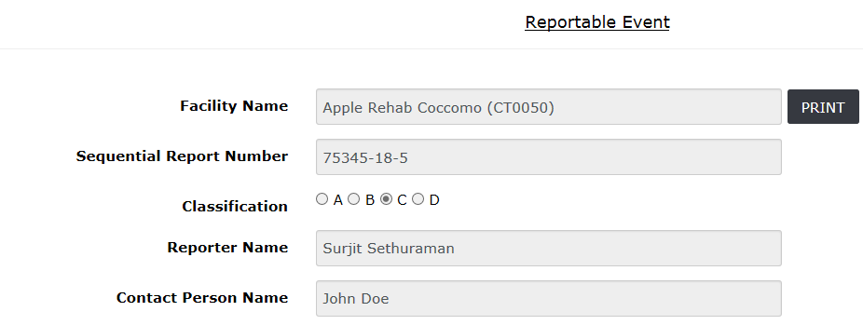
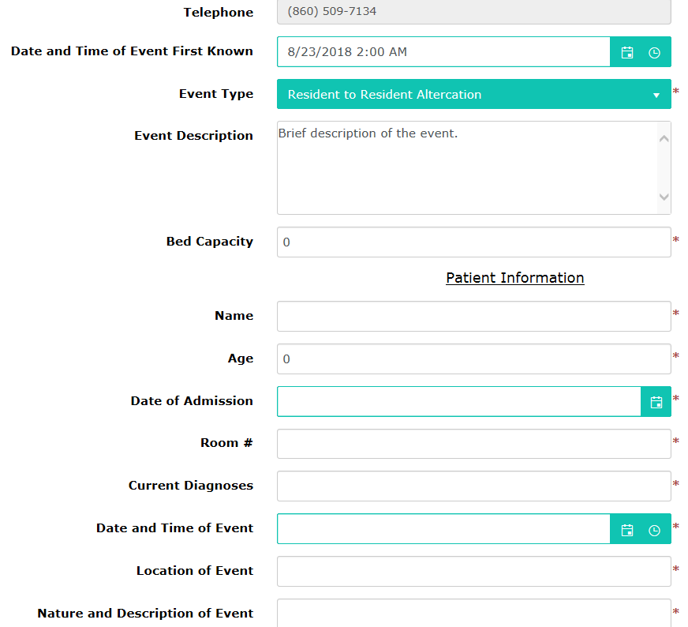
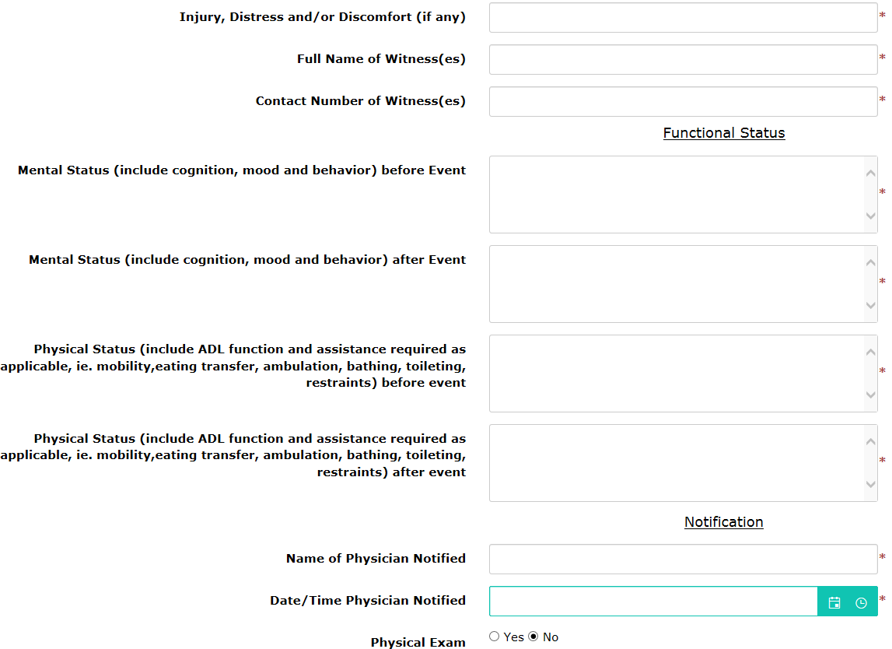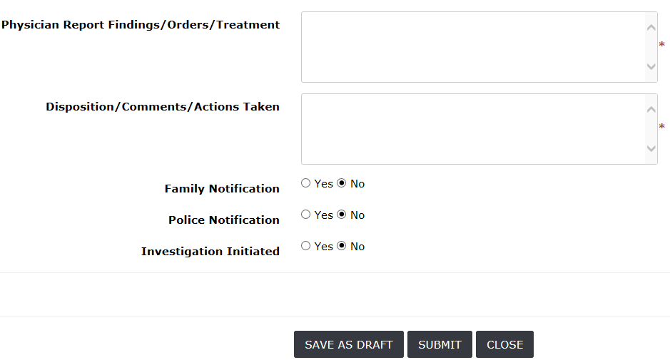
- At the end of the form there are three buttons.
SAVE AS DRAFT – This option is to save the reportable event before submitting in case it has to be reviewed by your immediate supervisor or to be continued at a later time.
SUBMIT – This button is to submit the fully completed reportable event form
CLOSE – This will close the form without saving and goes back to the home page.

Note | Once the reportable event has been submitted no modifications are allowed by the facility. The submission is final and in case if some data is entered wrong in the form you have to communicate with DPH-FLIS team to get it corrected. Once reportable event is initiated/submitted it cannot be deleted. Only DPH FLIS team can rescind an initiated/submitted event.

- Upon successful submission of Reportable Event the auto generated sequential report number will be generated and “Summary” button will be displayed.
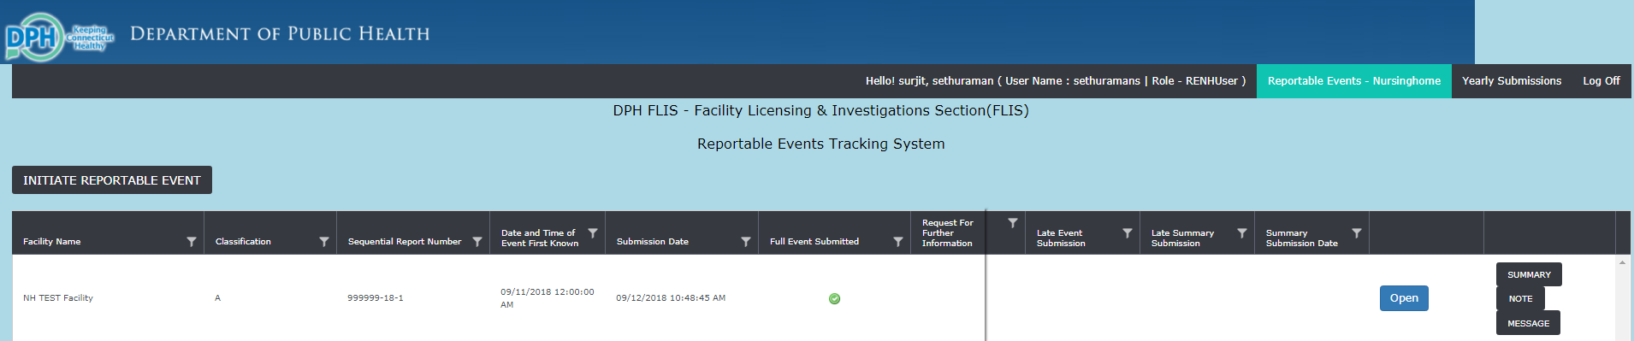
Note | Please double check before you submit the event. Facility users doesn’t have the authority to close or delete an event once submitted and needs to contact DPH FLIS to rescind it.

Chapter 4: Summary Submission

Summary Submission

Summary for an event can be submitted as soon as the reportable event is submitted (Initiated event will not be able to submit summary – only full submission if the event will have the option to submit summary). The “Summary” button opens up automatically once the event is submitted fully as shown in the screenshot below.

- “Summary” button appears once the event is submitted successfully.
- Late summary submission is checked automatically from the summary submission date and date and time of event first known to the facility data fields. A Red flag populates on the Late Summary Submission column in the home page if the summary is submitted late.
- Summary form will automatically be populated with facility name and sequential report number for printing and tracking purposes.
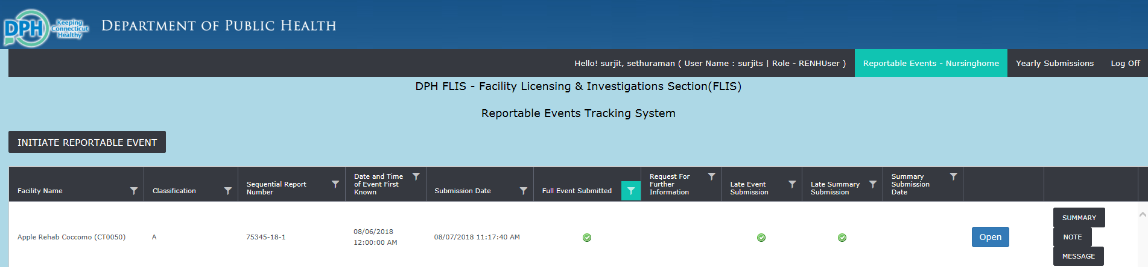

- Support/Exhibit documents can be attached in the Summary form.
- Click Submit at the bottom of the form upon completion. Summary data can be edited after submission incase additional details need to be updated to the form.
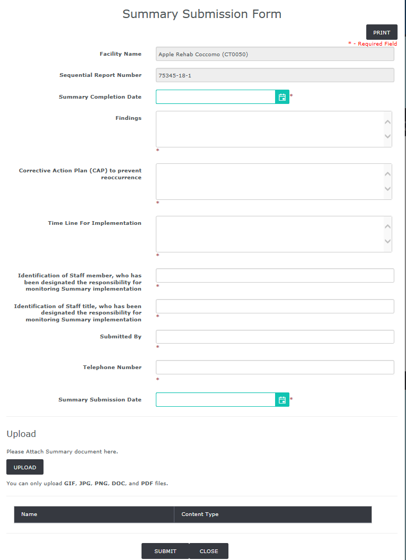

How to Attach Files to Summary Form
Exhibit/Supporting documents can be attached to the summary form if it’s needed or requested by DPH FLIS.
- Open the summary form for an event from the home page and you will see the “Upload” section at the bottom of the page
. 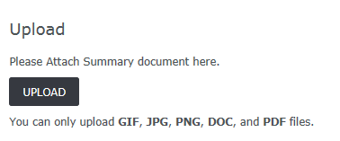
- Click the “UPLOAD” button and it opens the windows explorer pop up window and you can chose the file that needs to be attached.
- You have the option to attach multiple documents at the same time or click “UPLOAD” button again and select a new file to upload.
- DOC, PDF, JPG, PNG and GIF are the allowed files types that will be accepted.
- Once uploaded successfully you will see the attached document listed at the bottom.
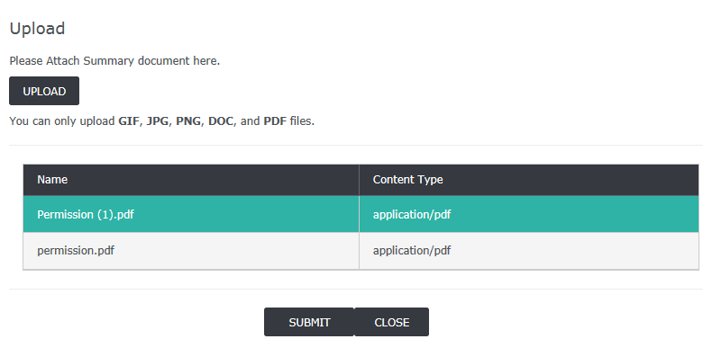

Note | You can print both the submitted Reportable Event and Summary by clicking the “Print” button at the top each form.

Communicating with DPH FLIS Team

We have designed this application in such a way that everything related to a reportable event can be communicated through the website.

- The column “Request for Further Information” will have an, if DPH FLIS needs additional information for a reportable event. The green check sign means there are no current communication for the event between DPH FLIS team and nursing home Facility.

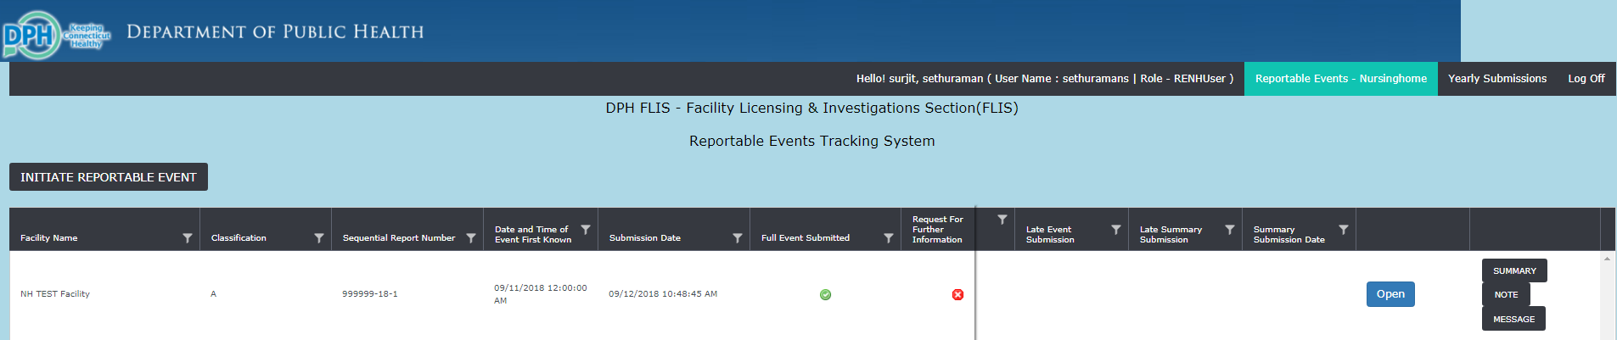

- Once you see the in request for further information column for an event click the “Message” button and you can see the message from DPH FLIS as shown in the screen shot below. Communication from DPH-FLIS can be seen in “Message from DPH-FLIS” text box and only they will be able edit in this box. Nursing home Facility user will be able to edit only “Message to DPH-FLIS” and can add their text to communicate to DPH-FLIS.

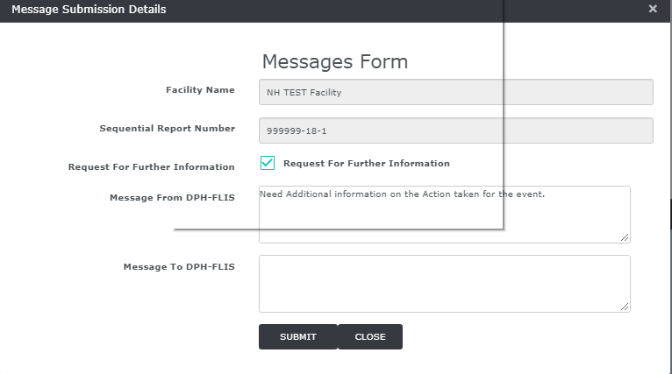
- Please enter your comments in “Message to DPH-FLIS” text box and click submit and FLIS administrators will see the message and respond.
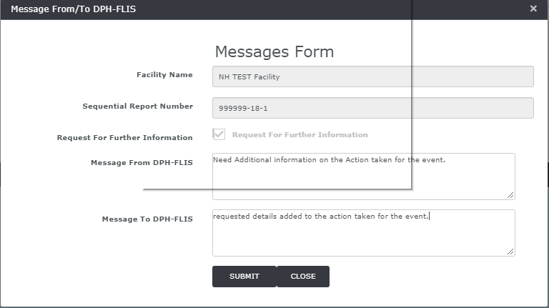

- This feature is designed in such a way that no separate phone calls, email messages or faxes needed to communicate with DPH FLIS team for any additional questions regarding an adverse event.

Chapter 5: Facility Administrator
The DPH FLIS Report Tracking System – Reportable Events allows Facility administrative users to view and manage the user accounts associated with their Facility(s). From the User screen, you may:

- Add a New User
- Search for an Existing User
- Enable/Disable a User Account
- Edit an Existing User's Account Information

Facility Administrator Registration

In order for Facility administrators to gain access to DPH FLIS Events Tracking System – Reportable events website you need to register yourself as a facility administrator.

- Go to https://dphflisevents.ct.gov page and click “Register as a facility administrator” button

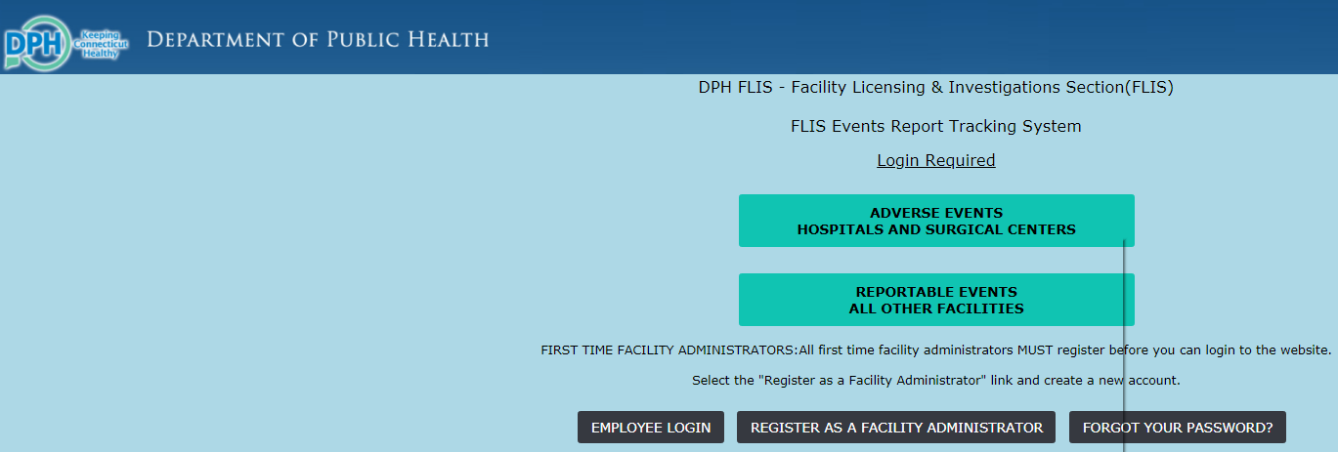

- This will open the new user registration page. Proceed to fill in the demographic and user details and click register. Make sure to select “Other Facilities” as shown in the pic below. (This Registration page is only for Facility Administrator Users)

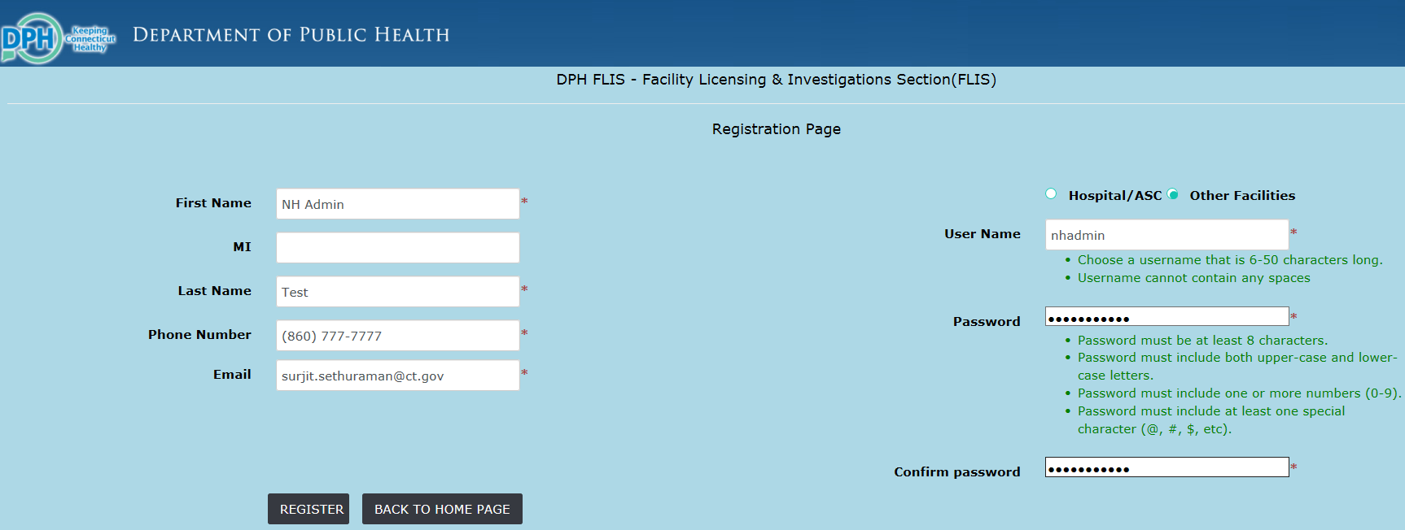

- The registration confirmation page displays after successful registration as a new user.
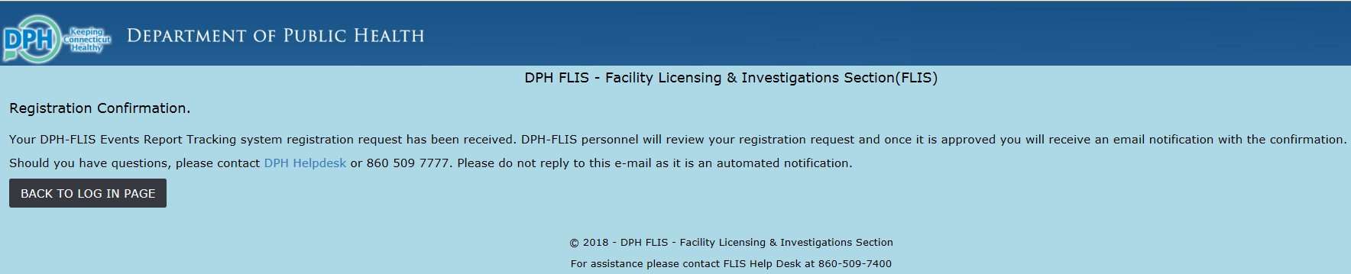
- DPH-FLIS personnel reviews your registration and assigns your approved facility (based on the Facility administrator survey data submission) and activates your account. Upon approval the Facility administrator will receive an auto email notification that your account has been approved.

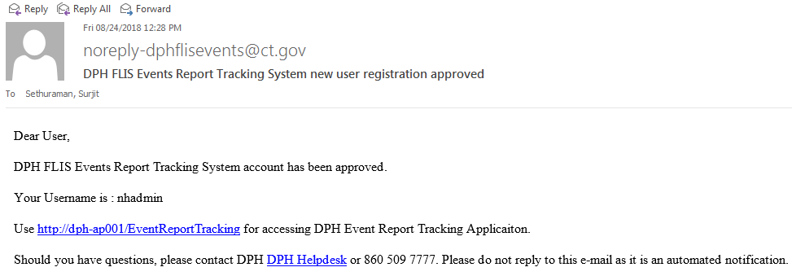

- Now you can go to https://dphflisevents.ct.gov and click “Reportable Events” button and login with your username and password.

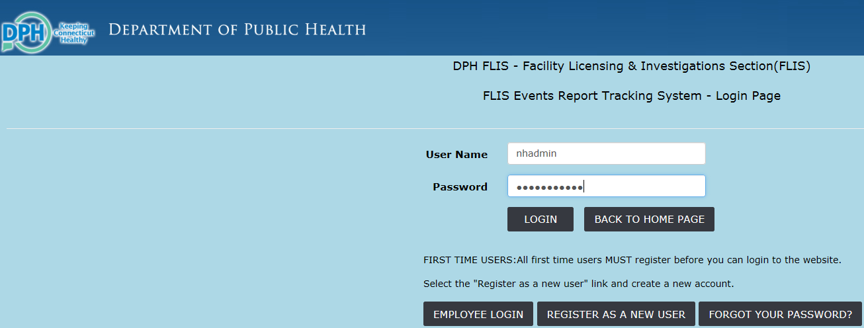

Create a New User for your Facility

- Facility Administrator can create users for your approved facility. Once you login to DPH-FLIS Events Tracking System – Reportable Events website click the “Users” tab at the top. This will show the user administration page. Now Click “Add New User” button.
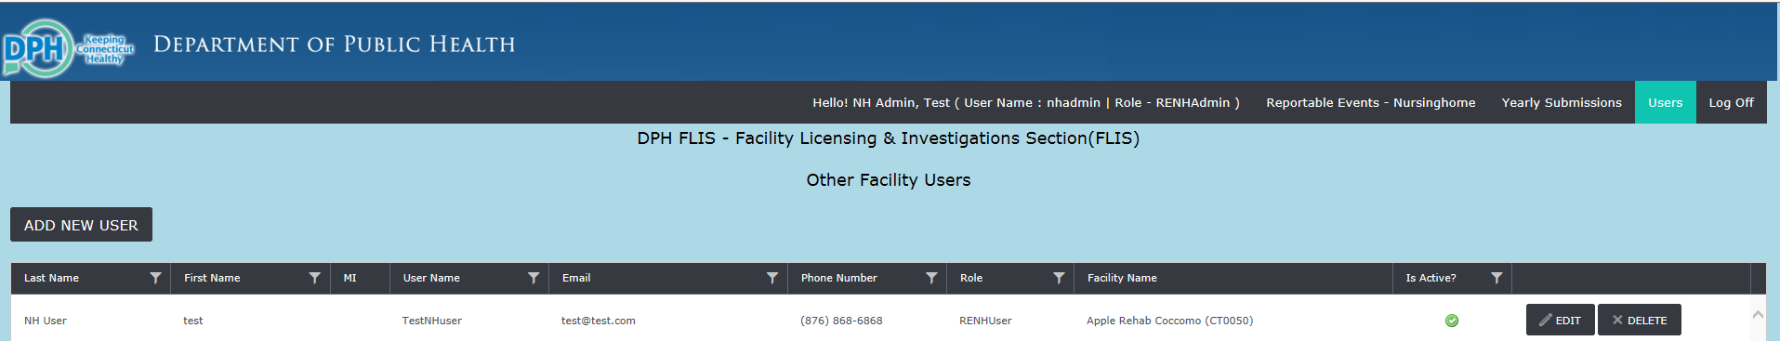

- Create a new user page is displayed and proceed to fill in the details and click “Create” button.

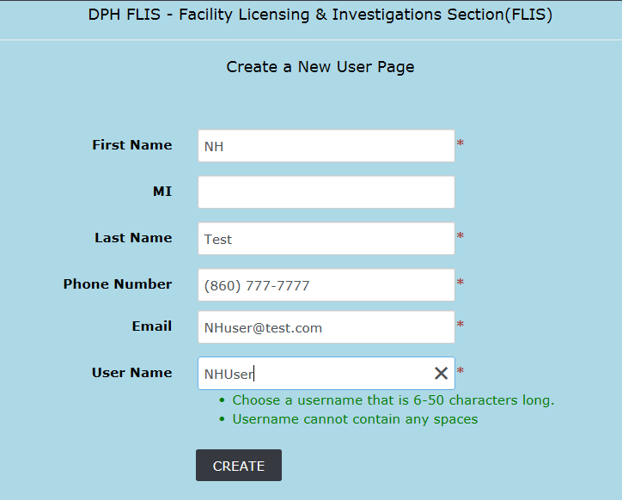
- Upon successful user creation it will display the user administration page and the new user account is displayed.

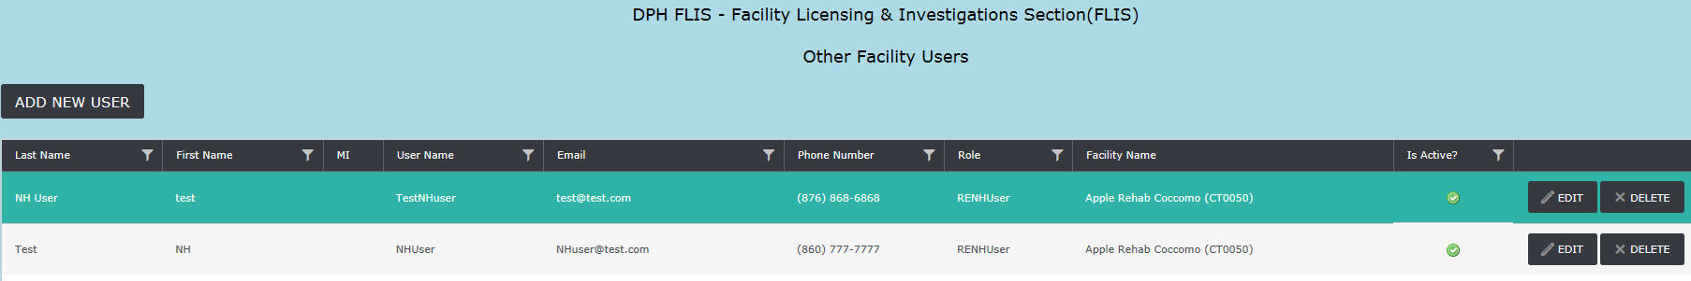
- Once a new user account is created the user receives an automated email notification to create password and will be able to login after that.
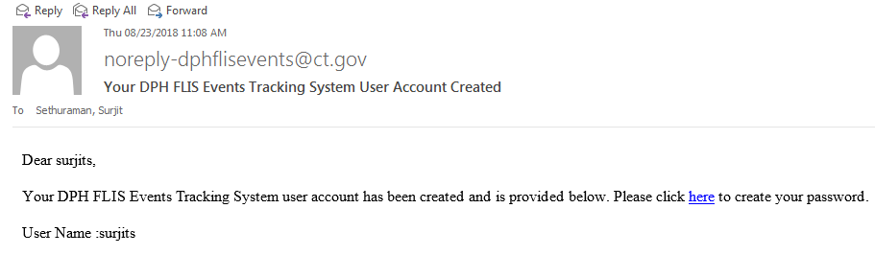

Edit/Delete a user account

- The Facility administrator can delete/inactivate a user account. If the user leaves the facility or doesn’t need access to reportable events website the facility administrator has to inactivate/delete the account. Go to User administration page by click “User” tab at the top of the page.
- To delete a user account click the “Delete” button corresponding to the user account.

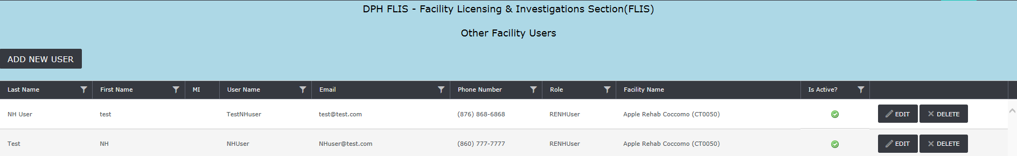

- To inactivate a user account, click the “Edit” button from the user administration page and uncheck the “Is Active?” box and click “Save” button.

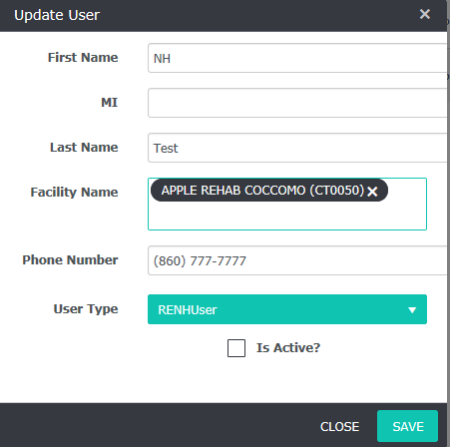

- Upon Inactivation of a user account you will see a Red X sign in the “Is Active? “Column against the user account.
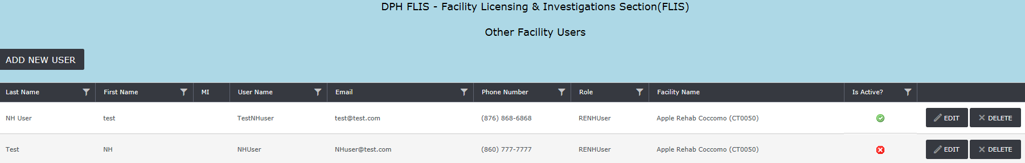

Facility Roles

There are two roles available to facility users.

RENHAdmin - Facility Administrator

Administrator role is an add-on role that allows the user to create and manage user accounts. Administrator can also initiate/submit reportable events and submit summary for an event.

Responsibilities:
- Create and manage other users for your facility
- Add users for the facility only
- Delete/Inactivate users

Note | RENHAdmin – Facility Administrator can delete/in activate only facility user accounts. Facilities need to contact DPH FLIS to approve or delete Facility administrators for your facility.

RENHUser - Facility User

- Able to perform all functions available to the facility users, except for the ability to set up other users.

END

