Attachment 3b

MGP Budget Worksheet Instructions
Contents
Overview 1
Instructions 2
Technical Assistance 5

Overview
Municipalities are eligible to receive an annual allocation of funding from the Connecticut Department of Transportation (CTDOT) for their appropriated Municipal Grant Program (MGP) funds. If an applicant submits a coordinated regional application, the funds for the coordinating municipalities will be granted to the coordinating entity. In this case, each participating municipality must certify that they are assigning their grant apportionment to the coordinating entity.
The municipality or the agency acting as the coordinating entity must fill out the attached MGP Budget Worksheet (Attachment 3a). Itemizing the expenditures and revenues will assist your municipality, the coordinating entity, and our office in further understanding your annual proposed Dial-a-Ride budget submittal. The information submitted by the municipality or coordinating entity will justify their request for funding as well as expedite the review/approval of your SFY 2025 MGP Transit Operating Document (TOD).

Instructions
To complete the MGP Budget Worksheet:
- Please fill in the name of your municipality or the agency acting as the coordinating entity in cell B3.
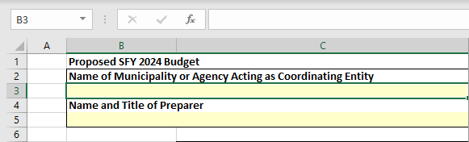
- Please fill in the name and title of the person preparing the worksheet in cell B5.
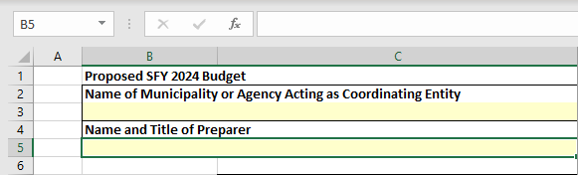
- Please fill in the municipality’s name in row 7 (column D) by clicking on the drop-down list and choosing your town or type in the name of your town. The appropriate maximum amount of municipal allocation available will be provided on the sheet in row 8 (column D) for your municipality. For those agencies acting as coordinating entities, you will complete this step by filling in the subsequent columns (E, F, G, etc.) for each municipality that is assigning its grant apportionment to the coordinating entity.
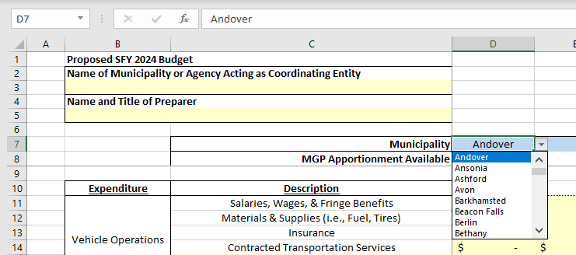

- Please fill in the ‘Expenditures’ section of the worksheet (rows 11 thru 27). Only one (1) column should be filled in per municipality.
Please ensure that this section reflects total dial-a-ride expenditures, inclusive of both those that are budgeted to be paid for by the municipality and those that are budgeted to be paid for via state or federal funds.
I.e., if the dial-a-ride program costs $10,000 to run, of which $5,000 of funding comes from the municipality and $5,000 from MGP, the total expenses should reflect the total $10,000 it costs to provide service for the year.
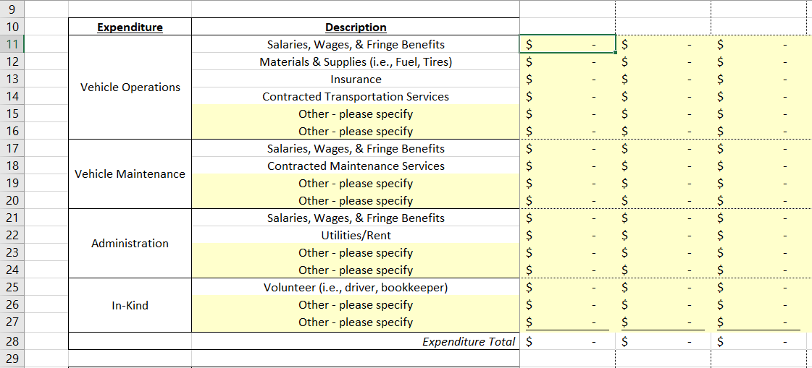

Vehicle Operations would include salaries for drivers, dispatchers and their fringes benefits and anything directly associated with the actual service; fuel, physicals/testing, cell phones and other materials & supplies.

Vehicle Maintenance would include a mechanic’s dollar amount associated with working on the vehicle.
E.g., town mechanic - time worked on vehicle plus fringe benefits; or exact cost of servicing the vehicle at a private shop and 100% of the material and supplies used to repair the vehicle. Lubricants - any oil changes or other fluids to the vehicle.

Administration would include expenses directly related to dial-a-ride operations which may include, but are not limited to, general administrative expenses and overhead costs such as: Salaries of the project director, bookkeeper, or other personnel performing job duties of an administrative nature. Please be aware administrative expenses cannot account for more than ten percent (10%) of the total grant apportionment, including the project director’s salary. You may also include the cost of administrative materials or supplies used for the service. For example, if the copy machine costs $1,000.00 a year to operate and you think you use the copy machine to make copies of MGP-related documentation 10% of the time, then you can enter $100.00 as an annual administrative expenditure in the worksheet.

In-Kind is volunteer’s time to the program. It can also be materials and supplies donated including loaned office space or loaned equipment.

- For those municipalities that have one line item for Dial-a-Ride transportation in your proposed budget, please specify the portion of the expenditures that are being allocated to your Vehicle Operating costs (cells C15 and C16), Vehicle Maintenance costs (cells C19 and C20), and Administrative costs (cells C23 and C24).
For coordinating entities that do not break out expenses on a per-municipality basis, expenses may be split evenly across all the municipalities or split based on the proportion of MGP funds each town contributes to the coordinating entity’s total.

- Please fill in the ‘Revenues’ section of the worksheet (rows 31 thru 45). Only one (1) column should be filled in per municipality.
Total revenues should reflect all forms of funding that pay for the program. This includes fares and donations as well as local, state, federal, and MGP funding.
I.e., if the dial-a-ride program costs $10,000 dollars to run, of which $5,000 of funding comes from the municipality and $5,000 from MGP, then the revenues should show $5,000 of funding from the municipality and $5,000 from MGP for a total of $10,000 in revenues.
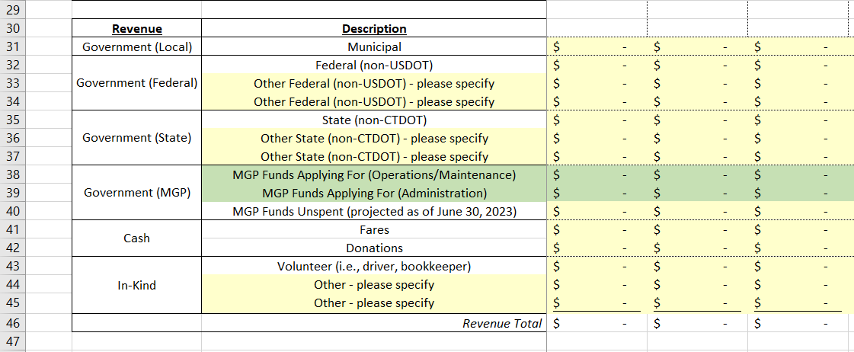
Governmental (Local) represents funding provided by the municipality to cover costs associated with its Dial-a-Ride transportation services. This would typically be the amount that the municipality itself has budgeted towards the service, as shown in the municipal budget.

Government (Federal) represents funding provided by the federal government (non-USDOT). For example, Area Agency on Aging funds provided for transportation, which originate with the U.S. Department of Health and Human Services, would be shown here.

Government (State) represents funding provided by the state government (non-CTDOT).

Government (MGP) represents the following:

    - MGP Funds Applying For (Operations/Maintenance) - The amount of MGP Funds for vehicle operations and maintenance that your town or coordinating entity is requesting from CTDOT.

    - MGP Funds Applying For (Administration) - The amount of MGP Funds for administration that your town or coordinating entity is requesting from CTDOT. This number may not exceed 10% of the total MGP apportionment available.

    - MGP Funds Unspent (projected as of June 30, 2023) - The amount of unspent MGP funds which have been paid out by CTDOT as of June 30, 2023, and are held by a municipality or coordinating entity.

Cash represents fares collected including donations (dollars donated to the service).
In-Kind is a volunteer’s time to the program. It can also be materials and supplies donated including loaned office space or loaned equipment.
- Any further comments about the budget submittal can be written in the tab named “Comments” in cell B3.
Ideally, once all expenses and revenues have been entered, the totals will or will come close to cancelling out. This shows that the program is neither running a large deficit nor a large surplus of funds.

Technical Assistance
Questions regarding the application contents or requests for technical assistance may be directed to Richard Nakatsuka at (860) 594-2839 or richard.nakatsuka@ct.gov . Alternatively, inquiries may be directed to the program inbox at DOT.PTransMGP@ct.gov . Applicants may also contact their COG for assistance with the MGP application.
Additional information on how CTDOT administers the MGP Program can be found on CTDOT’s website by clicking on the following link: State Matching Grant Program for Elderly and People with Disabilities (ct.gov)

