Language Assistance Plan Best Practices

Recipients must take reasonable steps to ensure meaningful access to benefits, services, and information for individuals who have Limited English proficiency (LEP). The organization must conduct a Four Factor Analysis and the results should be included as part of a Language Assistance Plan (LAP).
Four Factor Analysis:
To ensure meaningful access to programs, services, and activities, recipients shall use the information obtained in the Four Factor Analysis to determine the specific language services that are appropriate to provide. The analysis is an individualized assessment that balances the following four factors:
1. Demography – what is the number or proportion of LEP persons eligible to be served or likely to be encountered by the program or recipient?
Tips for completing:
- Use census or American Community Survey (ACS) data (table C16001) to complete this factor. We maintain a spreadsheet of this data for Connecticut towns that you can use ACCESSIBLE BY CLICKING THIS LINK HERE.
- This factor should include the counts, and the percentage of the total population per language.
- Indicate whether the language group reaches the LEP (5% of the total population) or safe harbor thresholds (5% or 1,000 persons, whichever is less).
- An example of how this factor should be charted is provided below (results for Hartford, CT based on 2017 ACS data): 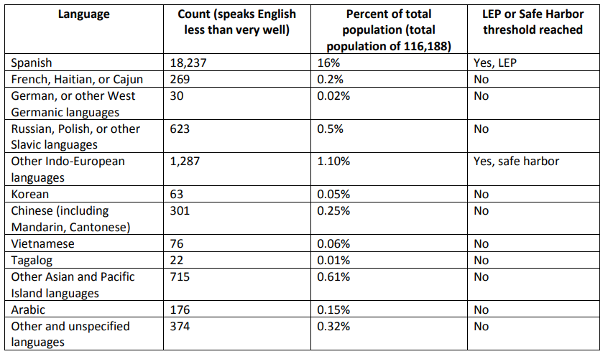

2. Frequency – how often do LEP persons come into contact with the service or program?
Tips for completing:
- Survey front line staff (drivers, receptionists, intake staff, etc.) to determine the frequency of previous contacts and requests for language assistance
- Customer surveys
- Customer service interactions
- Google translate clicks
3. Importance – How does the program, service, or activity affect people’s lives?
Tips for completing:
- Provide a brief summary of the services, benefits and activities offered by your organization.
- It may be helpful to gather input from community and faith-based organizations on the importance of this service to LEP persons.

4. Resources and Costs – What funding and resources are available for LEP outreach?
Tips for completing:
- Include a brief summary of the resources available and overall costs of providing language assistance.
- Analyze your organization’s budget to identify available funding for providing language assistance

Language Assistance Plan (LAP): Once you have conducted your four-factor analysis, you should use the results to develop your LAP.
Your LAP must include the following:
- Results of the four-factor analysis
- Description of current language assistance measures and any plans for future measures. Examples include, but are not limited to:
  - Over the phone interpretation service
  - Bilingual staff
  - Websites in other languages
  - I Speak Cards
  - Interpreters
  - Document translation
- Description of how LEP individuals are notified of the availability of language assistance. Examples include, but are not limited to:
  - Title VI Notice to the Public
  - Website o Communication with CBO/FBOs
  - Newsletter
  - During the registration process
- Description of how the plan is reviewed and updated. At a minimum, the LAP should be reviewed annually and updated triennially by assessing new census data, surveying customers and community or faith based organizations, and reviewing previous requests for language assistance.
- Description of how employees are trained to provide language assistance. At minimum employees should be trained on LEP requirements and the language assistance measures available when hired and with annual refresher training, or as new measures are implemented.
- Listing of vital documents and a schedule for translation (if LEP populations exceed the 5% or 1000 persons threshold).
Four-factor Analysis and Language Assistance Plan FAQ
Q: How do I find out what LEP populations we serve?
A: CTDOT provides LEP information online by town at the following link: https://portal.ct.gov/-/media/DOT/documents/dcontractcompliance/LEP-Population-by-Town.xlsx
Q: What is the threshold for whether a person is considered Limited English proficient?
A: If an individual speaks English less than very well, they are considered LEP. The census and ACS provide data specific to this threshold.
Q: At what point is my organization required to provide proactive (prior to a request from the public) language assistance to LEP populations in our service area?
A: If specific LEP populations exceed 5% or 1,000 individuals (whichever is less), the organization must provide written document translation services.
Q. We conducted our four-factor analysis and we do not have any LEP populations that reach the thresholds of LEP or safe harbor, are we still required to develop a Language Assistance Plan?
A. Yes, even if there are no LEP populations currently present in your service area, you are required to develop a language assistance plan outlining how your organization would provide language assistance if it were requested.
Q. What are vital documents?
A. Vital documents are any documents or forms necessary for utilizing your service, or receiving information on your service. FHWA defines the Title VI Notice to the Public, Title VI Complaint Form, and Title VI Complaint Process as vital documents. Other vital documents may include intake forms, registration forms, or rider policies.
Q: Title VI prohibits discrimination based on race, color, or national origin. Why is there a requirement under Title VI to provide language assistance?
A: Limited access to your organization’s programs based on a potential participant’s limited English proficiency may be considered a form of national origin discrimination. Executive Order 13166, “Improving Access to Services for Persons with Limited English Proficiency” requires recipients to take reasonable steps to ensure meaningful access to benefits, services, information or other important portions of their programs and activities for individuals who are LEP.

