ADULT DAY HEALTH Survey Results

# Purpose of Survey

This survey was designed to collect feedback from care managers about Adult Day Health providers (centers) that are located adjacent to or on the grounds of a nursing facility and serve 1915(i) and Elder waiver participants. The survey was designed to help the Connecticut Department of Social Services assess the centers’ compliance with the home and community-based (HCB) settings requirements in the Centers for Medicare & Medicaid Service’s (CMS) Final Rule related to home and community-based services (HCBS) issued March 17, 2104.

# Rating Methodology

Survey participants (care managers) were asked to assess nine statements, choosing from five possible response options:

* + - * 1. Completely False.
        2. Partially False.
        3. Neither True nor False.
        4. Partially True.
        5. Completely True.

Survey participants were also asked to provide comments on each statement as well as general comments regarding how the center meets the needs of participants.

Each response option was assigned a score from 1-5 as follows:

Completely False.

Partially False.

Neither True nor False.

Partially True.

Completely True.

If more than one survey was completed for a center, scores for that center were aggregated to establish an average score for each statement in the survey.

CMS has issued exploratory questions and other guidance to assist states in measuring the compliance of residential settings with the HCB settings requirements in the Final Rule, but has not issued similar guidance for non-residential settings. As a result, this survey was developed based on the language in the Final Rule and by adapting relevant guidance for residential settings to this non-residential setting.

# Responses

The survey was active from October 3, 2014 through October 20, 2014. In total, 36 surveys were completed by care managers for 10 unique centers. Please note that care managers serving participants in more than one center were not precluded from completing a separate survey for each center.

All centers had a least one survey completed by a care manager. Abbott Terrace Adult Day Center had the highest number of responses in the survey with 20 completed responses.

| Adult Day Health Center | Completed Surveys (36) |
| --- | --- |
| Abbott Terrace Adult Day Center | 20 |
| Goodwin Levine Adult Day Health Center | 3 |
| St. Joseph’s Manor Adult Day Center | 3 |
| Betty Larus Adult Day Center at Avery Heights | 2 |
| Mary Wade Adult Day Center | 2 |
| Waveny Care Center Adult Day Program | 2 |
| Alzheimer’s Resource Center of CT Adult Day Program | 1 |
| Geer Adult Day Center | 1 |
| Hebrew Health Adult Day Services | 1 |
| Saint Mary Home Adult Day Center | 1 |

# Overall Findings

Overall, care managers responding to the survey report that all centers are strongly aligned with the HCB settings requirements that were measured in this survey. Responses from all centers averaged an aggregate score of 4 or higher for each question in the survey.

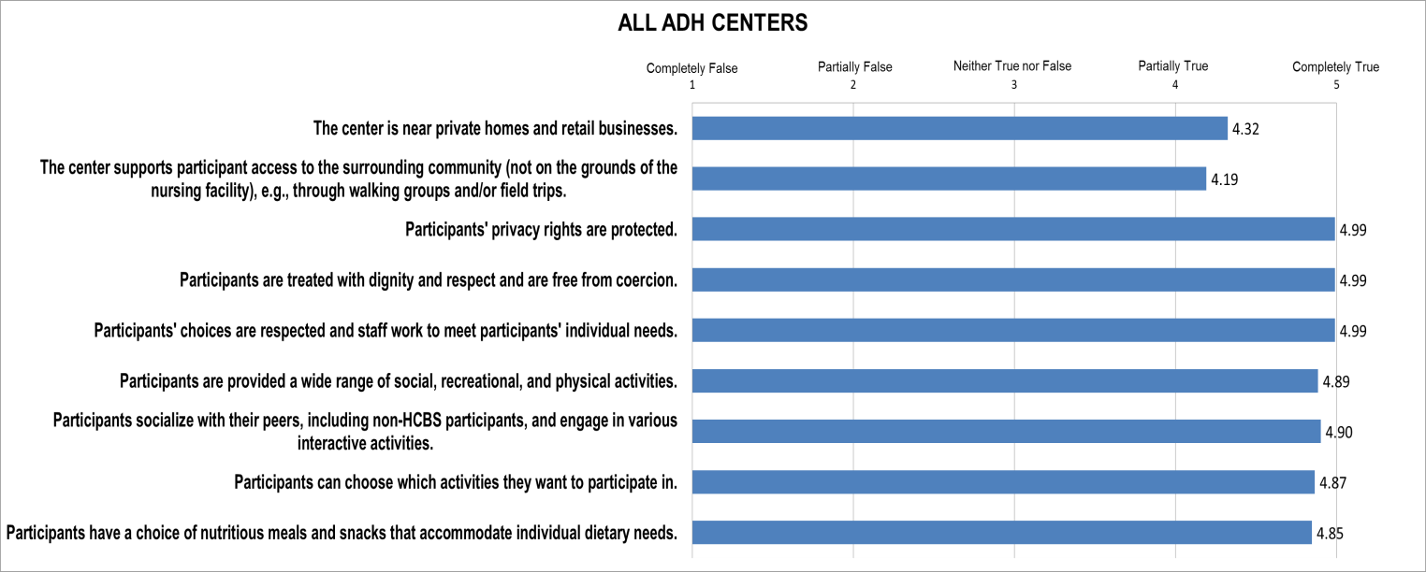

The highest aggregate response score was 4.99, which was the average rating for three statements in the survey. Care managers responded very positively (i.e., almost all responded “completely true”) when asked whether the center staff:

* + - * 1. Ensures participants’ rights are protected.
        2. Treats participants with dignity and respect.
        3. Respects participants’ choices and works to meet the individual needs of participants.

The lowest aggregate response score was 4.19 for the statement in which care managers were asked to rate whether the centers’ support participants’ access to the surrounding community, e.g., through walking groups and/or field trips.

Betty Larus Adult Day Center at Avery Heights scored the lowest of all centers for this statement (average score = 2). One care manager rated the center with a low score of 1, indicating the care manager believes the center fails to adequately support participant access to the community. Another care manager rated the center a 3. Unfortunately, no additional comments were provided in the survey to elaborate more on this finding.

Waveny Care Center Adult Day Program (Waveny) scored the second lowest of all centers for this statement (average score = 3). Both care managers rated the center with a 3, where one care manager commented that they are unaware of any walking groups or field trips taking place.

Waveny also received the only other score below a 4. Waveny received an average score of 3 for the statement in which care managers were asked to rate whether the center is near private homes and retail businesses. However, one of the care managers noted that two public schools and residential homes are nearby, so the care managers might have interpreted this statement very narrowly in their responses.

# Detail by Center

For a breakdown of scores for each center refer to Appendix A.

# Appendix A: Adult Day Health Center Tables

## Abbott Terrace Adult Day Center



## Alzheimer's Resource Center of CT Adult Day Program



## Betty Larus Adult Day Center at Avery Heights



## Geer Adult Day Center



## Goodwin Levine Adult Day Health Center



## Hebrew Health Adult Day Services



## Mary Wade Adult Day Center



## Saint Mary Home Adult Day Center



## St. Joseph’s Manor Adult Day Center



## Waveny Care Center Adult Day Program

