Connecticut Department of Public Health
Adverse Events Report Tracking System User Manual

Connecticut Department of Public Health
Facility Licensing & Investigation Section
410 Capitol Ave, MS#12HSR
Hartford, CT 06134-0308

Telephone #: (860) 509-7400
Web: https://dphadverseevents.ct.gov

Adverse Events Report Tracking System User Manual

Facility Licensing and Investigation Section (FLIS) is the agency that has regulatory oversight for all the licensed healthcare entities in the state. This manual will guide you through the Adverse Events Report Tracking System website and its functionalities.
Table of Contents

Chapter 1: Adverse Events Report Tracking System - Getting Started
- Introduction
- Register as a New User
- Log into Adverse Event Report Tracking System
- Forgot/Reset Password

Chapter 2: Home Page and Filter Options
- Home Page
- Filter Options

Chapter 3: Report New Adverse Events
- Report New Adverse Event

Chapter 4: Corrective Action Plan (CAP) Submission
- CAP Submission
- How to Attach Files to CAP Form
- Communicating with DPH FLIS Team – CAP & Adverse Events

Chapter 1: Adverse Events Reporting Getting Started

Introduction

Welcome to the Adverse Event Report Tracking system User’s Guide. This guide introduces you to the features of the web application and provides detailed instructions on how to navigate through the website.
The Adverse Event Report Tracking system is a web-based application that has been developed to assist Hospitals/Ambulatory Surgical Centers to report and track the events in an efficient and effective manner.
The following capabilities are available to providers on this easy-to-use, automated system:
- Submitting Adverse Events online
- Tracking the submitted Adverse Events
- Communicating with DPH-FLIS team through Adverse Events website

Prerequisites
You will need Internet Explorer version 8.0 or higher or Google Chrome for the system to run properly on your computer. The Adverse Events Report Tracking website can be accessed through different browsers and tablets.

Register as a New User

Enter the website address https://dphadverseevents.ct.gov in your web browser.

Click “Register as a new user” button from the login page as shown in the picture below.

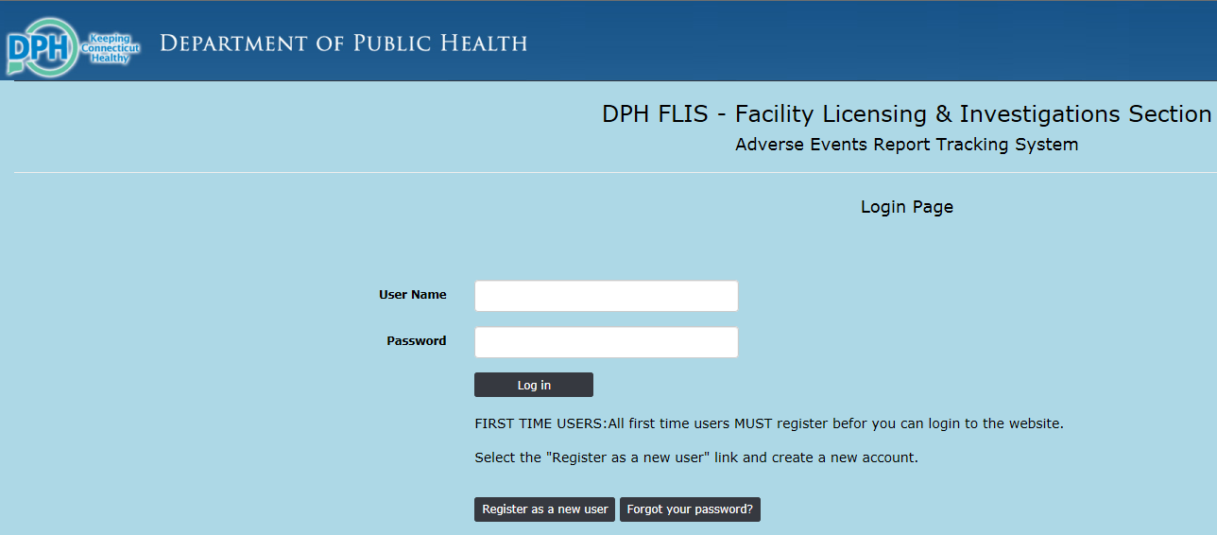

Note | Before registering yourself you have to be approved by your facility that you are an authorized user. DPH FLIS personnel confirms that with your facility before approving your account and until it is approved your user account will not be active.

Please go ahead and enter all the required fields (*) in the registration page and click Register button at the bottom.
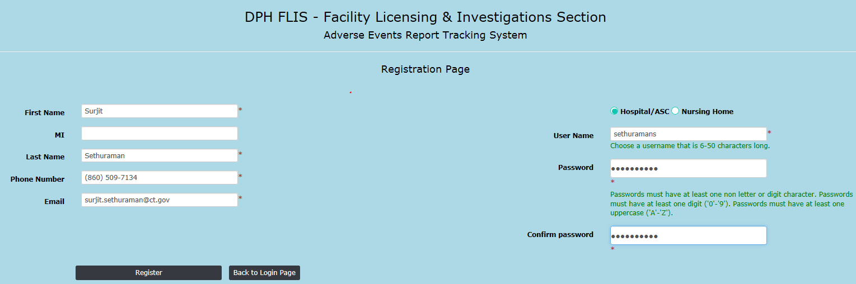

Once you click Register you will see the message that DPH FLIS personnel will review and process the registration request. Upon approval of your request you will receive an auto email notification that your account has been approved and you will be able to login.
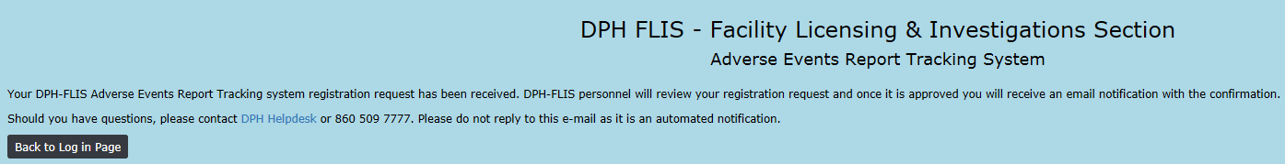

Log into Adverse Events Report Tracking System

Once DPH FLIS Personnel reviews and approves your registration request you will receive an auto email notification that your account has been approved as shown below.

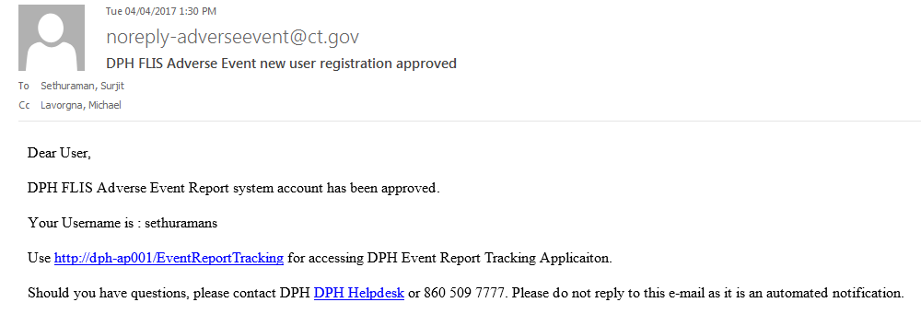
Now you may logon to the website https://dphadverseevents.ct.gov with your username and password.
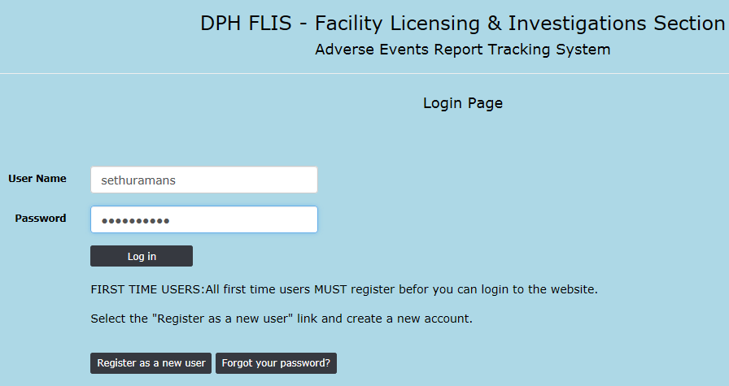

Forgot/Reset Password

From the Adverse Events Report tracking system Login Page, please click “Forgot your password” button as shown in the pic below,

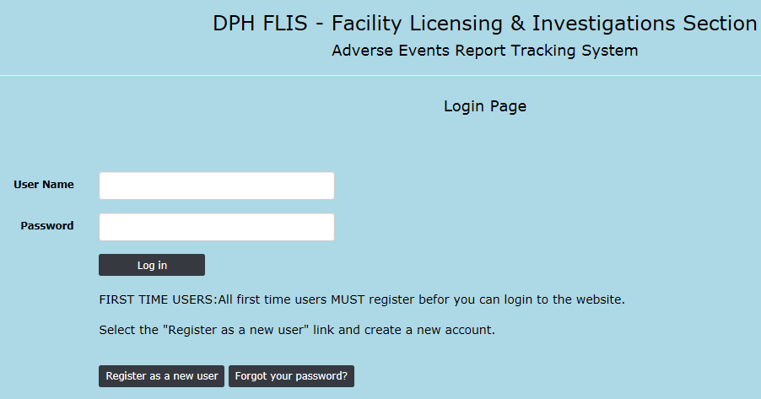

Enter your “User Name” in the Forgot Password Page and click Submit button.
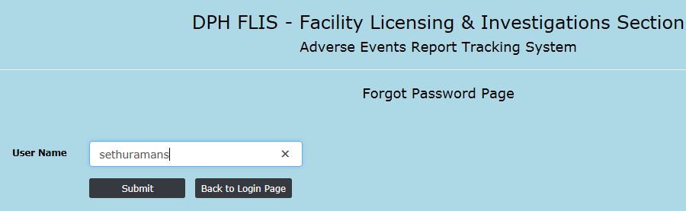

Once submitted you will see the password reset confirmation message. 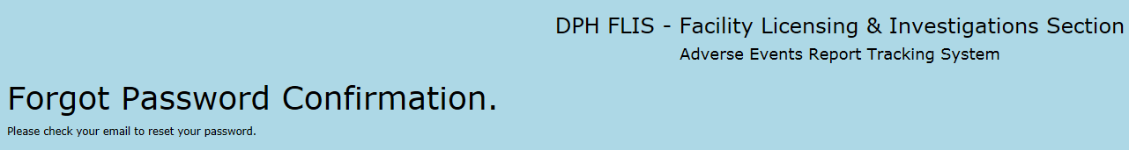
An automated email notification will be sent to the email account associated to the “User name” with the reset password link.
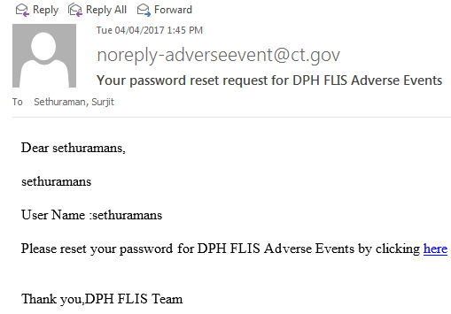
Now you can enter your new password along with your email and click the “Reset” button.
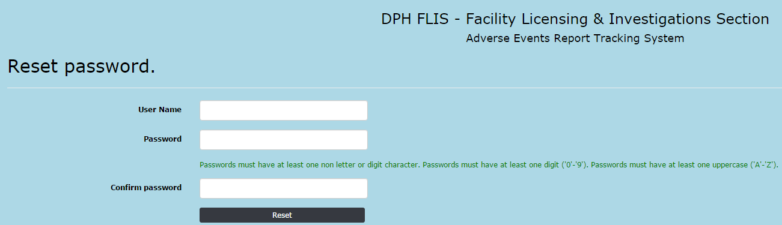

Once the new password is accepted you will receive the following conformation,
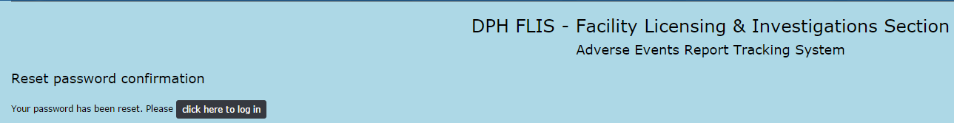

Click the “Click here to login” link and you will be directed to the login page. Now you can enter the user name and the new password and login to the Adverse Events Report Tracking System.

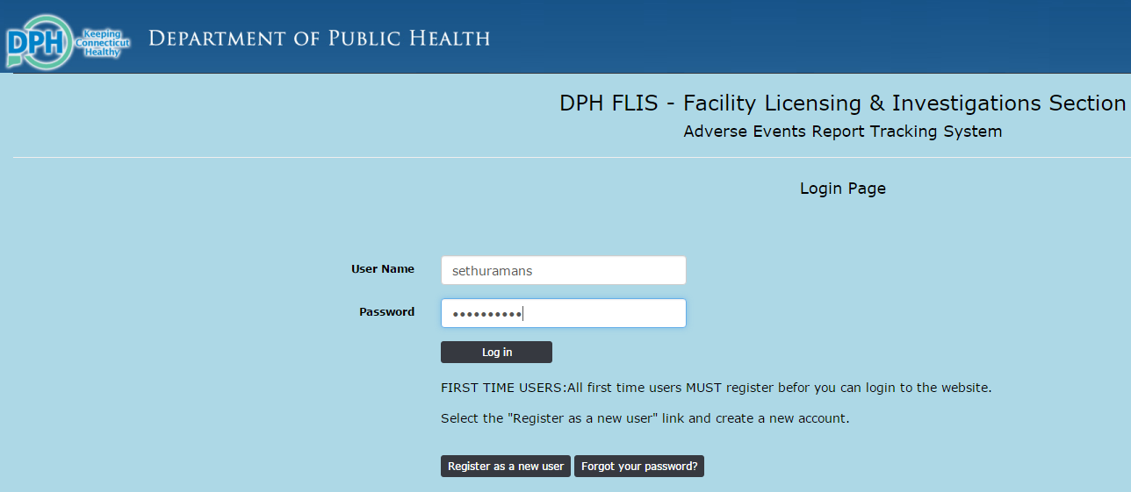

Chapter 2: Home Page and Filter Options

Home Page

This section focusses on the Home page and columns listed in it.
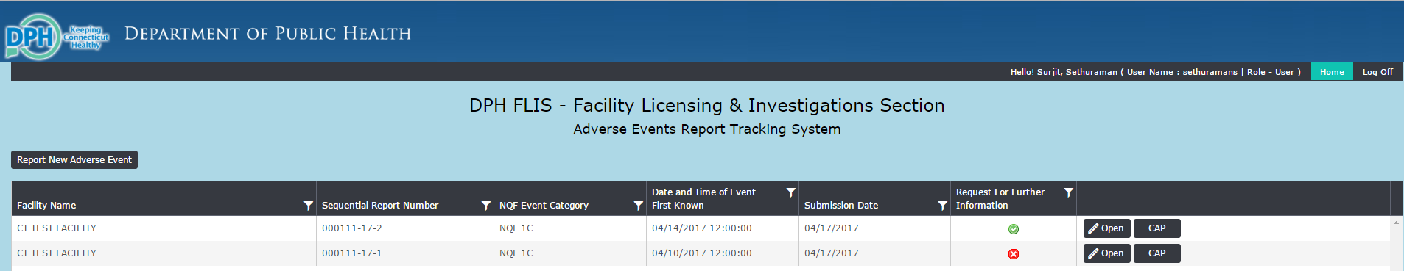

On the top Right Corner you will see your Full name, User Name, Role and log off link. As a facility your role will be always “User”.
Underneath the banner you will find “Report New Adverse Event” button to submit new adverse events for your facility. This will open up the adverse event Report Form page.

The body of the page will have 6 columns as given below,
Facility Name – Name of the Facility
Sequential Report Number – Auto generated sequential report number for each adverse event submitted
NQF Event Category – Event category
Date and Time of Event First Known – From the Adverse Event Form
Submission date – Date Adverse event submitted
Request for Further Information – In case DPH needs additional CAP (Corrective Action Plan) information this flag will be Red to notify the users that they need to provide more information.

All of the submitted adverse events will be displayed in the main page and you can use “Open” and “CAP” buttons for each event to view the details.
This will also help you reconcile the submitted events for your facility and other tracking purposes. These events will stay forever in the website and will not be deleted or moved anywhere.

Filter Options

This section will describe the filter option in the home page so to narrow down the adverse events which you would like to see. All the columns in the home page are filterable as to give a wide range of options to search for an event.

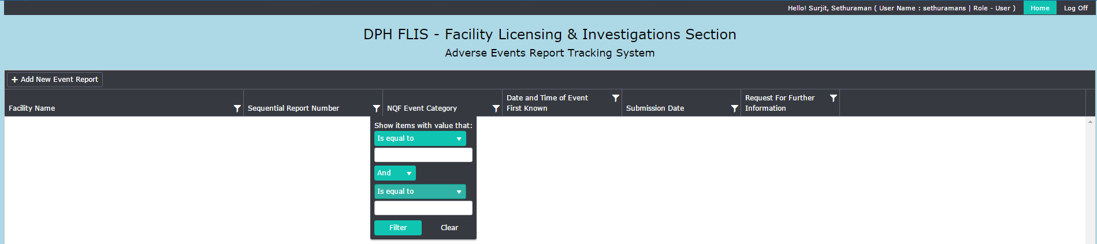

As shown in the above screenshot the funnel sign next to the column name is the filter option. When you click on the funnel link you will see the filter options. You can filter adverse events for your facility based on Sequential Report number, NQF Event category and Submission date ranges. You can either filter for the exact values or strings that contain in a statement. This will help narrow down your search and find the adverse events quickly to view it.
Note | To clear the filter and display the complete adverse events listing in the home page you can either user the clear option in the filter or click the “Home” link at the top right corner. Both will reset all the filters and gives you the complete view of events.

Chapter 3: Report New Adverse Events

Report New Adverse Event

This chapter takes you the step by step process of reporting a new adverse event.

Click the “Report New Adverse Event” button from the home page and it will open the form page.

New Adverse Event Report Form - *(Denotes required Field).

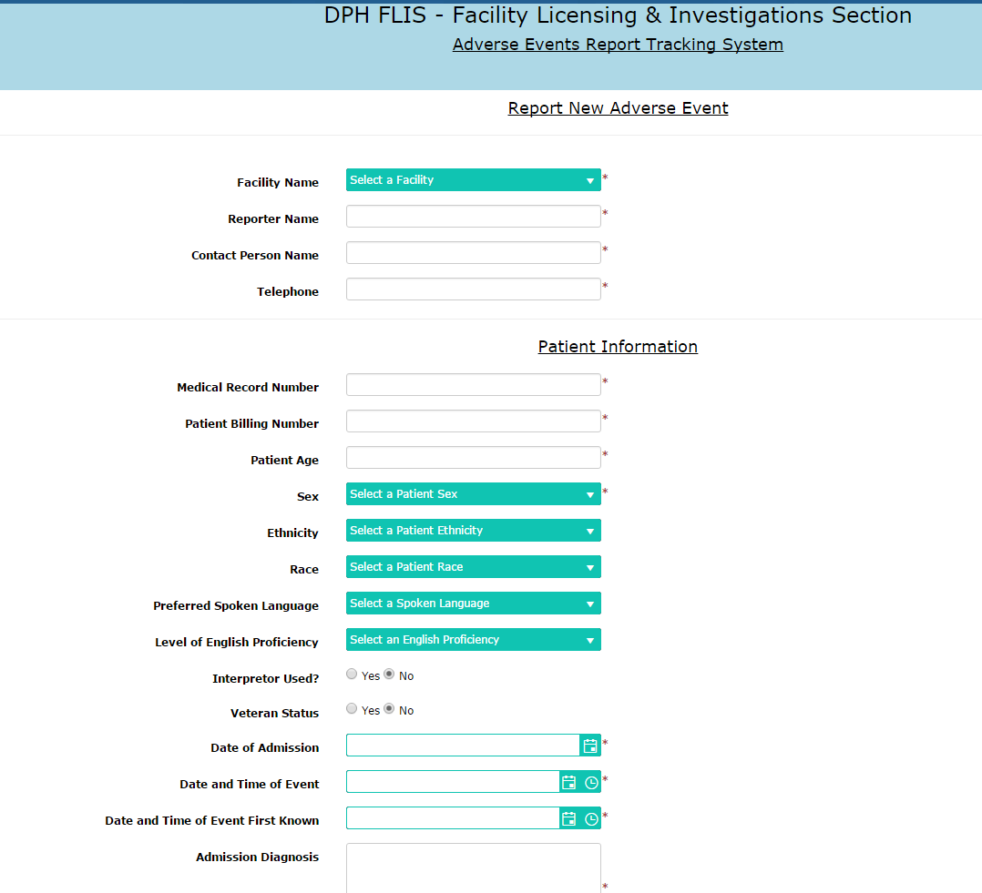

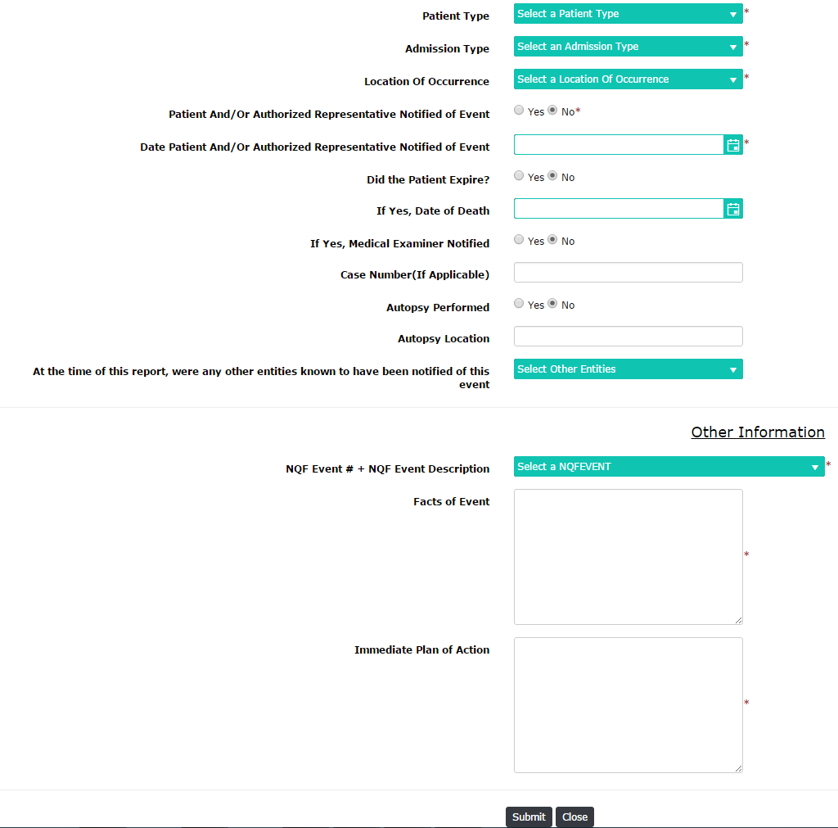
Fill in all the information and click the “Submit” button to report a new adverse event. If you want to cancel or close the event click the “Close” button

- The system will auto generate Sequential Report Numbers to avoid manual calculation and errors. Once the new adverse event is submitted you will see it in the home page with sequential report number for the corresponding event.
- Once the Event is submitted successfully the “CAP” button appears for the corresponding event and you will able to submit the Corrective Action Plan.
- The system auto calculates the late entries for both Adverse Event submission and CAP submissions based on the dates provided in the form.
- The list of all adverse events submitted for your facility will always stay in your home page for easy tracking. You will be able to use the filter options in the home page for other reporting purposes.
- Make sure to double check the new adverse event before submitting the form. Once submitted you will not be able to cancel or close the event. You will have to contact DPH FLIS to cancel the event.
- Once the adverse event is submitted you will see an “Open” button corresponding to the submitted event. This a view only mode and none of the fields can be edited.
Upon successful submission of Adverse Event the auto generated sequential report number will be generated and “CAP” button will be displayed.
Note | Please double check before you submit the event. Facility users doesn’t have the authority to close or delete an event once submitted and needs to contact DPH FLIS to rescind it.

Chapter 4: Corrective Action Plan(CAP) Submission

CAP Submission

Corrective Action Plan can be submitted as soon as the adverse event is submitted successfully. The “CAP” buttons opens up automatically once the event is submitted as shown in the screenshot below.

- “CAP” button appears once the event is submitted successfully.
- Based on the dates provided in the adverse event form CAP submission late entry is auto calculated and will be flagged to DPH FLIS administrators.
- CAP form will automatically be populated with facility name and sequential report number for printing and tracking purposes.

- Supporting/Exhibit documents can be attached in the CAP Form.
- * denotes the required field.
- Click Submit at the bottom of the form upon completion. CAP data can be edited after submission incase additional details need to be updated to the form.
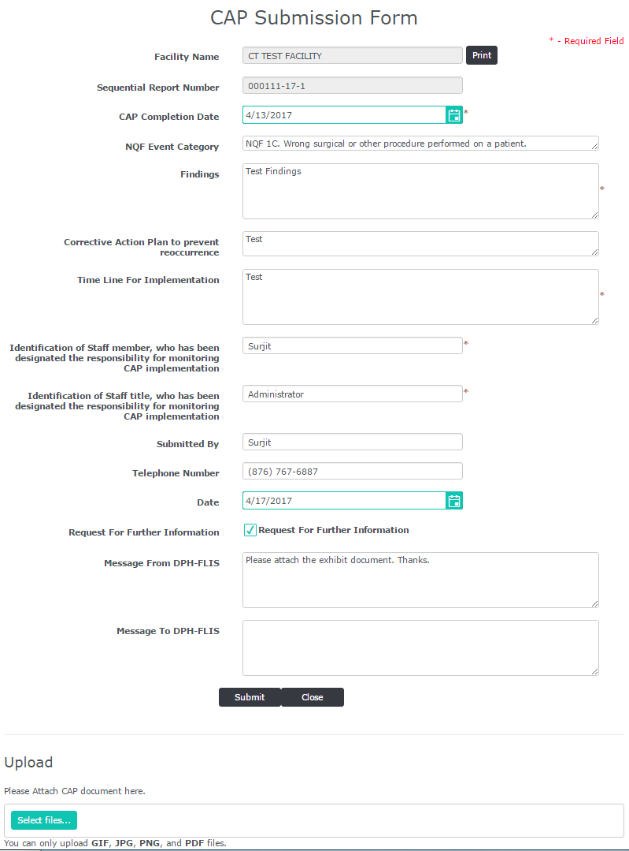

How to Attach Files to CAP Form
Exhibit/Supporting documents can be attached to the CAP form if it’s needed or requested by DPH FLIS.
Open the CAP form from the home page and you will see the “Upload” section at the bottom of the page.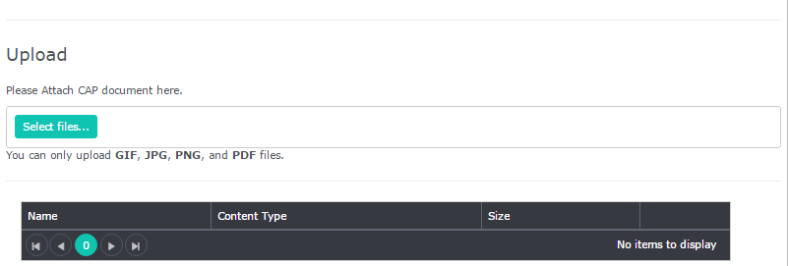

- Click “Select Files” and it opens the Windows Explorer pop up window and you can chose the file that needs to be attached.
- For multiple attachments click “Select Files” button again and upload the file.
- GIF, JPG, PNG and PDF are the allowed files types that will be accepted.
- Once uploaded successfully you will see the attached document listed at the bottom. The “Delete” button lets you delete the uploaded document.

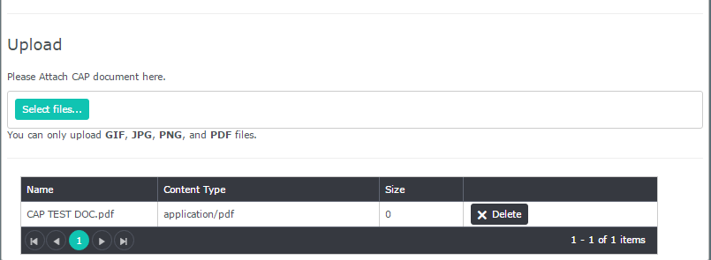

Note | You can print both the submitted adverse event and CAP by clicking the “Print” button at the top each form.

Communicating with DPH FLIS Team – CAP & Adverse Events

We have designed this application in such a way that everything related to an adverse event can be communicated through the website.

The column “Request for Further Information” will have an, if DPH FLIS needs additional information for an adverse event. This will be defaulted to green check sign if either DPH FLIS or Facility have asked for any details or requests.

Once you see the click the “CAP” button and you can see the message from DPH FLIS as shown in the screen shot below. Communication from DPH-FLIS can be seen in “Message from DPH-FLIS” text box and only they will be able edit in this box. Facility users will be able to edit only “Message to DPH-FLIS” and can add their text to communicate to DPH-FLIS.

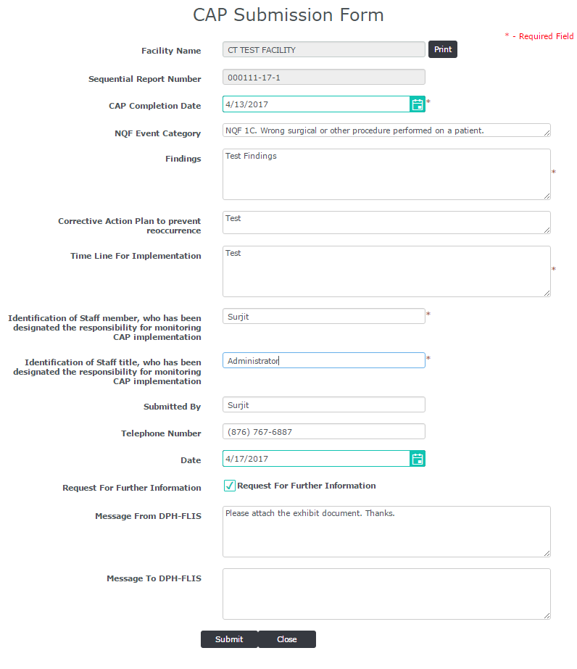

Please enter your comments in “Message to DPH-FLIS” text box and click submit and FLIS administrators will see the message and respond.

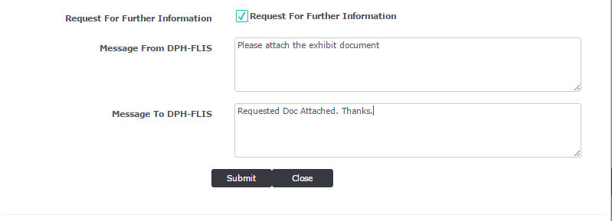

This feature is designed in such a way that no separate phone calls, email messages or faxes needed to communicate with DPH FLIS team for any additional questions regarding an adverse event.

END

